
West DC: Risk Assessment

Cycling Time Trials – West DC Course Risk Assessment Document. The measures to reduce risk identified in the right hand column must be included on the start sheet or implemented for the duration of the event as applicable. Failure to comply with the requirements of this document may result in approval being withheld with respect to subsequent race promotions by the promoting club.
(CTT Guidance Note 22 – Appendix 2 – Issue 2 September 2011 provides additional advice)

Course/Road(s) Assessed:  B3092; A361 | Course:  U370  Distance (in miles):  25
Date of Assessment/Review:  27 Sep 2022  Updated Jan 2023 with hyperlinked images | Name of Assessor:  Paul Winchcombe  Reviewed 2005 RA and reapproved
Course Description:
start on b3092 at the entrance to frome showground (about 200 yds past the layby where the maiden bradley 10 course starts). proceed to the blatchbridge r/bt on a361. take 3rd exit on a361to pylon r/bt and take 1st exit (left). go straight on at roundabout outside the new business park (note there is no other exit except into the business park). turn at oldford r/bt (care traffic from the right has priority) and retrace to blatchbridge r/bt. complete blatchbridge - oldford -blatchbridge circuit twice more. after completing the third circuit take the first exit at blatchbridge r/bt and proceed towards maiden bradley to finish opposite the start. note: it is the rider’s responsibility to know when to circle blatchbridge roundabout and retrace or to turn left at the end of the 3rd circuit.
Link:
https://www.strava.com/activities/7145271947
https://www.cyclingtimetrials.org.uk/course-details/u370

Traffic Flows:
Traffic counts are historically low
Course / Event History:
Course has been in general use since at least 2010. Also forms backbone of U375 on RaBs section of course

Risk Identified
No. | Distance / Location | Risk/Hazard | Level of Risk  (L / M / H) | Measures to reduce Risk  (if applicable)
a) Introduction
1 | General Requirements | Time of Road Usage meets CTT Traffic Standards | Low | Traffic counts within acceptable numbers; Take Traffic Counts during event.

b) HQ to Start
2 | Competitors riding to start from HQ at Maiden Bradley | Negligible, route avoids course or need for U turns | Low | Route to be on start sheet and warning that U turn will result in disqualification.  Prohibition on warming up past the start.
3 | Entrance to field used for Somerset Show about ¼ mile north of layby used for U369 start. B3092. | Competitors waiting; light traffic. Field entrance little used Timekeepers car would not impede entry to field. | Low | Instructions on Start Sheet warning against making ‘U’ turns; Cycle Event warning sign.
 |  | 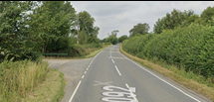
c) Start to Turn
4 | Blatchbridge RaB –junction with A361 | Riders take 3rd Exit: riders give way to traffic from the right; traffic joining the course. | Medium | Observer & direction signs or additional observers; Cycle Event warning signs (medium size) on A361 (both directions) and on approach to RaB from Frome.
 | Riders have good visibility of traffic on RaB | 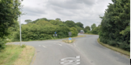
5 | Junction with A362 joining from the right. Riders have right of way. | Traffic joining the course. | Medium | Cycle Event Warning Sign on A362 (medium size), 100 yards before junction with A361.
6 | Pylon / Berkley Marsh RaB | Riders take 1st Exit: riders give way to traffic from the right; traffic joining the course. | Medium | Cycle Event warning sign on minor road approaching the roundabout.
 | Visibility on approaches to RaB are good | 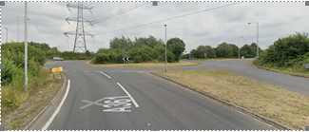

7 | Trading Estate RaB (new in 2005) | Riders take 2nd exit: anticipated to be little traffic entering / exiting the trading estate. | Low | No action required, subject to review regarding traffic levels using the estate.
 | Visibility on approaches to RaB are good | 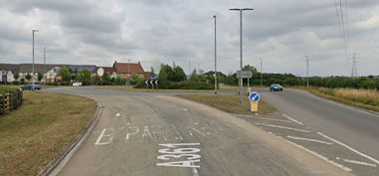
8 | Oldford RaB | Circle and retrace | Medium | Observer and direction signs or additional observers. Traffic joining the course: Cycle Event warning signs (medium size) on B3090 & A361.
 | Visibility on approaches to RaB are good. Caution for queuing traffic on approach to RaB | 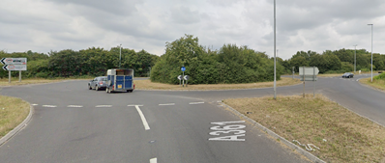
c) Turn to Blatchbridge RaB
9 | Trading Estate RaB (new in 2005) | Riders take 1st exit: anticipated to be little traffic entering / exiting the trading estate. | Low | No action required, subject to review and traffic levels using the estate.
10 | Pylon / Berkley Marsh RaB | Riders take 2nd Exit. | Medium | Cycle Event warning sign (see 6)
11 | A362 joins course | Riders have priority | Medium | Cycle Event warning sign on A362 (see 5)
d) Blatchbridge RaB – Turn - Blatchbridge RaB : 2nd circuit
12 | Blatchbridge RaB | Circle and repeat 5 to 11
e) Blatchbridge RaB – Turn - Blatchbridge RaB : 3rd circuit
13 | Blatchbridge RaB | Circle and repeat 5 to 11
f) Blatchbridge RaB to Finish
14 | Blatchbridge RaB | 1st Exit on B3092 | Low | No sign for turning - rider’s choice. Warning on start sheet . See 4.
15 | Finish timekeeper directly opposite start Finish at point of two dropped kerbs | Riders sprinting to finish; other road users | Low | Finish timekeeper to be parked in entry to field. Good visibility. Warning on start sheet not to perform ‘U’ turns at the finish. Also a note to be aware of surroundings and other road users at the finish.
16 | After finish | Straightforward route back to HQ | Low

Notes
- The use of a vehicle for the timekeeper(s) at start and finish is where appropriate and is only identified as an example for the action to be taken
- The small junctions or entrances to farms/ facilities (garage,.eatery, etc) that are not identified in this risk assessment have been considered, however are not considered significant to pose a risk and therefore have not been noted.

This document remains live and any changes to the items listed above or new hazards/risk that arise should be notified to the district committee at the earliest opportunity.

CYCLING TIME TRIALS IS A COMPANY LIMITED BY GUARANTEE REGISTERED IN ENGLAND No: 4413282
Registered Address: 77 ARLINGTON DRIVE, PENNINGTON, LEIGH, LANCASHIRE. WN7 3QP November 2003

