 | West DC Risk Assessment
Course : UC30 / 9 | 9.2 mile TT. Unclassified road and B3151
Sheet 1 of 2 | Date of Assessment 30/11/2009 updates 01/2020

Cycling Time Trials – West DC Course Risk Assessment Document. The measures to reduce risk identified in the right hand column must be included on the start sheet or implemented for the duration of the event as applicable. Failure to comply with the requirements of this document may result in approval being withheld with respect to subsequent race promotions by the promoting club.

No | Distance / Location | Risk/Hazard | Level of Risk  (Low/ Med/ High) | Measures to reduce Risk  (if applicable)
(a) Introduction
2 | Before Start | Competitors riding from Event HQ ; Competitors warming up | L | Instructions at event HQ.
3 | Area of Start, unclassified road  Queen Camel, W Camel Road | Competitors waiting | L | Instructions at event HQ riders to gather in Health Centre Car Park. Only starting ride in start area.
b) Start to Turn at Ilchester
5 | Start in gateway just west of Health Centre car park | Traffic approaching  Riders heading West on West Camel Road towards Fleet Air Arm Museum | L | Cycle Event Warning sign on exit at mini roundabout in Queen Camel
6 | Left turn onto B3151 at crossroads | Traffic on B3151 has priority. Riders have restricted visibility on approach to junction | M | Marshal and cycle event warning signs on all approaches
7 | Turn on Northover roundabout (Ilchester) | Riders retrace at turn. Traffic on roundabout. | M | Marshal on Somerton Road approach and cycle event warning signs on all approaches
8 | Right turn onto unclassified road | Oncoming vehicles | L | Good visibility. Riders instructed not to cut corner. Marshal as at 6
9 | Finish. Field gate west of start and Health Centre car park. | Left turn after finish into Health centre car park. | L | Rider instructed to return to Health centre car park and not proceed to mini roundabout.

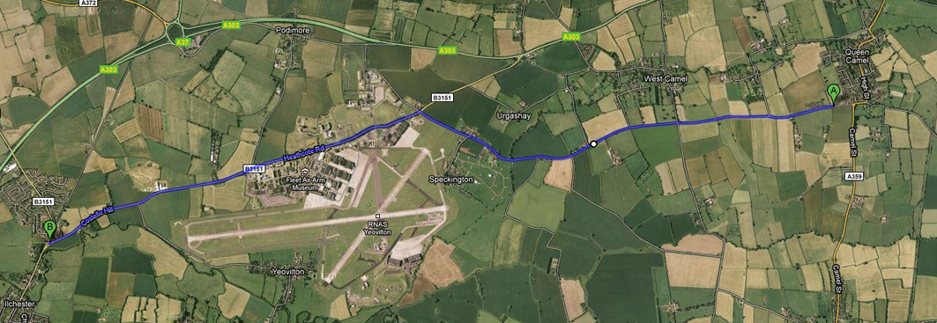

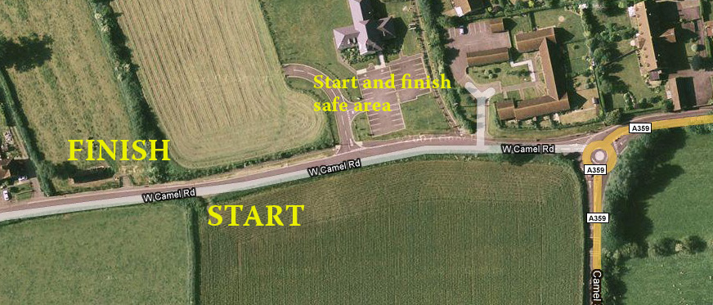

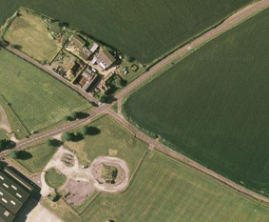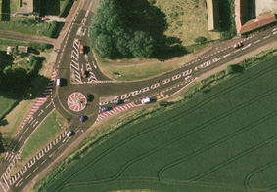

Left and right turn at Stockwitch Cross
U Turn on roundabout (riders approach and exit right)
Outbound: riders approach from bottom right and turn left
Return: riders approach from left and turn right

Traffic counts on all roads, throughout the year have not exceeded 200.

This document remains live and any changes to the items listed above or new hazards/risk that arise should be notified to the district committee at the earliest opportunity. This document was last updated in January 2020.

CYCLING TIME TRIALS IS A COMPANY LIMITED BY GUARANTEE REGISTERED IN ENGLAND No: 4413282
Registered Address: 77 ARLINGTON DRIVE, PENNINGTON, LEIGH, LANCASHIRE. WN7 3QP November 2003

