 | West DC Risk Assessment
Course : UC30 / 10 | 10 mile TT. Unclassified road and B3181
Sheet 1 of 2 | Date of Assessment 30/11/2009 updates 01/2022

Cycling Time Trials – West DC Course Risk Assessment Document. The measures to reduce risk identified in the right hand column must be included on the start sheet or implemented for the duration of the event as applicable. Failure to comply with the requirements of this document may result in approval being withheld with respect to subsequent race promotions by the promoting club.

No | Distance / Location | Risk/Hazard | Level of Risk  (Low/ Med/ High) | Measures to reduce Risk  (if applicable)
(a) Introduction
2 | Before Start | Competitors riding from Event HQ ; Competitors warming up | L | Instructions at event HQ.
3 | Area of Start, unclassified road | Competitors waiting | L | Instructions at event HQ riders to wait in layby opposite start. Only starting ride in start area.
b) Start to Turn at Ilchester
5 | At the drain cover on the northern edge of Woollen Lane | Traffic approaching | L | Cycle Event Warning signs on Camel road
6 | 1st exit on mini roundabout at Queen Camel | Traffic heading to west camel | L | Riders warned to be prepared to give way. Cycle warning sign on approach from Queen Camel centre
7 | Left turn onto B3151 at crossroads | Traffic on B3151 has priority. Riders have restricted visibility on approach to junction | M | Marshal and cycle event warning signs on all approaches
8 | Turn on Northover roundabout (Ilchester) | Riders retrace at turn. Traffic on roundabout. | M | Marshal on Somerton Road approach and cycle event warning signs on all approaches
9 | Right turn onto unclassified road | Oncoming vehicles | L | Good visibility. Riders instructed not to cut corner. Marshal as at 7
9 | Finish. 30mph sign on West Camel Road . | Parked vehicles after finish. | L | Riders instructed not to stop at finish but to return to Health centre car park.

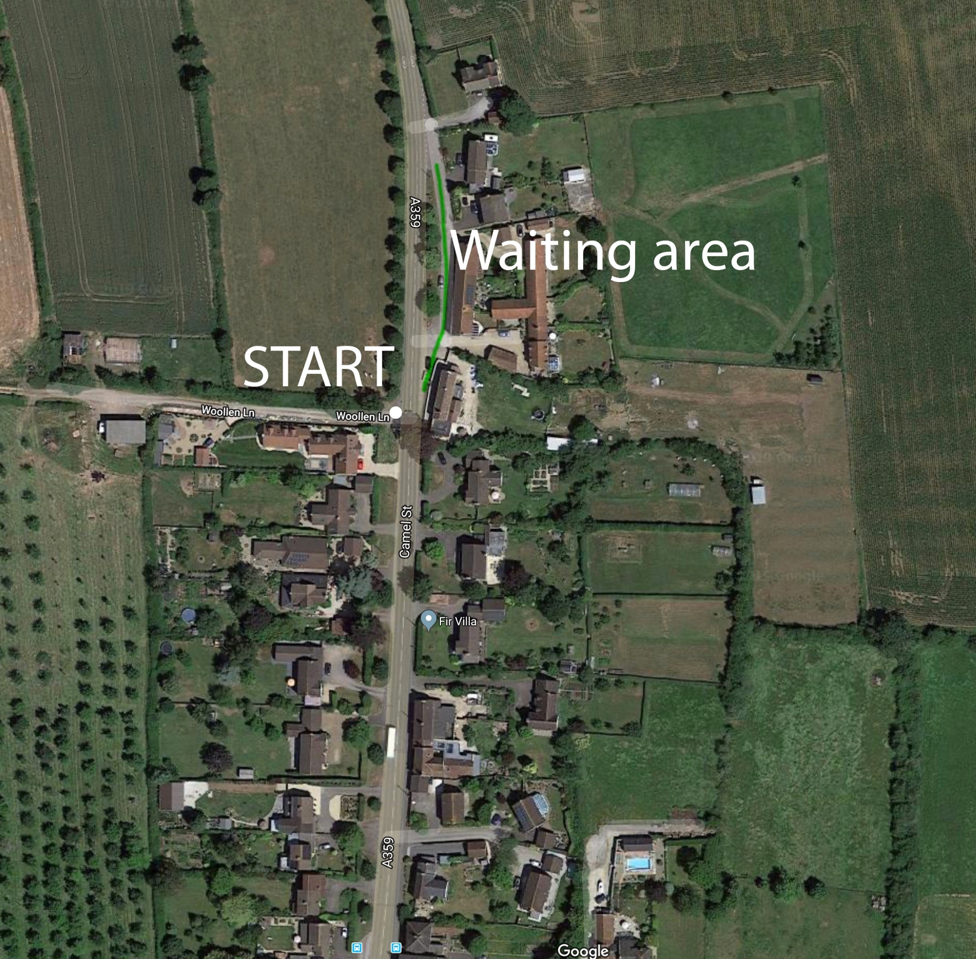

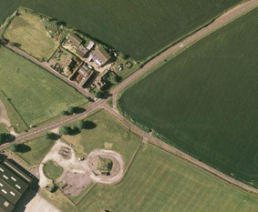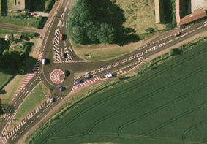

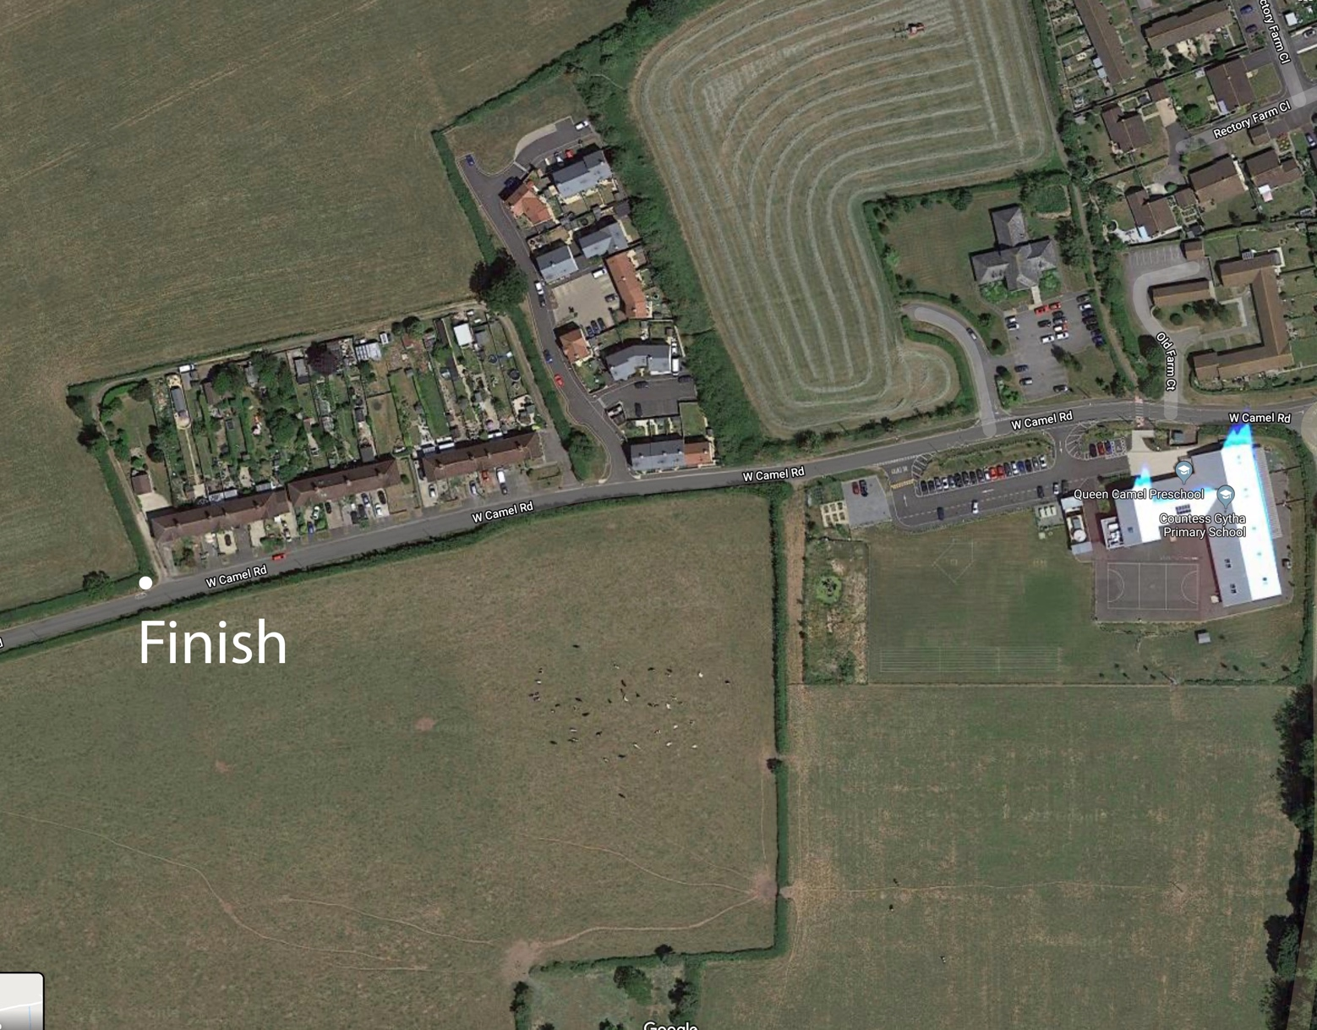

Start and finish areas
Left (outbound) and right (return) turn at Stockwitch Cross
U Turn on roundabout (riders approach and exit right)

This document remains live and any changes to the items listed above or new hazards/risk that arise should be notified to the district committee at the earliest opportunity. This document was last updated in January 2022.

CYCLING TIME TRIALS IS A COMPANY LIMITED BY GUARANTEE REGISTERED IN ENGLAND No: 4413282
Registered Address: 77 ARLINGTON DRIVE, PENNINGTON, LEIGH, LANCASHIRE. WN7 3QP November 2003

