Risk Assessment proforma

Course | M12S | 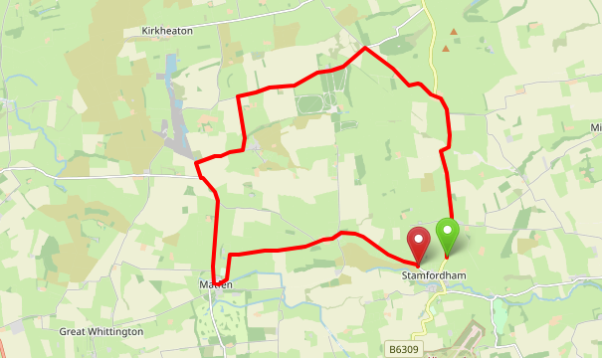
Area | NE District
Description | Rural/Circular Course
HQ | Stamfordham Village Hall or Stamfordham Cricket Club
Measured | Yes
Measured by | Unknown
Risk assessed | Yes
Assessed by | Terry Wilkinson
Date approved | 1st March 2024
Type A | Yes
Type B | Yes
Police Authority | Northumbria
Additional information | Some parking available near start lay-by.
Notes for riders | See below
Course Description

Stamfordham - Black Heddon - Ingoe - Matfen – Stamfordham (12 Miles)

START approximately half a mile north of Stamfordham on the B6309. Proceed north to Black Heddon, and bear left along a minor road to the crossroads for Belsay-Wallridge. At the crossroads, turn left towards Wallridge, then left towards Ingoe. At the T Junction, turn left towards Matfen. At the T Junction, turn left towards Stamfordham to FINISH at the small lay-by just beyond the Stamfordham sign and at the 20 MPH speed warning.

General Safety Notes and Requirements

● Vehicles of competitors/officials/marshals/helpers to be parked safely and without hindrance to other road users.
● All officials/marshals/helpers to wear fluorescent jackets or high visibility clothing.
● Marshals are to be briefed as to the extent of their roles/duties prior to the event.
● A marshal’s sole duty is to clearly indicate the route the rider is to follow before the rider reaches the marshal point (the rider may be unfamiliar with the course). This is done by either pointing out the direction of travel or holding a directional arrow/marker – marshals should not shout instruction or attempt to control the traffic in any way or interfere with its movement on the highway (Guidance Note 11).
● Whenever possible, marshals should be able to communicate with the organiser by mobile phone in case of accident/emergency

Rider Safety Notes

• No U-turns to be made in the vicinity of the timekeeper(s).
- No dismounting in the finishing area and riders to proceed carefully into the village, observing the 20mph speed limit on crossing the line.
- Take extreme care at road junctions, on descents and when passing through villages.
- In wet and frosty conditions, descents and sharp bends can be particularly hazardous and should be negotiated with extreme care.
- Keep to the left at all times and especially so on narrow roads with right hand bends.
• Road surface conditions may change depending on the season, weather, or condition of the road. It is the rider’s responsibility to ride in such a manner that allows them to ride safely and with consideration to other road users at all times.
- HARVESTING TIME – be aware that from around mid-late July until around October time, farmers will be bringing in the harvest so expect a higher level of slow-moving farm machinery on the course.
● Head down riding is prohibited and will result in disqualification.
● It is the responsibility of the rider to check the On-The-Day Risk Assessment to be aware of any extra hazards or changes they should be aware of.
• Every competitor MUST have, fixed to their machine, both a front and rear-facing, working light (either constant or flashing). These must be clearly visible (Regulation 14).
• Every rider MUST wear a helmet that conforms to current Safety Standards (Regulation 15), and it is their responsibility to ensure it fits correctly and is in good condition/undamaged.

NOTE TO THE ORGANISER: All of the above information should be included in the Start Sheet Information.

What 3 Words | Course description | Distance | Risk (L/M/H) | Risk description | Minimum management  (Without prejudice)
Coats.invisible.struggle | M12S START – layby at top of hill approximately half a mile north of Stamfordham on the B6309. | 0 | M | Oncoming and passing traffic in the start line area. | 1. Marshal to assist Start Timekeeper.  2. Cycle Event sign positioned approximately 200 metres BEFORE the start line.  3. Cycle Event sign positioned approximately 200 metres AFTER the start line to alert traffic approaching from the direction of Black Heddon.  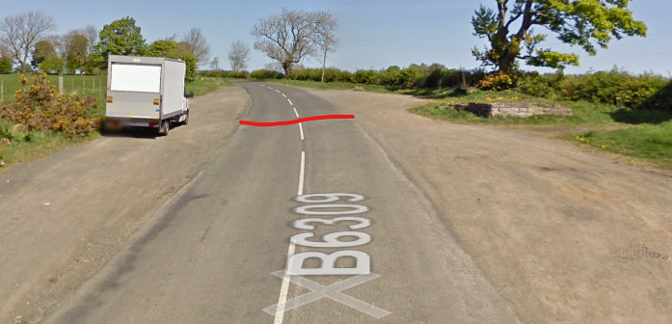
Ends.raves.exotic | B6309 – two sharp bends before Black Heddon |  | M | 90 degree right followed by 90 degree left turn. Road surface uneven with risk of gravel in places. | 1. A red flag positioned at an appropriate distance before each bend (2 required).
Earliest.jolt.cornfield | B6309 at Black Heddon – minor road on left (bear left onto minor road). | 2.5 Miles | M | Main road bears around to the right. Riders be cautious of cars approaching from right as they take left onto smaller side road. | 1. Marshal.  2. Directional arrow (left) as appropriate.  3. Cycle Event sign positioned approximately 50 metres to the right of the junction on the B6309 at the telegraph pole A78 to alert traffic approaching from the direction of Belsay.  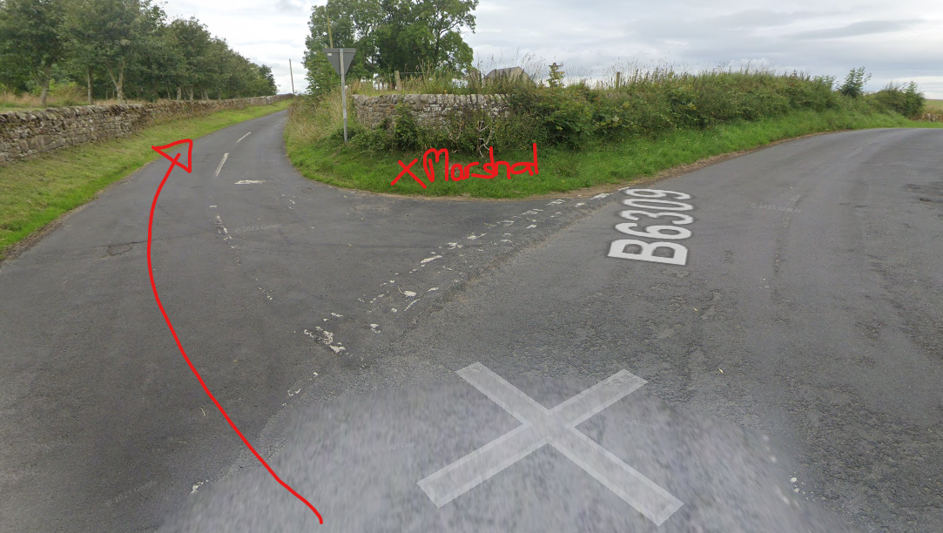
Prune.intrigues.attend | Minor Black Heddon to Wallridge road – turn left at Belsay-Wallridge Crossroads. | 3.7 Miles | M | Oncoming traffic from all directions with the possibility of low visibility due to hedge line. | 1. Marshal.  2. Directional Arrow (left) as appropriate.  3. Cycle Event sign positioned approximately 100 metres to the right of the crossroads to alert traffic approaching from the direction of Belsay.  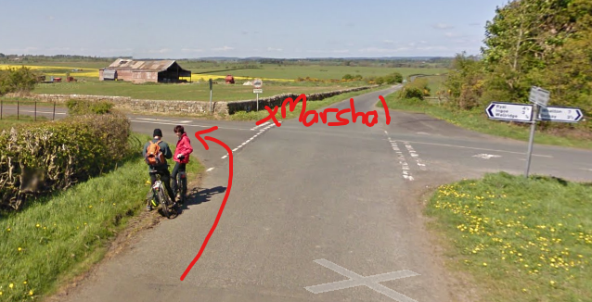
Pokes.though.coats | Minor Wallridge to Kirkheaton road – minor road on left towards Ingoe (turn left). | 5.6 Miles | L | A few potholes and recessed drain covers.  Fast descent down towards Ryal/Quarry. | 1. Marshal.  2. Directional Arrow (left) as appropriate approximately 100 metres BEFORE the left hand turn.  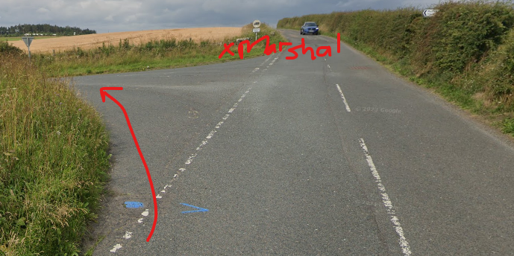
Ironic.splashes.deal | Minor Ingoe to Ryal road – sharp right-hand bend on descent at Ingoe. |  | M | Open view sharp right but lots of gravel and loose material collected in middle or road. | 1. Directional Arrow (right) as appropriate.  2. Cycle Event sign positioned approximately 30 metres to the left of the bend on the very minor road to alert traffic approaching from the direction of Ingoe.  Observation: Road markings indicating the direction of the course route are not distinct and a directional arrow would eliminate any doubts by riders.  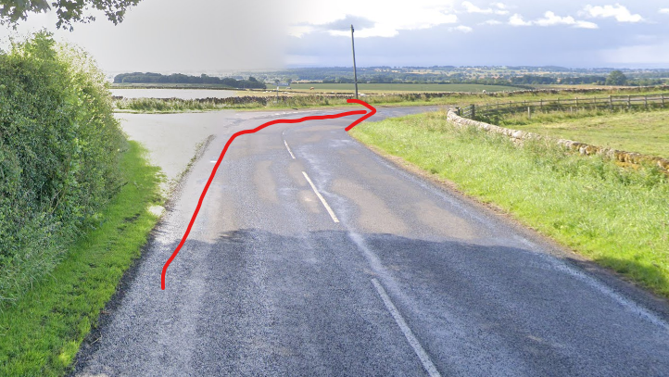
Tango.convinced.addicted | Minor Ingoe to Ryal road – sharp left-hand bend after Ingoe. |  | M | Obstructed view of the oncoming traffic from left going around sharp 90 degree bend due to high hedge line. Very loose gravel and debris on road. | 1. Red flag positioned at an appropriate distance BEFORE the bend.  2. Directional arrow (left) as appropriate  3. See Rider Safety Notes above.  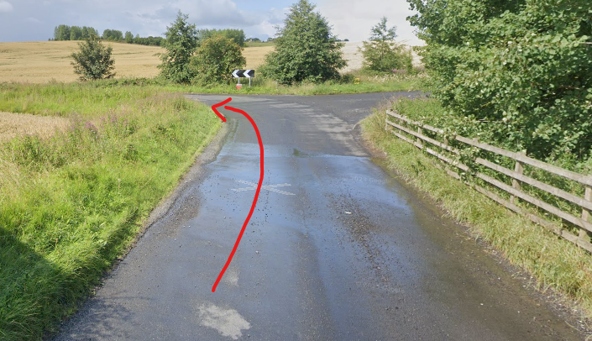
Strides.snug.rating | Minor Ingoe to Ryal road – T-Junction with Ryal to Matfen road (turn left). | 7.2 Miles | M |  | 1. Marshal.  2. Directional arrow (left) at an appropriate distance BEFORE the junction.  3. Cycle Event sign positioned approximately 100 metres to the right of the T-Junction to alert traffic approaching from the direction of Ryal.  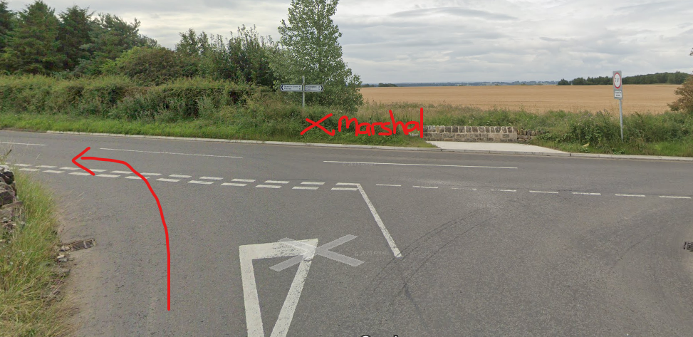
Obligated.undertone.strays | Minor Ryal to Matfen road – exit on left from small housing estate on outskirts of Matfen. |  | M |  | 1. Cycle Event sign positioned on the minor road at wall/grass verge directly opposite exit from The Oaks housing estate.
Trembles.tangible.charmingly | Minor Ryal to Matfen road – T-Junction in Matfen (left turn) | 8.8 Miles | M |  | 1. Marshal.  2. Directional arrow (left) at an appropriate distance BEFORE the T-Junction.  3. Cycle Event sign positioned approximately 75 metres to the right of the T-Junction to alert traffic approaching from the direction of Corbridge.  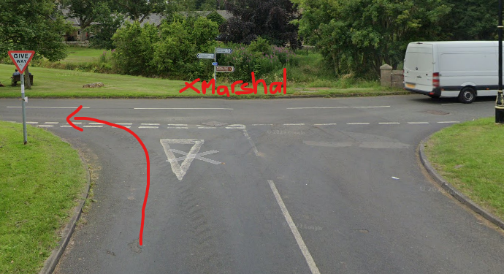
Mammal.affords.scorched | Minor road in Stamfordham-Fenwick. Possibility of parked vehicles and/or pedestrians. |  | L | There can be parked vehicles on the verge going around the bend to the left. Will be difficult to see until upon the corner. | 1. See Rider Safety notes above.
 | Minor road on left leading to Mainsbank Farm. |  | M | Risk of gravel on roadway pulled out of the entrance to Mainsbank Farm. | 1. See Rider Safety notes.  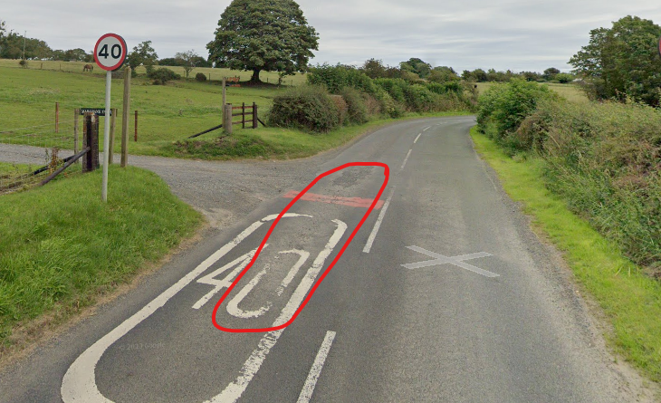
Mats.suckle.lecturers | M12 FINISH – at small lay-by before village at the Stamfordham sign. | 12.2 Miles | M | Travelling back into built-up area of the Village near the Pub and Church. Riders to take caution and slow down to the 20mph limit. | 1. Marshal to assist Timekeeper.  2. See Rider Safety notes above.  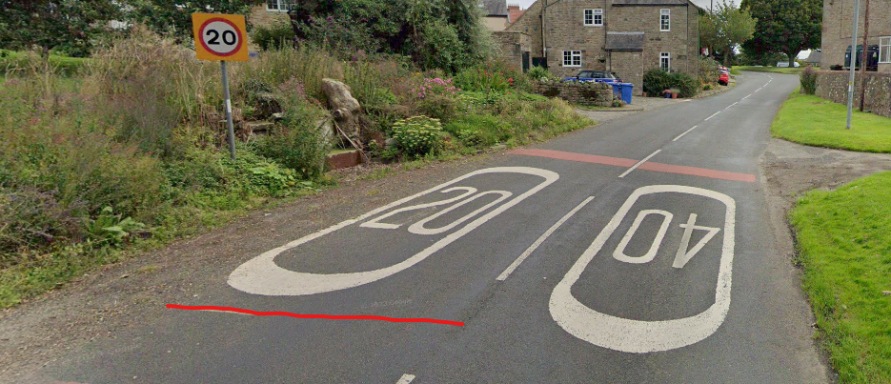

Requirements
Marshals | 7
Event Signs | 8
RH Directional Arrow | 1
LH Directional Arrow | 6
Red Flags | 3

References:

CTT GN22 – Risk Assessment

