

West DC: Risk Assessment

Cycling Time Trials – West DC Course Risk Assessment Document. The measures to reduce risk identified in the right hand column must be included on the start sheet or implemented for the duration of the event as applicable. Failure to comply with the requirements of this document may result in approval being withheld with respect to subsequent race promotions by the promoting club.
(CTT Guidance Note 22 – Appendix 2 – Issue 2 September 2011 provides additional advice)

Course/Road(s) Assessed:  A361 Lechlade - Burford | Course: U95/10  Distance (in miles):  10 miles
Date of Assessment/Review:  February 2009, Updated Jan 2012, Updated June 2015. Reviewed December 2022 | Name of Assessor:  Assessor(s): Ann and Toby Wooldridge (Gloucester City CC)  Updated June 2015: Paul Warren (Oxonian CC)  Reviewed Paul Winchcombe West DC RA Secretary December 2022
Review History:  First Produced (if known):  Last Review: December 2022  April 2020, February 2009, Updated Jan 2012, Updated June 2015 | Sponsoring Club or Organisation:  Oxonian CC (London West) using course in West District
Course Description:
START on A361 at the south side of the junction with the minor road to Shilton at the Cotswold Wildlife Park crossroads by a hydrant "SV 6-6 under a large Chestnut tree and opposite the Park gate house on the west side of the road. Grid ref 244086.
Go south on A361 to the Lechlade roundabout. .5.255 miles. Grid ref 218009.
Circle the roundabout and take the third exit to return northwards on A361.
Continue northwards to FINISH north of the crossroads to Kencott and Holwell at the fourth of a line of reflector posts, 20 yards before the crossroads sign on the opposite side of the road and 85 yards before the garden gate of a cottage on the west side of the road. 10 miles. Grid ref 241076
Link:
https://ridewithgps.com/routes/41640104
Ride with GPS
Course Type:
- Single Carriageway
- Out and Back repeated
- No traffic calming measures or 20mph restrictions identified
Traffic Flows:
Within limits – an updated count is needed for 2023
Course / Event History:
Course has been used since at least 2009 with no reported issues. Although a U course is more generally used as a club mid week course.
Police Authorities:
Gloucestershire | Road Safety and Traffic management, Gloucestershire Constabulary HQ, No 1 Waterwells, Quedgeley, GLOUCESTER, GL2 2AN | 01452 754547 Force Control Room – 101 | RoadSafety.&TrafficManagement@gloucestershire.pnn.police.uk (primary email as email is monitored)  David.Holland@gloucestershire.pnn.police.uk (secondary email)
Burford is in Oxfordshire – no details held for Oxfordshire Policy Authority reporting

No. | Distance / Location | Risk/Hazard | Level of Risk  (L / M / H) | Measures to reduce Risk  (if applicable)
a) Introduction
1 | General Requirements | Time of Road Usage meets CTT Traffic Standards | M | Traffic counts within acceptable numbers ; Take Traffic Counts during event
b) HQ to Start
2 | Before Start | Competitors riding from Event HQ; Competitors warming up | M | Instructions at event HQ signing on advising riders of safe routes; prohibition on warming up past the start
3 | Area of Start | Competitors waiting and merging with traffic at start. | M | Warning sign north of start on A361 facing southbound traffic.  Starter to wear hi-viz.
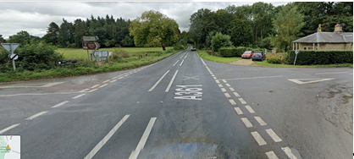
Start is on left of this view - ///emulated.headers.braked
c) Start to Turns and Finish
4 | Lechlade RaB | Traffic emerging from Lechlade entry to RaB. | M | Warning sign for approaching traffic from Lechlade; Turn sign before RaB  Good visibility on the RaB
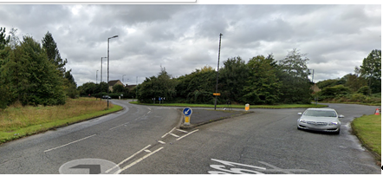
Approaching Lechlade RaB from North
 | FINISH north of the crossroads to Kencott and Holwell at the fourth of a line of reflector posts, 20 yards before the crossroads sign on the opposite side of the road and 85 yards before the garden gate of a cottage on the west side of the road |  | L
7 | Finish | Road Users – riders performing U turns after the finish | M | Warning not to perform ‘U’ turns at the finish. Also a note to be aware of surroundings and other road users at the finish.
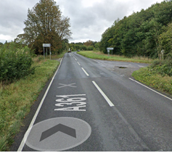
Cross roads before finish
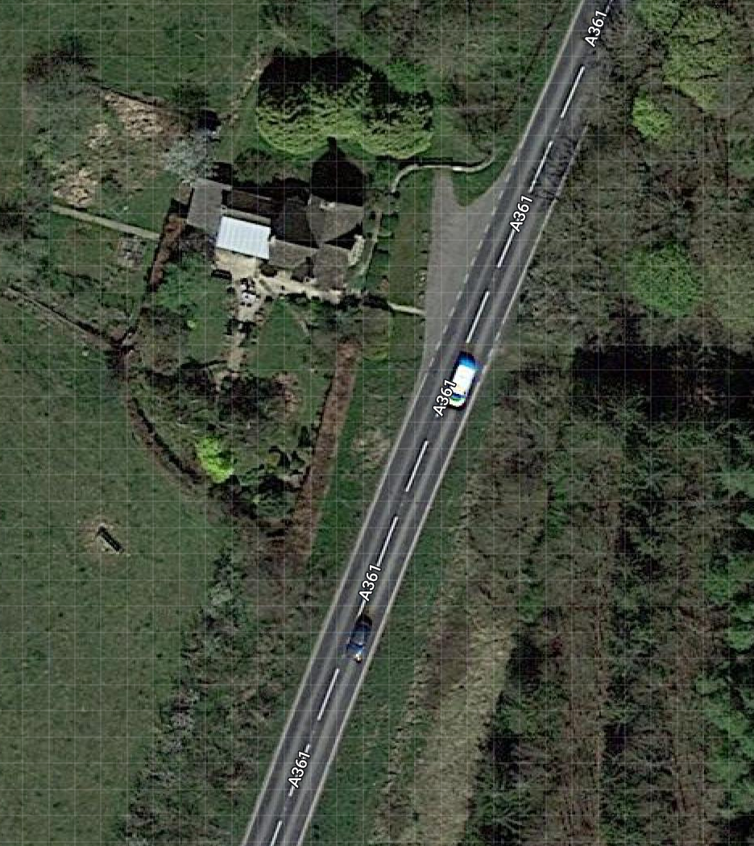
Overhead view of finish area and cottage on West of road
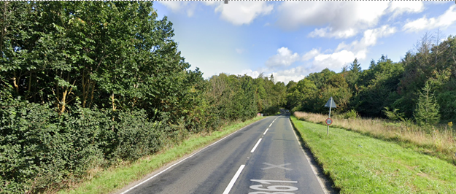
Finish is 20 yds short of sign on right of road
Aread of ///dynasties.speaking.hoping

Notes
- Note that the Wildlife Park is normally closed when there are evening time trials
- The use of a vehicle for the timekeeper(s) at start and finish is where appropriate and is only identified as an example for the action to be taken
- The small junctions or entrances to farms/ facilities (e.g. garage,eatery, etc) that are not identified in this risk assessment have been considered, however are not considered significant to pose a risk and therefore have not been noted.
- The course should not be used on public bank holiday weekends or when there are major local events. E.g. Womad, Badminton, Polo Competition, Air Show, etc

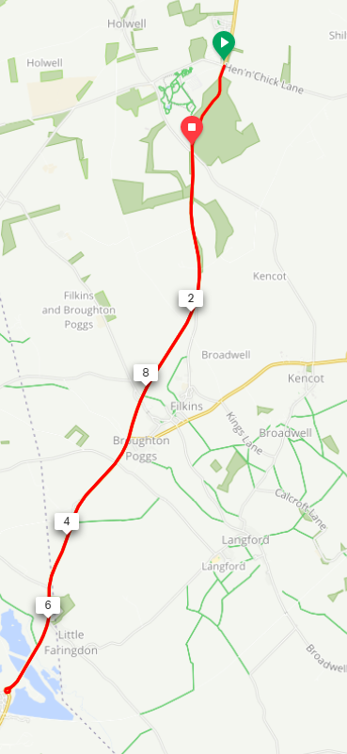

This document remains live and any changes to the items listed above or new hazards/risk that arise should be notified to the district committee at the earliest opportunity.

CYCLING TIME TRIALS IS A COMPANY LIMITED BY GUARANTEE REGISTERED IN ENGLAND No: 4413282
Registered Address: 77 ARLINGTON DRIVE, PENNINGTON, LEIGH, LANCASHIRE. WN7 3QP

