
West DC: Risk Assessment

Cycling Time Trials – West DC Course Risk Assessment Document. The measures to reduce risk identified in the right hand column must be included on the start sheet or implemented for the duration of the event as applicable. Failure to comply with the requirements of this document may result in approval being withheld with respect to subsequent race promotions by the promoting club.
(CTT Guidance Note 22 – Appendix 2 – Issue 2 September 2011 provides additional advice)
Course/Road(s) Assessed:  Daneway Lane to Sapperton | Course:  UHC42  Distance (in miles):  0.5 miles
Date of Assessment/Review:  3 September 2023 | Name of Assessor:  Daniel Smith
Review History:  First Produced (if known):  Last Review: 14 August 2021 | Sponsoring Club or Organisation:  Stroud Valley Velo
Course Description:
Start on Daneway Lane at the layby, opposite the parking area for walkers and the public footpath. Grid reference 51.72851 -2.0897 (0 miles) There is on going building works at this location. The area is boarded so no danger or likelihood of changes in road width.
Proceed southwards uphill, through the junction with Village Street Sapperton. Continue to beyond the junction with The Glebe at the Bus Stop. Finish at 0.5 Miles Grid reference 51.7264 -2.0790
https://www.cyclingtimetrials.org.uk/course-details/uhc42
Course Type:
- Single Carriageway
- Out Only
Traffic Flows:
Light. This is a country road without any white markings. Well tarmacked with good visibility.
Course / Event History:
Corinium Cycle Club ran this route for their Club Hill Climb for a number of years. Assessor spoke with previous competitors and they were not aware of nay incidents (Simon James ex member of Corinium now SVV)
SVV has now run 2 previous Club Hill climbs on this course without incident.
Key Identified Risks
No. | Distance / Location | Risk/Hazard | Level of Risk  (L / M / H) | Measures to reduce Risk  (if applicable)
a) Introduction
1 | General Requirements | Time of Road Usage meets CTT Traffic Standards | Low | Traffic counts within acceptable numbers
b) HQ to Start
2 | Before Start | Competitors riding from Event HQ; Competitors warming up | Low | Instructions on Start Sheet and at event HQ signing on advising riders of safe routes; prohibition on warming up past the start
0 miles | START:  Daneway Lane at the layby, opposite the parking area for walkers and the public footpath. Grid reference 51.72851 -2.0897 (0 miles) | Pedestrians/walkers  Cars Parking  Competitors waiting to start | Low | Cycle Event Warning Signs  Officials on or near start to wear high viz jackets.  Two persons at start to communicate re vehicles approaching  Riders not to perform U-turns or to warm up on the course
 |  | 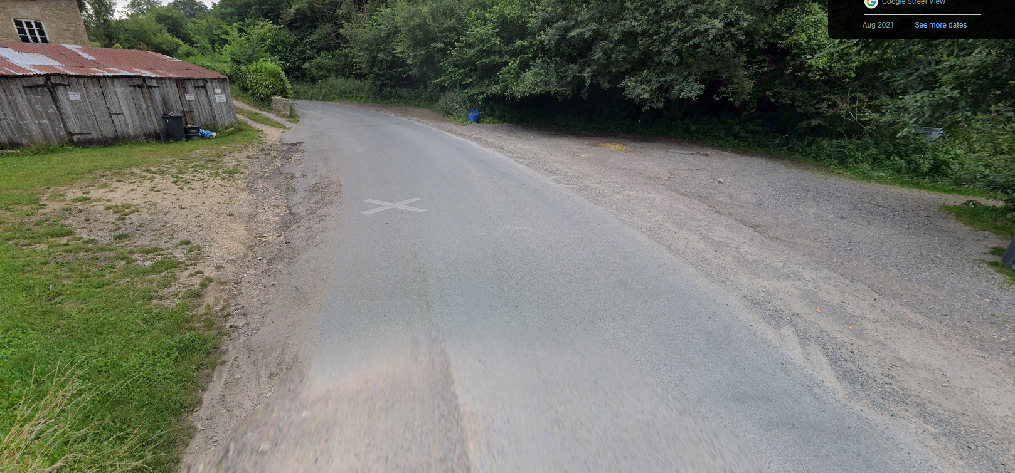

c) Start to Finish
3 | Road is of consistent width to Sapperton. Crossroads have good visibility and riders have priority. A number of driveways and cul de sacs in Sapperton |  | Low | Cycle Event Warning Sign at Cross Roads
d) Finish
1.25 miles | FINISH:  Beyond the junction with The Glebe at the Bus Stop. Finish at 0.5 Miles Grid reference 51.7264 -2.0790 | Traffic from Glebe Lane Cul de sac.  Walkers | Low | The Glebe is a quiet Cul De Sac.  Finish sign at approach to finish and finish board by timekeeper.  Officials at or near finish to wear high viz jackets.
 |  | 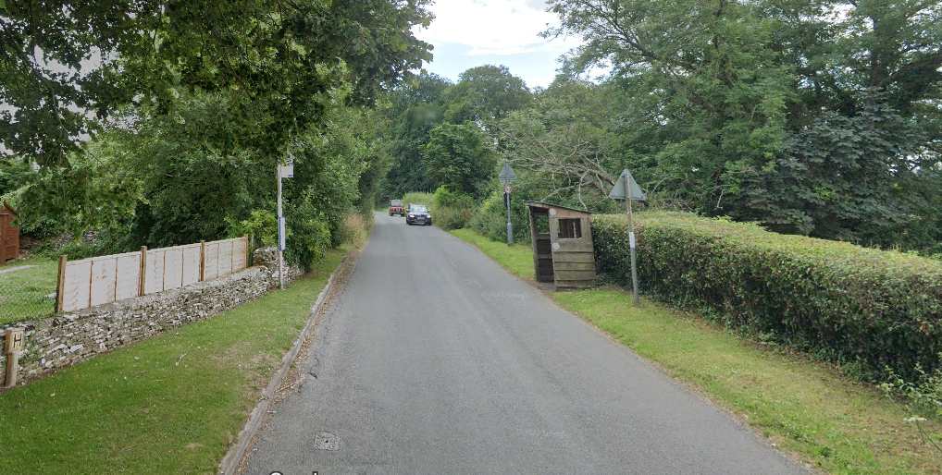
4 | After finish | Competitors returning to event HQ. | L | Instructions on safe route back from finish to HQ.

Notes
The small junctions or entrances to farms/ facilities that are not identified in this risk assessment have been considered, however are not considered significant to pose a risk and therefore have not been noted.
Signage and observers are stationed at Start, Finish and the junctions on the route to provide and added visual reference point for drivers

This document remains live and any changes to the items listed above or new hazards/risk that arise should be notified to the district committee at the earliest opportunity. This document was last updated on 10 August 2022.

