 | Risk Assessment
Course/Road(s) Assessed: Fareham Rd  B2150 Hambeldon Rd | Course: P817/10
Date of Assessment/Review: 118th November 2023 | Name of Assessor: David Knight PNECC

Course Description: P817 10mile course. HQ toilets and car parking at Wickham community centre or North Boarhunt Community Centre
SU573118
START 180m South of Soberton Village Hall on West Street at entrance to farmers field.
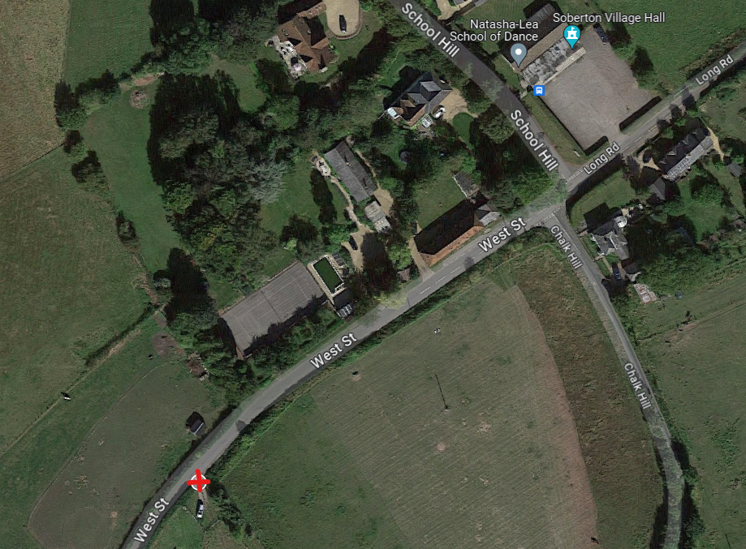
Proceed South Through Soberton High Street, Webbs Green and May Bush Lane.
Then South into Newtown, Church Road and Shoot Hill.
Turn Left at Junction onto Fareham Road.
Proceed East through Worlds End at T Junction with Habledon Rd(B2150) Turn left.
Continue through Hambeldon on Green Road over Grenville Hill
Turn left at cross roads onto Long Road.
Turn Left opposite Soberton Village Hall and Proceed up Chalk Hill to Finish (200yeard)

Finish is just before the crest of the hill at a gated entrance road to the North side of the road.
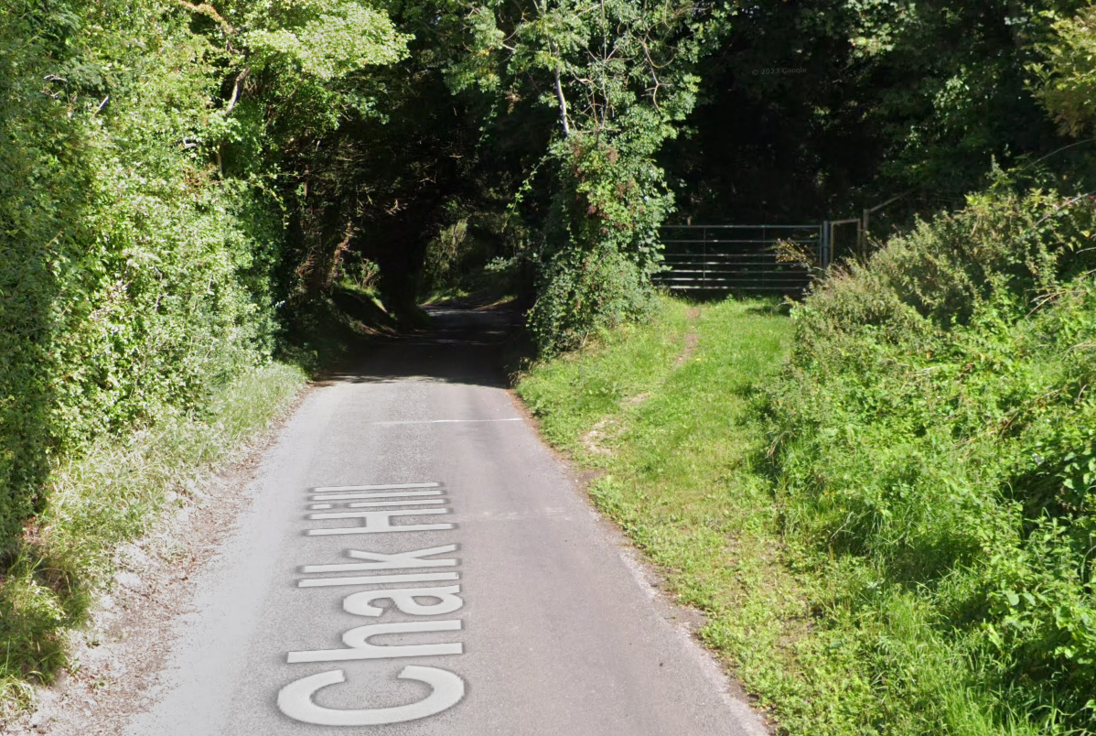

From HQ to start: Check start sheet to see which HQ is used.
Wickham community centre, Mill lane, Wickham. PO17 5AL SU573118: Left out of Houghton way onto Mill lane. End of road turn Right onto Bishops Wood Road. Turn Left on A32. Turn Right onto Cott Street. Turn Left onto Selworth Lane. Turn Left onto High Street proceed to Soberton Village Hall. Start 4.8miles from HQ.

North Boarhunt Social Club, Trampers Lane, North Boarhunt, Fareham, PO17 6DD. Right out of Carpark North on Trampers Lane Left onto Church Road. Continue through Newtown to Soberton. Start 4.2miles from HQ.

Safe route back: at finish continue to crest of hill, turn around, return downhill to start and retrace route to HQ

Traffic Flows: Light

Course/Event History: used periodically

Key Identified Risks

Distance | Location | Identified Significant Risk/Hazards | Level of Risk  Low/Med/High | Measures to reduce Risk  (if applicable)
 | General requirements | Road Usage meets CTT Traffic Standards | L | Traffic Counts  Time/day restrictions on use of Course
 | Before START | Competitors riding from Event Headquarters Competitors warming up. | M | Cycle Event Warning Signs Instructions on Start Sheet; - safe routes to START - prohibited areas for warming up and preferred warm up area - no U turns in sight of Timekeeper - No riding past the start or back across the finish - Reminder of basic safe riding and adherence to Road signs and consideration to other road users
 | Various | Protection of Riders | L | Advise all riders to have a working front and rear light and to wear a helmet
 | Start – Soberton West St 180m South of Village Hall | Competitors Line-up in Layby | L | Standard Cycle Race Sign 200yds either side of start area
 | Cole Hill / West Street triangle | Minor roads on right. Course is Priority route | L | No additional measures required
 | Peststead Ln | Minor road on left. Course is Priority route  Course is Priority route | L | No additional measures required
 | Chalk Hill | Minor road on left. Course is Priority route  Course is Priority route | L | No additional measures required
 | Continue onto High Street Webbs  Green, Plough Lane and  May Bush Lane. | Minor roads on right and  left  Selworth Ln  Hameldon ln  Ingolfield Ln  Chapel Rd  Course is Priority route | L | No additional measures required
 | Join Kiln Hill  (SU607138) and  continue onto  Church Road. | Minor roads on right and left  Forest Rd  Liberty Road  Dradfield Ln  Hundred Acres Rd  Course is Priority route | L | No additional measures required
 | Continue on Church  Road and then to  Shoothilll. | Minor roads on right and  left  Hundred Acres Rd  Ingodfield Ln  Marins Corner  Goathouse Ln  Travellers Rest PH  Course is Priority route | L | No additional measures required
 | Left turn onto Fareham Road | Cyclists Turn Left Onto Fareham Rd (no Right of way) | M | Standard Cycle Race Warning Sign for Traffic on major road  1 turn left sign
 |  | Minor roads on right and left  Kiln Ln  Bunns Ln  Green Ln  Forest Rd  Upland Rd  Broad Ln  Bent Ln |  | No additional measures required
 | Join B2150 Denmead  /Hambledon Road  (SU641140) (trailing  fork) and pinch point | Traffic on B2150 have right of way | M | Large warning signs 100yds  before jcn on B2150 or two standard warning signs  1 x straight on sign just after junction
 | Continue through  Hambledon on B2150 | Minor roads on right and  left  Cams Hill  West St  Green Lane  Brook lane  Course is Priority route | L | No additional measures required
 | Continue Towards  Droxford on B2150. | Minor roads on right and  left  East Hoe Road  Green Lane  Course is Priority route | L | No additional measures required
 | Turn left onto Long  Road toward Soberton  (SU628175) | Turning from B class road into minor road | L | Standard Warning signs on Long Road 100 meters before jcn with B2150.  Standard Warning on B2150 heading towards Hambledon sign 100 meters before jcn  1 turn left sign
 | Turn Left at crossroad onto Chalk Hill | Crossroad: Long Rd, Chalk Hill, West Street and School Hill | M | Standard Warning signs on School Hill Rd (otherside of cross roads) 1 turn left sign
10 miles | Finish 350m from junction adjacent to farm entrance gate |  | L | Std Chequered Board. And Warning Signs before finish line.

The small junctions or entrances to farms/ facilities that are not identified in this risk assessment have been considered, however are not considered significant to pose a risk and therefore have not been noted.

Date of original assessment: 11/04/2019 Nigel Sign Fareham wheelers cc (P813 modified)

Amended 10/01/2022 by David Knight PNECC
Amended 12/01/2022 by Nigel Sign to take account of new CTT regs (lights and helmet)
Amended 18/11/2023 by David Knight PNECC HQ update & course description

