Risk Assessment proforma*

Course | K32/1KM | 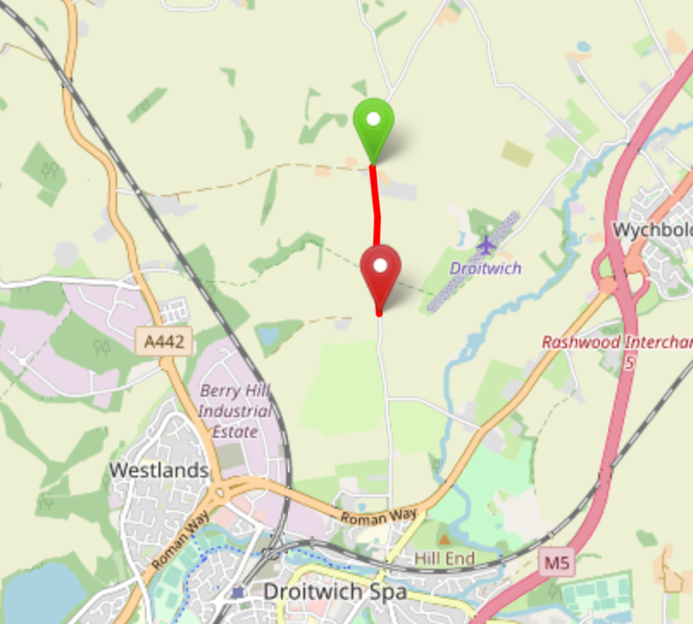
Area | Midland DC
Description | Crutch Lane - Droitwich
HQ
Measured | 02/12/2022
Measured by | D Grant
Risk assessed | 02/12/2022
Assessed by | DC Risk Assessor
Date approved
Type A | NOT APPROVED
Type B | APPROVED – TYPE B ONLY
Police Authority | West Mercia
Additional information | DC Committee to approve upgrade of course for Type A events
Notes for riders
OS Grid # | Course description | Distance | Risk (L/M/H) | Risk description | Minimum management  (Without prejudice)
SO90216624 | Start at: Crutch Lane – level with the southern end of the entrance to Crutch Farm Units. Ride south | 0 | L | Riders and officials in or near the road | Cycle event in progress signs. Officials on or near road to wear high viz jackets.
SO90266525 | Finish at: Crutch Lane - Level with telegraph pole (numbered 21) opposite Park Farm | 0.62 miles /  1 km | L | Riders and officials in or near the road | Cycle Event sign on southern approach to finish area  Finish sign at approach to finish and finish board by timekeeper. Officials on or near road to wear high viz jackets.

References:

CTT GN22 – Risk Assessment

Date of Issue | Reason of Revision | Author
March 2013 | New edition | David Barry  (CTT Board Director)  (CTT Course Risk Assessor)
August 2018 | Revised format | Nick Sharpe  (CTT National Secretary)
October 2022 | Revised to reflect current CTT Articles, Rules, and Regulations | David Barry  (CTT Board Director)

