
West DC: Risk Assessment

Cycling Time Trials – West DC Course Risk Assessment Document. The measures to reduce risk identified in the right hand column must be included on the start sheet or implemented for the duration of the event as applicable. Failure to comply with the requirements of this document may result in approval being withheld with respect to subsequent race promotions by the promoting club.
(CTT Guidance Note 22 – February 2024)

Course/Road(s) Assessed:  Dauntsey; Little Somerford; Great Somerford; Dauntsey | Course:  UC866 aka “Q” Course  Distance (in miles):  10
Date of Assessment/Review:  13 February 2024 | Name of Assessor:  Paul Winchcombe
Review History:  First Produced (if known): N/K  Last Review:1 March 2023 | Sponsoring Club or Organisation:  Chippenham & District Wheelers
Course Description:
To reach start from event HQ in Sutton Lane, turn right on minor road and travel North. Start is opposite junction with B4069. Take care when crossing the road.
START (G.R. 950787) in High Street, Sutton Benger. Go East on B4069 (direction of Lyneham). Continue towards turn at Swallet Gatet. Turn left into Church Lane and 100m after crossing M4 Motorway bridge turn right across road into The Green. Continue North West to Little Somerford along The Idover Lane. Turn left by bus shelter in Little Somerford. Continue towards Great Somerford. In Great Somerford turn left into Dauntsey Road. Continue to finish 10m before junction of Church Lane and the Green at Dauntsey.
Link:
https://www.strava.com/activities/7850512982
Course Type:
- Single Carriageway
- Circuit
- No identified traffic calming
Traffic Flows:
With the collapse of Lyneham Banks Traffic Flows are now very low.
Course / Event History:
Course is used through season by Chippenham Wheelers and has been in regular use since at least 2015. Is used when UC861 is not available.
Police Authorities:
Wiltshire Constabulary - Mr Bob Eccleston. Bob.Eccleston@wiltshire.police.uk

Key Identified Risks

No. | Distance / Location | Risk/Hazard | Level of Risk  (L / M / H) | Measures to reduce Risk  (if applicable)
a) Introduction
1 | General Requirements | Time of Road Usage meets CTT Traffic Standards | L | Traffic counts within acceptable numbers
b) HQ to Start
2 | Before Start | Competitors riding from Event HQ; Competitors warming up | M | Instructions on Start Sheet and at event HQ signing on advising riders of safe routes; prohibition on warming up past the start. Cycle event warning sign.
 |  | 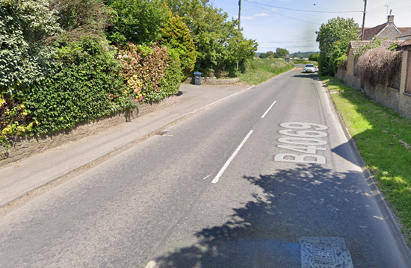
3 | Area of Start – B4069 | Competitors waiting on grass area next to start. | L | Instructions on Start Sheet and at event HQ signing on - warning against making ‘U’ turns, queue in single file; Cycle Event Warning signs
c) Start to Finish
4 | Sutton Lane Junction | Traffic turning across riders | L | Cyclist have right of way. Starter and Pusher-Off to warn of approaching traffic. Cycle event warning signs
5 | Dodford Lane turning | Traffic joins from left. Visibility is good | L | Nil. Lane leads to isolated farms. Not a through road.
6 | B4069 Swallett Gate Junction /Dauntsey Lock | Riders turn left; Slippery surface when wet  Car Boot Sale. | L | Instructions on start sheet and at start.  (Course is usually only used for evening club events)
 |  | 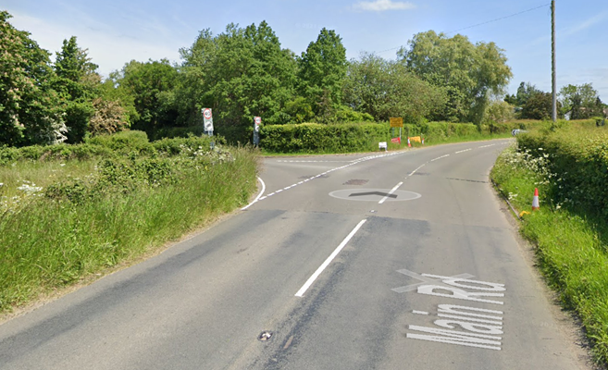
7 | Junction Church Lane/The Green | Riders turn right; Reverse angle turn; Slippery surface when wet;  Visibility of oncoming traffic is good. | M | Instructions on start sheet  Place 1 x observer wearing high visibility vest (not mandatory).  Riders are warned not to cut corner.  (Turn has been discussed with police and traffic volumes are very low)
 |  | 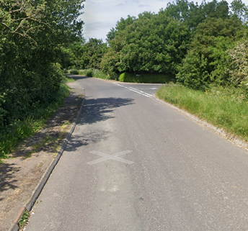
8 | Junction The Street/The Hill, Little Somerford. | Riders turn left but joining traffic has priority due to slip road. Visibility for both oncoming traffic which has to pause to turn and riders is good. Junction is wide. | L | Instructions on start sheet and at start.  Place 1 x observer wearing high visibility vest (not mandatory)
 |  | 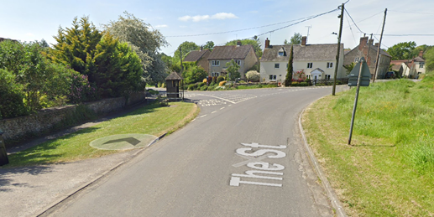
9 | Great Somerford | Parked traffic by church and pub. Road is narrowed. | L | Nil. Visibility towards potential hazard is good.
10 | Junction: Top Street / Dauntsey Road | Riders turn left into Dauntsey road, heading to Dauntsey | L | Place 1 x observer wearing high visibility vest (not mandatory)
 |  | 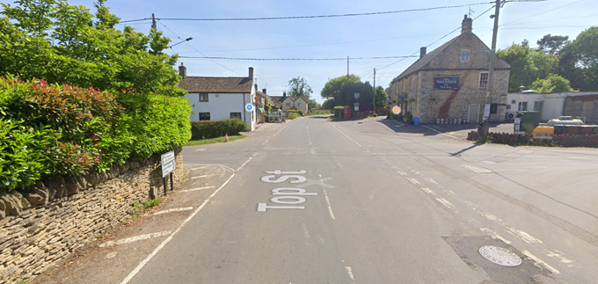
11 | Dauntsey Road / Church Lane | S-bends with poor road surface and poor visibility | L | Verbal warning at start
12 | FINISH: 10m before Junction of Church Lane and The Green in Dauntsey. | Finish area with time keepers vehicle only on grass verge. | L | Instructions that no times will be given to competitors or supporters at the finish. competitors should not U-turn at the finish. Cycle event warning sign on approach to finish from Church Road South.
 |  | 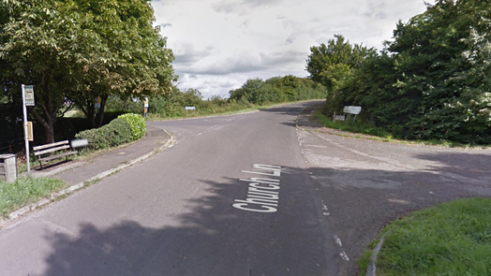
13 | Finish | Awareness of surroundings | L | No u-turns.  Note on start sheet to be aware of surroundings and other road users at the finish. Competitors to be aware other riders may still be on the course.
14 | After finish | Competitors returning to event HQ. | L | Instructions on safe route back from finish to HQ.

Notes
- The small junctions or entrances to farms/ facilities (garage,.eatery, etc) that are not identified in this risk assessment have been considered, however are not considered significant to pose a risk and therefore have not been noted.
Riders should be notified of:
- Left turn at Swallet Gate can be slippery as wet and if taken tight to corner riders may come close to centre line of road
- Right turn after M4 bridge where corner must not be “cut” as drivers on joining road cannot see riders approaching as driver approaches junction where they must give way
- Bend when Dauntsey Road becomes Church Lane is slippery when wet and also riders should not cut the corner.

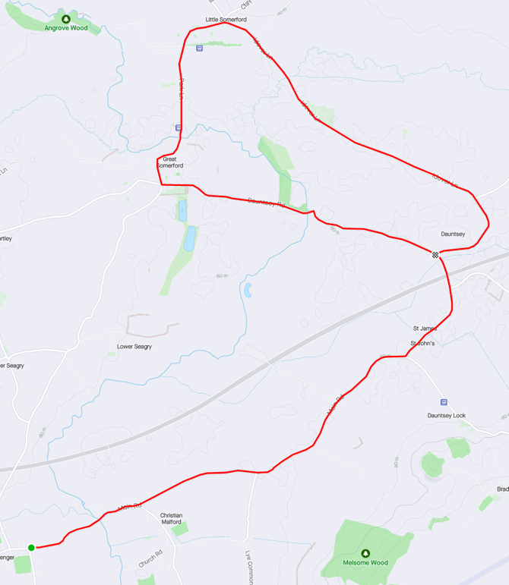

This document remains live and any changes to the items listed above or new hazards/risk that arise should be notified to the district committee at the earliest opportunity

CYCLING TIME TRIALS IS A COMPANY LIMITED BY GUARANTEE REGISTERED IN ENGLAND No: 4413282
Registered Address: 77 ARLINGTON DRIVE, PENNINGTON, LEIGH, LANCASHIRE. WN7 3QP

