
West DC: Risk Assessment

Cycling Time Trials – West DC Course Risk Assessment Document. The measures to reduce risk identified in the right hand column must be included on the start sheet or implemented for the duration of the event as applicable. Failure to comply with the requirements of this document may result in approval being withheld with respect to subsequent race promotions by the promoting club.
(CTT Guidance Note 22 – Appendix 2 – Issue 2 September 2011 provides additional advice)
Course/Road(s) Assessed:  Highridge Road and Dundry Lane, Bristol. | Course:  UHC377  Distance (in miles):  1.4
Date of Assessment/Review:  02 August 2023 | Name of Assessor:  Mark Bradley
Course History
UCH377 designation is a nod to the history of the event. That hillclimb was originally started by a group of fixie riders, and it was known as the HellClimb. In the same way as dodgy car numberplates, the UCH377 is supposed to resemble 'Hell' (if you squint a bit, they say!).
Course Description:
Start at top of Highridge Green in South Bristol, by the post box outside no 135 Highridge Road.
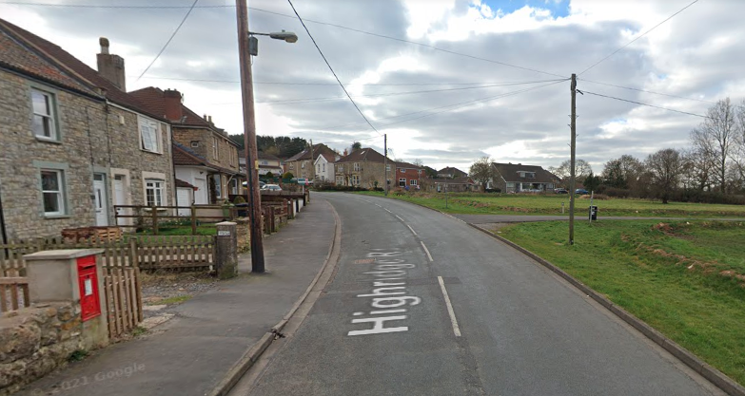
Proceed up Highridge road to the junction with Dundry Lane, turn sharp left
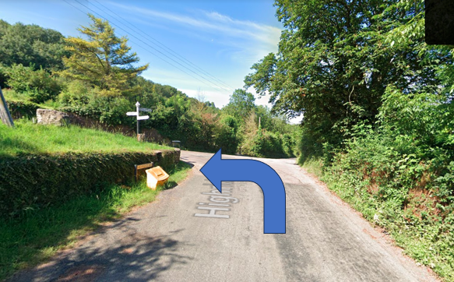
and continue through the village passing the church and graveyard. Follow Dundry Lane past Dundry Church and Dundry Inn (the road changes name to Church Lane). Finish 50m past the Dundry Inn midway between the Dundry Inn and Beechcroft Road.
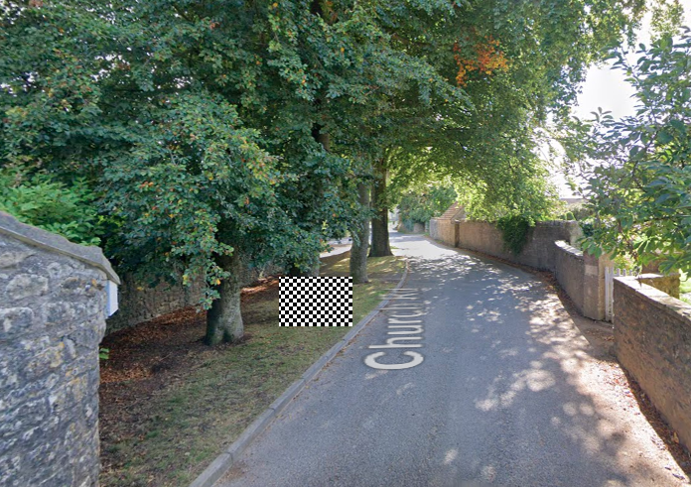
Link:
https://www.cyclingtimetrials.org.uk/course-details/uch377
Traffic Flows:
Very low, 1 or 2 cars per 10 minutes.
Course / Event History:
Used for club event every year since 2014. No incidents.

Key Identified Risks
No. | Distance / Location | Risk/Hazard | Level of Risk  (L / M / H) | Measures to reduce Risk  (if applicable)
a) Introduction
1 | General Requirements | Time of Road Usage meets CTT Traffic Standards | L | Traffic counts within acceptable numbers
b) HQ to Start
1 | N/a, club event without HQ
c) Start to Finish
2 | Area of Start  https://w3w.co/toned.bumpy.slide | Competitors wait in cul-de-sac entrance opposite, off road. | L | Cycle Event warning sign to warn oncoming traffic.  Verbal instructions given by start assistant.
3 | 0.54 miles | Junction of Highridge Road with Dundry Lane | L | Cycle Event warning sign to warn oncoming traffic.
4 | Area of Finish  https://w3w.co/hours.flats.summer | Competitors waiting, road width is limited. | L | Cycle Event warning sign to warn oncoming traffic.
5 | Area of Finish  https://w3w.co/hours.flats.summer | The shape of the road at the finish could encourage rider to cut the corner. | L | Riders instructed not to cut the corner.

Notes
The small junctions or entrances to farms/facilities (private drives and cul-de-sac side turnings) that are not identified in this risk assessment have been considered, however are not considered significant to pose a risk and therefore have not been noted.

https://www.strava.com/segments/15969081
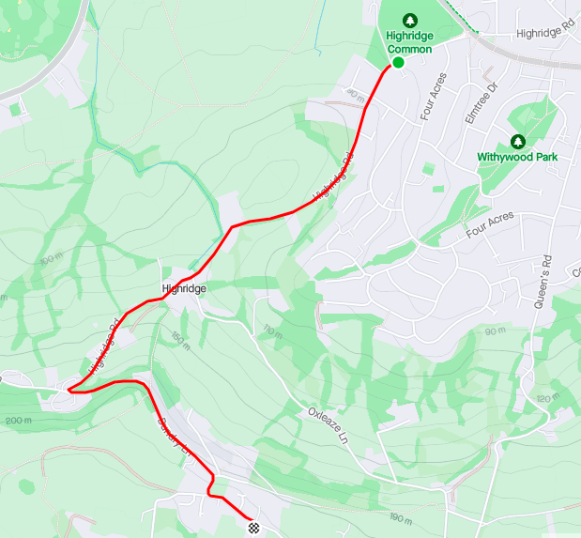

This document remains live and any changes to the items listed above or new hazards/risk that arise should be notified to the district committee at the earliest opportunity. This document was last updated on 10 August 2022.

