
West DC: Risk Assessment

Cycling Time Trials – West DC Course Risk Assessment Document. The measures to reduce risk identified in the right hand column must be included on the start sheet or implemented for the duration of the event as applicable. Failure to comply with the requirements of this document may result in approval being withheld with respect to subsequent race promotions by the promoting club.
(CTT Guidance Note 22 – provides additional guidance)

Course/Road(s) Assessed:  Bruton B3081 / B3092 | Course:  U321  Distance (in miles):  10 miles
Date of Assessment/Review:  9 March 2024 – inclusion of 20 mph restrictions, updated format | Name of Assessor:  John Naish
Review History:  First Produced (if known): N/K  Review Dates:  10 May 2022  11 May 2023 | Sponsoring Club or Organisation:  Westbury Wheelers
Course Description:
Start at Bradley Road, Longbridge Deverill (10m past entrance to Home Fields). Proceeding along Bradley Rd, westwards towards Maiden Bradley.There is a left turn into Back Lane. Following the road to the end, where there is a left run onto Kinston Lane heading eastwards. At the end of the road, Sharpe right onto unclassified road. At end of the road turn left onto B3095. Follow B3095 through Brixton Deverill to gate opposite entrance to Mill Close, where the finish is.
All roads are minor or unclassified roads which fall within the acceptable traffic count limits

Village of Maiden Bradley has a 20mph restriction on the High Street from Perry Farm to where it meets the B3092. This course travels through the 20mph limit on the High Street for approximately 112m, to a sharp left turn onto Back Lane where the limit reverts to 30mph. There is very little pedestrian or vehicular traffic on this stretch with no parked cars, and the left turn onto Back Lane means that cyclists will not be inclined to overtake slow moving vehicles. This is assessed as a low risk traffic environment. Riders will be reminded for events not to overtake vehicles in 20mph restricted areas or elsewhere unless safe to do so.

Link: https://www.cyclingtimetrials.org.uk/course-details/u321
All images are hyperlinked to Google Maps
Course Type:
- Single Carriageway
- Circuit
- Maiden Bradley 20 mph restriction.
Traffic Flows:
Traffic counts are within acceptable numbers. The roads are minor roads with limited traffic moving along at the time of day events are held. Events are held at 19.00h and traffic hasn’t increased in the flow over the last two years
Course / Event History:
Course is previously used course, U321
The events have been held during the past several years at the same course as part of the Westbury Wheelers fortnightly summer Time Trials. There is an overall cumulative competition for the Watercress Cup (Club Competition)
Police Authority:
Avon & Somerset Constabulary - Traffic Management Dept
Amanda Smith -Amanda.Smith@avonandsomerset.pnn.police.uk

Key Identified Risks

Distance | Location | Identified Significant Risk/Hazards | Level of Risk  Low/Med/High | Measures to reduce Risk  (if applicable)
0 miles | START: Start at Bradley Road, Longbridge Deverill  10m past the entrance to Home Fields (W3W:  arranger.encloses.  quilting)  Unclassified road | Waiting competitors  Minimal traffic | Low | Cycle event warning g signs  Instructions at sign on and race brief and Start Sheet to avoid U turns
 |  | 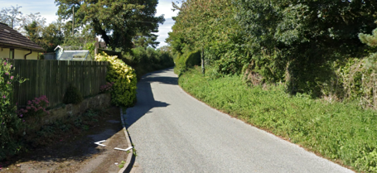
 | 20 mph restriction on entry to Maiden Bradley |  | Low | Riders not to overtake vehicles
 |  | 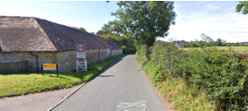
4.315 miles | Left turn into Back Lane, Maiden Bradley | Minor junction with low traffic | Low | Cycle event warning signs at junction
 |  | 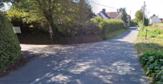
4.625 miles | Left turn Kingston Lane, Maiden Bradley | Minor junction with low traffic | Low | Cycle event warning signs at junction
 |  | 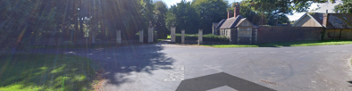
6.505 miles | End of Kingston Lane | Sharp turn at bottom of steep hill | Low | Warning on event notes for riders. Also put double direction arrows at turn and brief riders accordingly. If enough marshals then one placed here as priority
7.435 miles | Left turn onto B3095 | Joins minor road, low traffic | Low | Cycle event warning signs on B3095 in both directions and marshal at junction to warn of traffic
 |  | 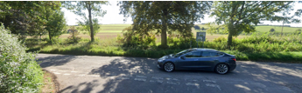
10 miles | FINISH: Timekeeper Near Mill Farm, B3095, Longbridge Deverill (W3W: harp.workloads  .steep)  Finish to event HQ | Riders sprinting to finish, unclassified road with low traffic  Short ride back through village with low traffic | Med  Low | Cycle event warning sign past finish  Marshalls / time keepers in place  Instructions on start sheet, No stopping at finish, continue along road to HQ. Directions at sign on
 |  | 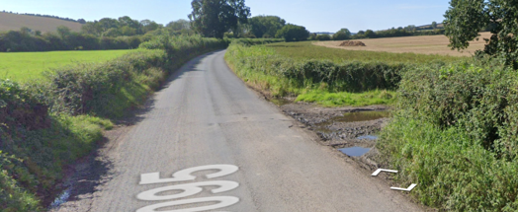

The small junctions or entrances to farms/ facilities that are not identified in this risk assessment have been considered, however are not considered significant to pose a risk and therefore have not been noted.

