
West DC: Risk Assessment

Cycling Time Trials – West DC Course Risk Assessment Document. The measures to reduce risk identified in the right hand column must be included on the start sheet or implemented for the duration of the event as applicable. Failure to comply with the requirements of this document may result in approval being withheld with respect to subsequent race promotions by the promoting club.
(CTT Guidance Note 22 – provides additional guidance)

Course/Road(s) Assessed:  B3133 Yatton | Course:  U242  Distance (in miles):
Date of Assessment/Review:  15 February 2024 – update to new format | Name of Assessor:  Mark Hazell (Grad IOSH)
Review History:  First Produced (if known): April 2016  Last Review: 21 April 2023 | Sponsoring Club or Organisation:  Clevedon & District RC
Course Description:
START on B3133 just after junction with Kenn Street toward Yatton. Proceed to Yatton to turn left into Kenn Moor Road. Follow Kenn Moor Road to turn left into Davis Lane. Follow Davis Lane to turn left into B3133. Pass start and repeat to finish in Kenn Moor Road at field gate app 100 yards before junction with Kenn Street
Link:
https://www.cyclingtimetrials.org.uk/course-details/u242-2
Course Type: Please choose one of the options below and delete the others
- Dual Carriageway – Single Carriageway – Dual Carriageway and Single Carriageway
- Circuit – Out and Back – Out Only
- No traffic calming measures or 20mph speed restrictions identified
Traffic Flows:
Light traffic over whole course, B3133 slightly busier than Kennmooor and Davis Lanes
Traffic counts April 2016: 19:00 370 units / hour & 19:30 350 units / hour
Traffic counts April 2021: 19:00 354 units /hour
Traffic counts April 2022: 19:15 372 units / hour
Traffic counts 19th April 2023: 19:15 287 units / hour kenn Green & 190 units / hour at Yatton Rugby Club at 19:45
Course / Event History:
Course used for over 50years for club events on Tuesday evenings from early May to early September. Start time 19.00 in early May then 19.30 as light improves moving back to 19:00 in late summer.
The CDRC TT cordinator reserves the right to cancel events in case of adverse weather or roadworks. Riders to be informed of cancellation by 4PM on day of event.
Police Authorities:
Avon & Somerset Constabulary - Amanda.Smith@avonandsomerset.pnn.police.uk
Key Identified Risks

Distance | Location | Identified Significant Risk/Hazards | Level of Risk  Low/Med/High | Measures to reduce Risk  (if applicable)

0 miles | START: at At junction of access road and B3133 just South of junction with Kenn street (Yatton side of Kenn Green). | Traffic passing riders awaiting to start. | LOW | Riders well off carraigeway - good visibility to oncoming traffic.  “Cycle Event” sign on Clevedon side of Kenn Green approx 50m before start.  Two start officials will manage rider start process waering hi-vis bibs.  Pre-start briefing to riders in the event of specific course hazards such as roadworks, road damage (potholes etc) or weather related hazards.  Riders wear CTT approved race numbers.  Riders attention raised to traffic movement at start and held from starting until adequate gap in traffic flow.  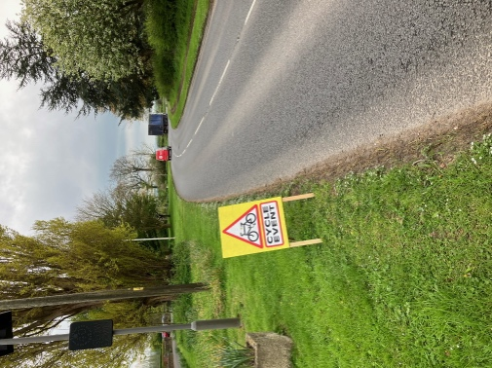
1.5 miles | Railway bridge N of Bridge Inn. Road bears left at brow of bridge. | Can be queueing traffic in direction riders travel and traffic entering route from right at brow of bridge | Low | Riders need to take normal care  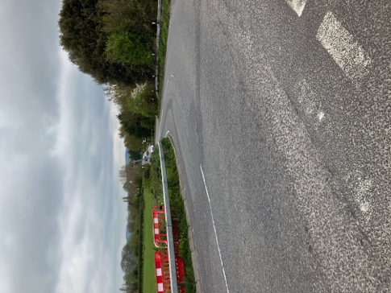
2.5 miles | Roundabout edge of Yatton | Traffic entering B3133 from right. Can be queing traffic in direction riders travel. | Med | Visibility good at entry to roundabout. Riders need to take normal care keeping in left hand lane across roundabout.  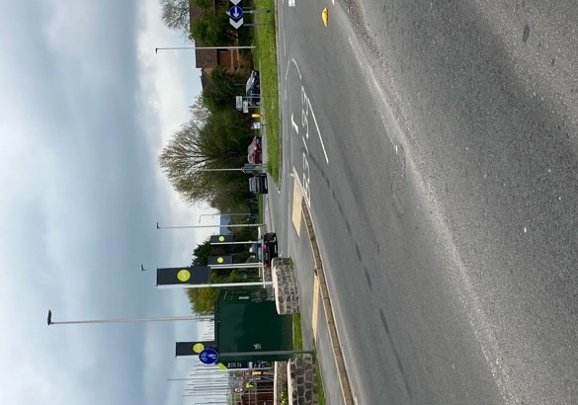
3.0 miles | Mini Roundabout on edge of Yatton | Traffic entering from right. Can be queing traffic in direction riders travel. | Med | Visibility poor - riders need to take care and reduce speed to anticipate traffic entering roundabout.  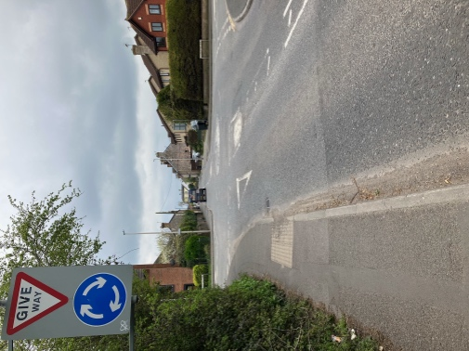
3.2miles | Turn left into Kenn Moor Road  90deg turn. Cars can be parked after turn reducing space. | Left turn. Riders could turn into traffic passing parked cars – need to ensure stay to left | Med | Visibility poor - riders need to take care and stay left at turn to anticipate reduced space and oncoming traffic after turn.  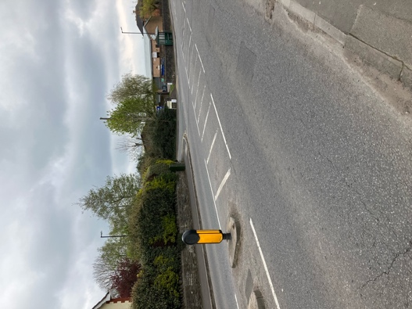
4.5 miles | Turn left into Davis Lane | Pass over narrow bridge before entering side road before junction with Davis Lane. Road narrows and potential for oncoming traffic. Care needed. Riders need to stay left. | Med | Visibility poor – riders need to take care and reduce speed to anticipate reduced space and oncoming traffic.  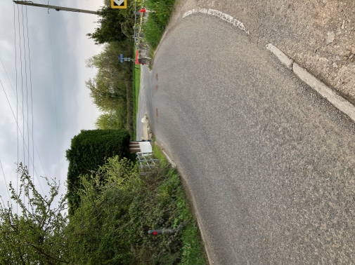  "Cycle Event" sign to warn traffic entering course on Kenn Pier Green before junction with Davis Lane.  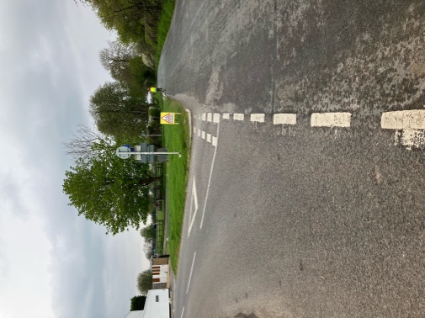
5.5 miles | Turn left into B3133 | Left turn onto main Clevedon to Yatton road. Higher traffic counts anticipated but wider road than other parts of the course. | Med | Entering wider road - visibility fairly good. Riders need to take normal care, reducing speed to anticipate oncoming traffic from right.  "Cycle Event" sign on B3133 to alert traffic prior to junction with Davis Lane.  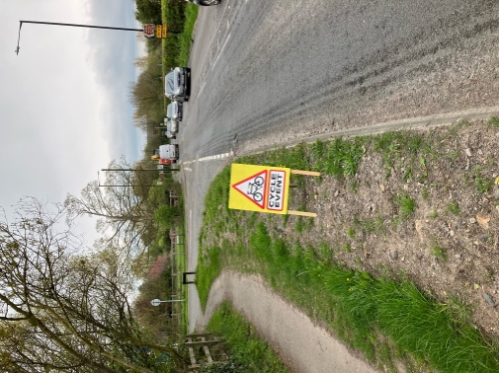
6 miles | Pass start | Repeat 1.5, 2.5, 3.0 and 3.2 miles actions
10 Miles | FINISH on Kenn Moor road about 100 yards before junction with Kenn Street just after parked/abandoned Land Rover. | Only time keeper and assistant at finish | LOW | Riders instructed to ride on after finish and not return to finish area. Wait approx. 100m after turning into Kenn street for results. Riders to keep off road as far as possible at results area allowing sufficient space for passing traffic. Finishing riders and officials will be offered a biscuit.

NOTES:

1. The use of a vehicle for the timekeeper(s) at start and finish is where appropriate and is only identified as an example for the action to be taken
2. The small junctions or entrances to farms/ facilities (garage, eatery, etc) that are not identified in this risk assessment have been considered, however are not considered significant to pose a risk and therefore have not been noted.

