
West DC: Risk Assessment

Cycling Time Trials – West DC Course Risk Assessment Document. The measures to reduce risk identified in the right hand column must be included on the start sheet or implemented for the duration of the event as applicable. Failure to comply with the requirements of this document may result in approval being withheld with respect to subsequent race promotions by the promoting club.
(CTT Guidance Note 22 – Appendix 2 – Issue 2 September 2011 provides additional advice)
THIS IS A GUIDANCE TEMPLATE – DELETE UNECCESSARY DETAILS OR IRRELVANT INFORMATION (INLCUDING THIS NOTE! And all text in red typeface)
RAs must be reviewed annually and review date amended. An RA is only valid for 12 months, so a course should not be used if RA is out of date. Good practice would be to check RA before course is used for first time in year and then updated. An email to RA Sec will prevent lots of chasing emails. Without an RA the course does not have valid CTT insurance.
Course/Road(s) Assessed:  (A and B road designators with relevant village names) | Course:  (Will be a “U” course for West DC)  Distance (in miles):
Date of Assessment/Review:  (To be updated every year, any assessment more than 5 years old is to be considered out of date and course will require recertification by District RA Official) | Name of Assessor:  (Should be a competent person)
Review History:  First Produced (if known):  Last Review: | Sponsoring Club or Organisation:  (For club courses will be relevant club, for courses used by several clubs may be West District)
Course Description:
(This should allow major turns, start and finish to be identified. This may be the course description used in the Police Notification Form.)
Link:
(Provide a link to the CTT Course Description and Map or to a valid Strava link which may be used until the CTT website has been update)
Course Type: Please choose one of the options below and delete the others
- Dual Carriageway – Single Carriageway – Dual Carriageway and Single Carriageway
- Circuit – Out and Back – Out Only
Traffic Flows:
(A general description of traffic count on major roads on course with a traffic count number which is at a similar time to the courses normal time of use)
Course / Event History:
(To include date course first used (if known), any issues experienced when using the course.)
Guidance for completion:
- The term observer is preferred as the term marshal has legal connotations. Remember that Observers may only indicate direction (which is ideally done by well placed direction arrows) and are only a visual indication to traffic that something is happening.
- Observers with signage are only mandatory at High Risk turns where double signage is deemed not sufficient to mitigate the risk.
- Start finish descriptions should include enough to identify the location and ideally have a What3Words reference or Grid Reference. Include Google Street map view of start and finish.
- If necessary, clarify risk mitigation method. For example, place Cycle Event Warning sign 50 yds before RAB and one at RAB on the “A” road approach.
Key Identified Risks
No. | Distance / Location | Risk/Hazard | Level of Risk  (L / M / H) | Measures to reduce Risk  (if applicable)
a) Introduction
1 | General Requirements | Time of Road Usage meets CTT Traffic Standards | L | Traffic counts within acceptable numbers
b) HQ to Start
2 | Before Start | Competitors riding from Event HQ; Competitors warming up | L | Instructions on Start Sheet and at event HQ signing on advising riders of safe routes; prohibition on warming up past the start
3 | Area of Start:  Grid Reference or What3Words with description, drain cover, bus stop, etc | Competitors wait in entrance off road | L | Instructions on Start Sheet and at event HQ signing on - warning against making ‘U’ turns, queue in single file; Cycle Event Warning signs
 |  | Image of start area
c) Start to Finish
 | Description of road feature with cumulative running distance total  - Left turn  - RAB  - S Bend | Description of Hazard | Assessed level of risk | Mitigation to reduce risk
4 |  | Road narrows with central traffic island  Traffic may try to pass. | L | Cycle Event Warning signs
 |  | 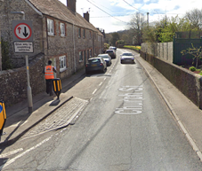 |  | Note riders must give way to oncoming traffic
5 |  | RAB junction  Traffic turning around RAB to head East will have priority.  Continue straight on. | L | Visibility is good  Place 1 x observer wearing high visibility vest (not mandatory)..
 |  | 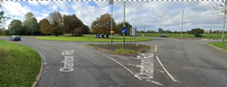 |  | Riders take first left exit to join A429
6 |  | Turn left onto B road  Oncoming cars may turn across riders | M | Drivers can see junction clearly  Cycle Event Warning signs Place 1 x observer wearing high visibility vest. (not mandatory)
7 |  | Turn left onto unclassified road | L | Visibility is good and riders have priority, wide junction.  Direction signs needed
 |  | 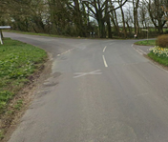
8 |  | Turn left onto B road  Traffic from right has priority. | M | Cycle Event Warning Sign  Place 1 x observer wearing high visibility vest. Mandatory
 |  | 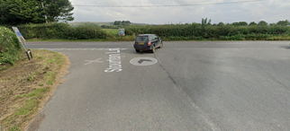
9 | Fast descent into dip | Poor surface, loose gravel | L | Warning on Start Sheet
14 | Finish:  (Give GR or What3Words with description – drain cover, bust stop, etc) | Awareness of surroundings | L | No u-turns.  Note on start sheet to be aware of surroundings and other road users at the finish.
 |  | Image of finish area
15 | After finish | Competitors returning to event HQ. | L | Instructions on safe route back from finish to HQ.

The notes below are examples of notes which may be appropriate. Note 2 should be used where courses have small joining side roads rather than producing an RA with multiple rows where the assessment is “low” and riders continue straight on with priority. This list of notes may be contradictory as they are just examples.

Notes
- The use of a vehicle for the timekeeper(s) at start and finish is where appropriate and is only identified as an example for the action to be taken
- The small junctions or entrances to farms/ facilities (garages,restaurants, etc) that are not identified in this risk assessment have been considered, however are not considered significant to pose a risk and therefore have not been noted.
- The course should not be used on public bank holiday weekends or when there are major local events. E.g. Womad, Badminton, Polo Competition, Air Show, etc
- The course should not be used during summer holidays when traffic to nearby motorway junctions produce high traffic counts.
- The course may not be used on Saturdays due to high traffic counts.
- All riders are to be off the course by 0900 hrs due to high traffic counts.
- A large part of this course is a dual carriageway and if the weather is poor the visibility deteriorates quickly. The event will be delayed or cancelled if there is a danger to riders.

You may wish to include a jpg image of the course, which indicates key features.
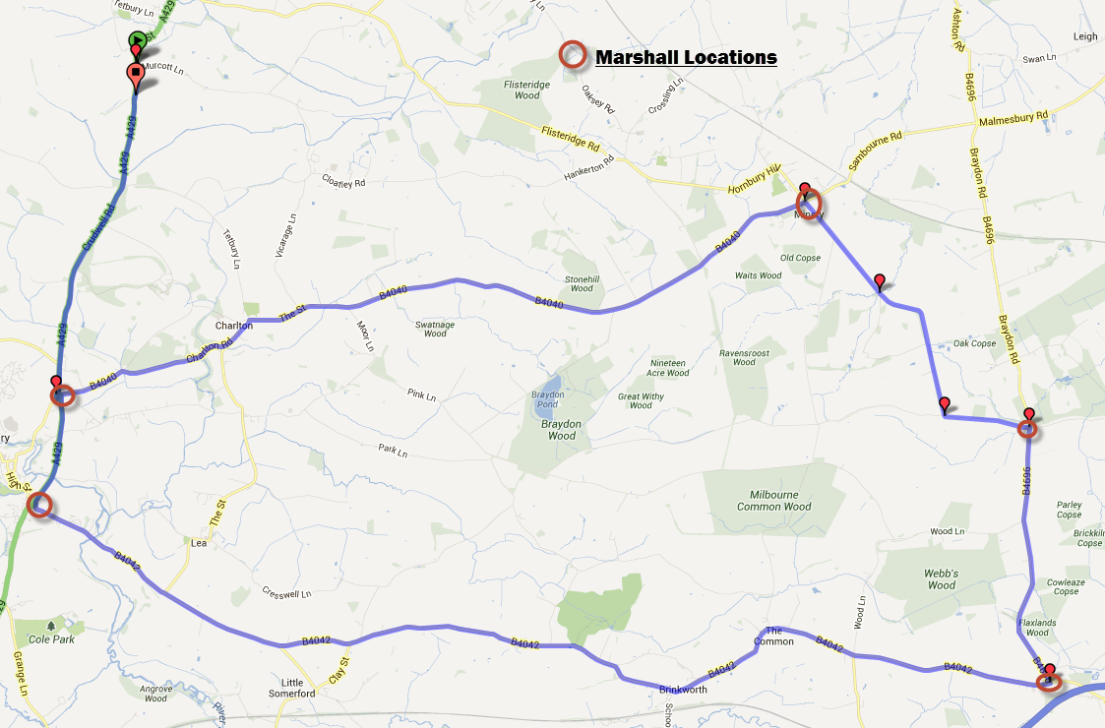

This document remains live and any changes to the items listed above or new hazards/risk that arise should be notified to the district committee at the earliest opportunity. This document was last updated on 10 August 2022.

