
West DC: Risk Assessment

Cycling Time Trials – West DC Course Risk Assessment Document. The measures to reduce risk identified in the right hand column must be included on the start sheet or implemented for the duration of the event as applicable. Failure to comply with the requirements of this document may result in approval being withheld with respect to subsequent race promotions by the promoting club.
(CTT Guidance Note 22 – Appendix 2 – Issue 2 September 2011 provides additional advice)
Course/Road(s) Assessed:  Unclassified Road. Little Dewchurch Road | Course:  UHC519R  Distance (in miles):  0.64 miles
Date of Assessment/Review:  7 September 2023 | Name of Assessor:  Adam Spector
Review History:  First Produced (if known): 7 September 2023  Last Review: N/A | Sponsoring Club or Organisation:  Ross on Wye & Dist CC
Course Description:
Start at crossroads in Hoarwithy by church; end of Little Dewchurch Road and head north on the road towards Little Dewchurch. Finish by farm track.
https://www.cyclingtimetrials.org.uk/course-details/uhc519r
Course Type:
- Single Carriageway
- Out Only
Traffic Flows:
Light. This is a country road without any white markings. Well tarmacked with good visibility.
Course / Event History:
Course has been used by Ross on Wye & Dist CC for many years on Sunday mornings in September without incident
Key Identified Risks
No. | Distance / Location | Risk/Hazard | Level of Risk  (L / M / H) | Measures to reduce Risk  (if applicable)
a) Introduction
1 | General Requirements | Time of Road Usage meets CTT Traffic Standards | Low | Traffic counts within acceptable numbers
b) HQ to Start
2 | Before Start | Competitors riding from Event HQ;  Competitors warming up | Low | Instructions on Start Sheet and at event HQ signing on advising riders of safe routes; prohibition on warming up past the start
0 miles | START:  Start at end of Little Dewchurch Road at cross roads before chruch  ///plod.landscape.instance | Pedestrians/walkers  Cars Parking  Competitors waiting to start | Low | Cycle Event Warning Signs  Officials on or near start to wear high viz jackets and instruct riders on exact start location  Riders not to perform U-turns or to warm up on the course
 |  | 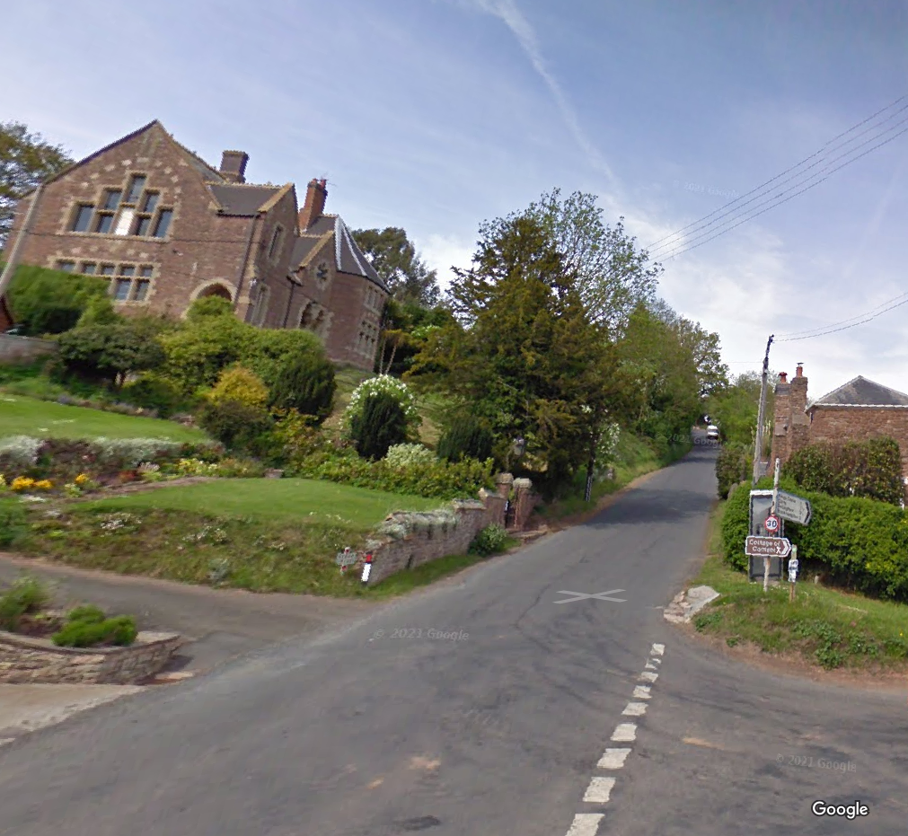

c) Start to Finish
3 | Road is of consistent width to Finish  No line markings | Some minor entrances from farm buildings and fields | Low | None
d) Finish
0.64 miles | FINISH:  Farm track on left beyond farm buildings on left hand bend  ///reflected.escorting.hydration |  | Low | Finish sign at approach to finish and finish board by timekeeper.  Officials at or near finish to wear high viz jackets.
 |  | 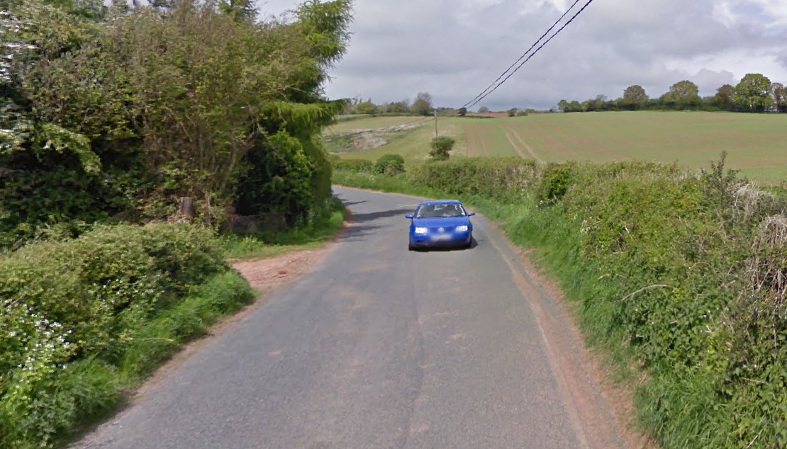
4 | After finish | Competitors returning to event HQ. | L | Instructions on safe route back from finish to HQ.

Notes
The small junctions or entrances to farms/ facilities that are not identified in this risk assessment have been considered, however are not considered significant to pose a risk and therefore have not been noted.
Signage and observers are stationed at Start, Finish to provide and added visual reference point for drivers
This document remains live and any changes to the items listed above or new hazards/risk that arise should be notified to the district committee at the earliest opportunity. This document was last updated on 10 August 2022.

