 | Risk Assessment

Course Identification : West Buckland Hill Climb

Course: West Buckland Hill Climb | Road(s) Assessed: Silver Street, Buckland Hill
Pages: 14 | Date of Assessment : 9th October 2023

Restrictions: Minimum number of marshals required - 15 not including time keepers
No. | Distance / Location | Risk/Hazard | Risk | Measures to reduce Risk  (if applicable)
a) Introduction
1 | General Requirements | Time of Road Usage meets CTT Traffic Standards | L | Traffic counts within acceptable numbers
b) HQ to Start
2 | Before Start | Competitors riding from Event HQ; Competitors warming up | M | Instructions on Start Sheet and at event HQ signing on advising riders of safe routes; prohibition on warming up past the start after 09:45. Cycle Event Warning signs on Silver Street approaching village hall in directions
3 | Area of Start | Competitors waiting | L | Cycle Event warning signs; Instructions on Start Sheet and at event HQ signing on - warning against making ‘U’ turns  IMAGE
c) Start to Turn at Finish
4 | Motorway Bridge to Five Cross Way | Riders follow Silver St as it is joined by Wildmoor Lane | M | Instructions on start sheet  Cycle Event Warning sign on Wildmoor Lane and Coombe Hill before junction with Silver Street on both roads Marshal required.  IMAGE
5 | Five Cross Way to Budgett’s Cross | Riders proceed southwest to staggered junction | M | Instructions on start sheet  Cycle Event Warning signs on roads joining Silver Street.  3 x Marshals required  IMAGE
6 | Budgett’s Cross to Birdcage Cottage junction. | Silver Street narrows and a lane joins from right on sharp left corner as the gradient rises | M | Instructions on start sheet  Cycle Event Warning Signs on lane joining Silver Street.  2x Marshal required.  IMAGE
7 | Birdcage Cottage to right corner on hill | Restricted visibility for climbers and descenders. Tendency to ‘cut the corner’ may lead to collisions with cars and bicycles | M | Instructions on start sheet.  Cyclists Warning sign on both sides of the road  IMAGE
8 | Right corner to sharp right corner | Restricted visibility for climbers and descenders. Tendency to ‘cut the corner’ may lead to collisions with cars and bicycles | L | Instructions on start sheet.  Cyclists Warning on both sides  Marshal required  IMAGE
9 | Finish to junction with Blackdowns Ridge Road (county boundary) | Traffic joining the course from Ridge Road. Riders congregating. | M | 2x marshals joining traffic with cyclist warning signs on the junction with Buckland Hill and the County Boundary
10 | Riders turning right on to the Ridge Road | Collision hazard as cyclists turn right on to a faster road | M | 1x marshal to ensure safe crossing by cyclists on to the larger road  IMAGE
11 | Riders turn right on to Ford Street | Potential collision hazard with faster traffic as riders turn right | M | 1 x marshal to ensure safe passage of riders on to Ford Street. Warning signs both sides of the junction.  IMAGE
12 | Right turn off Ford Street to return to race HQ | Potential collision hazard as riders turn right | M | 1 x marshal to ensure safe passage across the road. Warning signs to motorists above and below the junction.  IMAGE

Course Description:
Parking & toilets at West Buckland Village Hall. This is race HQ.
Riders to cycle south out of village towards start at motorway bridge. Allow 5 mins.
Course:
Start at motorway bridge. Stay on Silver Street until it becomes West Buckland Hill. Finish is approximately 200 metres from junction with Blackdowns Ridge Road (county boundary). 2.2 miles.
Finish
To reduce the amount of traffic on the hill, riders will be required to follow a ‘one-way’ route to return to race HQ.

Road surface is moderate. A few rough patches and bumps to be mindful of, but easily negotiated.

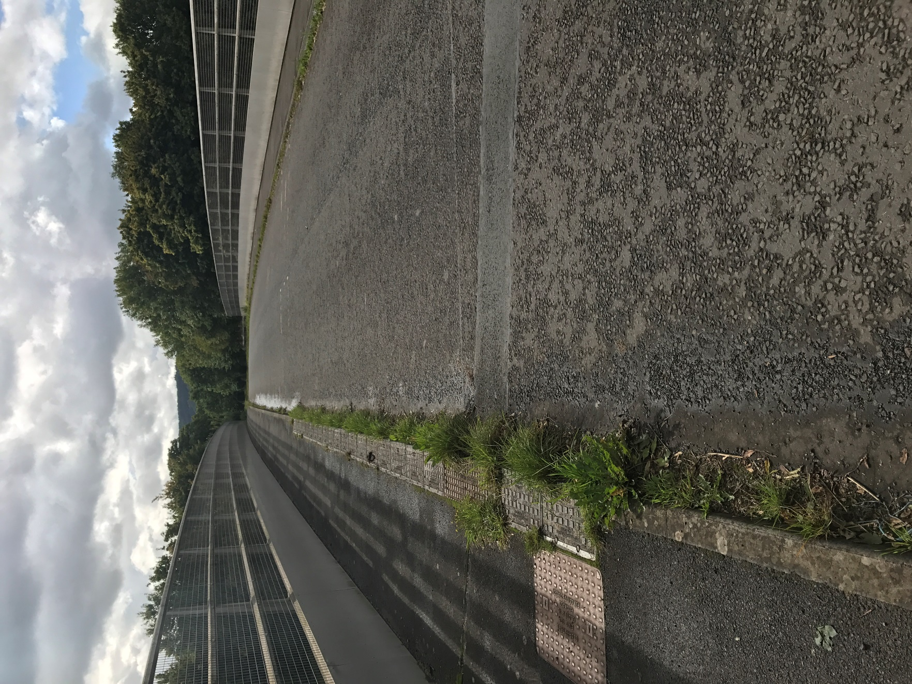

BACK
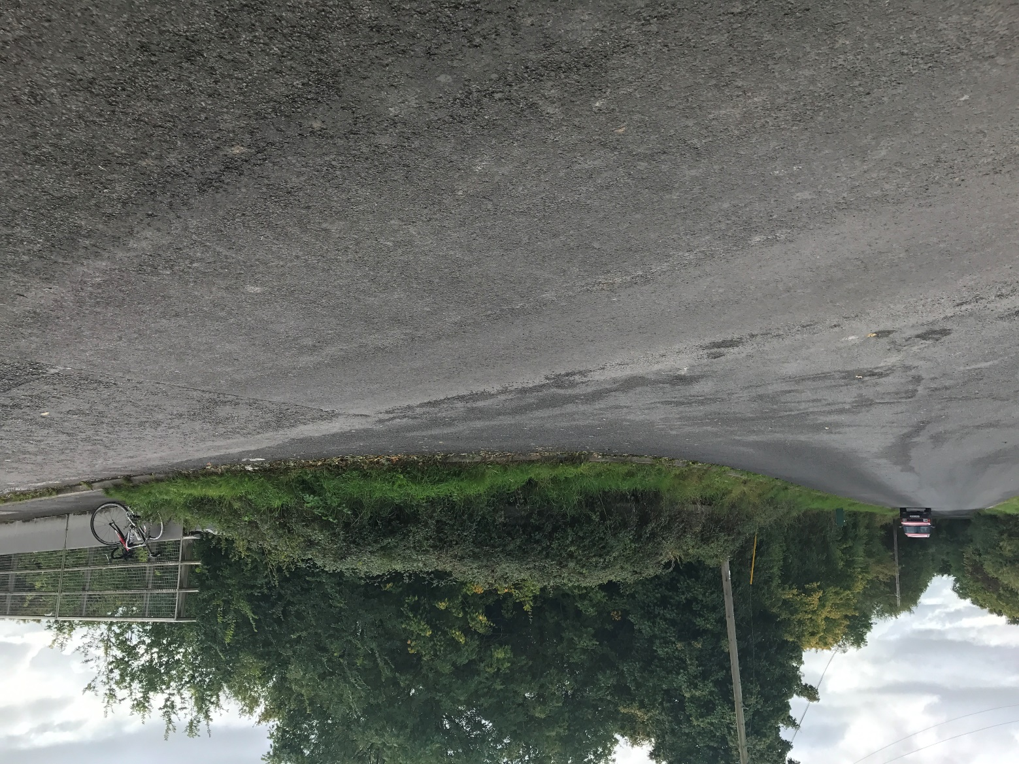

BACK

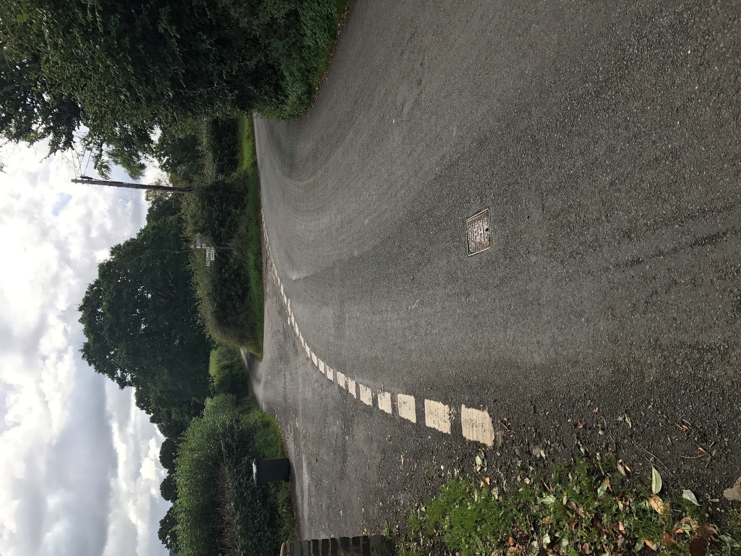

BACK

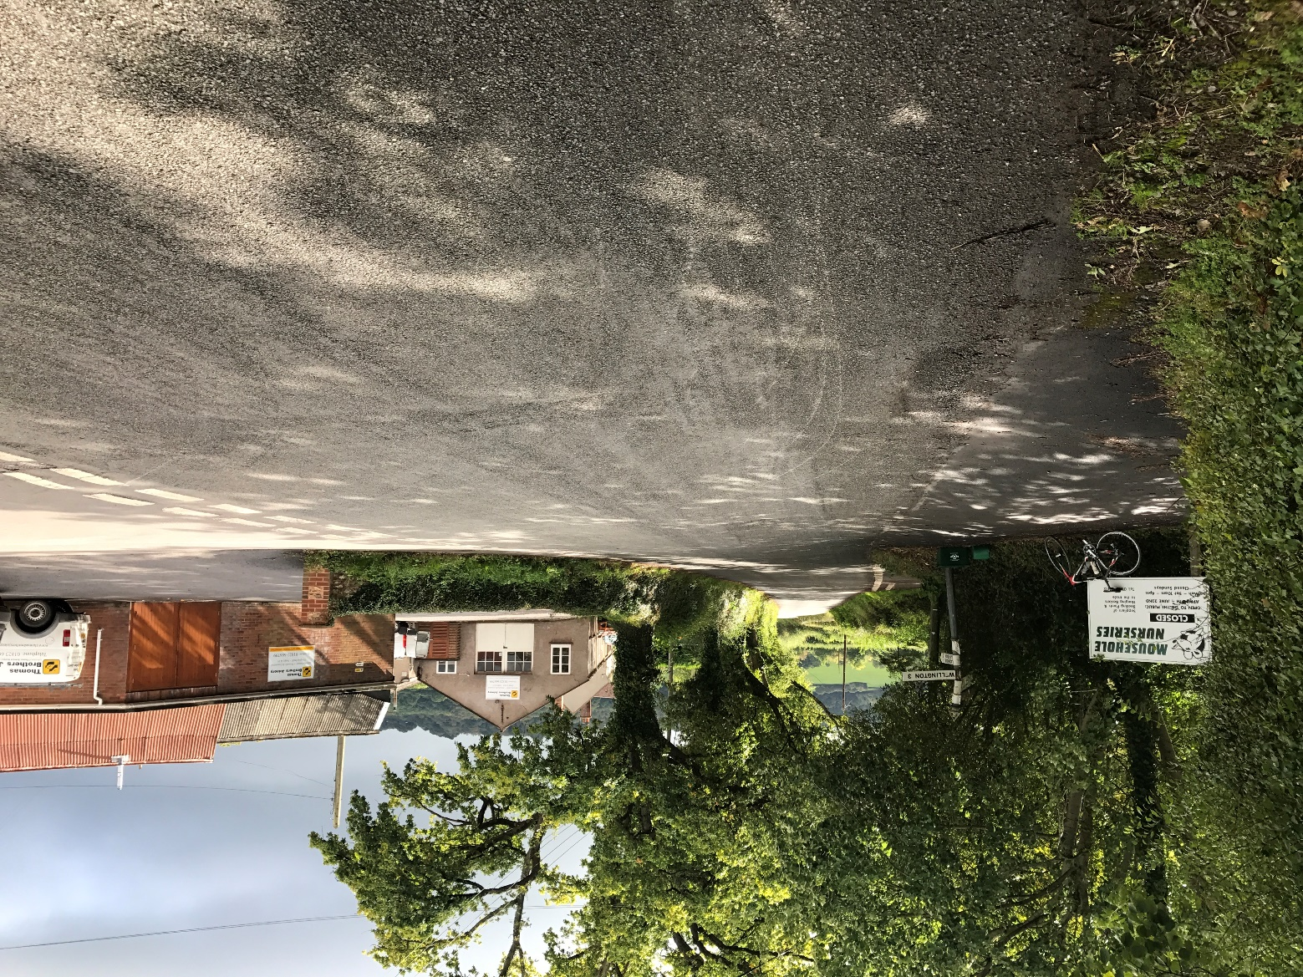

BACK

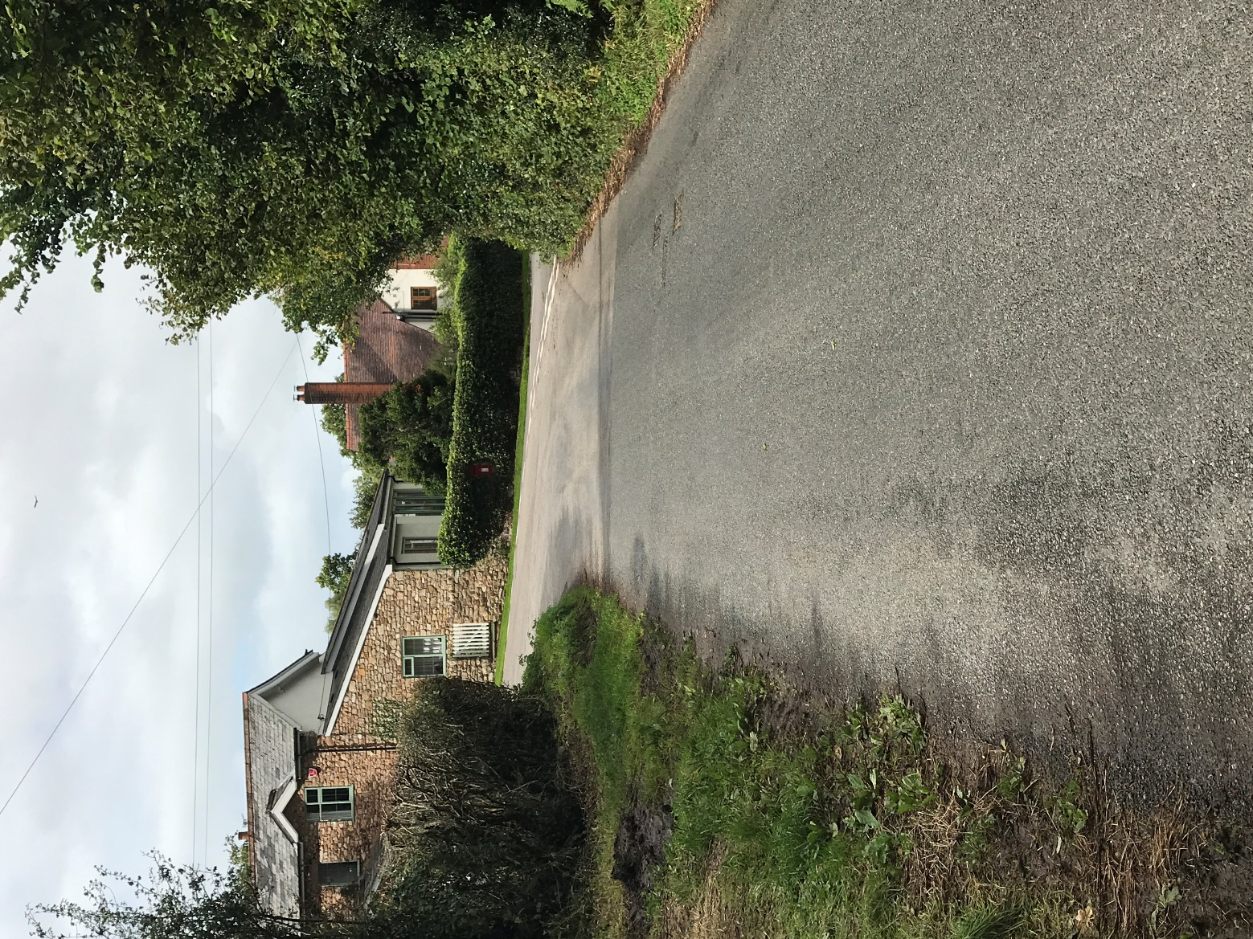

BACK

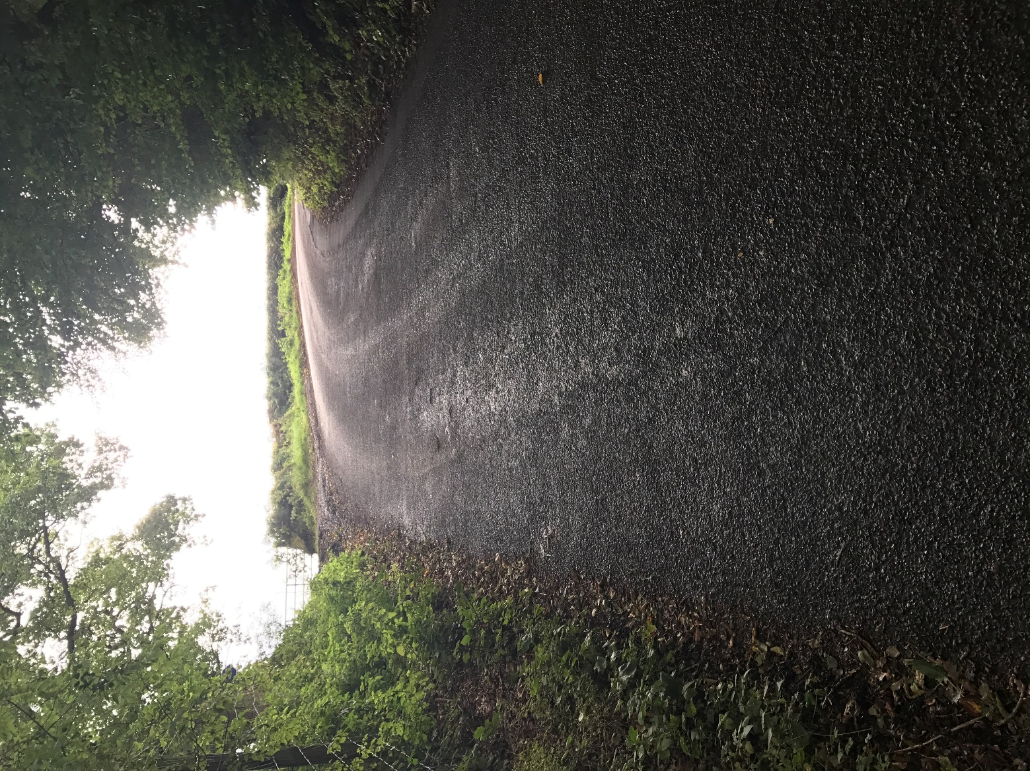

BACK

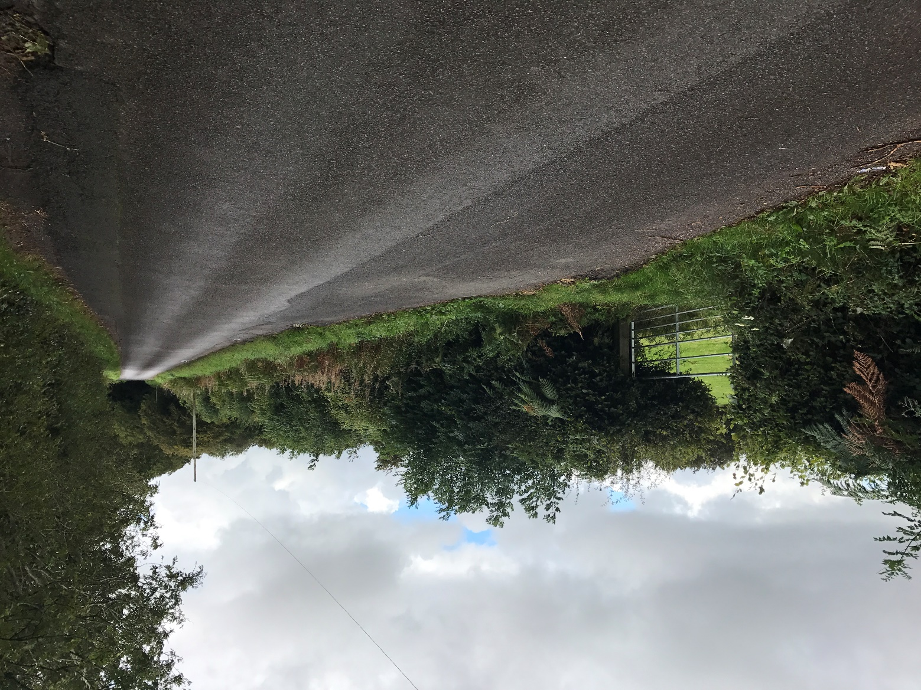
BACK

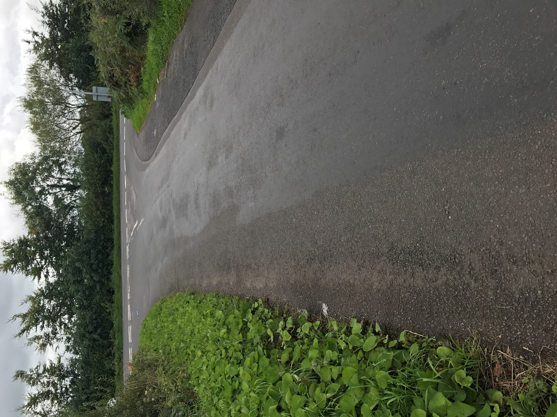

BACK

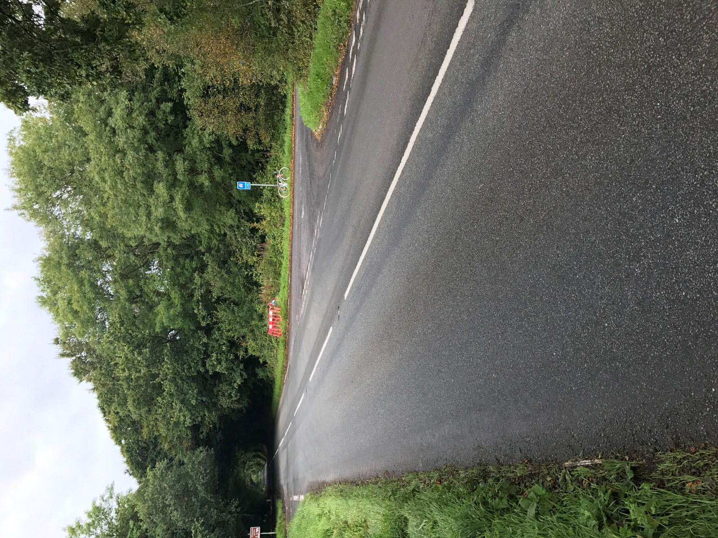

BACK

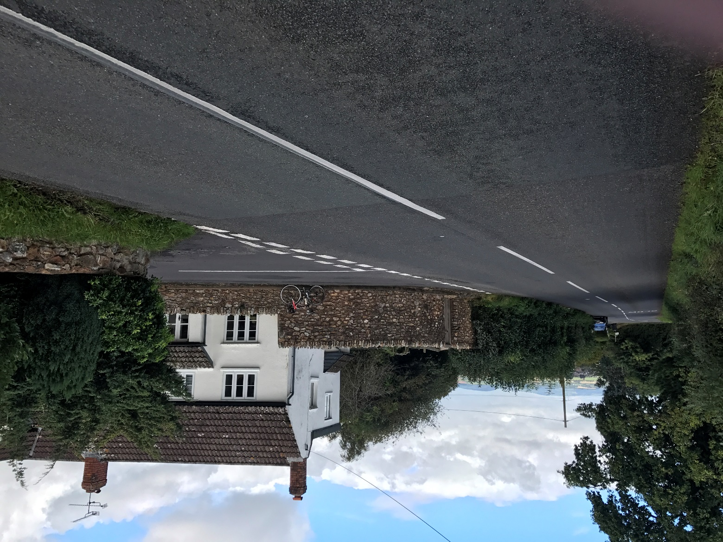
BACK

