 | Risk Assessment

Cycling Time Trials – West DC Course Risk Assessment Document. The measures to reduce risk identified in the right hand column must be included on the start sheet or implemented for the duration of the event as applicable. Failure to comply with the requirements of this document may result in approval being withheld with respect to subsequent race promotions by the promoting club.
(CTT Guidance Note 22 – Appendix 2 – Issue 2 September 2011 provides additional advice)

Course/Road(s) Assessed:  B3124 Clevedon to Portishead return | Course:  U241  Distance (in miles):  8 miles
Date of Assessment/Review:  4 December 2023 – updated to reflect 20mph speed restriction | Name of Assessor:  Emma Hazell
Review History:  First Produced (if known): April 2016  Last Review:30 Aug 2023 | Sponsoring Club or Organisation:  Clevedon & District Road Club
Course Description:
START at the end of the bus stop lay-by adjacent to the Clevedon School playing field on B3124. Proceed through Walton in Gordano & Weston in Gordano to Gordano school. Straight across mini roundabout at school continuing on B3124 for approx 300m before left turn into one way system. Then keep turn right, giving way to traffic joining from left. Keep in right hand land, turn right at next roundabout to complete turn and return on B3124 to Clevedon to finish at Swiss Valley Garage opposite to start point.

Village of Weston In Gordano has a 20mph restriction between the church and shortly before the Gordano Motor Services (and reverse) for under a mile. The village also has some traffic calming measures which means historically it is unlikely vehicles travelled above 20mph. The road structure means that cyclists would not have overtaken vehicles travelling at slower speeds as it would not have been practical to. This is assessed as a low risk traffic environment. Riders will be reminded for events not to overtake vehicles in 20mph restricted areas or elsewhere unless safe to do so.
Link:
https://www.cyclingtimetrials.org.uk/course-details/u241
Course Type:
- Single Carriageway
- Out and Back
- 0.4 miles of course in Walton in Gordano has 20mph speed restriction and traffic calming
Traffic Flows:
Light traffic over whole course, B3124. Event is run on Boxing Day at 10 a.m. and traffic count is typically 30 units per hour.

Event needs to clear Clevedon Road before 11 a.m. as is closed for the Boxing Day 10 km running event.
Course / Event History:
Course used as CDRC weekly Club TT for many years until move to the U242. Currently only used on Boxing Day when traffic generally very light and has been since at least 2021.

Key Identified Risks

Distance | Location | Identified Significant Risk/Hazards | Level of Risk  Low/Med/High | Measures to reduce Risk  (if applicable)
0 miles | START: at At bus stop layby on B3124 opposite junction with Conygar Close.  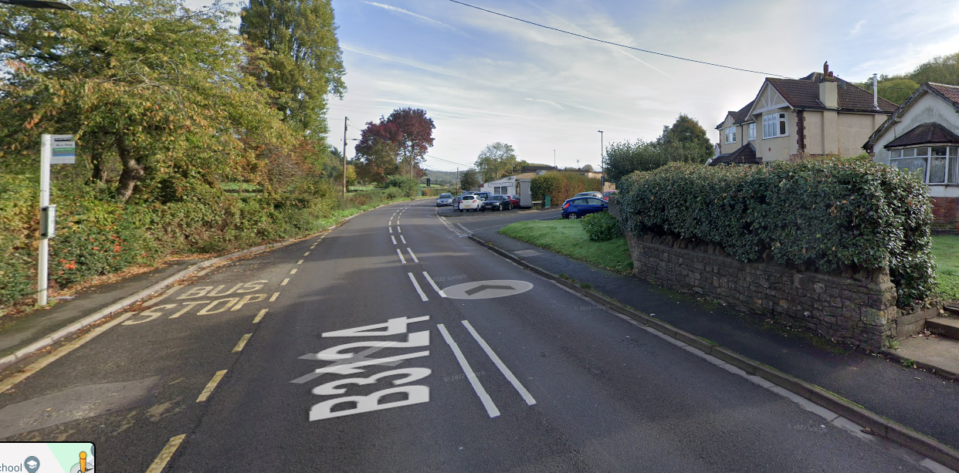 | Traffic passing riders waiting to start. | Low | Riders well off carraigeway - good visibility to oncoming traffic.  “Cycle Event” sign on Clevedon side of layby approx 50m before start.  Two start officials will manage rider start process wearing hi-vis bibs.  Pre-start briefing to riders to include 20mph zone restrictions and also in the event of specific course hazards such as roadworks, road damage (potholes etc) or weather related hazards.  Riders wear CTT approved race numbers.  Riders attention raised to traffic movement at start and held from starting until adequate gap in traffic flow.
 | Village of Weston in Gordano has a 20mph speed restriction and traffic calming measures for 0.4miles from St Pete and St Paul’s Church and village exit and also on return from Portishead. The village has footpaths on both sides of road except at the Eastern end where there are clear road markings for pedestrians. The village has a small population and very light foot or vehicular traffic so the assessed risk for riders is very low. There is good visibility throughout the village for riders, pedestrians and motor vehicles. Riders are not to overtake motor vehicles unless it is clearly safe to do so and not at speeds in excess of the 20 mph restriction.
2 miles | Weston in Gordano, at St Peter and St Pauls Church. 20mph speed limit through village. (Distance 0.4 miles)  Road narrows. | May be queueing traffic in direction riders travel. | Low | Riders must slow to observe speed limit.  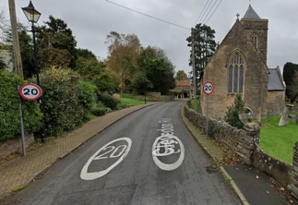  Cycle Event warning sign
2.2 miles | Weston in Gordano, traffic calming planter in carriageway. Road narrows. | Can be queueing traffic in direction riders travel. | Low | Riders should take care and anticipate queuing traffic at traffic calming.  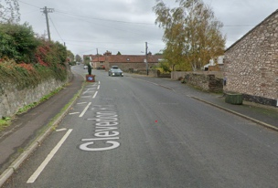
2.3 miles | Weston in Gordano, traffic calming planter on opposite side of carriageway. Road narrows. | May be queueing traffic in direction riders travel. | Low | Riders should take care and anticipate queuing traffic at traffic calming.  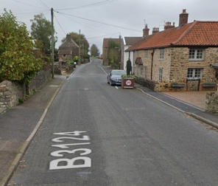
2.4 miles | Weston in Gordano. Road narrows as exiting village | May be queueing traffic in direction riders travel. | Low | Riders should take care and anticipate queuing traffic at traffic calming.  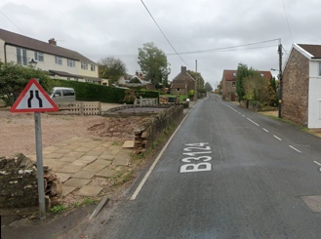
3.4 miles | North Weston, after village hall. Zebra crossing. | May be traffic waiting for people to cross, or riders will need to stop to allow people to cross. | Low | Riders should take care and anticipate queuing traffic at traffic calming.  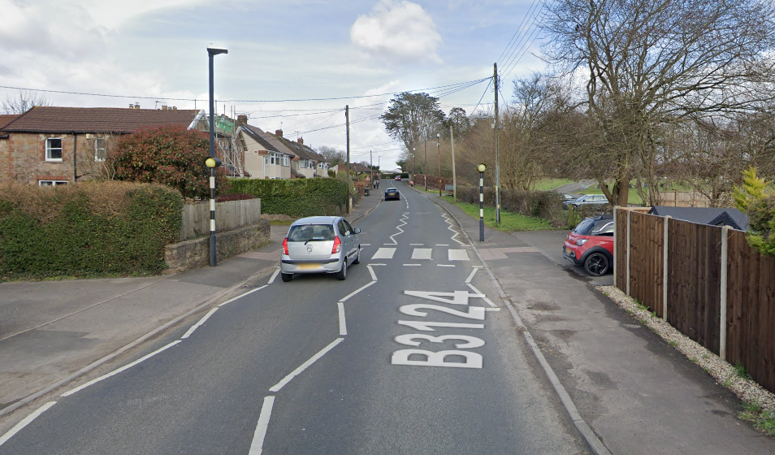
3.7 miles | Roundabout at the junction with Clapton Lane. | Traffic entering B3124 from the right. Can be queuing traffic in direction riders travel. | Med | Visibility limited at entry to roundabout. Riders need to take normal care keeping in left hand lane across roundabout.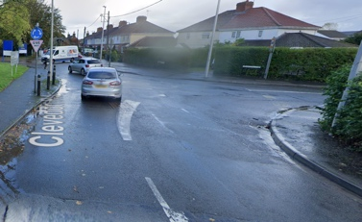  Cycle event warning sign on right hand approach road
3.8 miles | Zebra crossing. | Can be traffic waiting for people to cross, or riders will need to stop to allow people to cross. | Low | Riders need to take normal care  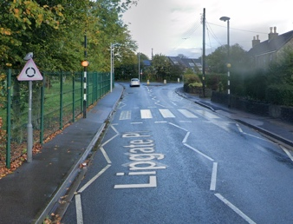
3.8 miles | Roundabout junction Lipgate Place and Clevedon Road. | Traffic entering B3124 from the right. Can be queuing traffic in direction riders travel. | Low | Visibility good at entry to roundabout for riders and vehicles. Riders need to take normal care keeping in left hand lane to turn left at roundabout.  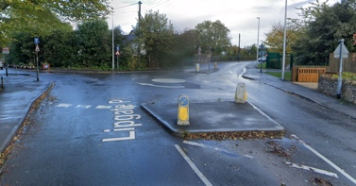
3.9 miles | Right turn to B3124. | Riders must give way to the left. May be queuing traffic in direction of riders travel.  There is no traffic from right as one way road so riders awareness is to left. | Med | Visibility limited by blind bend to the left at entry to junction. Riders need to take care to slow down keeping in right hand lane.  Riders view:  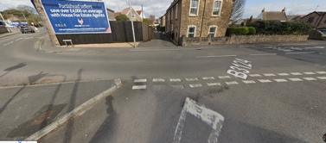  Drivers view:  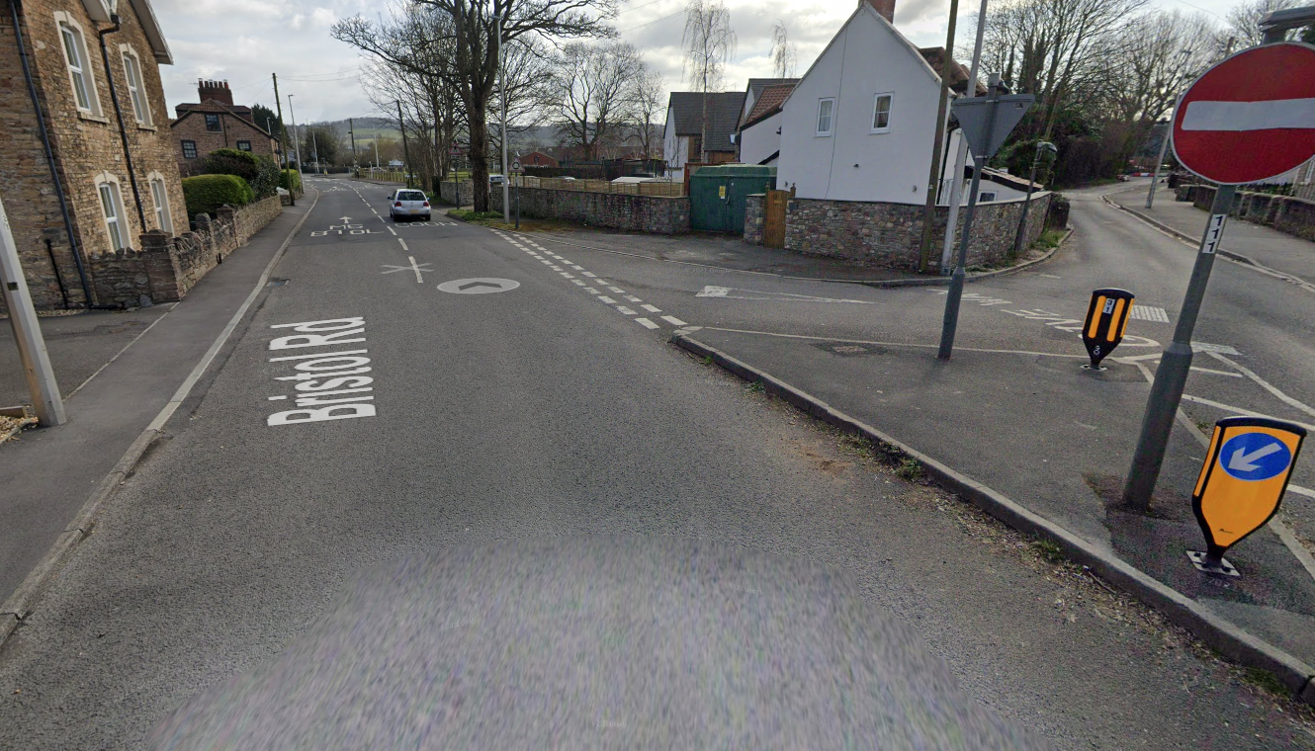  Cycle event sign at no entry sign
4 miles | Zebra crossing. Bristol Road before Albion pub | Can be traffic waiting for people to cross, or riders will need to stop to allow people to cross. | Low | Riders should take care and anticipate queuing traffic at zebra crossing.
4 miles | Roundabout junction Clevedon Road and Bristol Road. | Traffic entering roundabout from the right. May be queuing traffic in direction of riders travel. | Low | Riders need to take normal care keeping in right hand lane to turn right at roundabout.  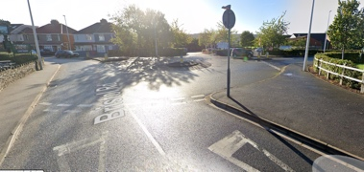  Cycle event warning sign on approach road from right
4.1 miles | Pelican request crossing on a raised table. Adjacent to St Josephs Primary School.  (Unlikely to be being used on non school days.) | May be traffic waiting for people to cross. If lights are on “red” riders must stop. | Low | Riders should take care and anticipate queuing traffic at traffic calming.  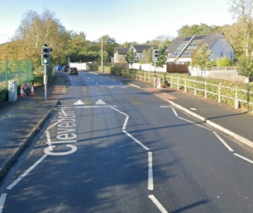
4.2 miles | Roundabout junction Lipgate Place and Clevedon Road.  Note: No traffic from left as is a one way road. | Repeat actions from 3.8 miles returning to start. | Nil | 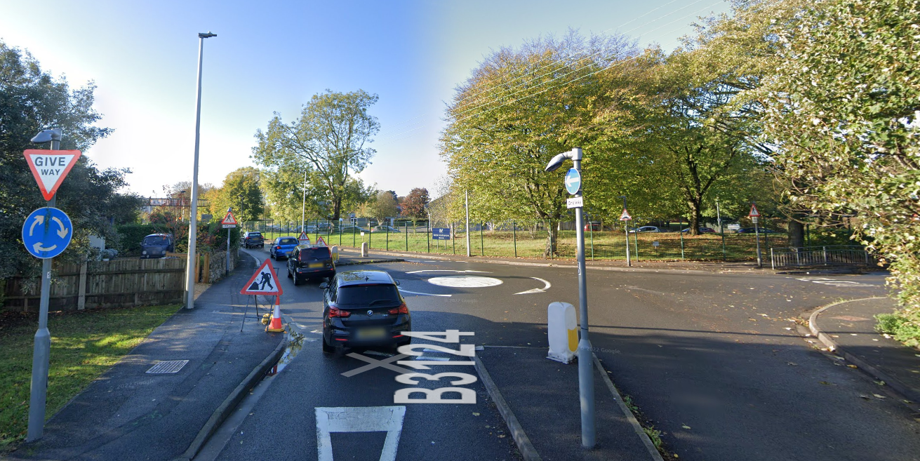
8 miles | FINISH on B3124 opposite start. | Only time keeper and assistant at finish | Low | Riders instructed to ride on after finish and not return to finish area. Wait on Swiss Valley Garage forecourt at junction of B3124 and Conygar Close for results. Riders to keep off road as far as possible at results area allowing sufficient space for passing traffic. Finishing riders and officials will be offered a biscuit.

NOTES:

1. The use of a vehicle for the timekeeper(s) at start and finish is where appropriate and is only identified as an example for the action to be taken
2. The small junctions or entrances to farms/ facilities (garage,.eatery, etc) that are not identified in this risk assessment have been considered, however are not considered significant to pose a risk and therefore have not been noted.

