
West DC: Risk Assessment

Cycling Time Trials – West DC Course Risk Assessment Document. The measures to reduce risk identified in the right hand column must be included on the start sheet or implemented for the duration of the event as applicable. Failure to comply with the requirements of this document may result in approval being withheld with respect to subsequent race promotions by the promoting club.
(CTT Guidance Note 22 – Appendix 2 – Issue 2 September 2011 provides additional advice)
Course/Road(s) Assessed:  Cirencester to Malmesbury A429 – Tetbury to Cirencester A433 | Course:  U42  Distance (in miles):  100 miles
Date of Assessment/Review:  New RA using elements of U84 National 100 RA from 2020 | Name of Assessor:  Paul Winchcombe
Review History:  First Produced (if known): December 2023  Last Review: | Sponsoring Club or Organisation:  West District
Course Description:
(This should allow major turns, start and finish to be identified. This may be the course description used in the Police Notification Form.)
Link:
https://gb.mapometer.com/cycling/route_5492756
Draft link – couple of course corrections required, only shows one lap and start / finish needs to be set
https://ridewithgps.com/routes/45131863
Ride with GPS one lap
https://ridewithgps.com/routes/45131863
Ride with GPS three laps. Note where this actually puts the finish. It is not back at Cirencester.
Course Type:
- Single Carriageway
- Circuit (3 laps)
- No traffic calming measures identified on course. 2 pinch points under railway bridges.
Traffic Flows:
Traffic count will be needed on A433 near Culkerton and on A429 at Malmesbury and at junction of A429/A433
Course / Event History:
This is a new course for the National 100 in 2025. It uses roads which were used for the National 100 in 2025 but with the start and finish now in Cirencester.

Key Identified Risks
No. | Distance / Location | Risk/Hazard | Level of Risk  (L / M / H) | Measures to reduce Risk  (if applicable)
a) Introduction
1 | General Requirements | Time of Road Usage meets CTT Traffic Standards | L | Traffic counts within acceptable numbers
b) HQ to Start
2 | Before Start | Competitors riding from Event HQ; Competitors warming up | L | Instructions on Start Sheet and at event HQ signing on advising riders of safe routes; prohibition on warming up past the start
3 | Area of Start:  Grid Reference or What3Words with description, drain cover, bus stop, etc | Competitors wait in entrance off road | L | Instructions on Start Sheet and at event HQ signing on - warning against making ‘U’ turns, queue in single file; Cycle Event Warning signs
Image of start area
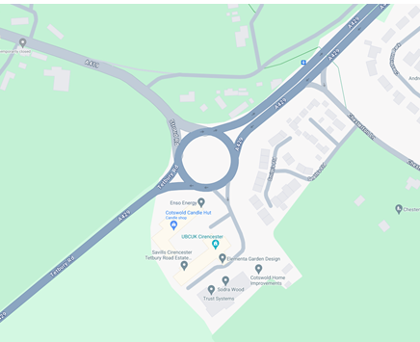

c) Start to Finish
4 | Left Turn on A429 from A433 | Note this is a slip road junction so cars turning right from A433 have priority. | M | Cycle Event Warning signs on A433 and A429 (4 – allows for riders returning to Cirencester)  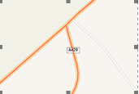
 |  | 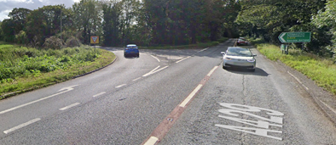
5 | Kemble request pedestrian controlled lights | Riders failing to obey lights | L
6 | Crudwell pedestrian controlled lights | Riders failing to obey lights | L
7 | Garden Centre/Filands RaB | Riders to move into right hand land  Right turn to B4014 | L | Cycle Event Warning signs on all RaB approaches (4).  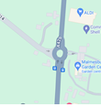
 |  | 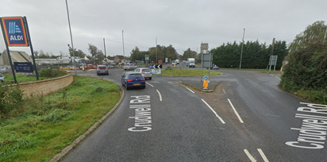
8 | Dyson RaB | Riders to move into right hand land  Circle & retrace approaching traffic | M | Warning signs on all RaB approaches. (4)  Observer to check riders have completed course.  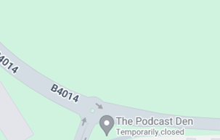
9 |  | 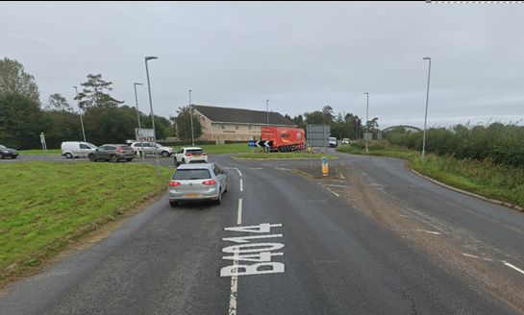
10 | Garden Centre/Filands RaB | Left turn to A429 | L | Warning signs on all RaB approaches. (as Ser 7)  Observer optional.  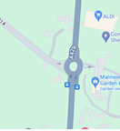
 |  | 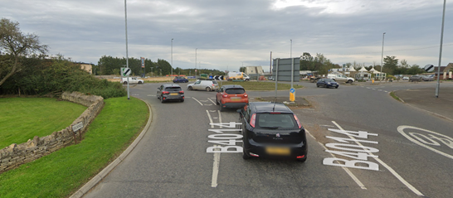
 | Crudwell pedestrian controlled lights | Riders failing to obey lights | L
11 | Kemble left turn into Windmill Road | Left turn on descent to unclassified road | L | Cycle Event Warning signs on Windmill Road  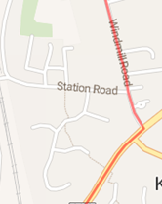
 |  | 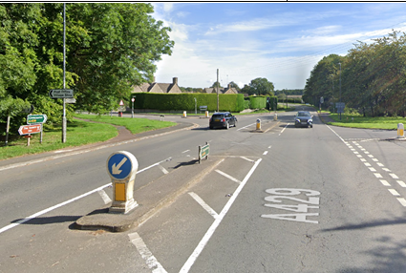
12 | Kemble village store (on left) | Parked cars and pedestrians | L | Warning on start sheet and signing on.
 | Original RA for 2020 had this as Medium risk but not clear why or if it even needs a mention on the start sheet | 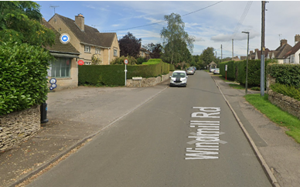
13 | Kemble railway bridge | Road narrows under bridge  May be queuing traffic | L | Cycle Event Warning sign for cars approaching bridge from North
 |  | 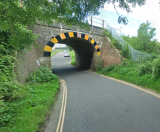
14 | Left turn onto A433 | T junction. Give way to traffic to right  Riders have limited visibility to right  Drain cover on turn slippery when wet | M | Cycle Event Warning signs on all approaches. (2)  Observer on A433 north of turn  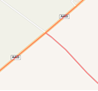
 | Late visibility to right | 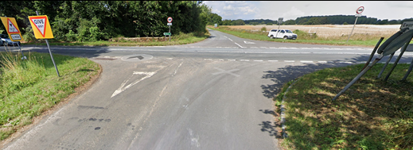
15 | Tetbury RaB | Give way to traffic from right | L | Cycle Event Warning signs on all approaches (3)  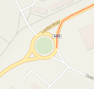
 | Good visibility for all RaB users | 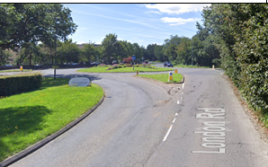
15 | Thames Head railway bridge | Narrow road. Slowing traffic on approach. | M | Cycle Event Warning sign on approach from Cirencester.  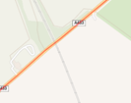
 |  | 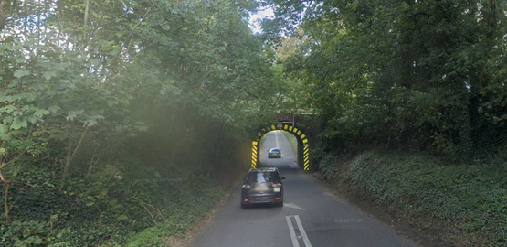
16 | Cirencester RaB | Circle & retrace approaching traffic  Riders to keep right | M | Cycle Event Warning signs on all approaches to RaB (4)  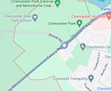
 |  | 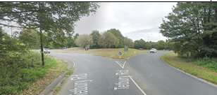
 | Repeat serials 4 – 16 | 2 more laps
17 | Finish:  ///steered.heartburn.itself  3 laps puts finish at GR ST98560 99039 | Awareness of surroundings | L | No u-turns.  Note on start sheet to be aware of surroundings and other road users at the finish.
 |  | 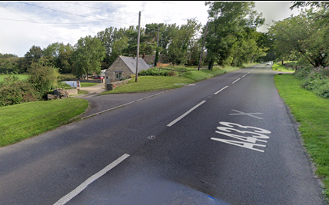
18 | After finish | Competitors returning to event HQ.  Follow A433 to Cirencester RaB | L | Instructions on safe route back from finish to HQ.

Notes
- The use of a vehicle for the timekeeper(s) at start and finish is where appropriate and is only identified as an example for the action to be taken
- The small junctions or entrances to farms/ facilities (garages, restaurants, etc) that are not identified in this risk assessment have been considered, however are not considered significant to pose a risk and therefore have not been noted.
- The course should not be used on public bank holiday weekends or when there are major local events. E.g. Womad, Badminton, Polo Competition, Air Show, etc

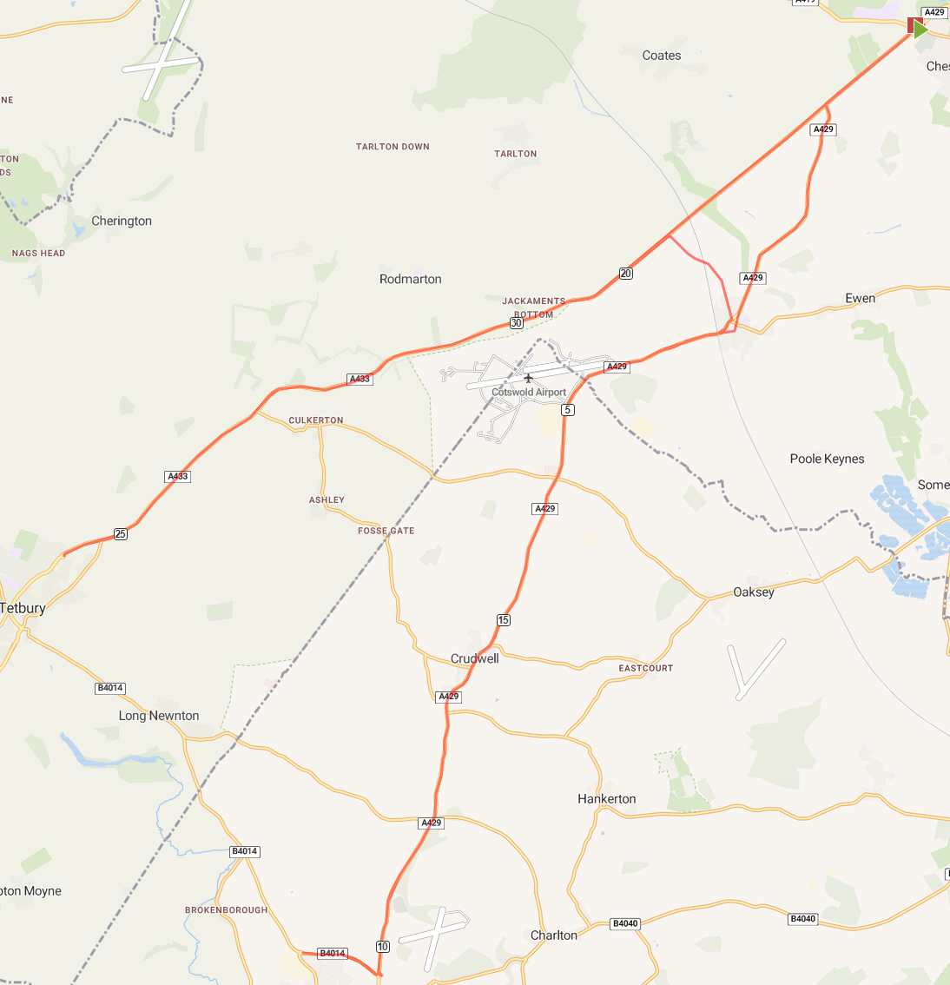

This document remains live and any changes to the items listed above or new hazards/risk that arise should be notified to the district committee at the earliest opportunity. This document was last updated on 10 August 2022.

