
West DC: Risk Assessment

Cycling Time Trials – West DC Course Risk Assessment Document. The measures to reduce risk identified in the right hand column must be included on the start sheet or implemented for the duration of the event as applicable. Failure to comply with the requirements of this document may result in approval being withheld with respect to subsequent race promotions by the promoting club.
(CTT Guidance Note 22 – Appendix 2 – Issue 2 September 2011 provides additional advice)
Course/Road(s) Assessed:  B4226 - B4227 – A4151 – A4136 – B4234 – B4266 | Course:  UC504  Distance (in miles):
Date of Assessment/Review:  1 February 2024 | Name of Assessor:  John Linden
Review History:  First Produced (if known): 8/12/06  Last Review: | Sponsoring Club or Organisation:  Royal Dean Forest CC
Course Description:
Start (GR SO 62390 12396) on B4226 1/3rd mile east of Speech House Hotel and proceed in an easterly direction to turn left onto B4227, then left onto A4151 through Steam Mills to turn left onto A4136, then left onto B4234 to Pygmy Pinetum crossroads where left onto B4226 to finish at start.
Link:
https://ridewithgps.com/routes/45486035
Course Type:
- Single Carriageway
- Out Only
- Identify any traffic calming measures, including speed restrictions
Traffic Flows:
B4226 carries significantly higher traffic flow and is the “limit” on the course. Evening flows are about half Sunday morning flows
Tuesday evening (19th April 22)
Speech Ho: 156 units
Course / Event History:
Used since at least 2006 with no reported incidents
Key Identified Risks
No. | Distance / Location | Risk/Hazard | Level of Risk  (L / M / H) | Measures to reduce Risk  (if applicable)
a) Introduction
1 | General Requirements | Time of Road Usage meets CTT Traffic Standards | L | Traffic counts within acceptable numbers
b) HQ to Start
2 | Before Start | Competitors riding from Event HQ; Competitors warming up | L | Instructions on Start Sheet and at event HQ signing on advising riders of safe routes; prohibition on warming up past the start
3 | Area of Start: | Competitors wait in entrance off road | L | Instructions on Start Sheet and at event HQ signing on - warning against making ‘U’ turns, queue in single file; Cycle Event Warning signs
 | Start by mile stone at entrance to Speech Ho Car Park  SO 62390 12396 or ///instance.slyly.lays | 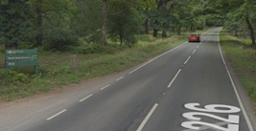
c) Start to Finish
 | B4227 junction | Riders make fast left turn off priority road. Road surface poor. Drain covers slippery when wet | L | Riders new to course made aware before start.
 |  | 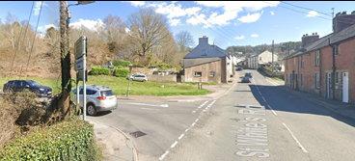
4 | RaB GR SO 64980 13893 | Riders take 2nd exit following Valley Rd | L | Observer optional as all have good visibility on RaB and approach.
 | Riders must give way to cars from right | 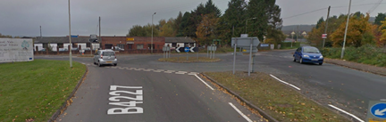  Note riders must give way to oncoming traffic
5 |  | RAB junction  Traffic turning around RAB to head West will have priority.  Continue straight on. | L | Visibility is good  Place 1 x observer wearing high visibility vest (not mandatory)..
 |  |  |  | Riders take first left exit to stay on B4277
6 | Junction of B4277 / A4151 Steam Mills Road | Turn left onto A road  Drives on A road have priority | M | Drivers can see junction clearly and riders have good visibility to right  Cycle Event Warning sign  Place 1 x observer wearing high visibility vest. (not mandatory)
7 |  | 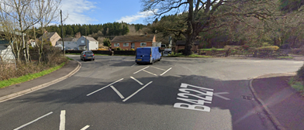
8 | Left filter on A4136 for Coleford | Cars filtering into right lane | L | Riders to keep left
 |  | 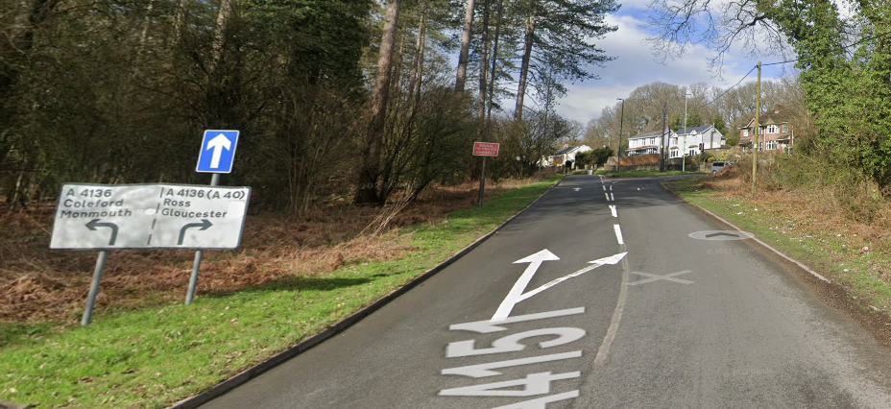
9 | Left Turn Junction with A4151 / A4136 | Traffic from Right has priority  Visibility at junction slightly obscured by traffic furniture | L | Cycle Event Warning Sign  Place 1 x observer wearing high visibility vest. Mandatory
 |  | 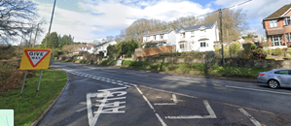
 | Left off A4136 onto B4234 | Cars turning across riders | L | Riders have priority
 |  | 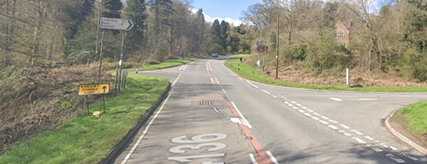
 | Turn Left onto B4266 Speech House Road B4226 | Drives on B4226 have priority | L | Cycle Event Warning Sign  Place 1 x observer wearing high visibility vest. (not mandatory)
 |  | 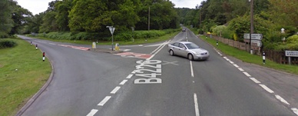
14 | Finish: (as start) | Awareness of surroundings | L | No u-turns.  Note on start sheet to be aware of surroundings and other road users at the finish.
 | By mile stone at entrance to Speech Ho Car Park  SO 62390 12396 or ///instance.slyly.lays | 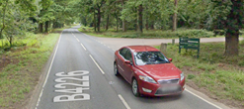
15 | After finish | Competitors returning to event HQ. | L | Instructions on safe route back from finish to HQ.

Notes
- The use of a vehicle for the timekeeper(s) at start and finish is where appropriate and is only identified as an example for the action to be taken
- The small junctions or entrances to farms/ facilities (garages, restaurants, etc) that are not identified in this risk assessment have been considered, however are not considered significant to pose a risk and therefore have not been noted.

This document remains live and any changes to the items listed above or new hazards/risk that arise should be notified to the district committee at the earliest opportunity.

