
West DC: Risk Assessment

Cycling Time Trials – West DC Course Risk Assessment Document. The measures to reduce risk identified in the right hand column must be included on the start sheet or implemented for the duration of the event as applicable. Failure to comply with the requirements of this document may result in approval being withheld with respect to subsequent race promotions by the promoting club.
(CTT Guidance Note 22 – provides additional advice)
Course/Road(s) Assessed:  B4040: Sherston – Twatley Cottages  Unclassified Road: Twatley Cottages – Shipton Moyne – Close Farm  A433: Close Farm – Westonbirt  Unclassified Road: Westonbirt - Sherston | Course:  UC105  Distance (in miles):  10.13 miles (16.3km)
Date of Assessment/Review:  27 Jan 24 – pre-season review | Name of Assessor:  Simon Vannerley
Review History:  First Produced (if known): January 2024  Last Review: 22 February 2024 – addition of policy authority and tidying up  28 February 2024 – addition of traffic counts  2 March 2024 – update serial 4 and traffic flows | Sponsoring Club or Organisation:  Sherston Velo CC
Course Description:
Event HQ: Sherston Village Hall car park. To reach the start, turn right out of car park and proceed along Easton Town (B4040).
- The start is at gr ST 8557 8623 w3w incisions.genius.breaches, the end of the splay at the junction of Huntersfield and Easton Town (B4040 eastbound). Proceed east on the B4040.
- 3.8mi (6.2km) gr ST 9126 8792 w3w washroom.agree.recall: Turn left onto unclassified road signposted SHIPTON MOYNE, continue through village. TAKE CARE at triangular junction: sharp left turn, potholes and GIVE WAY to traffic coming from the right as per road markings.
- 7.2mi (11.6km) gr ST 8833 9186 w3w coping.stereos.exile: Turn left onto A433 at T junction, signposted BATH. Proceed south-west on A433.
- 9.4mi (15.2km) gr ST 8560 8966 w3w taskbar.robots.milkman: Turn left onto unclassified road signposted WESTONBIRT VILLAGE, opposite entrance to Arboretum. Take care: road narrows in places.
- 10mi (16.1km) gr ST 8579 8858 w3w relegate.technical.ended: FINISH is level with footpath sign.
- Return to event HQ by proceeding ahead from finish to SHERSTON village (approximately 1 mile).
Link:
SVCC Club 10 TT | 16.1 km Cycling Route on Strava

Course Type:
- Single Carriageway
- Circuit
- No identified traffic calming measures
Traffic Flows:
The main roads used on this course (A433 and B4040) are generally quiet outside commuting times. Both roads are of reasonable width for their type, with ample straight stretches to allow motor vehicles to pass cyclists safely. Attention must be paid by organisers to any evening events taking place at Westonbirt Arboretum. These may attract high traffic volumes: event dates and times should be adjusted accordingly.
The unclassified roads used on this course are generally very quiet outside commuting hours. They are single carriageway but are sufficiently wide for two-way traffic at all points along the course.
Count on 26 February 2024 – B4040 – 54 units per hour, A433 – 60 units per hour. An updated count should be carried out during 2025 for assurance
Course / Event History:
This is a new course (2024), however it is based upon part of the Westonbirt Triathlon bike course, which has been in regular use for more than 10 years, including events with a significant number of competitors.
Police Authorities:
Gloucestershire Constabulary – David Holland, Road Safety and Traffic Management, Gloucestershire Constabulary HQ, No 1 Waterwells, Quedgeley, GLOUCESTER, GL2 2AN. Tel: 01452 754547 RoadSafety.&TrafficManagement@gloucestershire.pnn.police.uk
Wiltshire Constabulary – Bob Eccleston. Bob.Eccleston@wiltshire.police.uk (Start and Finish)

Key Identified Risks
No. | Distance / Location | Risk/Hazard | Level of Risk  (L / M / H) | Measures to reduce Risk  (if applicable)
a) Introduction
1 | General Requirements | Traffic level at time of Road Usage meets CTT Traffic Standards | L | Traffic counts within acceptable numbers; Take Traffic Counts during event
b) HQ to Start
2 | Before Start | Competitors riding from Event HQ; Competitors warming up | M | Instructions on Start Sheet and at event HQ signing on advising riders of safe routes; prohibition on warming up past the start
3 | Area of Start – B4040 | Competitors waiting on road / pavement area next to start. | L | There is a wide pavement area for waiting riders. The road is also sufficiently wide to allow motor vehicles ample space to pass riders waiting to start in a safe manner.  Instructions on Start Sheet and at event HQ signing on warning against making ‘U’ turns, queue in single file. Cycle Event Warning signs, use of traffic cones.
3 | Area of Start – B4040 | 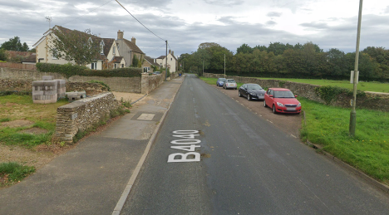  B4040 (Easton Town) – start of course indicated by green line
c) Start to Finish
4 | B4040 - Roads joining from left and Whitewalls Industrial Estate | 4 x minor roads joining from left. Visibility from B4040 and from joining roads is good at all junctions  Businesses at Whitewalls Industrial Estate (including) coach depot. Located on longer straight stretch of road, giving excellent visibility for riders and drivers. | L | Nil. Visibility for riders and joining traffic is good.  Businesses at Whitewalls are likely to be closed during the hours when TT events are being held, with no large vehicle movements anticipated: no further measures are required.
5 | Turn #1  Junction of B4040 and unclassified road to Shipton Moyne | Riders turn left at triangular junction where traffic coming from the right has priority.  Road surface at junction in poor condition in places | L | Traffic flows are low at this junction. (Course is usually only used for evening club events)  Visibility for riders and motorists is very good at this junction  Riders to be given instructions on start sheet and at start.  Place 1 x observer wearing high visibility vest (not mandatory).  Cycle Event Warning Sign for oncoming traffic
5 |  | 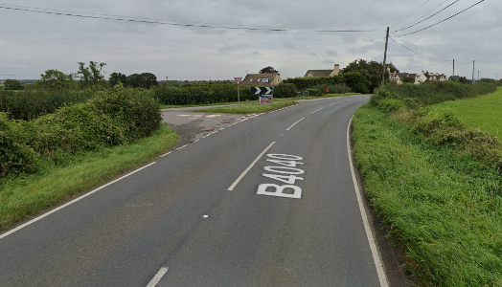Junction of B4040 and unclassified road at Turn #1 – note road markings and condition of road surface
6 | Unclassified road through Shipton Moyne | Traffic joining from minor roads and public house car park  Parked vehicles in village  30mph speed limit | M | Instructions on start sheet  Riders to be briefed not to cut corner into main street, to be aware of parked vehicles and to be aware of vehicles approaching while passing parked vehicles.  Visibility from joining roads is good for both riders and drivers. Traffic flows are generally low in this village, particularly outside commuting times.
7 | Turn #2  Junction of unclassified road and A433 | Riders turn left: traffic on A433 has priority.  Visibility for both riders joining A433 and approaching drivers is good due to junction being on outside of a curve in the road. | L | Instructions on start sheet and at start.  Place 1 x observer wearing high visibility vest (not mandatory).  Cycle Event Warning Sign on A433
7 | Turn #2  Junction of unclassified road and A433 | 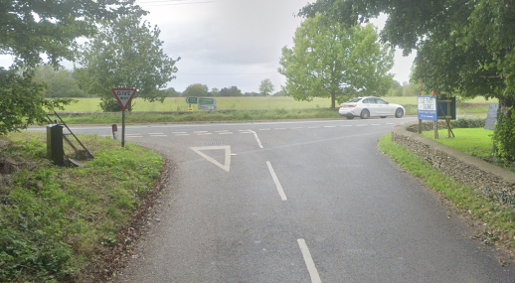  Junction of unclassified road and A433 at Turn #2
8 | A433 – Roads joining from left | One minor road (junction with Bowldown Lane at Hare and Hounds) | L | Nil. Visibility for riders and joining traffic is good.
9 | Turn #3  Junction of A433 and unclassified road to Westonbirt Village | Turn is opposite entrance to Westonbirt Arboretum tourist attraction. Traffic flows can be high when evening events are being held at the Arboretum. | L | Organisers to take care to avoid holding TTs that clash with Westonbirt events.  Otherwise, no further measures required.
9 |  | 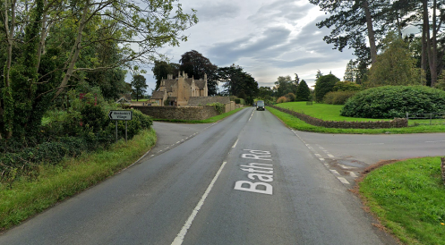  Junction of A433 and unclassified road at Turn #3
10 | FINISH | Finish area with timekeeper’s vehicle only on grass verge.  Road is straight at this point, visibility is good in both directions. | L | Instructions on start sheet and rider briefing that riders are not to stop at the finish. No U-turns are permitted.  Timekeeper to wear high-visibility vest.  If supporters are present, consider placing an observer wearing a high-visibility vest to maintain a safe environment for riders and timekeeper  No times will be given to competitors or supporters at the finish.  Timekeeper’s vehicle (if used) to be parked appropriately to not cause a hazard to riders or other road users.
10 | FINISH | 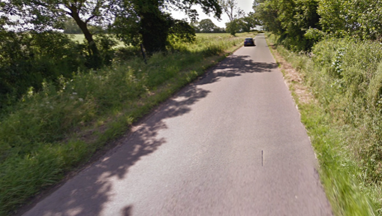  View of finish line (in red). Yellow box shows footpath sign denoting finish point.
Finish and return to Event HQ
11 | Finish | Awareness of surroundings | L | No U-turns.  Note on start sheet to be aware of surroundings and other road users at the finish.
12 | After finish | Competitors returning to event HQ.  Care to be taken when turning right at Easton Town crossroads | L | Instructions on safe route back from finish to HQ to be given on start sheet and in rider briefing

Notes
- Any minor junctions, entrances to properties, farms, fields or other facilities that are not included in this risk assessment have been considered but are not believed to constitute a hazard to participants and therefore have not been noted.
Prior to the start of the event, riders shall be notified of the following:
- Current road conditions and any changes to the route that may impact upon safety, such as the appearance of potholes, roadworks or other hazards.
- Where to wait near the start prior to being called forward by the start timekeeper.
- The rider briefing, including the safety notes contained in this risk assessment.
- What to do on completion of the course.
- The route back to event HQ.

Course overview map
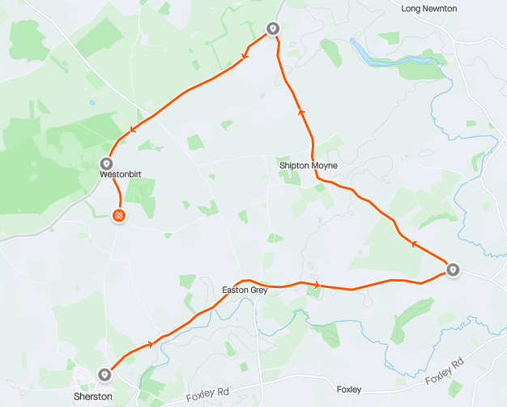

This document remains live and any changes to the items listed above or new hazards/risk that arise should be notified to the district committee at the earliest opportunity.

