**Course History**

The Ledbury and Back course has been used by the Ross-on-Wye & District Cycling Club for decades and is an out and back course from the Old Gore crossroads.

Recently traffic lights have been put on the course at the start/finish, which makes in its current form unsuitable to run.

By moving the start 0.7 miles further down the course, to a long straight and a layby with good visibility and the finish being moved immediately opposite, the course can be retained in a safe manner.

A traffic count was completed at the new start to demonstrate the low traffic count and the risk assessment has been updated to reflect the new start. The traffic count averaged from both counts, is 78 units per our north east (outbound) and 117units per hour in the south west (return)

The traffic count and risk assessment are on the following pages of this document.

For the purpose of this document I have named the revised course UC 678A vs the original UC 678, this is for

It is also worth noting this course runs ALONG the South Wales and West DC boundary. The start, finish and the entire course runs on the boundary with not a single piece of the course going into a single district.

**Course Description**

|  |  |  |
| --- | --- | --- |
|  | **Original UC 678** | **Modified UC678A (This request)** |
| **Description** | Start on the A449 Ross-on-Wye Ledbury Road  Start at the Old Gore crossroads and proceed to Preston Cross Roundabout, take the 2nd exit towards Ledbury to the next roundabout. Take the 4th exit to retrace back to start. | Start on the A449 Ross-on-Wye Ledbury Road  Start 0.65* miles past the Old Gore crossroads towards Ledbury, in the left hand layby opposite a gate. Proceed to Preston Cross Roundabout, take the 2nd exit towards Ledbury to the next roundabout. Take the 4th exit to retrace back to finish immediately opposite the start |
| **Distance** | 16 miles | 14.7 miles |

* The updated start would be only 0.65 miles past the cross roads, not 0.7miles as the course start and finish was slightly before the cross roads.

**Course Map**

**Old Route:**

**New Route:**

The only change is moving the start down the course.

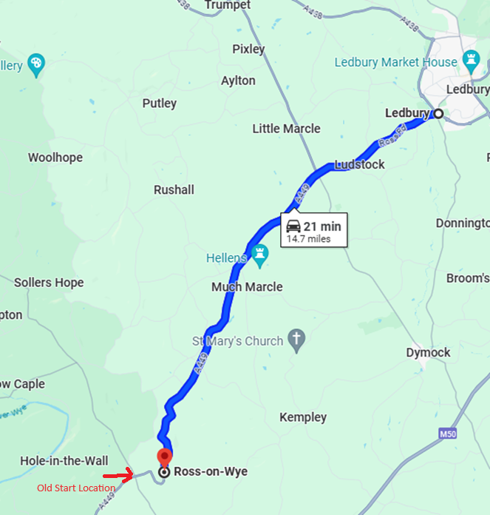

**Traffic Counts at Revised Start**

|  |  |
| --- | --- |
| Name of Event: Vintage Tankard | Date of Event: 22nd September 2024 |
| Precise Location of Count:  A449 - 51.953817, -2.526988  In Layby at proposed new start | Single or Dual Carriageway: S |
| MoT Road Number: A449 | Direction of Traffic Flow: North East |
| Person doing the Count: Will Bevan | Club: Ross-on-Wye and District CC |
| Status in club/District Council: Racing Sec. | Course Key: UC-678A |

**Location diagram**

|  |  |  |  |
| --- | --- | --- | --- |
| Time | Units Recorded | Total | Units / Hour |
| From:  10:01  To:  10:11am | Cars, Motorcycles, small vans = 1 unit  11 cars/motorcycles/small vans: 11 total.  Other vehicle = 3 units  No other vehicles. 0 units | 11 units | 66 units |

|  |  |  |  |
| --- | --- | --- | --- |
| Time | Units Recorded | Total | Units / Hour |
| From: 10:12AM  To:  10:22 am | Cars, Motorcycles, small vans = 1 unit  23 cars/motorcycles/small vans: 23 total.  Other vehicle = 3 units  No other vehicles. 0 units | 15 units  0 units | 90 units |

**Traffic Counts at Revised Finish**

|  |  |
| --- | --- |
| Name of Event: Vintage Tankard | Date of Event: 22nd September 2024 |
| Precise Location of Count:  A449 - 51.953817, -2.526988  In Layby at proposed new start | Single or Dual Carriageway: S |
| MoT Road Number: A449 | Direction of Traffic Flow: South West |
| Person doing the Count: Will Bevan | Club: Ross-on-Wye and District CC |
| Status in club/District Council: Racing Sec. | Course Key: UC-678A |

**Location diagram**

|  |  |  |  |
| --- | --- | --- | --- |
| Time | Units Recorded | Total | Units / Hour |
| From:  10:01  To:  10:11am | Cars, Motorcycles, small vans = 1 unit  11 cars/motorcycles/small vans: 21 total.  Other vehicle = 3 units  No other vehicles. 0 units | 21 units | 126 units |

|  |  |  |  |
| --- | --- | --- | --- |
| Time | Units Recorded | Total | Units / Hour |
| From: 10:12AM  To:  10:22 am | Cars, Motorcycles, small vans = 1 unit  23 cars/motorcycles/small vans: 18 total.  Other vehicle = 3 units  No other vehicles. 0 units | 18 units  0 units | 108 units |

|  |  |
| --- | --- |
|  | S. Wales : Risk Assessment |

### Course Identification : UC 678A

Course / Road(s) LEDBURY & BACK Assessor(s): W. Bevan

Club: Ross-on-Wye & District CC

Date of Assessment: 27/05/2024

**Cycling Time Trials – West DC** Course Risk Assessment Document. The measures to reduce risk identified in the right hand column must be included on the start sheet or implemented for the duration of the event as applicable. Failure to comply with the requirements of this document may result in approval being withheld with respect to subsequent race promotions by the promoting club.

Number of Sheets: 3

|  |  |  |  |  |  |  |  |
| --- | --- | --- | --- | --- | --- | --- | --- |
| No. | Distance / Location | | **Risk/Hazard** | | **Level of Risk** (L / M / H) | | Measures to reduce Risk **(if applicable)** |
| **a) Introduction** | | | | | | |  |
| 1 | General Requirements | | Time of Road Usage meets CTT Traffic Standards | |  | | Traffic counts within acceptable numbers ; Take Traffic Counts during event |
| **b) HQ to Start** | | | | | | |  |
| 2 | Before Start | | Competitors riding from Event HQ; Competitors warming up | |  | | Verbal instruction of conduct |
| 3 | Area of Start | | Competitors waiting | |  | | Verbal instruction of conduct |
| **c) Start to xxx** | | | | | | |  |
| 4 | | YATTON JNC. | | LH TURN | | L |  |
| 5 | | YATTON/ KEMPLY | | X ROADS | | L |  |
| 6 | | MUCH MARCLE | | X ROADS & PH CARPARK | | L |  |
| 7 | | FARM ROAD | | LH TURN | | L |  |
| 8 | | ROYAL OAK | | PH CAR PARK LH. | | L |  |
| 9 | | Preston's CROSS | | ROUNDABOUT | | L | Marshal if available |
| 10 | | LEADINGTON | | RH TURN | | L |  |
| 11 | | LILLY LANE | | LH TURN | | L |  |
| 12 | | LEADINGTON | | RH TURN | | L |  |
| 13 | | SPORTS CENTRE | | LH TURN | | L |  |
| 14 | | LEADON VALLEY CARPARK | | LH TURN | | L |  |
| 15 | | FULL PITCHER | | ROUNDABOUT | | L | MARSHAL & Signs |
| 16 | | LEADON VALLEY CARPARK | | RH TURN | | L |  |
| 17 | | SPORTS CENTRE | | RH TURN | | L |  |
| 18 | | LEADINGTON | | LH TURN | | L |  |
| 19 | | LILLY LANE | | RH TURN | | L |  |
| 20 | | LEADINGTON | | RH TURN | | L |  |
| 21 | | Preston's CROSS | | ROUNDABOUT | | L |  |
| 22 | | ROYAL OAK | | PH CAR PARK RH. | | L |  |
| 23 | | FARM ROAD | | RH TURN | | L |  |
| 24 | | MUCH MARCLE | | X ROADS & PH CARPARK | | L |  |
| 25 | | YATTON/ KEMPLY | | X ROADS | | L |  |
| 26 | | YATTON JNC. | | RH TURN | | L |  |
| 27 | | FARM EXIT | | LH TURN | | L |  |
| 28 | | Finish | | Road Users – riders performing U turns after the finish | | L | Told to be aware of surroundings and other road users at the finish. |

This document remains live and any changes to the items listed above or new hazards/risk that arise should be notified to the district committee at the earliest opportunity. This document was last updated on 14/3/05.

CYCLING TIME TRIALS IS A COMPANY LIMITED BY GUARANTEE REGISTERED IN ENGLAND No: 4413282   
Registered Address: 77 ARLINGTON DRIVE, PENNINGTON, LEIGH, LANCASHIRE. WN7 3QP November 2003