Risk Assessment proforma*

Course | K15/25 | 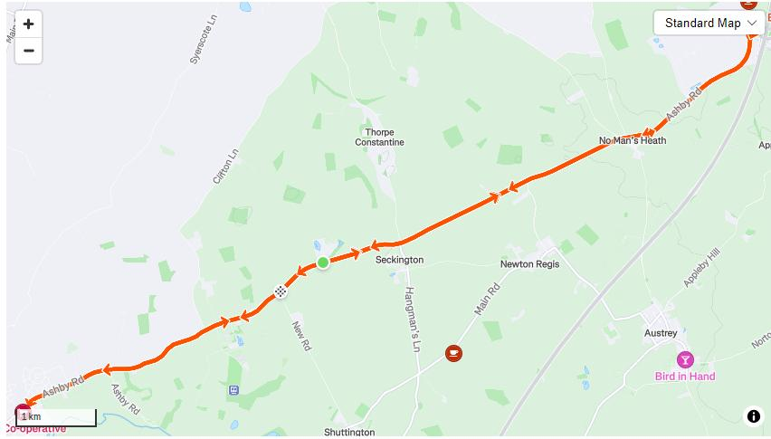
Area | Midland DC
Description | B5493 - No Man's Heath - Mercia Park - Tamworth/ Arkall Green
HQ | Shuttington & Alvecote Parish Hall
Measured | 24/01/2025
Measured by | S. Loraine
Risk assessed | 18/02/2025
Assessed by | S Loraine
Date approved by District Committee | 00/00/2025
Type A | A
Type B
Police Authority | Warwickshire, Staffordshire & Leicestershire
Additional information | PNF Required to three Police Authorities:  Warwickshire, Leicestershire, Staffordshire
Notes for riders | This is a new two-lap course on a rural former ‘A’ road. There are roundabouts at both ends of the course, to be encircled on each lap. There is a major distribution centre entrance near the northerly roundabout. A leisure park entrance is passed twice per lap. There are two housing estate access roads at the southerly roundabout.
OS Grid # | Course description | Distance | Risk (L/M/H) | Risk description | Minimum management  (Without prejudice)
SK 252 074 | Start at: on the B5493, in a lay-by, approximately 25m SW of Lonkhills farm entrance driveway | 0 | M | Traffic approaching race start from rear | Cycle event signs before Start, on both sides of the highway.  Officials to wear high vis. jackets.
SK 261 076 | Seckington crossroads | 0.6m | L | Traffic entering/crossing course | Cycle event signs on both sides of crossroads. Officials to wear high vis. jackets.
SK 289 089 | No Man’s Heath crossroads | 2.5m | L | Off-set crossroads with traffic entering the course from three junctions | Cycle event signs on each junction. Officials to wear high viz jackets.
SK 304 102 | Encircle Mercia Park Distribution Centre traffic island, taking the third exit, signed B5493 Tamworth | 4m | M | Traffic entering island from M42 interchange; commercial vehicles entering course from distribution centre | Cycle event signs on all approaches to the traffic island. Officials to wear high vis. jackets.
SK 239 066 | Statfold Leisure Park entrance | 9m | L | Traffic entering/exiting course from venue | Cycle event sign at entrance to venue.
SK 216 057 | Encircle mini roundabout at Arkall Green, taking fourth exit to rejoin B5493 and retrace course north-east to the Start | 10.6m | M | Traffic entering course from B5493 direction Tamworth and two housing estates | Cycle event signs on all approaches to traffic island. Officials to wear high vis. jackets.
SK 252 074 | Pass the Start layby and begin the second lap: proceeding NE to Mercia Park Distribution Centre r/a, returning SW along B5493 to Arkall Green r/a, retracing NE on B5493 | 13.2m | L | (NB No additional risk as riders continue past the start point) | Cycle event signs before Start, on both sides of the highway. Officials to wear high vis. jackets
SK 246 070 | To Finish at: Layby at Thorpe Gorse cottages, opposite New Road junction | 25m | L | Officials near highway | Finish flag/board with timekeeper. Officials to wear high vis jackets.
References:

CTT GN22 – Risk Assessment

Date of Issue | Reason of Revision | Author
March 2013 | New edition | David Barry  (CTT Board Director)  (CTT Course Risk Assessor)
August 2018 | Revised format | Nick Sharpe  (CTT National Secretary)
October 2022 | Revised to reflect current CTT Articles, Rules, and Regulations | David Barry  (CTT Board Director)

