
West DC: Risk Assessment

Cycling Time Trials – West DC Course Risk Assessment Document. The measures to reduce risk identified in the right hand column must be included on the start sheet or implemented for the duration of the event as applicable. Failure to comply with the requirements of this document may result in approval being withheld with respect to subsequent race promotions by the promoting club.
(CTT Guidance Note 22 – provides additional advice)
Course/Road(s) Assessed:  B4040: Sherston – Twatley Cottages  Unclassified Road: Twatley Cottages – Shipton Moyne | Course:  UC105X  Distance (in miles):  5.5 miles (8.9km)
Date of Assessment/Review:  27 Jan 25 – New course | Name of Assessor:  Simon Vannerley
Review History:  First Produced: January 2025 | Sponsoring Club or Organisation:  Sherston Velo CC
Course Description:
Event HQ: Sherston Village Hall car park. To reach the start, turn right out of car park and proceed along Easton Town (B4040).
- The start is at gr ST 8557 8623 w3w incisions.genius.breaches, the end of the splay at the junction of Huntersfield and Easton Town (B4040 eastbound). Proceed east on the B4040.
- 3.8mi (6.2km) gr ST 9126 8792 w3w washroom.agree.recall: Turn left onto unclassified road signposted SHIPTON MOYNE, continue through village. TAKE CARE at triangular junction: sharp left turn, potholes and GIVE WAY to traffic coming from the right as per road markings.
- 5.5mi (8.9km) gr ST 89206 89375 w3w idealist.steaming.reserved: FINISH is at 30mph sign at entrance to SHIPTON MOYNE village.
- Recommended route back to event HQ: take next left (Hedgeditch Lane), then left at T. At next T junction, right onto B4040 to return to SHERSTON (approx. 2 miles).
Link:
UC105X Sherston 5.5 Mile Time Trial · Ride with GPS

Course Type:
- Single Carriageway
- Straight out
- No identified traffic calming measures
Traffic Flows:
The B4040 is generally quiet outside commuting times. The road is of reasonable width, with ample straight stretches to allow motor vehicles to pass cyclists safely.
The unclassified road used on this course is generally very quiet outside commuting hours. It is single carriageway and sufficiently wide for two-way traffic at all points along the course.
Traffic count on 26 February 2024 – B4040 – 54 units per hour. An updated count should be carried out during 2025 for assurance.
Course / Event History:
This is a new course (2025). It is part of UC105 (the parent course) and part of the Westonbirt Triathlon bike course. These roads have been in use for events for more than 10 years, including events with a significant number of competitors.
All parts of UC105X were in use last year as part of a series of 10-mile time trials with no incidents.
Police Authorities: The majority of the route lies in Wiltshire. The final kilometre of the route is in Gloucestershire.
Wiltshire Constabulary – Bob Eccleston. Bob.Eccleston@wiltshire.police.uk
Gloucestershire Constabulary – David Holland, Road Safety and Traffic Management, Gloucestershire Constabulary HQ, No 1 Waterwells, Quedgeley, GLOUCESTER, GL2 2AN. Tel: 01452 754547 RoadSafety.&TrafficManagement@gloucestershire.pnn.police.uk

Key Identified Risks
No. | Distance / Location | Risk/Hazard | Level of Risk  (L / M / H) | Measures to reduce Risk  (if applicable)
a) Introduction
1 | General Requirements | Traffic level at time of Road Usage meets CTT Traffic Standards | L | Traffic counts within acceptable numbers; Take Traffic Counts during event
b) HQ to Start
2 | Before Start | Competitors riding from Event HQ; Competitors warming up | M | Instructions on Start Sheet and at event HQ signing on advising riders of safe routes; prohibition on warming up past the start
3 | Area of Start – B4040 | Competitors waiting on road / pavement area next to start. | L | There is a wide pavement area for waiting riders. The road is also sufficiently wide to allow motor vehicles ample space to pass riders waiting to start in a safe manner.  Instructions on Start Sheet and at event HQ signing on warning against making ‘U’ turns, queue in single file. Cycle Event Warning signs, use of traffic cones.
3 | Area of Start – B4040 | 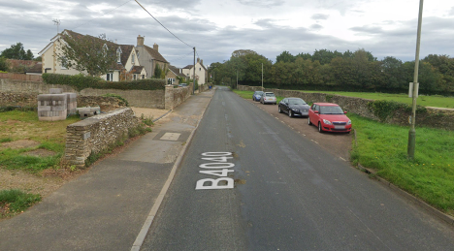  B4040 (Easton Town) – start of course indicated by green line
c) Start to Finish
4 | B4040 - Roads joining from left and Whitewalls Industrial Estate | 4 x minor roads joining from left. Visibility from B4040 and from joining roads is good at all junctions  Businesses at Whitewalls Industrial Estate (including) coach depot. Located on longer straight stretch of road, giving excellent visibility for riders and drivers. | L | Nil. Visibility for riders and joining traffic is good.  Businesses at Whitewalls are likely to be closed during the hours when TT events are being held, with no large vehicle movements anticipated: no further measures are required.
5 | Turn #1  Junction of B4040 and unclassified road to Shipton Moyne | Riders turn left at triangular junction where traffic coming from the right has priority.  Road surface at junction in poor condition in places | L | Traffic flows are low at this junction. (Course is usually only used for evening club events)  Visibility for riders and motorists is very good at this junction  Riders to be given instructions on start sheet and at start.  Place 1 x observer wearing high visibility vest (not mandatory).  Cycle Event Warning Sign for oncoming traffic
5 |  | 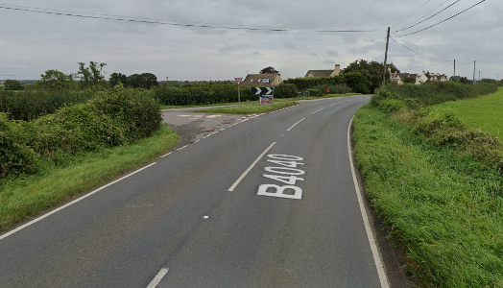Junction of B4040 and unclassified road at Turn #1 – note road markings and condition of road surface
10 | FINISH | Finish area – point of concentration of riders and event staff on edge of village.  Road is straight/shallow bend to right at this point, visibility is good in both directions. | L | Instructions on start sheet and rider briefing that riders are not to stop at the finish. No U-turns are permitted.  Event staff (e.g. timekeeper) to wear high-visibility vests.  If supporters are present, consider placing an observer wearing a high-visibility vest to maintain a safe environment for riders and timekeeper  No times will be given to competitors or supporters at the finish.  Timekeeper’s vehicle to be parked appropriately to not cause a hazard to riders or other road users. Recommended to park at least 50m beyond finish line.
10 | FINISH | 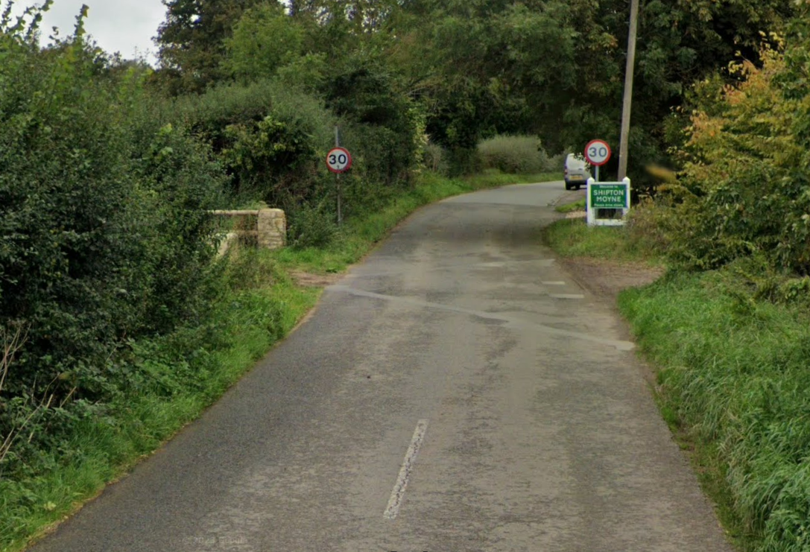  View of finish – the finish line is a line between the two 30mph speed limit indicator signs.
Finish and return to Event HQ
11 | Finish | Awareness of surroundings | L | No U-turns.  Note on start sheet to be aware of surroundings and other road users at the finish.
12 | After finish | Competitors returning to event HQ. | L | Instructions on safe route back from finish to HQ to be given on start sheet and in rider briefing. Care to be taken at junctions.

Notes
- Any minor junctions, entrances to properties, farms, fields or other facilities that are not included in this risk assessment have been considered but are not believed to constitute a hazard to participants and therefore have not been noted.
Prior to the start of the event, riders shall be notified of the following:
- Current road conditions and any changes to the route that may impact upon safety, such as the appearance of potholes, roadworks or other hazards.
- Where to wait near the start prior to being called forward by the start timekeeper.
- The rider briefing, including the safety notes contained in this risk assessment.
- What to do on completion of the course.
- The recommended route back to event HQ.

Course overview map
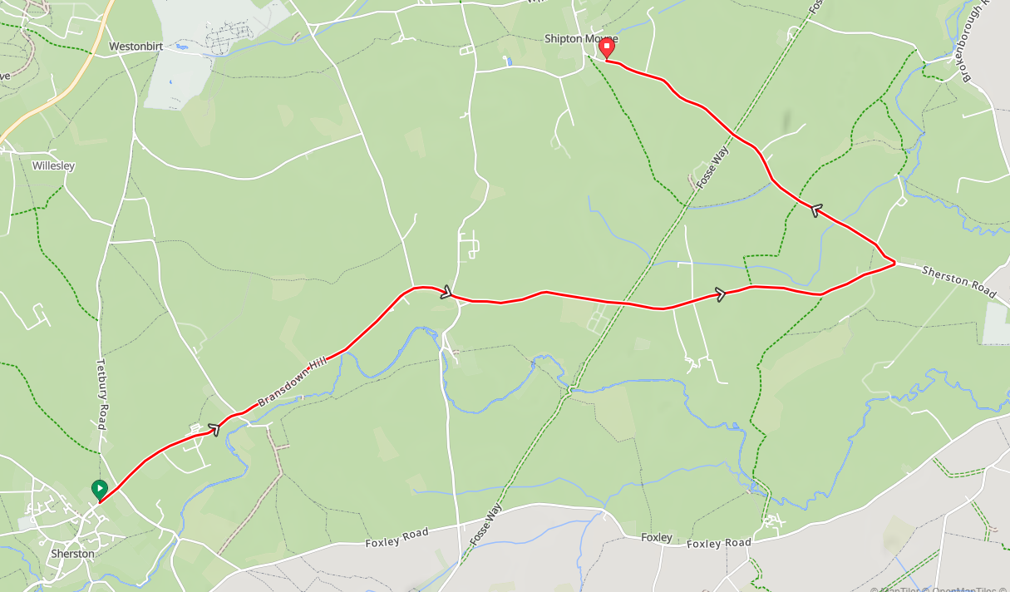

This document remains live and any changes to the items listed above or new hazards/risk that arise should be notified to the district committee at the earliest opportunity.

