
West DC: Risk Assessment
Cycling Time Trials – West DC Course Risk Assessment Document. The measures to reduce risk identified in the right hand column must be included on the start sheet or implemented for the duration of the event as applicable. Failure to comply with the requirements of this document may result in approval being withheld with respect to subsequent race promotions by the promoting club.
(CTT Guidance Note 22 – Appendix 2 – Issue 2 September 2011 provides additional advice)
Course/Road(s) Assessed:  B4042; B4696; B4040; A429  WTTA (Hardrider) | Course: U871  Distance (in miles): 31
Date of Assessment/Review:  3rd January 2023 | Name of Assessor:  Paul Winchcombe  Reviewed 2018 RA and reapproved  Updated January 2023 with street view images (all hyperlinked)
Course Description:
START at small lay-by on the Seagry Road ½ mile North of Sutton Benger. Proceed North through Seagry Heath and Great Somerford, turn left in Little Somerford to junction with B4042 where you turn left. Proceed to Malmesbury Hospital RAB, circle and retrace on B4042 through Brinkworth, turn left onto B4696 (SP Minety), turn left at Battle Lake (SP Garsdon). Proceed to junction of B4040 at Minety, turn left, give way to traffic from right. Proceed to water tower RAB, junction A429, turn left. Proceed to Malmesbury Hospital RAB, proceed straight on (second exit). Turn left into Grange Lane. Proceed through Startley. FINISH at Old Field Gate ¼ mile North of Cross Roads at Upper Seagry.

Link
https://www.strava.com/activities/46613353
Traffic Flows:
Traffic Counts are historically low
Course/Event History:
Course has been in general use since at least 2010. Also uses U86/25 course as its main segment.

No. | Distance/Location | Risk/Hazard | Level of Risk (L / M / H) | Measures to reduce Risk (if applicable)
- Introduction
1 | General Requirements | Time of Road Usage meets CTT Traffic Standards | L | Traffic counts within acceptable numbers; Take Traffic Counts during event.
- HQ to start
2 | Before Start | Competitors riding from Event HQ; Competitors warming up | L | Instructions on Start Sheet and at event HQ signing on advising riders of safe routes; prohibition on warming up past start
3 | Area of Start | Competitors waiting | L | Instructions on Start Sheet and at event HQ signing on - warning against making ‘U’ turns; Cycle Event warning signs in both directions.
- Start to Minety
4 | Start on unclassified road | 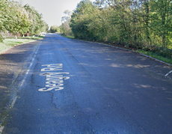 | L | Start is top of layby before M4 motorway bridge
5 | Through Great Somerford Village | Road narrows; parked cars and general village activity | L | General warning on Start Sheet
6 | Left in Little Somerford | Road narrows; parked cars and general village activity; riders turn left - give way to traffic from the right  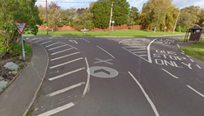 | M | As 5 above; Observer (optional good lines of sight and riders travelling uphill); Direction sign; Cycle Event warning signs.
7 | Junction with B4042 | Riders turn left onto main road - give way to traffic from the right  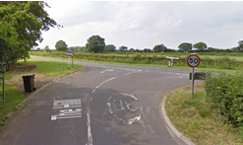 | M | Observer; Direction sign; Cycle Event warning signs
8 | Hospital RaB, Malmsbury | Riders turn (4th exit) and retrace on B4042; traffic on RaB from A429.  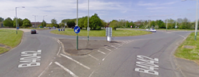 | M | Observer (optional and is a large RAB with good lines of sight); Direction sign; Cycle Event warning signs on all approaches  Warning on start sheet as descent to RaB is fast.
 |  |  |  | Descent from top of hill towards River Avon and is fast. Drivers may hold up riders, especially if turning, riders are not to overtake cars on the descent
9 | B4042 through Brinkworth village | Road narrows; parked cars and general village activity | L | General warning on Start Sheet
10 | Left on B4696 SP Minety | Left turn priority  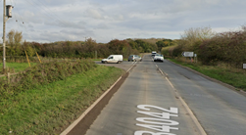 | L | Observer; Direction sign; Cycle Event warning signs
11 | Left at Braydon Crossroads SP Garsdon | Drain and 3 x hydrant covers on riders lane  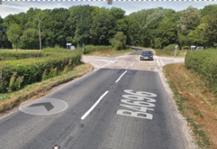 | L | Warning on Start Sheet  Observer (optional, riders have right of way); Direction sign; Cycle Event warning signs
12 | Right Bend at Braydon Manor | Road direction priority follows bend | L | Direction Sign
13 | Left at Minety | Riders turn left onto B4040 - give way to traffic on right; limited visibility  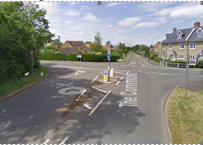 | M | Observer; Direction sign; Cycle Event warning signs on all approaches
- Minety to Finish
14 | Sharp left corner in Charlton | Slippery if wet | L | Warning on Start Sheet
15 | Sharp left corner at bridge at bottom of descent, road narrows | Rider may drift onto wrong side of road. Slippery if wet. | L | Warning on Start Sheet
16 | Left at Water Tower roundabout | Riders take first left exit to join A429  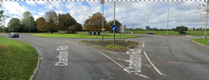 | L | Observer (optional, large RAB with good lines of sight); Direction arrow; Warning signs
17 | Hospital RaB, Malmsbury | Riders go straight on (2nd exit); give way to the right  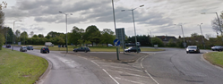 | L | Observer (optional, large RAB with good lines of sight); Direction arrow; Warning signs
18 | Outside Malmsbury Hospital | Zebra pedestrian crossing | L | Riders to give way to pedestrians, warning on Start Sheet
19 | Left off A429 onto Grange Lane unclassified road | Riders turn left; traffic on Grange Lane | L | Observer (optional riders have right of way); Direction sign; Cycle Event warning signs
20 | 2 x Fast descents into dips | Poor surface, loose gravel | L | Warning on Start Sheet
21 | Approach to finish at Upper Seagry | Parked cars | L | Warning on Start Sheet
22 | Finish | Riders sprinting; Traffic joining course | L | Cycle Event warning signs
23 | After Finish | Road Users; riders performing U turns after the finish | M | Warning on start sheet not to perform ‘U’ turns at the finish. Also a note to be aware of surroundings and other road users at the finish.

Notes
- The use of a vehicle for the timekeeper(s) at start and finish is where appropriate and is only identified as an example for the action to be taken
- The small junctions or entrances to farms/facilities (garage, eatery, etc.) that are not identified in this risk assessment have been considered, however are not considered significant to pose a risk and therefore have not been notified.

This document remains live and any changes to the items listed above or new hazards/risks that arise should be notified to the district committee at the earliest opportunity.
CYCLING TIME TRIALS IS A COMPANY LIMITED BY GUARANTEE REGISTERED IN ENGLAND No: 4413282
Registered Address: 77 ARLINGTON DRIVE, PENNINGTON, LEIGH, LANCASHIRE, EN7 3QP November 2003

