 | South District Risk Assessment Form

CTT Course Number (if already Allocated): P472A  Distance: 10 miles |  | Course Name(or location): Furzehill
Date of Original Risk Assessment Jan 2011 |  | Name of Assessor: Louisa Cooper  Club: Bournemouth Jubilee Wheelers
Total number of marshals required: 2
Course Description:
START at corner of Petersham Lane at Pig Oak. Proceed N through Gaunt`s Common and Chalbury Common to Horton (CARE - sharp bends on entrance to village). At T-junction turn left (CARE – GIVE WAY to traffic on more major road) to Horton Inn. Turn left (CARE – GIVE WAY to traffic on main road) on to B3078 Cranborne Road, continue south through Stanbridge to the Furzehill Road where sharp left up hill to FINISH at opening on left just before Pig Oak

Road Types: ( Please click checkbox for all that are relevant) Mainly Dual Carriageway☐ All single carriageway Dual and Singal Mix ☐
Does the course go through a 20mph zone ☐ or 30mph Zone
Course type: Out and back☐ Circuit Hill climb☐
Course Use : Club Open☐
Course/Event History: The course has been used for many years for Club time trials without any significant incident during events. Traffic in the evenings is light on the B3078 and even lighter on the minor roads afterwards.

Distance | Location | Identified Significant Risk/Hazards | Level of Risk Low/Med/High | Measure to reduce Risk (if applicable)
1. | General Requirements | Road Usage meets CTT Traffic Standards | L | Traffic Counts  Time restrictions on use of Course.
2 | Before START | Competitors riding from Event Headquarters  Competitors warming up. | M | Cycle Event Warning Sign  Instructions on Start Sheet;  - safe routes to START  no U turns in sight of Timekeeper
3 | Area of START  Petersham Lane just after Pig Oak | Congestion | L | No additional measures required, plenty of space at junction.
4 | START | Competitor and/or holder-up falling | L | No additional measures required.
5 | Pig Oak  SU023032 | Vehicles turning left | M | Cycle event warning signs.
6 | Triangle before Gaunts Common SU022051 | Traffic coming from right | L | No additional measures required.
7 | Chalbury Common  SU026067 | Traffic from Chalbury | L | No additional measures required.
8 | Chalbury crossroads SU026063 | Traffic from Holt Wood | L | No additional measures required.
9 | Approaching Horton village SU030073 to SU029075 | Fast descent with sharp bends | M | Warning note on start sheet /  at signing-on
10 | Horton Village T junction SU 030075 | Blind junction | M | Cycle event warning signs and marshal.  Warning on start sheet/ at signing-on
11 | Horton Inn T junction  SU 017087 | Busy junction, poor visibility | M | Cycle event warning signs, plus marshal. Warning on start sheet / at signing-on
12 | Didlington crossroads  SU 001076 | Farm traffic (rare) | L | No additional measures required.
13 | Witchhampton crossroads SU 003057 | Traffic from right | L | No additional measures required.
14 | Clapgate crossroads SU 010026 | Traffic (rare) | L | No additional measures required.
15 | Furzehill junction SU 011017 | Traffic from right | M | Cycle event warning signs.
16 | Furzehill Council Office entrance SU014021 | Business traffic during day | L | No additional measures required.
17 | Furzehill crossroads. SU016023 | Traffic in vicinity of Public House | L | No additional measures required. Adequate visibility.
18 | FINISH SU022030 | Traffic from left (rare) | L | Cycle event warning sign further on.
NOTES:
- The small junctions or entrances to farms/facilities (garage, eatery, etc) that are not identified in this risk assessment have been considered, however are not considered significant to pose a risk and therefore have not been noted.
- No warming up on the course once the event has started
- No U Turns within sight of start/finish
- Antisocial Behaviour will not be tolerated
- First rider on road 7pm (evening events)

Please add any more as required

Traffic Counts (Average units across the whole event)
Date | Time | Location and Direction | Count as per CTT Guidance | Location and Direction | Count as per CTT Guidance | Performed by
1/1/2024 | 09:00

 | 20mph dispensation to be completed by two members of the district committee
Official Name | Position | Date | Notes on reasoning
N/A

Assessment History
 | Date of assessment | Reason for Review | Performed by:
Version 1 | Jan 2011 | Original RA | Bob Waring
Version 2 | March 2025 | Review and update RA | Louisa Cooper
Version 3
Version 4
Version 5

Signage Positioning Optional , but shows best practice
Distance | Location | Signage | Photo and Fixing Instructions
2 miles | Example Please delete | Cycle Event Sign | 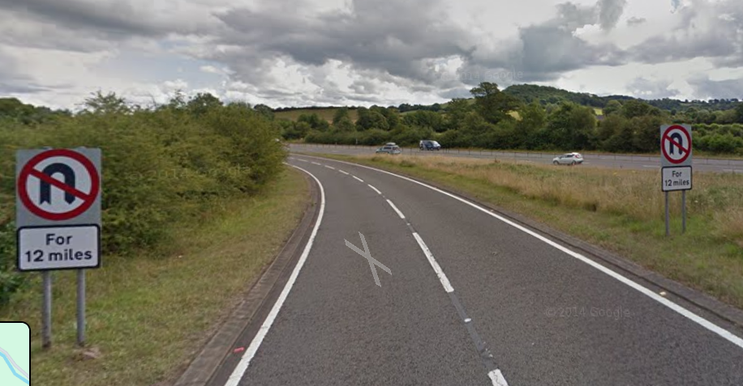  Affixed to legs of No U turn sign on the left or on “spikes” nearby. Preferably the left-hand side of lane.

