Northover's VT
Sponsored by Rudy Project

Present their

Easter 2Up 10 Mile Time Trials
Event Sponsored by:
Yellow Ltd
Rudy Project

Monday April 17th 2017

Course S26R/10

HQ Feniton Village Hall
Feniton, Nr Honiton

(Promoted for and on behalf of Cycling Time Trials under
their rules and Regulations)

IN THE INTEREST OF YOUR OWN SAFETY, Cycling Time Trials and the event Promoters strongly advise you to wear a HARD SHELL HELMET that meets an internationally accepted safety standard.

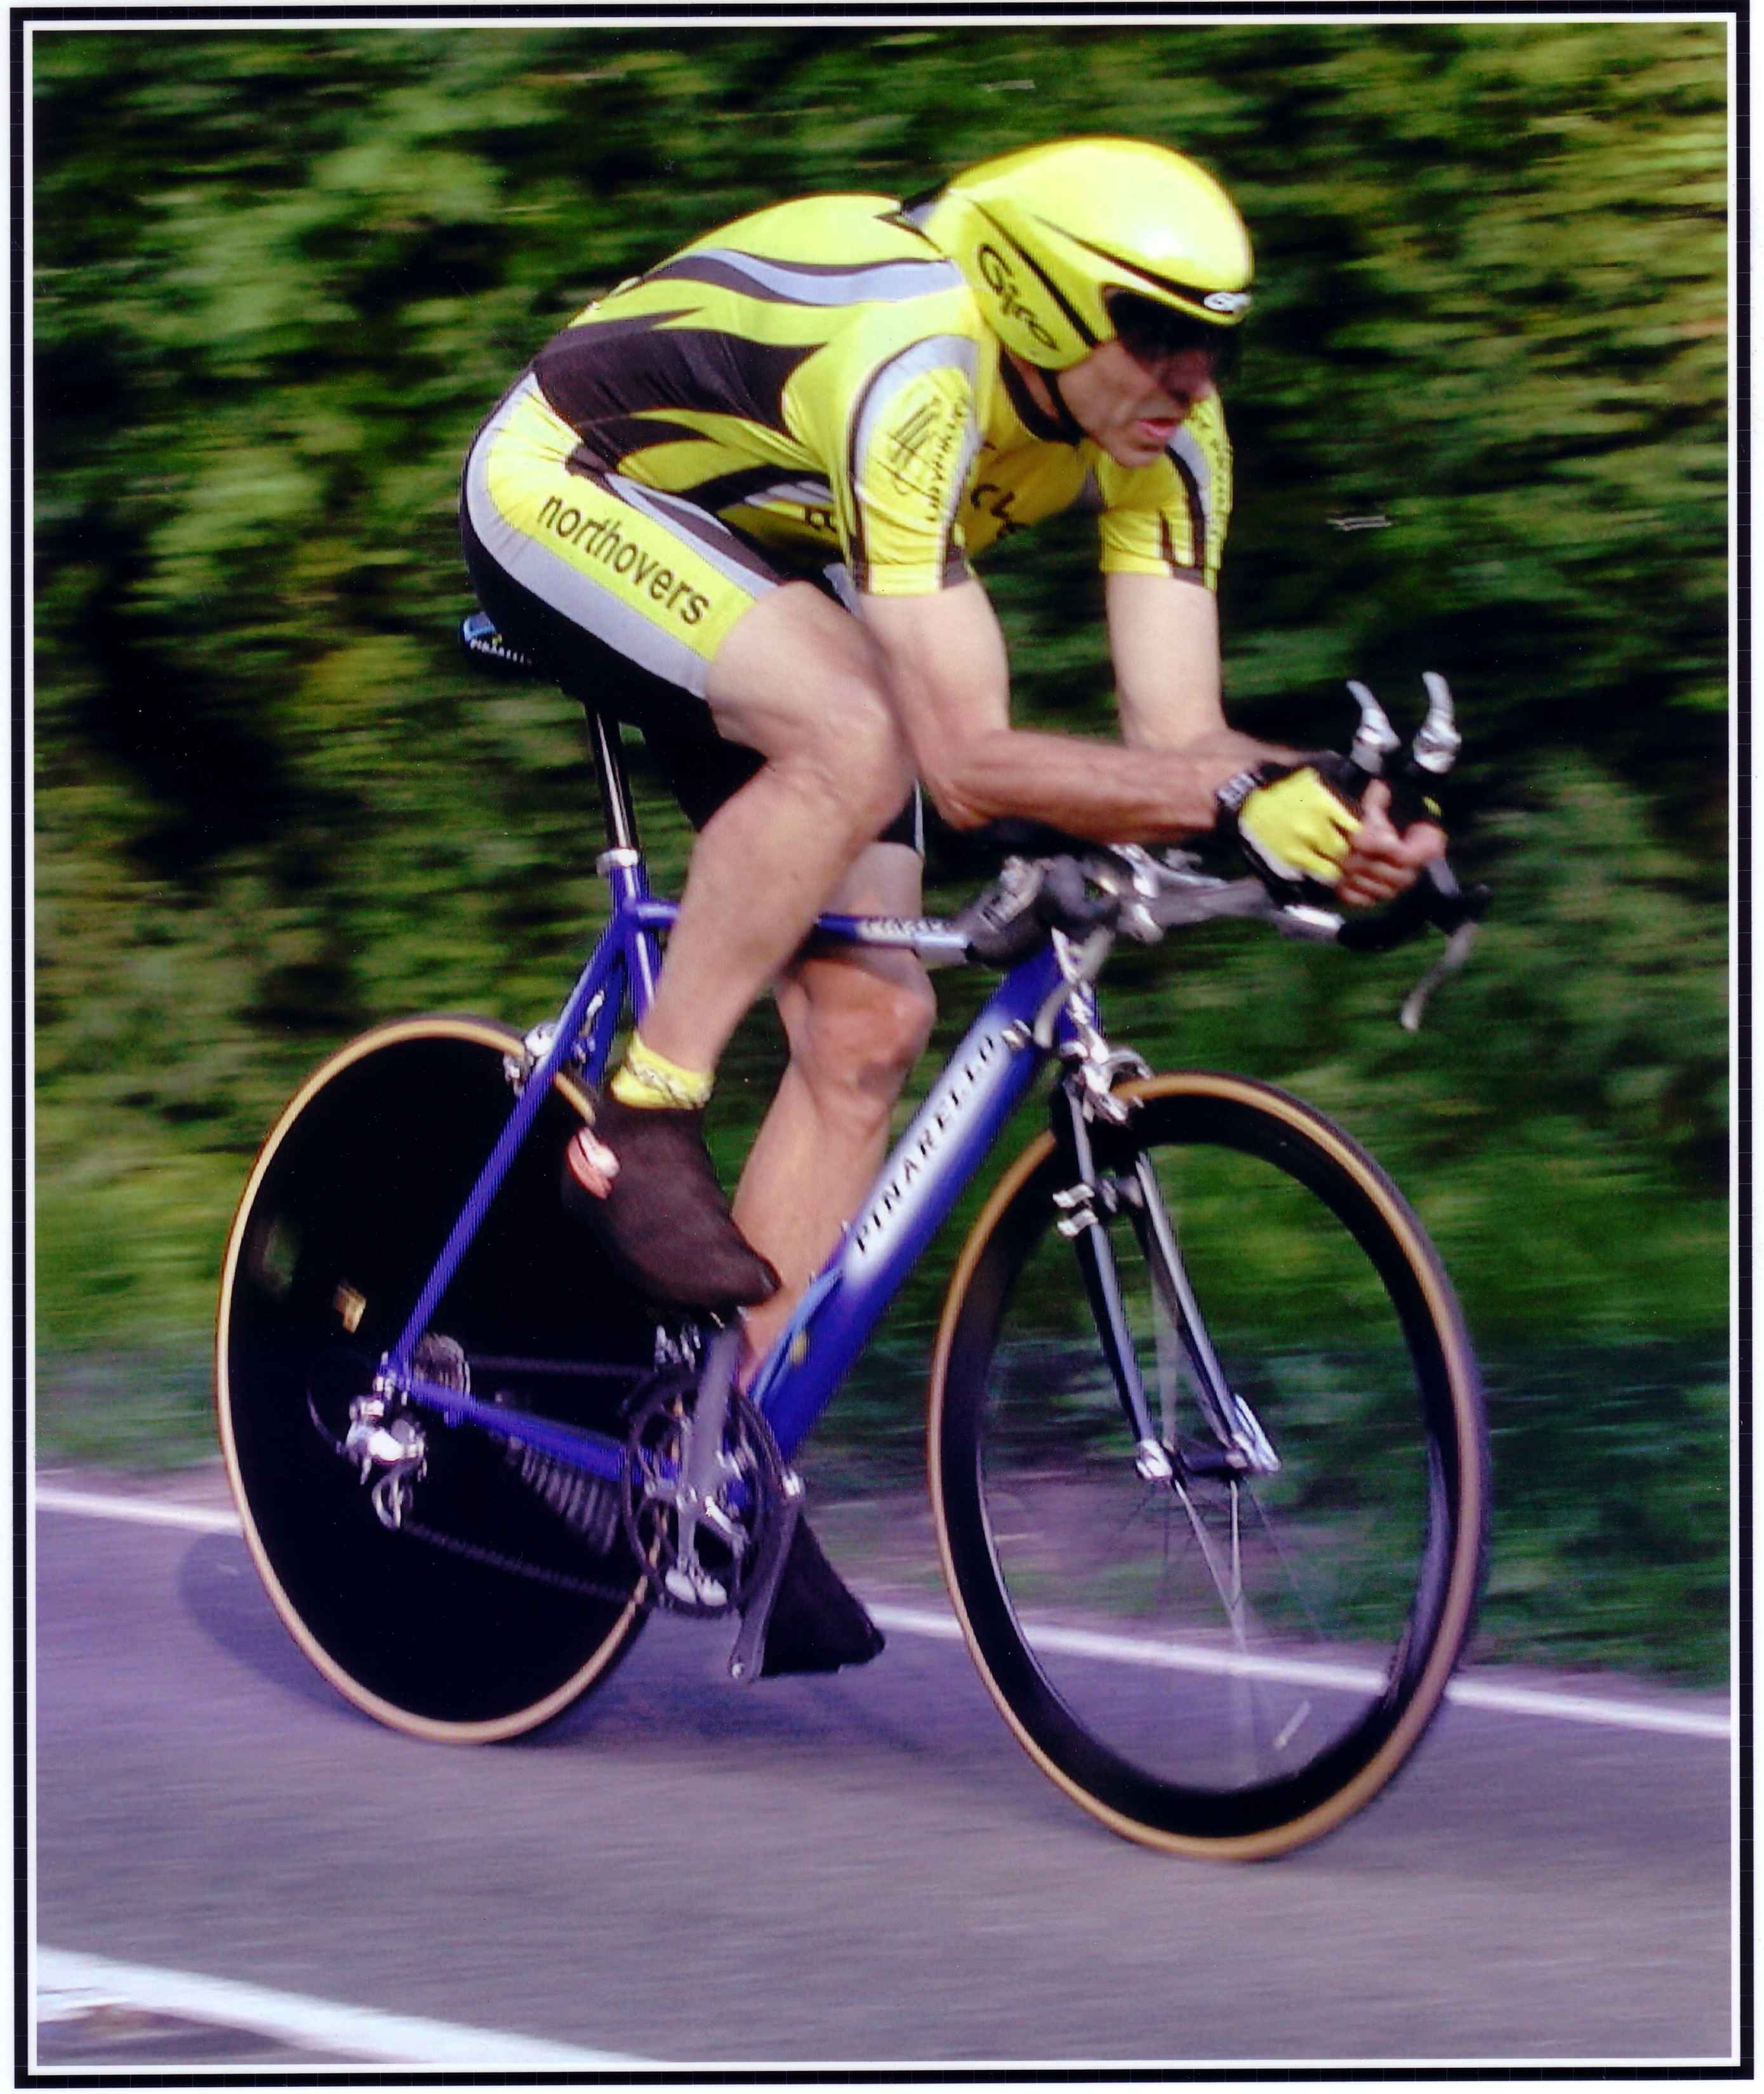

This Northover’s VT 10 Mile Solo & 2up TT is organised in memory of
our team-mate and good friend Bob Redrup.
who passed away unexpectedly on 26 September 2003 whilst on a training ride with the team prior to the Duo Normandy in Marigny, France.

Easter Solo & 2Up 10 Mile Time Trial
Results

Prize List - Solo
1st £35 – Matt Slater Revo Racing 20:17
2nd £25 – Conrad Moss – Mid Devon CC 20:21
3rd £15 - Liam Bard Revo Racing 20 :50
4th £10 - Jon Wynn Northover VT 20:51
5th £5 – Graham Collins 20:56
1st Vet 40+ £15 – James Tribbile Mid Devon CC 21:17
1st Vet 50+ £15 – Steve Hockings-Thompson Revo Racing 21:38
1st Vet 60+ £15 – Chris Scawn Plymouth Corinthians CC 22:41
1st Vet 70+ £15 – Ray Retter North Devon Wheelers 24:00
1st Junior £15 – George Kimper CS Dynamo 21:19

1st lady £35 – Lauren Dolan Liv CC 22:42
2nd Lady £25 – Pfieffer Georgi Liv CC 23:01
3rd Lady £15 – Natilie Grinczer
Lantern Rouge £20 - Doug Ward Yeovil CC 33:55
Lantern Rouge -1 £15 – Liz Hall North Devon Wheelers 18:22
Spot Prize 1 £10 – Darren Avery National Ventilation 26:19
Spot Prize 2 £10 – Jack Courtney Team Zoyland 27:28

Prize List – 2up
1st Club Team or Composite £35 - Northover VT Mark Ashurst / Tom Cox 21:58
2nd Club Team or Composite £25 – VC Equipe / VC St Raphael Nicki Carr / Steve Potts 22:47
3rd Club Team or Composite £15 Somerset Road Club Andrew and Daniel Wellings 24:03
4th Club Team or Composite £10 – Sid Valley CC Doug Parker / Mike Rose 24:03
Thanks

I would like to congratulate all the prize winners and hope to see you all back next year. It will again be Easter Monday 2018, the hall is booked already!

Thanks must also go to the timekeepers Andy Greatwood & Angie Nicholls. The lonely lady in the kitchen serviing refreshments, Lesley Pollard. My wife Rosemary who could not be with us this year due to a back problem, but still managed to help me sort out all the cakes. Ray and Lesley for additional shopping on Saturday!

Thanks to all the marshals in particular John Nicholls, we are only a small team and without help from others we could not put our bit back into the sport. Lastly thanks to all members of Northovers VT who helped in this promotion in particular, Ray Pollard, Jon Wynn, John Williams, Rick Johnston. Leigh Pinchen, Jay Durban, Simon & Dawn Coles, Dave Parsons

Finally thanks to anyone I have missed.

Tom Cox

