 | UNIVERSITY OF BATH CYCLING CLUB  3-Up Team Time Trial & BUCS Team Time Trial Championships  Course U601b – Saturday 29th April 2017  Promoted for and on behalf of Cycling Time Trials  under their Rules and Regulations

Event Headquarters
Tormarton Village Hall (GL9 1HU) - available from 0800.
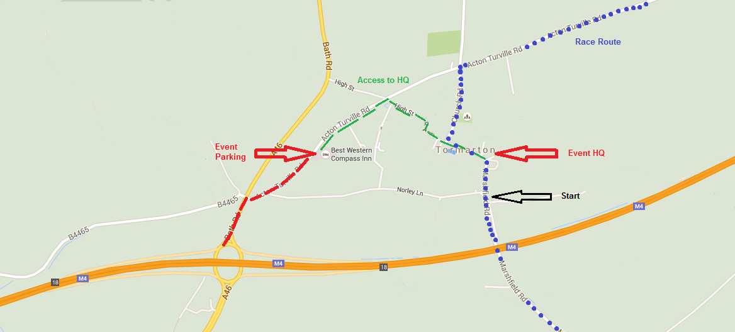
From the M4, exit at junction 18 (Signposted for Stroud), north on A46 towards Stroud. Take first right turn towards Tormarton. Tormarton Village is in the centre of the village (see map) beyond the Best Western Compass Inn (see parking). Please note, this is not the same HQ as was used for the event in 2015.
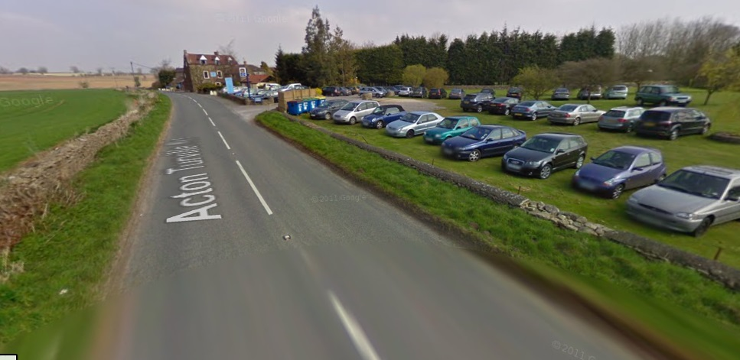
Parking
There is only limited parking at the Village Hall; the overflow carpark at the Best Western Compass Inn (see image) will be used as the main event parking for competitors. This is located on the right as you approach Tormarton village. Please park here and ride to the HQ (about 1km) rather than driving into and parking in the village as the main road through the village is on the race route. Please be aware that you are joining the race route before you reach the HQ, and teams on the race route have priority over you. Please keep left on the race route so as to not obstruct teams that are racing. Under no circumstances should you park on the race route within Tormarton village. Please do not park near the start as this may disturb the residents on this part of the route.

Course Details
To the START. Turn LEFT out of the HQ onto Marshfield Road. The start is located in the layby on your left approximately 200m from the HQ. Please be aware that you are on the race route and you should avoid obstructing the course for teams racing by keeping to the left.
Head south on Marshfield Road to Shire Hill. Beware: As you join road, teams who are racing may be passing the start on their way to the finish.
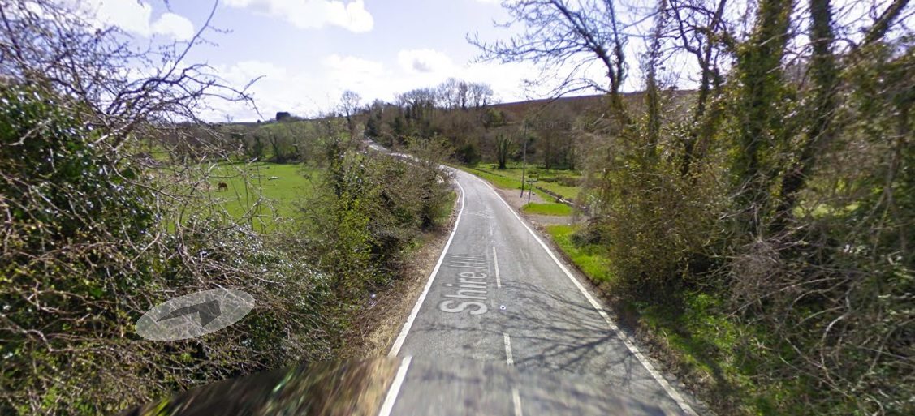
Descend into Broadmead Brook. Beware: Road is narrow on the fast descent and approaching vehicles may be in centre of road. You should endeavor to keep to the left hand side of the road but should be aware of the broken road surface on the left hand gutter at the bottom of the hill. (see image)

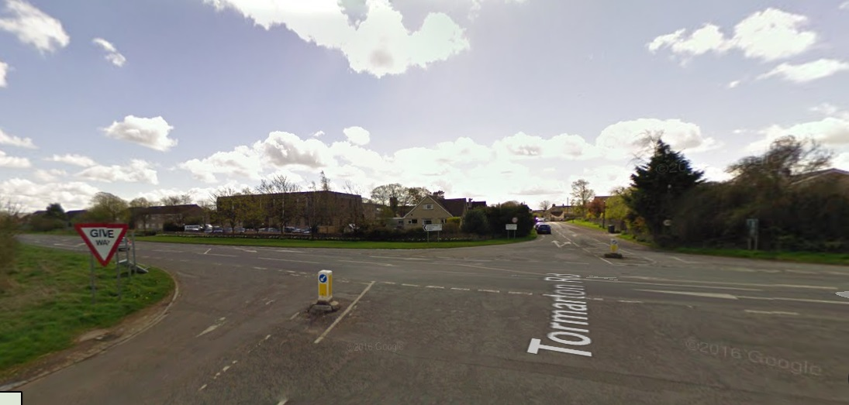
Continue on Tormarton Road to junction with the A420.

Turn left onto A420 towards Chippenham. Beware: You are joining a main road and must give way to approaching traffic. Keep to the left hand side as you join the A420. (see image)

Continue on A420 to the junction with the B4039.

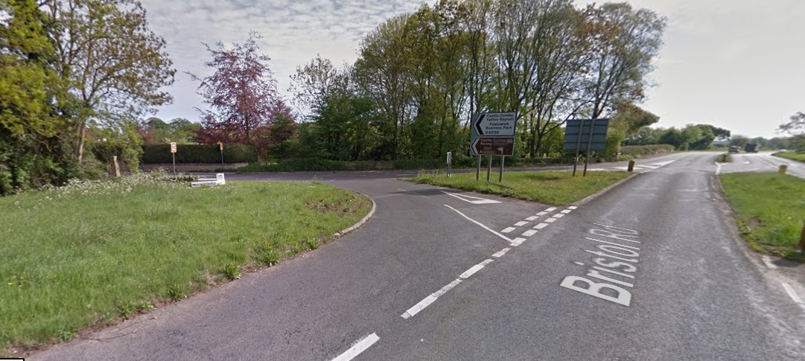
Turn sharp left onto B4039 towards Castle Combe. Beware: This is a tight corner, and you must give way to traffic coming from the right as you join the B4039. You should not cross the centre broken white line on the exit of the corner. Spotters and cameras will be located at this junction, and any teams that cross the broken white line will be penalized – up to and including disqualification. (see image)
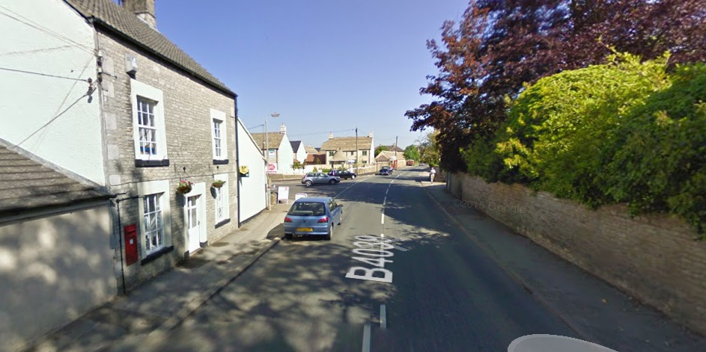
Continue on B4039 through Yatton Keynell to Acton Turville. Beware: Parked cars in Yatton Keynell. (see image)

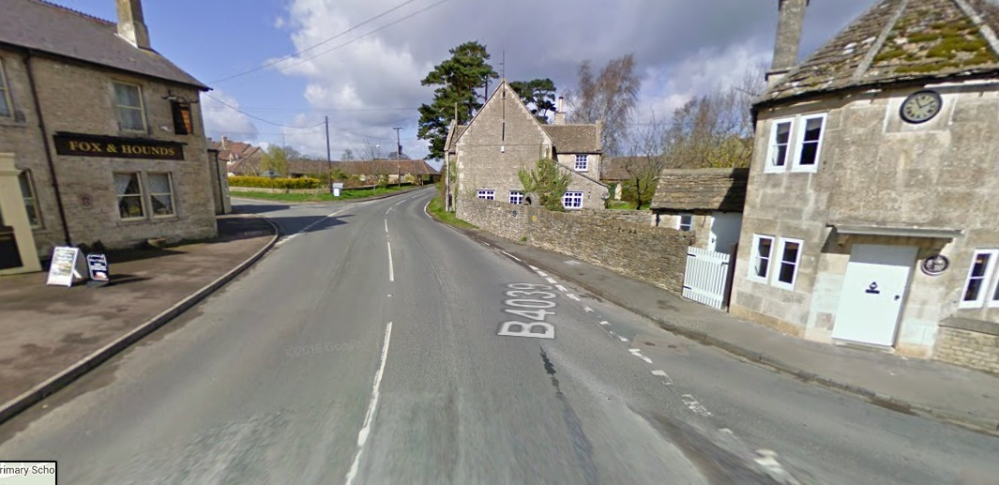
Turn left in Acton Turville onto Tormarton Road. Beware: The visibility for this corner is poor, and the road surface is broken. There is a post office just after the corner so there may be pedestrians. (see image)

Continue on Tormarton Road/Acton Turville Road to Tormarton village. Road Surface is broken in places.
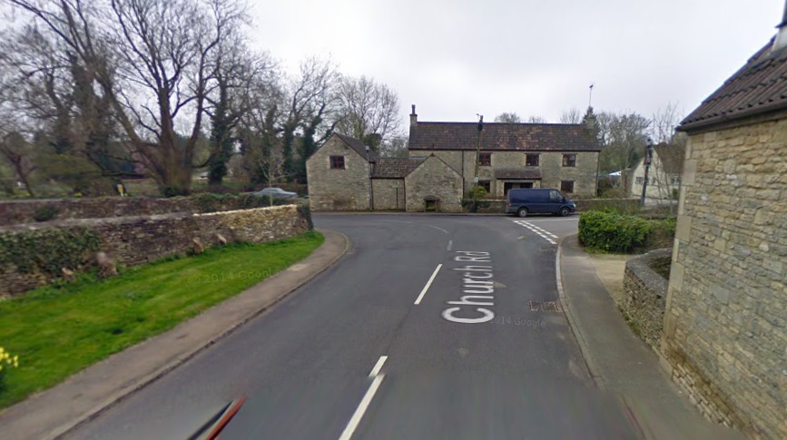
Turn left onto Church Road

Follow road round to the left through the village. Beware: Corner is blind, so keep left on exit of corner. Be aware of parked cars in village after the corner. (see image)

Pass the Start.
Descend into Broadmead Brook (for the second time). Beware: Road is narrow on the fast descent and approaching vehicles may be in centre of road. You should endeavor to keep to the left hand side of the road but should be aware of the broken road surface on the left hand gutter at the bottom of the hill.
Continue on Marshfield Road to the Finish.
Finish is located at the entrance to C.E. Davies site, approximately 300m before the junction with the A420. Please shout your number at the FINISH. After crossing the finish line, please be aware that you are still on the race route and teams who are still racing may be passing you. Continue beyond the finish to the cemetery on the left before the junction with the A420. You should turn around here and return to the HQ. Please do not perform U-turns whilst still on the main carriageway, please turn around at the cemetery.
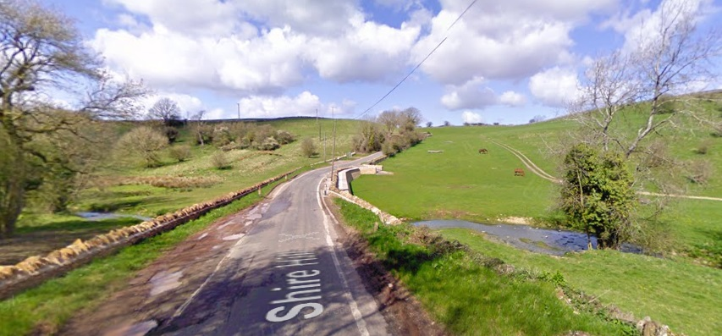
Whilst returning to the HQ, please keep to the left hand side of the road, especially on the descent to Broadmead Brook, as racing teams will be approaching you from the opposite direction. (see image)

Safety
The Police have requested that inconvenience to the public and other road users be kept to a minimum.
Riders are asked to take great care and, in particular, note the following points:
- To avoid congestion at the start please queue off the main road in single file.
- Please do not make ‘U’ turns at either the start or finish.
- Please be considerate to other road users including horses and riders.
- Please take extra care when joining the A420
- Please take care at all the junctions.
- Please be aware of the surroundings and other road users at the finish.
- With the condition of many roads across the country a concern, please be extra careful.
Dangerous riding will result in disqualification. Please keep your head up for a safe ride. Cycling Time Trials recommends that competitors wear a hard shell helmet that meets an internationally accepted safety standard. All junior/juvenile riders MUST wear Protective Hard Shell Helmets.

Numbers
Race numbers will be available from the HQ. A drink will be available at HQ on return of your number. Please do not wear cycling shoes in the main hall.

Signing on
All competitors are required to sign on before the start. The signing-on sheets will be in the HQ.

Competitors clothing
To assist the timekeepers and other officials, riders from each team should wear similar jerseys. This is particularly important for riders in composite teams.
Prizes (Open TTT only)
3 Up Team Time Trial
Fastest team overall £60
Second fastest team overall £30

Fastest Female team £60

Fastest Juvenile team £30

Fastest Espoir team £30

Fastest Veteran team £30

N.B. Teams must include at least one rider from the category to be eligible for the prize for that category. Teams must be present at prize giving after the event to receive their prize. One prize per team.

Event Secretary
Felix Young
82 Cotswold Road, Bath, BA2 2DN
Mob: 07709718572

Timekeepers
Dennis Davis, Sheila Edwards and Sue Andrews

Course Map & Profile
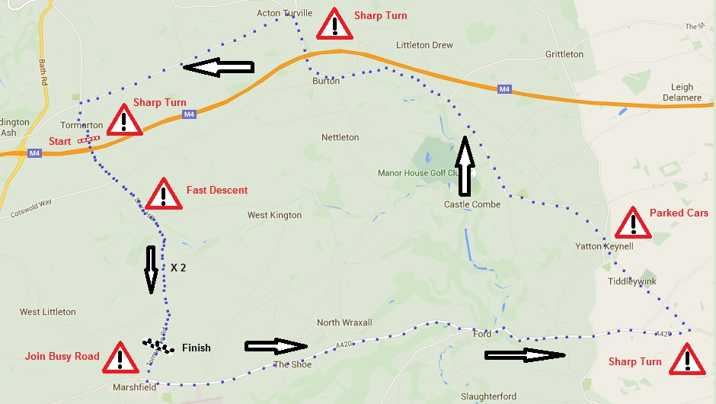
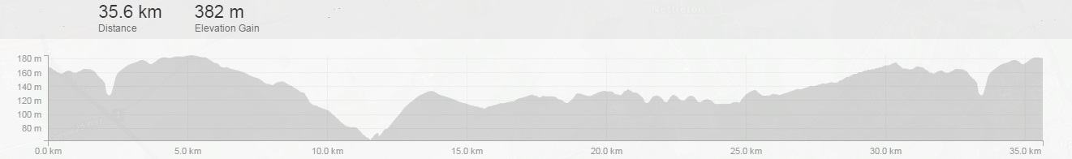

Open 3-Up Team Time Trial

NUMBER | START TIME | NAME | TEAM | CAT
1 | 0931 | Emma McKie | University of Bath Cycling Club | F-Esp
2 |  | Charli Lamb | University of Bath Cycling Club | F-Esp
3 |  | Emily Stewart | University of Bath Cycling Club | F-Esp
4 | 0934 | Damian Morley | Salt and Sham Cycling Club | M-Vet
5 |  | Richard Nelson | Salt and Sham Cycling Club | M-Vet
6 |  | Jamie Smith | Salt and Sham Cycling Club | M-Vet
7 | 0937 | Haydn Gill | University of Bath Cycling Club | M-Esp
8 |  | Jemima Cooper | University of Bath Cycling Club | F-Esp
9 |  | Chloe White | University of Bath Cycling Club | F-Esp
10 | 0940 | Matthew Butters | Velo Club Walcot | M-Vet
11 |  | Sam Butters | Sulis Scorpions YCA | M-Juv
12 |  | Edward Tucker | Sulis Scorpions YCA | M-Vet
13 | 0943 | Alan Adams | University of Bath Cycling Club | M-Esp
14 |  | Tom Allport | University of Bath Cycling Club | M-Esp
15 |  | Ben Phillips | University of Bath Cycling Club | M-Esp
16 | 0946 | Tom McManners | Thames Valley Triathletes | M-Esp
17 |  | Tom Crawford | Bath Cycling Club | M-Esp
18 |  | Connor Waller | Penzance Wheelers | M-Esp
19 | 0949 | Laurence Boyce | University of Bath Cycling Club | M-Esp
20 |  | Ryan Oldam | University of Bath Cycling Club | M-Esp
21 |  | Andy Butler | University of Bath Cycling Club | M-Sen
22 | 0952 | Richard Bullett | Salt and Sham Cycling Club | M-Sen
23 |  | Jenson Harris | Salt and Sham Cycling Club | M-Juv
24 |  | Bryn Ruck | Bristol Cycling Development Squad | M-Juv
25 | 0955 | Eugene Cross | University of Sheffield Cycling Club | M-Esp
26 |  | Nicholas Clayton | University of Sheffield Cycling Club | M-Esp
27 |  | Joe Auty | University of Sheffield Cycling Club | M-Esp
28 | 0958 | Steven McGuigan | Bristol Road Club | M-Sen
29 |  | James Phillips | Bristol Road Club | M-Sen
30 |  | Phil Moyne | Props Cycling Club | M-Vet
31 | 1001 | Sophie Hewitson | University of Sheffield Cycling Club | F-Esp
32 |  | Amy MacFarlane | University of Sheffield Cycling Club | F-Sen
33 |  | Savannah Kelly | University of Sheffield Cycling Club | F-Esp
34 | 1004 | Patrick Clarke | University of Sheffield Cycling Club | M-Esp
35 |  | Archie Cross | Team B38/Underpin Racing | M-Sen
36 |  | Kieran Savage | Yorkshire Road Club | M-Esp
37 | 1007 | Elliot Davis | Team Tor 2000 (Kalas) | M-Vet
38 |  | John Hollier | Team Tor 2000 (Kalas) | M-Vet
39 |  | Joshua Gray | Team Tor 2000 (Kalas) | M-Sen
40 | 1010 | Daniel Collier | University of Sheffield Cycling Club | M-Esp
41 |  | Cameron Taylor | University of Sheffield Cycling Club | M-Sen
42 |  | Will Powell | University of Sheffield Cycling Club | M-Esp
43 | 1013 | James Coleman | DRK Racing | M-Sen
44 |  | Tavis Walker | DRK Racing | M-Sen
45 |  | Charles Coleman | DRK Racing | M-Sen
46 | 1016 | Sean Davenport | University of Sheffield Cycling Club | M-Esp
47 |  | Max McMurdo | SSLL Racing Team | M-Esp
48 |  | Robert Telford | Veloton | M-Sen
49 | 1019 | Harry Tucker | Sulis Scorpions YCA | M-Juv
50 |  | Josh Lacey | Sulis Scorpions YCA | M-Jun
51 |  | Nick Cornish | University of Bath Cycling Club | M-Esp

Men’s BUCS 3-Up Team Time Trial – Morning Session

NUMBER | START TIME | NAME | TEAM | CAT
52 | 1022 | Oliver Bent | Oxford University
53 |  | Angus Fisk | Oxford University
54 |  | Bryn Davies | Oxford University
55 | 1025 | Tom Collins | University of Bath
56 |  | Harvey Thomas Phillips | University of Bath
57 |  | Nick Tyrie | University of Bath
58 | 1028 | Niall Dickin | University of Southampton
59 |  | Oliver Handley | University of Southampton
60 |  | Rhys Thomas | University of Southampton
61 | 1031 | Liam Allcock | Swansea University
62 |  | Ben Kent | Swansea University
63 |  | Bryn Tawton | Swansea University
64 | 1034 | Kieran Howarth | University of Bristol
65 |  | Andrew Kirby | University of Bristol
66 |  | Ben Alexander | University of Bristol
67 | 1037 | Sam Chandler | University of Warwick
68 |  | Doug Heynderickx | University of Warwick
69 |  | Dominic Smyth | University of Warwick
70 | 1040 | Josh Long | Oxford University
71 |  | Alexander Rowe-Lowes | Oxford University
72 |  | Toby Adkins | Oxford University
73 | 1043 | Harrison Knight | University of Plymouth
74 |  | Matthew Fallon | University of Plymouth
75 |  | Harry Jenkins | University of Plymouth
76 | 1046 | Pete Douglass | University of Southampton
77 |  | Chris McGovern | University of Southampton
78 |  | Tom Ellis | University of Southampton
79 | 1049 | Kacper Gorski | Swansea University
80 |  | Joseph Bailey | Swansea University
81 |  | David Shillabeer | Swansea University
82 | 1052 | Bede Constantinides | University of Manchester
83 |  | Chris Walkinshaw | University of Manchester
84 |  | Oliver Wade | University of Manchester
85 | 1055 | Mark Ellis | University of Bristol
86 |  | Mark Blyth | University of Bristol
87 |  | Joe Hawksworth | University of Bristol
88 | 1058 | Jack Taylor | Nottingham Trent University
89 |  | Paddy Callaghan | Nottingham Trent University
90 |  | Ben Hudson | Nottingham Trent University

Men’s BUCS 3-Up Team Time Trial – Afternoon Session
NUMBER | START TIME | Name | TEAM | CAT
1 | 1331 | Alex Pierce | University of Manchester
2 |  | Joss Bennett | University of Manchester
3 |  | Max Rose | University of Manchester
4 | 1334 | Joe Morrow | Oxford University
5 |  | Vincenzo Pratley | Oxford University
6 |  | Jack Brent | Oxford University
7 | 1337 | Fred Phillips | University of Southampton
8 |  | Scott Michaels | University of Southampton
9 |  | Harry Chamberlain | University of Southampton
10 | 1340 | Thomas Weir | Swansea University
11 |  | Peter Barlow | Swansea University
12 |  | Ayrton Peel | Swansea University
13 | 1343 | Alistair Golby | University of Cambridge
14 |  | Oliver Mytton | University of Cambridge
15 |  | Rob Walker | University of Cambridge
16 | 1346 | Will Robson | University of Plymouth
17 |  | Chris Dawson | University of Plymouth
18 |  | Michael Lewis | University of Plymouth
19 | 1349 | Joshua Andrews | University of East Anglia
20 |  | Robin White | University of East Anglia
21 |  | Tom Yiangou | University of East Anglia
22 | 1352 | Carlisle King | Imperial College London
23 |  | Rowan Brackston | Imperial College London
24 |  | Ayoob Ghani | Imperial College London
25 | 1355 | John Brett | University of Manchester
26 |  | Jamie Wiley | University of Manchester
27 |  | Oscar Twinning | University of Manchester
28 | 1358 | Jack Barber | Nottingham Trent University
29 |  | Peter Sibley | Nottingham Trent University
30 |  | Matteo Stainer | Nottingham Trent University
31 | 1401 | Dafydd Rhys Thomas | Cardiff University
32 |  | Matthew Newell | Cardiff University
33 |  | Ben Griffiths | Cardiff University
34 | 1404 | Jack O'Neill | University of Warwick
35 |  | Jamie Howarth | University of Warwick
36 |  | Jude Taylor | University of Warwick
37 | 1407 | Karl Baillie | University of Derby
38 |  | Edward O'Connell | University of Derby
39 |  | Will Perrett | University of Derby
40 | 1410 | Dewi Lord | University of Liverpool
41 |  | Dan Merriman | University of Liverpool
42 |  | Joe Gilbody | University of Liverpool
43 | 1413 | Tom Southey | University of Nottingham
44 |  | Chau Du | University of Nottingham
45 |  | Cong Ying Hey | University of Nottingham
46 | 1416 | William Sloper | King's College London
47 |  | Bernard Harrington-Voigt | King's College London
48 |  | Elliott Merritt | King's College London
49 | 1419 | Jack Bartle | University of the West of England (UWE)
50 |  | Louis Salisbury | University of the West of England (UWE)
51 |  | Luke Alexandre | University of the West of England (UWE)
52 | 1422 | Cam Miles | Loughborough University
53 |  | Harry Lock | Loughborough University
54 |  | Sam Roper | Loughborough University
55 | 1425 | Jonny Brown | St George's, University of London
56 |  | Dan Powers | St George's, University of London
57 |  | Tom Shaw | St George's, University of London
58 | 1428 | Harry Brook-Dobson | University of Bath
59 |  | Dan Martin | University of Bath
60 |  | Oli Cooper | University of Bath
61 | 1431 | Oscar Sinfield | University of Liverpool
62 |  | Dominic Skinner | University of Liverpool
63 |  | Tom Hill | University of Liverpool
64 | 1434 | Mark Goodhead | University of Birmingham
65 |  | Mark Alston | University of Birmingham
66 |  | Maxwell Cameron-Jones | University of Birmingham
67 | 1437 | Hugo MacMillan | Durham University
68 |  | Callum Stewart | Durham University
69 |  | Rory MacMillan | Durham University
70 | 1440 | Daniel Joyce | Swansea University
71 |  | Benjamin Tanner | Swansea University
72 |  | Jamie Williams | Swansea University
73 | 1443 | Nicholas Onyett | University of Chester
74 |  | Kieran Wynne-Cattanach | University of Chester
75 |  | Mark Allen | University of Chester
76 | 1446 | Cameron Toms | University of Bristol
77 |  | Chris Parker | University of Bristol
78 |  | Oliver Walker-Hayes | University of Bristol
79 | 1449 | Ben Millar | Cardiff University
80 |  | Oliver Blagden | Cardiff University
81 |  | Sion Harlow | Cardiff University
82 | 1452 | George Charles | University of Plymouth
83 |  | Oliver Parsons | University of Plymouth
84 |  | Michael Hoare | University of Plymouth
85 | 1455 | Harold Bradbury | University of Cambridge
86 |  | Sebastian Dickson | University of Cambridge
87 |  | John Mulvey | University of Cambridge
88 | 1458 | Tom Ward | Loughborough University
89 |  | George Rowlands | Loughborough University
90 |  | Peter Hitt | Loughborough University

Women’s BUCS 3-Up Team Time Trial
NUMBER | START TIME | NAME | TEAM | CAT
31 | 1531 | Martha King | University of Bristol
32 |  | Adele Coupland | University of Bristol
33 |  | Rebekah Nash | University of Bristol
34 | 1534 | Charlotte Brass | Cardiff University
35 |  | Gwynon Williams | Cardiff University
36 |  | Elizabeth Robertson | Cardiff University
37 | 1537 | Hannah Evans | University of Cambridge
38 |  | Holly Knox | University of Cambridge
39 |  | Emilie Lostis | University of Cambridge
40 | 1540 | Fran Bromley | University of Bath
41 |  | Amelia Mitchell | University of Bath
42 |  | Molly Hodges | University of Bath
43 | 1543 | Mimi Harrison | Oxford University
44 |  | Cyndi Goh | Oxford University
45 |  | Eleanor Law | Oxford University
46 | 1546 | Kathryn Hill | Durham University
47 |  | Victoria Duncan | Durham University
48 |  | Mari Cole | Durham University
49 | 1549 | Alicia Love | University of Liverpool
50 |  | Anna Lawther | University of Liverpool
51 |  | Eleri James | University of Liverpool
52 | 1552 | Isabella Wild | University of Nottingham
53 |  | Laura Owler | University of Nottingham
54 |  | Hannah Gibbs | University of Nottingham
55 | 1555 | Karishma Patel | University of Warwick
56 |  | Eleanor Jones | University of Warwick
57 |  | Isobel Taylor | University of Warwick
58 | 1558 | Heather Douglas | Loughborough University
59 |  | Francesca Hall | Loughborough University
60 |  | Abigail Carter | Loughborough University
61 | 1501 | Lauren Jakeman | University of Manchester
62 |  | Amy Pearce | University of Manchester
63 |  | Ellie Roberts | University of Manchester
64 | 1504 | Anna Morris | Loughborough University
65 |  | Ellie Cooper | Loughborough University
66 |  | Zoe Chandler | Loughborough University
67 | 1507 | Becca Stubbs | University of Bristol
68 |  | Beth Rolf | University of Bristol
69 |  | Meg Dickerson | University of Bristol
70 | 1610 | Sophie Lankford | Cardiff University
71 |  | Jasmine Jones | Cardiff University
72 |  | Jade Payne | Cardiff University
73 | 1613 | Jane Brooks | University of Plymouth
74 |  | Paige Wills | University of Plymouth
75 |  | Lucy Walker | University of Plymouth
76 | 1616 | Jess Atkinson | University of Cambridge
77 |  | Lottie Mallin-Martin | University of Cambridge
78 |  | Joy Lisney | University of Cambridge
79 | 1619 | Kate Baker | University of Bath
80 |  | Lucy Scott | University of Bath
81 |  | Ashia Fenwick | University of Bath

