
Brighton Excelsior
Time Trial
Weekend

Men, Women, Juniors 25 mile event
on
Sunday 17th July 2016 starting at 7.00 am.
Course G25/93
HQ: The Steyning Centre, Fletcher's Croft, Steyning W Sussex. BN44 3XZ.

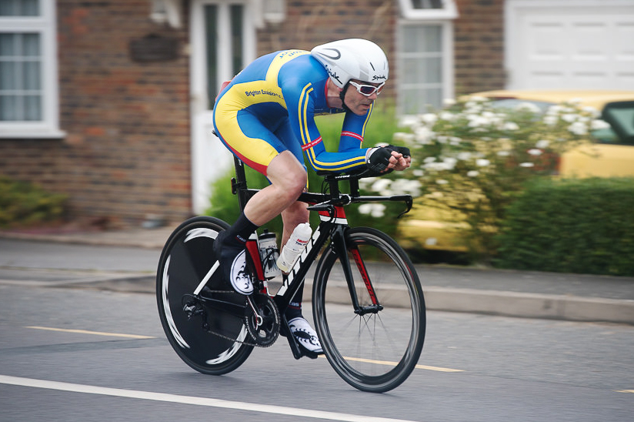
Tom Houghton Brighton Excelsior CC

For and on behalf of Cycling Time Trials under their Rules & Regulations
Event organiser
Bob Harber; 51 Church Lane Upper Beeding Steyning, W Sussex BN44 3HP.
Tel 01903 879598 and 07979 836259
Email bikerider@phonecoop.coop

Timekeepers
Start: Mick Irons, Worthing Excelsior Finish: Mick Kilby, Lewes Wanderers

Course details
Course G25/93
START on B2135 just south of entrance to Wappingthorn Manor (Map ref TQ 172131)
Proceed north on the B2135 through Partridge Green to junction with A24 (6.71 miles)
Turn LEFT and proceed southwards on the A24 to Washington Roundabout (12.52 miles)
Turn LEFT on A283 and proceed east, via Bramber and Beeding Court Roundabout to
TURN at Adur Bridge RBT (Adur Flyover A27) (20.99 miles)
RETRACE on A283 via Beeding Court and Bramber Roundabouts to
FINISH 25 yards before Canons Way. (Map ref TQ 181118) (25.00 miles).
MAP: http://www.sussexca.org.uk/g2593.html

Notes to competitors
- At HQ, please read the course risk notice adjacent to the signing-on sheet, for up to date information about the course
- Numbers will be at the signing-on sheet in the HQ
- No cycling shoes in the HQ
- It is recommended that a working rear light, either flashing or constant, is fitted to the machine in a position clearly visible to following road users and is active while the machine is in use
- Please be respectful to the neighbours in the vicinity of the HQ.
- Use the HQ wc’s
- We suggest that you allow approximately 15 minutes to ride to the start from the HQ.
- Please do not block the entrance to Wappingthorn Manor Farm at the Start which is regularly used
- No times will be given at the finish. On finishing riders should continue to Horsham Rd and turn left into Steyning and return to the Hall
- No U-turns are to be made within sight of the timekeepers
- CTT regulations require the compulsory use of helmets for riders under 18 years old. In the interests of your own safety, Cycling Time Trials and the event promoters strongly advise all competitors to wear a hard shell helmet that meets internationally accepted safety standards.

Awards
 |  | 25 miles | Combined 10+25
Women | 1st | £30.00 | £20.00
Men | 1st  2nd  3rd | £40.00  £30.00  £20.00 | £20.00
Veterans | 1st  2nd  3rd | £20.00  £15.00  £10.00
Team (3 Riders) | 1st | £15.00 each
Start list of riders
Race No. | start time
1 | 7.01 | Martin | Naylor | Brighton Excelsior CC | M | V
2 | 7.02 | Martin | Booker | Worthing Excelsior CC | M | V
3 | 7.03 | Richard | Moult | Brighton Mitre CC | M | S
4 | 7.04 | Stuart | Payne | Central Sussex CC | M | V
5 | 7.05 | Chris | Lord | Brighton Excelsior CC | M | V
6 | 7.06 | David | Clark | Eastbourne Rovers CC | M | V
7 | 7.07 | Kevin | James | Crawley Wheelers | M | V
8 | 7.08 | Colin | Toppin | Brighton Excelsior CC | M | V
9 | 7.09 | David | Bridle | Southdown Velo | M | V
10 | 7.10 | Hamish | Walker | Blazing Saddles | M | V
11 | 7.11 | Jack | Churchill | Brighton Excelsior CC | M | Jv
12 | 7.12 | Colin | Barton | Worthing Excelsior CC | M | V
13 | 7.13 | Adrian | Bennett | Crawley Wheelers | M | V
14 | 7.14 | Alan | Coom | Brighton Excelsior CC | M | S
15 | 7.15 | Pete | Morris | Team ASL360 | M | S
16 | 7.16 | Trevor | Chilman | In-Gear Quickvit Trainsharp RT | M | V
17 | 7.17 | Bryn | Reeves | Horsham Cycling | M | V
18 | 7.18 | Nick | Martin | East Grinstead CC | M | Jn
19 | 7.19 | Chris | Boocock | Sussex Nomads CC | M | V
20 | 7.20 | Mark | Emsley | Team ASL360 | M | S
21 | 7.21 | Erica | Martin | Eastbourne Rovers CC | F | S
22 | 7.22 | Kathryn | Parkin | East Grinstead Tri Club | F | S
23 | 7.23 | Sarah | Phelps | Brighton Mitre CC | F | S
24 | 7.24 | Gina | McGeever | Lewes Wanderers CC | F | V
25 | 7.25 | Katie | Crowe | Dulwich Paragon CC | F | V
26 | 7.26 | James | Horan | South Downs Bikes/ Casco Europe | M | V
27 | 7.27 | Andrew | Seltzer | In-Gear Quickvit Trainsharp RT | M | V
28 | 7.28 | Ian | Cheesman | Worthing Excelsior CC | M | V
29 | 7.29 | Lee | McGeever | Brighton Excelsior CC | M | V
30 | 7.30 | Simon | McNamara | South Downs Bikes/ Casco Europe | M | V
31 | 7.31 | Robert | Charles | Blazing Saddles | M | V
32 | 7.32 | Conor | Clancy | Brighton Excelsior CC | M | S
33 | 7.33 | David | Le Petit | Dorking Cycling Club | M | V
34 | 7.34 | Neil | Crowther | Worthing Excelsior CC | M | V
35 | 7.35 | Howard | Bayley | Blazing Saddles | M | V
36 | 7.36 | Iain | Brogden | Eastbourne Rovers CC | M | V
37 | 7.37 | Michael | Thyer | Sussex Nomads CC | M | V
38 | 7.38 | Jon | Fairclough | Woking CC | M | V
39 | 7.39 | Anthony | Vince | Mid Sussex Tri Club | M | S
40 | 7.40 | Chris | McNamara | Nuun-Sigma Sport-London RT | M | V
cont ...
41 | 7.41 | Jack | Donaldson | Neon Velo | M | S
42 | 7.42 | Ivor | Hewitt | Oxted CC | M | V
43 | 7.43 | Simon | Underwood | CC Topp | M | V
44 | 7.44 | Andrew | Haste | Worthing Excelsior CC | M | V
45 | 7.45 | Brian | Molloy | Brighton Excelsior CC | M | V
46 | 7.46 | John | Tindell | Brighton Phoenix Tri Club | M | S
47 | 7.47 | Matthew | Butt | Team ASL360 | M | S
48 | 7.48 | Laurence | Toombs | West Kent RC | M | V
49 | 7.49 | Clive | Jackson | Central Sussex CC | M | V
50 | 7.50 | Christian | Yates | East Grinstead CC | M | V
51 | 7.51 | John | Powell | Team ASL360 | M | S
52 | 7.52 | James | Stone | Brighton Excelsior CC | M | V
53 | 7.53 | Trace | Harris | Brighton Triathlon Club | M | V
54 | 7.54 | Peter | Owen | Norwood Paragon CC | M | V
55 | 7.55 | Steve | Kane | Brighton Excelsior CC | M | S
56 | 7.56 | Kevin | Plummer | South Downs Bikes/Casco Europe | M | V
57 | 7.57 | Donald | Parker | Brighton Mitre CC | M | V
58 | 7.58 | Tom | Pritchard | Hampshire RC | M | S
59 | 7.59 | James | Woodward | Sussex Revolution VC | M | S
60 | 8.00 | Howard | Shaw | Eastbourne Rovers CC | M | S
61 | 8.01 | Philip | Murrell | Finsbury Park CC | M | V
62 | 8.02 | James | Rix | Crawley Wheelers | M | V

