Promoted for and on behalf of Cycling Time Trials under their Rules and Regulations

Birdwell Wheelers Open 25 Mile Time Trial
Saturday 29th April 2017

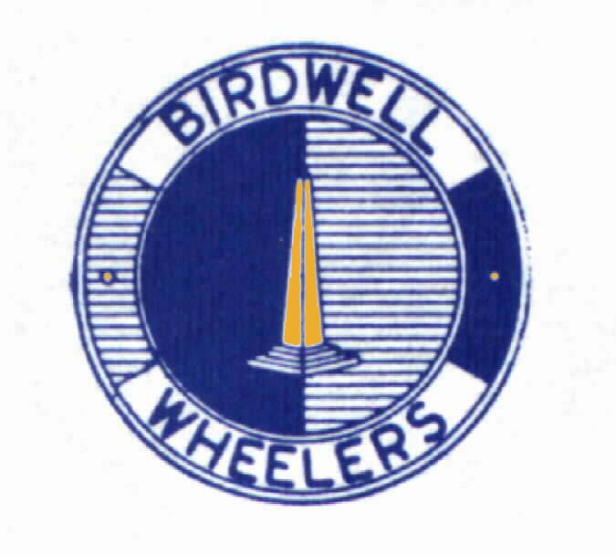
Event Secretary:
Paul Heggie 10 Wellfield Road BARNSLEY S75 2AL

Timekeepers: Philip Minto Jan Wilson

South Yorkshire Times Trophy :Philip Graves

1st Male Philip Graves £30 2nd Male Richard Sharp £20
3rd Male Dan Taylor £15
1st Woman £30 Ann Walsham 2nd Woman Emilie Verroken £20
3rd Woman Amy Ogden £15

Categories

1st Vet40-44 Anthony Bromley £10
1st Vet45-49 Tim Fearn £10
1st Vet50-59 Trevor Mayne £10
1st Vet60+ Stephen I Anson £10
1st U19 Harry Buxton £10

1st team
Birdwell Whs :Dan Taylor,Paul Mason,Trevor Mayne £30

Thanks to all the helpers without whose efforts the event would not have happened!

Roger Bacon Carol Booth Katie Booth Dave Cutts Shaun Dolby Jack Hollington John Langston Christine Minto Frank Minto Philip Minto Malcolm Wilson Jan Wilson Dave Wingfield John Woodhouse Dave Woodhouse Sue Woodhouse

Photos of the event may be found on Birdwell Wheelers Facebook page
https://www.facebook.com/groups/159188917476030/
Please acknowledge Rob Booth’s copyright if you use any of the photos.

1. | Philip Graves | NOPINZ | 0:51:51
2. | Richard Sharp | York Cycleworks | 0:54:18
3. | Dan Taylor | Birdwell Whs | 0:54:53
4. | Anthony Bromley | SSLL Racing Team | 0:55:09
5. | Harry Buxton | T.H.R.E. Datawolves R.T. | 0:55:34
6. | Jack Levick | Tuxford Clarion C C | 0:55:52
7. | Darryl Wall | Out of the Saddle CC | 0:55:55
8. | Nicholas Latimer | Rutland CC | 0:56:10
9. | Liam Golton | Selby CC | 0:56:26
10. | Andrew Cutts | Team Bottrill / HSS Hire | 0:56:45
11. | Trevor Mayne | Birdwell Whs | 0:57:01
12. | Mark Sayner | Featherstone RC | 0:57:27
13. | Paul Mason | Birdwell Whs | 0:57:34
14. | Richard Lunt | Rossington Whs CC | 0:57:37
15. | Tim Fearn | Langsett Cycles Race Team | 0:57:55
16. | Toby Wilson | Rutland CC | 0:58:25
17. | Daryl May | Sheffrec CC | 0:58:32
18. | Thomas Booth | Birdwell Whs | 0:58:42
19. | Alan Cooke | Peak RC | 0:58:46
20. | Colin Parkinson | South Western RC/Evans Cycles | 0:58:57
21. | James Darren Gough | Barnsley RC | 0:59:29
22. | Richard Hey | Holme Valley Whs | 0:59:44
23. | Stewart Smith | Stocksbridge CC/Full Gas Bikes/IM Solicitors | 1:00:43
24. | Steven Hollowood | Kiveton Park CC | 1:00:45
25. | Joe Howcroft | PH-MAS Cycling | 1:00:53
26. | Steven Bunting | Rutland CC | 1:01:13
27. | Ian Clarke | Tuxford Clarion C C | 1:01:22
28. | Lee Ibbitson | Stocksbridge CC/Full Gas Bikes/IMl Solicitors | 1:01:31
29. | Paul Mapletoft | Kiveton Park CC | 1:02:07
30. | Simon Holmes | Rutland CC | 1:02:09
31. | David Staniland | Sheffrec CC | 1:02:38
32. | Jake Morgan | Sheffrec CC | 1:02:57
33. | Ann Walsham W | Maxx R. T. | 1:03:39
34. | Stephen I'Anson | Buxton CC/Sett Valley Cycles | 1:03:46
35. | Emilie Verroken W | Maxx R. T. | 1:04:07
36. | Amy Ogden W | Tuxford Clarion C C | 1:04:12
37. | Anthony McNamara | Rockingham CC | 1:04:48
38. | Conor Salisbury | Rutland CC | 1:06:24
39. | Greg Godley | Birdwell Whs | 1:06:32
40. | Matt Bourne | Huddersfield Star Whs | 1:07:22
41. | David Bowen | Barnsley RC | 1:07:23
42. | Dave Fitzpatrick | Drighlington BC | 1:08:06
43. | Chico Taylor | Rutland CC | 1:08:29
44. | Michael Weaver | Rotherham Whs CC | 1:09:00
45. | Gary Thornton | Barnsley RC | 1:09:02
46. | David Bird | Barnsley RC | 1:09:08
47. | Andrew Gurnhill | Doncaster Whs C.C. | 1:09:48
48. | Lee Thortersen | Calder Clarion | 1:17:02
49. | Martin Turner | Holmfirth C C | DNS
49. | Carolyn Gaunt W | WCS Racing Team | DNS
49. | Robert Keyte | Team Cystic Fibrosis | DNS
49. | Andy Turner | Team Bottrill / HSS Hire | DNS
49. | Owyn Wallace | Doncaster Whs C.C. | DNS
49. | Nicky Green W | Albarosa CC | DNS
49. | Richard Wilkinson | Rutland CC | DNS
49. | Chris Bott | Harworth and District CC | DNS
49. | Julian Read | Team Swift | DNS
49. | John Gadie | Barton Whs CC | DNS
49. | Peter Barusevicus | Team KTM | DNS
49. | Craig Haslingden | Sheffield Tri Club | DNS
49. | John Haycock | Sheffrec CC | DNS
49. | Sarah Harrison W | Sheffield Tri Club | DNS
49. | Liam Bosley | Team PrimaVelo | DNS
49. | John Hatfield | Ravensthorpe CC | DNF
49. | Andrew Blades | Rutland CC | DNS

