 Reading CC David Gaida Memorial 50-Mile Time-Trial
Promoted by Reading CC for and on behalf of Cycling Time Trials under its Rules and Regulations
https://www.cyclingtimetrials.org.uk/articles/view/11
Sunday 19th May, starting at 08:01
Thank you for entering the 2024 Clive Pugh Memorial-Mile Time-Trial. Reading CC hopes to provide you with a friendly, competitive experience. Please follow the race protocols and respect the local residents and the guidance/decisions of the volunteer team at all times. Please note that the M4 westbound Jct 11 to Jct 12 has a planned carriageway closure on Sunday so check your journey to the event for potential delays.
This is the start-sheet cover note only. Start times are available on the CTT website.
Event Headquarters: Woolhampton Village Hall, Bath Road, Woolhampton, Reading, RG7 5RE
Sign on opens at 07:00
Distance from HQ to start: 0.3 miles
To reach the start exit the event HQ and turn right. Proceed for approx. 0.3 miles through the village. The start is located in the layby on the left just beyond the petrol station.
Parking Information: There is a small amount of parking available at the Event Headquarters. Further parking is available in the large Sunhill layby 0.5 miles east of the start. https://goo.gl/maps/h3UNi4d2JkT1iLU4A
Officials:
Event organiser: Karen Stuart-Smith, 07756082074
Timekeeper: Christina Gustafson, Reading CC
Your result will be calculated from your scheduled start time and not adjusted for a late start. Should you miss your start time please report it immediately to the start timekeeper/assistant so that your late penalty is as accurate as possible.
Marshals: Members of Reading Cycling Club
Before heading to the start remember your: number, helmet and working front and rear light. Remember to return your number and sign out before leaving.

Competitors are requested not to warm up on the course after the first competitor has started.
If you DNS/DNF please make the event organiser/HQ volunteers know so that our course marshals are aware

Course Description and Details: Riders are responsible for knowing the course and where to turn
The event will be held on the H50/1C course.

Start in the middle of the long layby immediately East of the Petrol Filling Station in the middle of Woolhampton, 10 metres west of lamp post WN27. SU578667 Exit the layby and head East along the A4. Go straight across the roundabout at the junction with the A340 1.7 miles SU603676 (care, traffic from the right) to a short dual carriageway. Continue past the dual carriageway to the large roundabout at Theale, junction of A4 and A340, 4.5 miles, SU632706. Circle the roundabout and retrace along the A4 to go straight across the A4/A340 junction/roundabout. Continue on through Woolhampton on A4 passing the start and exit the village (care light controlled pedestrian crossing).Continue on to the Kennet Park roundabout at the junction with Gables Way (Turn) 11.33 miles SU541668Circle the roundabout and retrace along the A4 to go straight across the A4/A340 junction (care, traffic from the right) to a short dual carriageway and on to the large roundabout at the junction with the A340. (Pangbourne Lane) (Turn) 18.17 miles SU632706.Repeat the above circuit (lap 2) between Pangbourne Lane and Kennet Park roundabouts. 31.84 miles.Repeat the above circuit (lap 3) between Pangbourne Lane and Kennet Park roundabouts. 45.5 miles.Circle the roundabout and take the fifth exit to retrace along the A4 westwards, go straight across the Aldermaston roundabout at the A4/A340 junction SU603676 Finish on the south side of the A4 directly opposite the start. 50 miles SU578667

​

Traffic Flows: The A4 is a busy main road linking Reading and Newbury. It is mainly single carriageway with some sections of dual carriageway. Traffic can build up during rush hours. Traffic conditions for this course are considered to be within the CTT guidelines subject to restrictions.

​
Course Map:
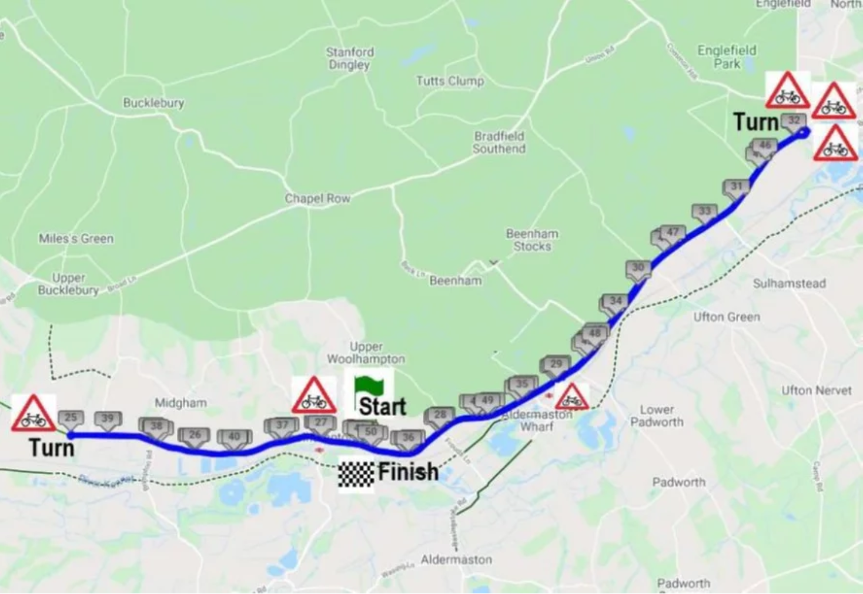
Details of any hazards not listed in this rider manual will be displayed or advised at the signing on point. All competitors must take note of these details when they sign on.
The start is in a large layby after the BP garage. When waiting to ride please wait in the layby safely until your number is called. Do not line up along the road and aim not to arrive at the start too early.
Marshals will be present at the key areas on the course to provide visible cues to drivers that an event is taking place, to indicate directions to riders and to be present in the case of an incident. Marshals are not authorised to direct or regulate the traffic. It is the rider’s responsibility for knowing the course and where to turn.
Riders are responsible for their own safety and are required to observe the law relating to road use.
There is a light controlled pedestrian crossing on the course in Woolhampton Village. The crossing is lightly used but riders must obey the lights and stop if required to do so.
On the approach to the turn roundabouts riders should check behind them and take the appropriate line to circle the roundabout safely. Signal clearly to other road users the course you intend to take. Always give priority to traffic from your right when negotiating roundabouts. When riding through narrow sections with central refuges, riders should be aware of traffic approaching from behind.
Please ride head up at all times and be mindful of the road conditions.
After finishing, riders should proceed to the headquarters and NOT stop at the FINISH.
Course Records:
Solo Open | Solo Female | Solo Open (Junior) | Solo Female (Junior) | Tandem
01:43:41 | 01:56:43 | - | - | -
Sebastian Dickson | Lizi Duncombe | - | - | -
16-May-21 | 16-May-21 | - | - | -

Results:

Results will be displayed at HQ as soon as possible after the event and will be available at the ResultSheet website by following the link https://resultsheet.app/rsd/1715701712850x858008664311595000
or QR code below.



Please do not approach the finish timekeeper at any point for any reason

Prize List:

 | 1st | 2nd | 3rd
Open | £30 | £20 | £15
Women | £30 | £20 | £15
Open Road Bike | £20 | £10
Female Road Bike | £20 | £10
Junior Open | £10
Junior Female | £10
Vet 40-49 Open | £10
Vet 40-49 Female | £10
Vet 50-59 Open | £10
Vet 50-59 Female | £10
Vet 60-69 Open | £10
Vet 60-69 Female | £10
Vet 70+ Open | £10
Vet 70+ Female | £10

There will be refreshments available for all competitors on number return and a brief prize presentation at approximately 11:15am
Road Bike Rules -
To be eligible for a prize in the road-bike category event please make sure your equipment complies with the following points (CTT criteria):
(a) The road bike can possess drop or straight handlebars; no tri-bars, clip-on bars or Spinaci bars are allowed; no disc wheels; both front & rear wheels must have at least 12 spokes each; the maximum rim depth allowed is 90mm.
(b) Helmets used in Road Bike category events must not cover the ears or have a tear drop/pointy style "tail", any helmet vents must not be covered or blocked. The helmet must not have been altered or had any element added or removed in terms of design or form but may be used as the manufacturer intended (e.g., sliding vents). It is prohibited to add a detachable cover to a helmet. The composition of the helmet material and its surface condition are not subject to any regulations. However, additions to the helmet are not allowed (cover, tape etc.).
N.B. For competitors riding Road Bikes, competitors must predominantly ride holding the drops or brake hoods. Riders may not ride in the "Puppy Paws" Position or simulate a Tri-Bar position by resting the forearms on the handlebars
IMPORTANT – NOTES TO COMPETITORS:

1. Protective Helmets

All competitors must wear a properly affixed helmet which must be of hard/soft shell construction. Helmets should conform to a recognised Standard such as SNELL B95, ANSI Z90.4, AUS/NZS 2063:96, DIN 33-954, CPSC or EN 1078. It is the responsibility of the rider to:
(a) Select a helmet that offers protection against head injury and does not restrict the rider's vision or hearing.
(b) Ensure that the helmet is properly fitted, is undamaged and in good condition.
2. Numbers and Lights:
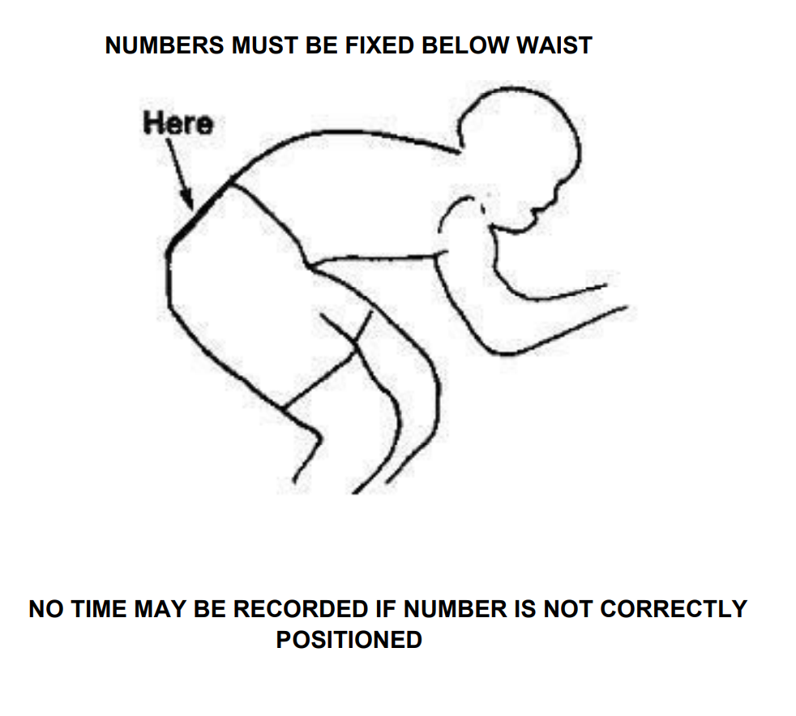
CTT REGULATION: ALL RIDERS MUST START WITH BOTH A WORKING FRONT AND REAR LIGHT ATTACHED TO THEIR MACHINE
3. Signing-on Sheet and Signing-out Sheet:
(a) The competitors in all types of events must make themselves aware of any special safety instructions for the event and sign the official signing-on sheet when collecting their number
(b) In Type A events a competitor must return to the event HQ either during the event or within a reasonable time after the last rider has finished the event and must
(i) return their race number(s); and
(ii) sign the official signing-out sheet. A rider who fails to sign the official signing-out sheet shall be recorded as DNF
Local Regulations – London West DC:

Restriction of Parking at the Start and Finish
LWDC 2 - No vehicles, except those of the timekeeper(s) and other event officials, shall be parked in the vicinity of the start or finish points.

Use of Turbo Trainers
LWDC 3 – Noisy Turbo Trainers are not to be used at morning events within 100 yards of residential accommodation

Prohibition of U-turns
LWDC 8 – Prohibition of U-Turns U-Turns are not permitted within sight of the Start or Finish points, nor on the course. Offenders will be liable to disqualification and will be reported to the District Committee. This may lead to disciplinary action being taken against the rider.
We look forward to welcoming you – have a fast, safe ride.

