**London Rd _ Grass Verges to Avoid**



Image capture: Oct 2021

© 2022 Google

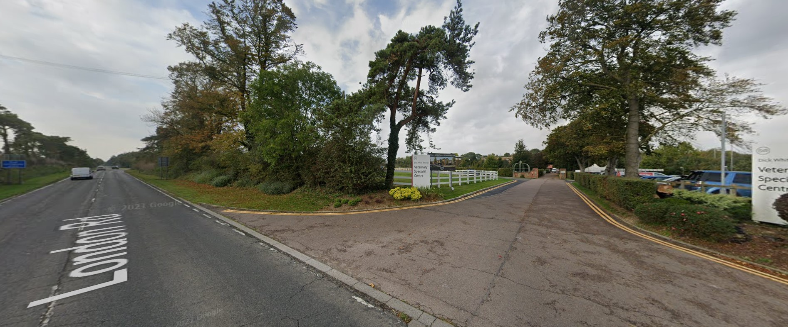

2/2