Promoted for and on behalf of Cycling Time Trials under their rules and regulations

Open 25 Time Trial

Sunday 29th September 2024 8am

On Bentley H25/88 course

HQ: Bentley Memorial Hall, Hole Lane, Bentley GU10 5NB

**Organiser:** Daniel Arthur. Ewell, Epsom KT17 1NU [daniel@epsomcc.co.uk](mailto:daniel@epsomcc.co.uk) Mobile: 07985 414490

**Timekeepers**: Donald Ashton & Michael Rice

**HQ:** Bentley Memorial Hall Hole Lane Bentley GU10 5NB

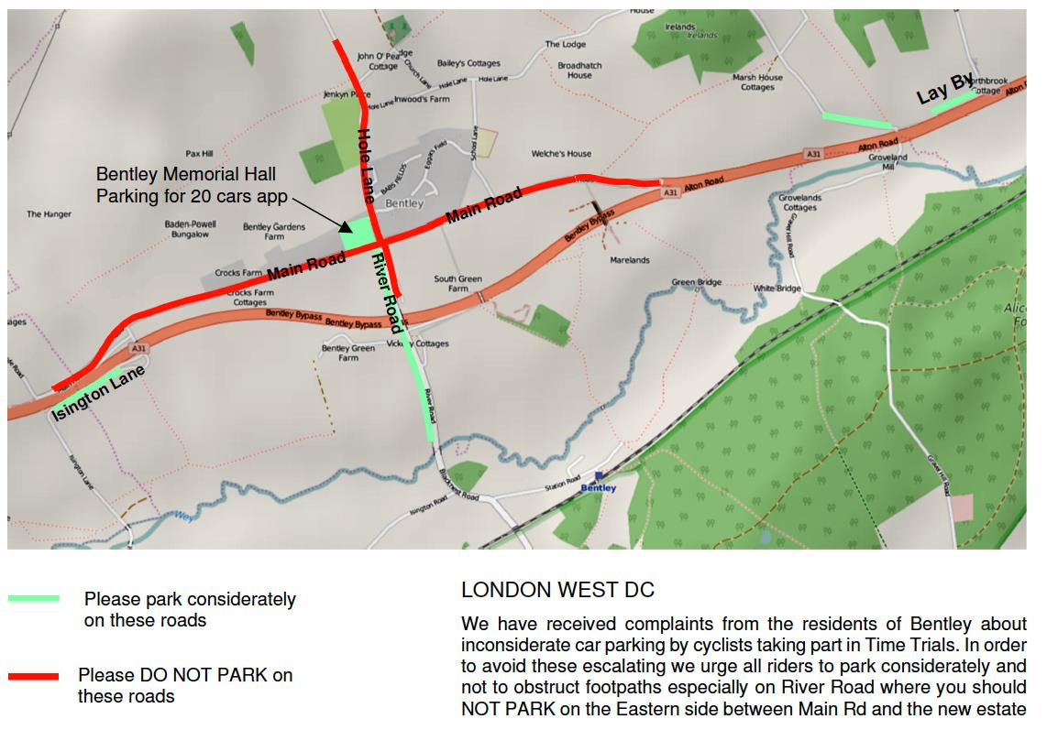

**IMPORTANT NOTES**

* Numbers to be collected from the HQ where you must sign on & SIGN OUT. Numbers can be exchanged for a drink when returned.
* The HQ is in a residential area, please be considerate to the people who live there and keep noise to a minimum. **Note areas where you can park on map above.** Please **respect the local residents of Bentley by parking considerately**.
* Do not park on the road near the HQ, even for a short period of time. Please adhere to the guidance on the parking diagram included. If we receive complaints, we may lose Bentley Memorial Hall as an option for the HQ. This could potentially mean the end of up to 20 open events on the course during the year.
* Please **respect** the volunteers and the timekeepers who are giving up their time to help out.
* Please sign on and collect your numbers from the headquarters and return numbers after **& sign out.** Position your main number so that it is visible from the rear when in the racing position. Please return to the HQ and sign out as soon as possible after you finish.
* **No cleats or bikes in in the hall**.
* **Head-down riding kills –** if dangerous riding is witnessed it will be investigated and reported.
* No vehicles, except those of the timekeepers, shall be parked at the start or finish.

**Route from HQ to Start and return after Finish**

Proceed East from Bentley to join the A31 and proceed 2 miles to Runwick Lane. Pull over to side and cross the carriageway over to River Lane when safe to do so. **Please allow at least 15 minutes to get to the start as it is 2.5 miles from the hall.** The start is on the opposite side of the carriageway from the HQ. Riders should only use designated crossing points and must not climb over the central reservation. **Anyone seen doing so will be disqualified.**

After finishing, riders must not stop but continue to one or other of the central reservation breaks, cross over with great care and go westwards passing the start point lay-by and along the Bentley by- pass to fork left onto the slip road signposted ‘Bentley’. Turn right at the ‘T’ junction to the Bentley Memorial Hall which you can see ahead of you.

Course Map (downloadable as GPX): <https://www.plotaroute.com/route/3071>. There will be marshals and checkers but it your responsibility to make sure you know the course. If you do have any further questions regarding the course or getting to the start please do not hesitate to ask.

**A31 Width restrictions & LWDC Regulation 11**

Competitors are to act in a manner appropriate to competing on a single lane road whilst within the restrictions imposed by the road cross-hatching areas:

1. The normal dual carriageway of the A31 has been reduced to a single lane at a point approximately 19.5 miles from the start, returning from the Holybourne roundabout on the north side of the A31. The road has been reduced to a single lane by road cross-hatching on the right-hand lane commencing approximately 220 yards before the junction to Mill Court on the south side and finishing adjacent to the Hen & Chicken Public House on the north side.
2. Please also note the LWDC A31 width restriction Regulation 11 – see box below – for the last ~1.5 miles of the course, after the Bentley junction. For a larger map, see: [LWDC Regulation 11](https://www.londonwestdc.co.uk/_files/ugd/067d8e_4605bc3ce93442a0a2770250465ad005.pdf).

For clarification, regarding the possibility of overtaking manoeuvres, this means that: *Subject to the rules of the road, if in the judgement of the faster rider it is possible to overtake safely, whilst* ***BOTH*** *using the unhatched carriageway* ***AND*** *where they can do so, without moving into the path of an overtaking motor vehicle/ rider, in these circumstances riders may overtake inside the width restriction, where it is safe to do. If in doubt riders should not overtake.*

**IN THE INTERESTS OF YOUR OWN SAFETY:**

1. HARD SHELL HELMETS that meet an internationally accepted safety standard are compulsory
2. No competitor shall be permitted to start either a Type A or Type B event unless such competitor has affixed to the rear of their machine a working rear red light, either flashing or constant, that is illuminated and in a position that is clearly visible to other road users.
3. No competitor shall be permitted to start either a Type A or Type B event unless such competitor has affixed to the front of their machine a working front white light, either flashing or constant, that is illuminated and in a position that is clearly visible to other road users.

|  |  |  |
| --- | --- | --- |
| **OS Ref** | **Course Description** | **Dist** |
| 822455 | START in the lead out from the River Lane / Runwick Lane cross roads on the south side at a point adjacent to the second road drain just before joining the A.31. | 00.00 |
| 736403 | Proceed westwards along the Bentley By-pass, through Froyle (Dual carriageway reduced to a single lane for approx half a mile) and proceed on the A.31 to the Holybourne Roundabout. | 06.50 |
| 704374 | Keeping to the LEFT lane take the first exit (M) straight ahead) and continue on the A.31 to the roundabout at Chawton (approach in the RIGHT lane) (M2) at the junction with the A.32. (1st TURN). | 09.40 |
| 734403 | Circle the roundabout (M3/4) and take the fourth exit (M5) (LEFT lane) back on to the A.31 and continue to the Holybourne Roundabout.(Keep to the RIGHT lane) (M6). Great care, downhill approach. Circle the roundabout (M7/8) (2nd TURN) to take the third exit (M1) back on the A.31 keeping to the left lane. | 12.48 |
| 704374 | Continue on the A.31 to the Chawton roundabout at the junction with the A.32 (M2). Circle the roundabout (3rd TURN) (M3/4) and take the fourth exit (M5) (LEFT lane) back on to the A.31 and continue to the Holybourne roundabout,(Keep to the left lane to go straight ahead) downhill approach (Great care). (avoid first exit) (M7) | 15.54 |
| 734403 | At Holybourne roundabout take the second exit (M8) (straight ahead) keeping on the A.31 to go through Froyle (Dual carriageway reduced to a single lane for approx half a mile) continue along the Bentley By-pass | 18.60 |
| 820454 | Continue to a point on the north side, 1108yds beyond the County boundary stone,85yds beyond the centre of the gateway to Bunces Farm and 245 yds short of the Start point (on the south side) where FINISH. | 25.00 |

**Prizes**

**Ratified results will be posted to CTT as soon as possible.**

**We will have live provisional results at www.resultsheet.co.uk**

No prizes on the day. All prizes will be notified & awarded after the event by bank transfer.

No rider can win more than one award other than team.

Epsom CC would like to thank Bob Stapley of the Epsom CC for his generous donation of £100 for the Best Improvement Prizes of £50, £30, £20 for riders outside 1:00:00 in the last three seasons.

Other prizes tbd.