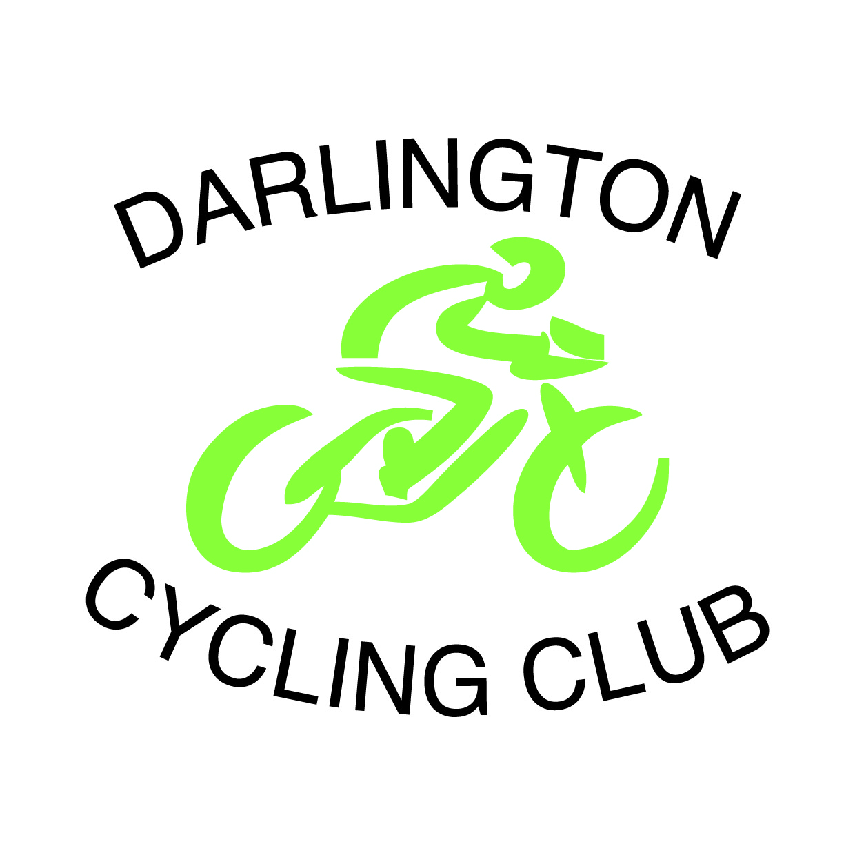

10 Mile TT – Sunday 24th July 2016

Promoted for and on behalf of Cycling Time Trials under their Rules and Regulations

Event Secretary: Timekeepers:
Steve Fullerton J Harper
2 Westgate Crescent R Lightle
Darlington
Co.Durham
DL3 0SX
Tel: 07527 671781 Email: stevefullerton01@gmail.com

Start: First Riders off at 09:001hrs Course T104

HQ address - Leeming Village Hall, Mill Lane Leeming, Northallerton, DL7 9SS.
Toilets, refreshments and numbers are available here.
No warming up at HQ, please see designated warm up area
T104 – Course Description
Start – on Dere Street (road from Londonderry),at gulley access point at west end of bridge approx 8yds from double broken line at junction with A6055. Join southbound A6055 and continuing through 1st roundabout (RAF on A6055Leeming/Gatenby) to encircle 2nd roundabout (Sinderby 4.6mls). Retrace northwards back to 1st roundabout (RAF Leeming/Gatenby) where straight over to finish approx 0.8 mls north of start at manhole cover in pavement on west side of carriageway, approximately 15yds north of 2nd Exelby turn-off. (10mls)

The Attention of all riders is drawn to the District CTT guidelines:
- No parking near Start or Finish – Parking on Dere St South of Leeming Village, found by leaving HQ and return to main road and turn right, park where the double yellow lines end.
- No cars other than the event officials to be parked at the start or finish.
- No U-Turns will be permitted in the vicinity of the Start.
- Riders are not to warm up on any part of the course, whilst the event has started.
- No turbo trainers are to be used for warming up within 100 yard s of any inhabited properties.

PRIZE LIST

Overall
1st £40 Age related prize
2nd £30 Under 40 1st £15
3rd £25 40-49 1st £15
4th £20 50-69 1st £15
5th £15 70+ 1st £15
Fastest Lady £ 20

In the interest of your own safety, Cycling Time Trials and the event promoter strongly advise that you to
wear a hard shell helmet that meets an internationally accepted safety standards. All competitors under the
age of 18 years/or juniors must wear a properly affixed helmet, which conforms to recognized Standards.
In addition it is also recommended that riders use a working rear light, either flashing or constant, fitted
to the machine in a position visible to following road users and that it is active whilst the machine is in use.

http://www.darlingtoncyclingclub.co.uk/ https://www.facebook.com/DarlingtonCyclingClub

