Rhos on Sea CC open 25

24th July 2016
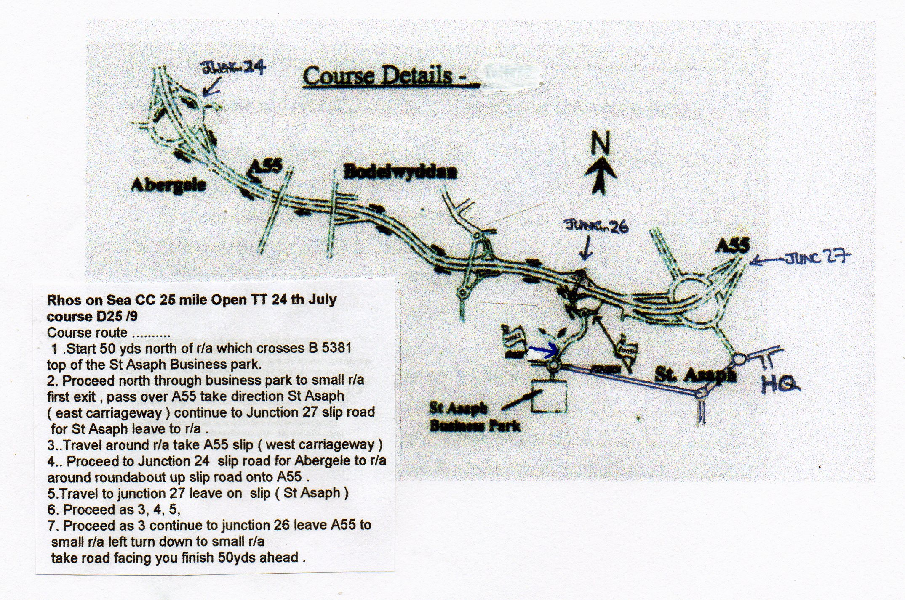
Directions to race HQ Postcode LL17 0RG
Community Playing Fields Roe Plas Meadow St Asaph
Exit junction 27
From Chester :- first exit left on roundabout direction St Asaph
From Abergele:- 3rd exit on roundabout direction St Asaph
Enter next roundabout take 1st exit left over river 1st right onto playing fields

Directions to start From HQ to start approx 15 mins
Left out of HQ enter roundabout take 1st exit left .
Proceed to next roundabout straight over (2nd exit )
Continue on this road up the hill and onto business park .
At roundabout 3rd exit the start is 50yds on left

Rider’s Notes:
- The results will be displayed at the HQ
- Cycling Time Trials advise you to wear a hard shell helmet. Under 18’s must wear a helmet.
- Tea and cakes will be available at the HQ.
- Care at Road Junctions - Riders must exercise caution at all junctions and roundabouts and obey the highway code .

Have a good ride and enjoy the event

