Paramount CRT Montford Bridge 10m Open TT

Revolutions Racing Series Round 10 of 16 (SCCA).
Promoted for and on behalf of Cycling Time Trials
under their rules & regulations
______________________________________________________
Sunday 25th June 8.00am
HQ: Montford Bridge Cafe SY4 1EB off the A5 (map enclosed)

Timekeepers: Dave & Jenny York MSW
Timekeeper’s Assts: Jason Davis & Martin Cowell Paramount CRT
Event Secretary: Jason Davis, 49 Greenfields Gardens, Shrewsbury, SY1 2RN 07907 201010

COURSE D10/22

Start at white line on A5 left out of café and 50m past the first bridge. Proceed North on A5 straight over 1st roundabout (2.5m) and continue on the A5 Nesscliffe bypass to the 2nd roundabout (5.4m) encircle roundabout and retrace to finish at the end of the Bus stop just past the Shawardine turning.
https://www.strava.com/segments/9558169

1st Actual overall £15.00 1st SCCA Veteran on Standard £15.00
1st SCCA Woman £15.00 1st SCCA Woman Vet £15.00 1st ^{t} SCCA Junior Male £15.00 1st SCCA Junior Female £15.00

IN THE INTERESTS OF YOUR OWN SAFETY
Cycling Time Trials and the event promoters strongly advise you to wear a HARD SHELL that meets an internationally accepted safety standard.
In accordance with regulation 15 all junior competitors MUST wear Protective Hard Shell Helmet. It is recommended that a working rear light, either flashing or constant is fitted to the machine in a position visible to following road users and is active whilst the machine is in use.

Competitors please note

THERE SHALL BE NO U-TURNING AT OR NEAR THE START FINISH, FAILURE TO COMPLY WILL LEAD TO DISQUALIFICATION.

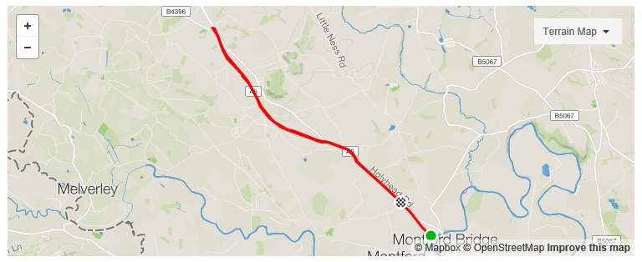

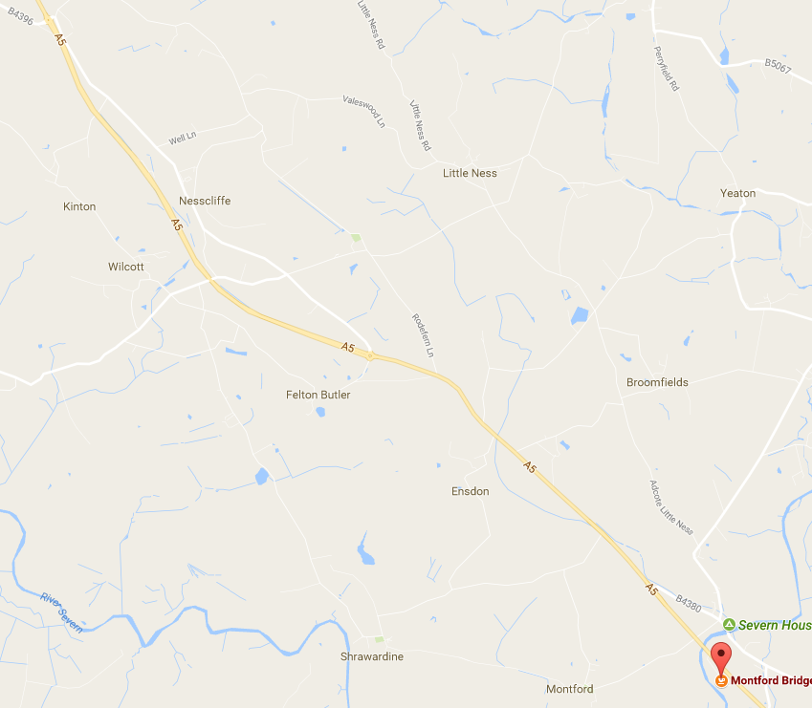
HQ Sign on & OFF
Start line
Finish Line
1st Roundabout 2 Marshals.
2nd Roundabout 3 Marshals.

