‘Promoted for and on behalf of Cycling Time Trials under their Rules and Regulations’

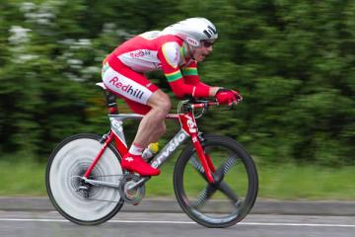

Redhill Cycling Club
14.06 mile 'Sporting' Time Trial – GS/189

Saturday 1st July 2017 at 14:00

Event Secretary: Jonny Bradbourne
jbradbourne@hotmail.com
07476364410 (for contact on the day)
19 Lynn Walk,
Reigate,
Surrey,
RH2 7NZ

Headquarters: Faygate Village Hall,
Park Road,
Faygate,
Sussex.
RH12 4SH

Timekeepers: Mr. Mick Irons
Mr. Mike Labrum
Signing On
- HQ opens at 13:00 (first rider off 14:01)
- Sign-on and start numbers at Event HQ (Faygate Village Hall)
- Numbers are to be worn in conjunction with Regulation 16. “No time may be recorded if number is not correctly positioned.”
- Allow 3 minutes from HQ to START turn Right out of HQ and Right again at mini roundabout. (approximately 350 yards)

Signing out
Please be aware of an addition to the regulations for 2017.
Regulation 17 (b) In Type A events a competitor must return to the event HQ either during the event or within a reasonable time after the last rider has finished the event and must (i) return their race number(s) and (ii) sign the official Signing-out Sheet.

Safety Instructions
- CTT regulations require compulsory use of helmets for the under 18's. In the interests of your own safety, Cycling Time Trials and the event promoters strongly advise all competitors to wear a hard/soft shell helmet that meets an internationally accepted safety standard.
- Competitors Machines: It is recommended that a working, rear light, either flashing or constant, is fitted to the machine in a position clearly visible to following road users and is active while the machine is in use.
- Competitors are requested not to warm up on the course after the first competitor has started.
- Details of any additional hazards not listed on the start sheet will be displayed at the signing on point. All competitors must read these details when they sign on.
- No times will be given at the finish.

General Notes
- London South District Regulation: No vehicles shall be parked on the highway within sight of the starting or finishing points.

Specific to Event
- Competitors must exercise extra care at T junction of Partridge Lane with Rusper road.

Parking
- Please park in the HQ car park. There is sufficient space for everyone.

Prizes

- One cash prize per rider of the highest value (excluding team prize)

Prize List | 1st | 2nd | 3rd
Men | £30 | £20 | £10
Women | £20 | - | -
Veteran on standard | £20 | £15 | £10
Team | £15 | - | -

COURSE DETAILS

FAYGATE/RUSPER/NEWDIGATE/PARKGATE/FAYGATE

OS REF DETAILS DISTANCES
217346 START in Faygate Lane (unclassified) 114 yards north of centre of 0.00 0.00
Railway bridge at Faygate at a point just north of entrance to timber yard
and opposite TP637203 on east side of road

Proceed northwards to Rusper continuing through village to junction with
205375 Capel Road 2.34 2.34

Bear RIGHT on Newdigate Road and proceed via Newdigate Village to
207436 junction with Broad Lane at Parkgate (CHECK) 4.46 6.80

Straight on now in Partridge Lane, and follow this road in a southerly
208386 direction to T junction with Rusper Road (CHECK) 4.26 11.06

LEFT on Rusper Road and proceed through Rusper bearing LEFT at the
Star PH and then bearing RIGHT into Faygate Lane to FINISH opposite
217346 centre of metal field gate on left 21 yards before start 3.00 14.06

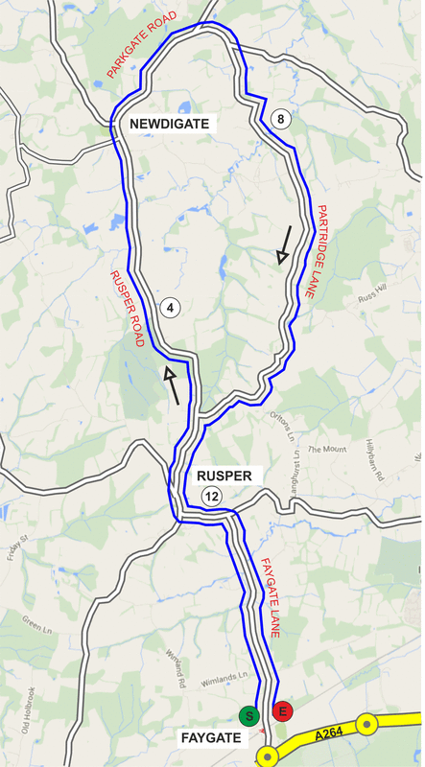

Bib | Start Time | Firstname | Lastname | Club | Gender | Category
1 | 14:01:00 | simon | powell | Redhill CC | Male | Veteran
2 | 14:02:00 | Stuart | Payne | Central Sussex CC | Male | Veteran
3 | 14:03:00 | Tom | Pemberton | New Malden Velo | Male | Senior
4 | 14:04:00 | Keith | Johnson | Medway Velo Club | Male | Veteran
5 | 14:05:00 | Nick | Davy | C and N Cycles RT | Male | Veteran
6 | 14:06:00 | James | Waddington | VELOSPORT CC | Male | Veteran
7 | 14:07:00 | Craig | Swatton | Crawley Wheelers | Male | Senior
8 | 14:08:00 | David | Powis | Dorking Cycling Club | Male | Senior
9 | 14:09:00 | David | Eccles | Redmon CC | Male | Veteran
10 | 14:10:00 | Matthew | Ferguson | Redhill CC | Male | Espoir
11 | 14:11:00 | John | McGlashan | Redmon CC | Male | Veteran
12 | 14:12:00 | Laura | Wilkey | Crawley Wheelers | Female | Senior
13 | 14:13:00 | Olivia | Webb | Eastbourne Rovers CC | Female | Veteran
14 | 14:14:00 | Frances | Bromley | Buxton CC/Sett Valley Cycles | Female | Espoir
15 | 14:15:00 | Helen | McKay | Les Filles Racing Team | Female | Senior
16 | 14:16:00 | philip | deacon | Epsom CC | Male | Veteran
17 | 14:17:00 | Phil | Booth | Medway Velo Club | Male | Veteran
18 | 14:18:00 | Chris | Jones | Bynea Cycling Club | Male | Veteran
19 | 14:19:00 | Alistair | Canning | Redhill CC | Male | Juvenile
20 | 14:20:00 | Nicolas | Stagg | Hounslow & District Whs | Male | Veteran
21 | 14:21:00 | Chris | Newberry | Redhill CC | Male | Senior
22 | 14:22:00 | Callum | Middleton | Lewes Wanderers CC | Male | Senior
23 | 14:23:00 | Alistair | Cunningham | Redhill CC | Male | Senior
24 | 14:24:00 | Paul | Batten | Crawley Wheelers | Male | Senior
25 | 14:25:00 | Chris | Lord | Brighton Excelsior CC | Male | Veteran
26 | 14:26:00 | Nolan | Heather | Worthing Excelsior CC | Male | Veteran
27 | 14:27:00 | Dale | Baldwin | Horsham Cycling | Male | Veteran
28 | 14:28:00 | Harris | Ryan | Redhill CC | Male | Veteran
29 | 14:29:00 | Danny | York | Westerham Cycling Club | Male | Senior
30 | 14:30:00 | Matt | Peel | Redhill CC | Male | Senior
31 | 14:31:00 | Ray | Sullivan | Metropolitan Police Cycle Club | Male | Veteran

Wishing you a SAFE and FAST ride. Keep your head up.

Please exchange race number for a free drink at HQ and DON’T FORGET YOU MUST SIGN OUT

Redhill Cycling Club
www.redhill.cc

