
Manchester and District
Ladies’ Cycling Association

1st July 2017

Ladies Open Handicapped and Men’s Invitation

10 mile Time Trial

Promoted for and on behalf of Cycling Time Trials under their Rules & Regulations.
Handicapped using standard tables.

Event Organiser: K. Jackson, 7 Burford Crescent, Wilmslow, Cheshire, SK9 6BL. 01625 537401
Timekeepers: Mrs J Green & Mr I Ross First rider off at 2:01 pm
Headquarters: Lower Withington Methodist Hall on B5392 between Jodrell Bank and Lower Withington, the HQ and its car park are only available from 2.30pm onwards due to the Rose Festival parade.
Numbers will be at the start layby – riders must sign the signing on sheet when collecting their number. DO NOT park in the start layby. Please return numbers to the headquarters, where there will be the results board and refreshments. Please note that each rider must SIGN-ON when collecting their number, and SIGN-OFF when returning it. Failure to do so will result in that rider being classified as DNF.

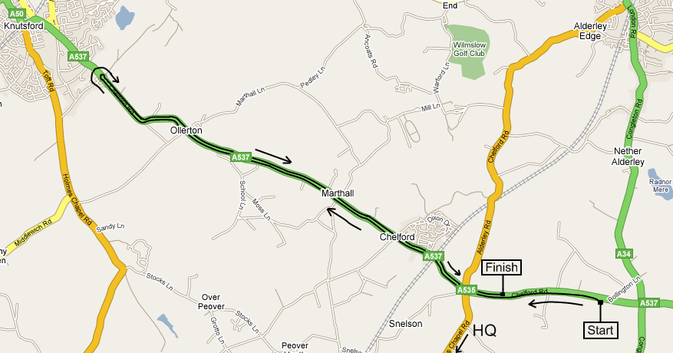

Course: J2/1
Start at JS1 mark in centre of lay-by on the A537, approximately 500 yards west of the A34 at Monks Heath. Proceed west on the A537 via Chelford Island to Booths Hall Island. 5.258m
Encircle the island and retrace via Chelford Island to Finish at JF1 mark adjacent
to the second stud back from the end of the first lay-by after Chelford Island. 10.000m

Prizes
Ladies |  |  |  |  | Men |  |  | Combined
1st | £25.00 | 1st handicap | £20.00 |  | 1st | £25.00 |  | 1st | £20.00 each
2nd | £20.00 | 2nd handicap | £15.00 |  | 2nd | £20.00 |  | 2nd | £15.00 each
3rd | £15.00 | 3rd handicap | £10.00 |  | 3rd | £15.00 |  | 3rd | £10.00 each

Fastest team of two Ladies: £10.00 each
Fastest team of two Men: £10.00 each

Certificate to be awarded to fastest M&DLCA Vet
on standard, fastest Junior girl and fastest Juvenile girl at Annual Dinner.

One rider one prize, except Combination and Team.

Ladies

Num | Name | Cat | Club | H/Cap | Std | Start
1 | Jill Fielding |  | North Cheshire Clarion | 7:48 |  | 2:01
2 | Rhianna Parkinson |  | Salford CC | 8:39 |  | 2:02
3 | Rachel Connerney |  | Cyclesport International RT | 10:15 |  | 2:03
4 | Julie Holden | V | Salford CC |  | 28:29 | 2:04
5 | Molly Horsley Frost | V | Buxton CC | 7:15 | 28:08 | 2:05
6 | Annia Modlinsky | V | Manchester Wheelers | 8:14 | 28:08 | 2:06
7 | Michelle Fairclough | V | Salford CC | 9:39 | 28:08 | 2:07
8 | Joanne Harcourt | V | Stretford Wheelers | 10:27 | 28:48 | 2:08
9 | Jennie Richardson | V | Black Horse Velo CC |  | 28:29 | 2:09
10 | Jayne Dickens | V | Vision Racing | 6:25 | 28:43 | 2:10
11 | Alisa Healy |  | The Racing Chance Foundation | 7:30 |  | 2:11
12 | Karen Bailey | V | East Lancs RC | 8:28 | 28:02 | 2:12
13 | Amanda Young | V | Lyme RC | 9:40 | 29:09 | 2:13
14 | Jane Eccleston | V | Salford CC |  | 28:53 | 2:14
15 | Ruth Gamwell | V | Macclesfield Wheelers | 7:14 | 28:13 | 2:15
16 | Caroline Fearon | V | Weaver Valley CC | 8:04 | 29:03 | 2:16
17 | Sandra Griffiths |  | Lyme RC | 9:20 |  | 2:17
18 | Tarja Barnes | V | North Cheshire Clarion | 10:31 | 28:43 | 2:18
19 | Julie Hamilton |  | Salford CC |  |  | 2:19
20 | Claire Harrison | V | Vision Racing | 6:39 | 28:19 | 2:20
21 | Georgina Cape | V | East Lancs RC | 7:39 | 28:34 | 2:21
22 | Holly Carter |  | Manchester Wheelers | 8:23 |  | 2:22
23 | Gill Henshaw | V | VC Long Eaton | 9:25 | 35:33 | 2:23
24 | Emma Higgins | V | Salford CC |  | 28:02 | 2:24
25 | Zoe Whiteside | V | Team Bottrill/ HSS Hire | 5:03 | 28:19 | 2:25
26 | Alice Leclercq |  | Boot Out Breast Cancer CC | 7:56 |  | 2:26
27 | Emma Walker |  | Manchester Wheelers | 9:12 |  | 2:27
28 | Nicole Decamps | Juv | East Lancs RC | 13:57 |  | 2:28
29 | Elizabeth Pressage |  | City RC (Hull) |  |  | 2:29

Men

Num | Name | Club | Invited by | Start
32 | Neil Fort | Yorkshire Road Club | Holly Carter | 2:32
33 | Julian Ainsworth | Salford CC | Rhianna Parkinson | 2:33
34 | Wilf Lewis | Altrincham Ravens CC | Gill Henshaw | 2:34
35 | Scott Leverington | Springfield Financial RT | Zoe Whiteside | 2:35
36 | Robbie Harcourt | Salford CC | Michelle Fairclough | 2:36
37 | William Howarth | East Lancs RC | Alice Leclercq | 2:37
38 | David Steele | Lyme RC | Sandra Griffiths | 2:38
39 | Ewart Howkins | Weaver Valley CC | Molly Horsley Frost | 2:39
40 | Tristan Pilling | Middleton CC | Elizabeth Pressage | 2:40
41 | David Trippier | East Lancs RC | Emma Walker | 2:41
42 | Ian Middleton | Vision Racing | Jayne Dickens | 2:42
43 | Cyril Wynne | Stretford Wheelers | Jill Fielding | 2:43
44 | Andrew Cheetham | Salford CC | Emma Higgins | 2:44
45 | Kevin Corden | Stone Wheelers | Rachel Connerney | 2:45
46 | Roy Nield | Lancashire RC | Karen Bailey | 2:46
47 | Kevin Woodward | Salford CC | Julie Holden | 2:47
48 | Ian Bracegirdle | Stretford Wheelers | Joanne Harcourt | 2:48
49 | Jonny Decamps | East Lancs RC | Nicole Decamps | 2:49
50 | Roger Wrenn | Macclesfield Wheelers | Ruth Gamwell | 2:50
51 | Tim Marshall | North Cheshire Clarion | Tarja Barnes | 2:51
52 | Dave Fearon | Weaver Valley CC | Caroline Fearon | 2:52
53 | Andrew Wood | Salford CC | Jane Eccleston | 2:53
54 | Trevor Bracegirdle | Stretford Wheelers | Alisa Healy | 2:54
55 | Steve Hall | Lyme RC | Amanda Young | 2:55
56 | Daniel Parish | Vision Racing | Claire Harrison | 2:56
57 | Andrew Harrison | Withington Wheelers | Annia Modlinsky | 2:57
58 | Nigel Suter | East Lancs RC | Georgina Cape | 2:58
59 | Philip Hoyle | Salford CC | Julie Hamilton | 2:59
60 | Darren Maironis | Velotik Racing Team | Jennie Richardson | 3:00

Sponsored Clubs: Vision Racing - Delamere Dairy/GRM Property Consultants/Swinnerton

Warnings:
Warming Up: Riders must not warm up past the start and finish areas.
Care at road junctions: Riders must exercise caution at all junctions. Any competitor whose riding line causes her/him to cross the white line when approaching or leaving a junction will be liable to disqualification from the event and may be reported to the District Committee for further disciplinary action.
U turns: Any rider making a U turn in the vicinity of the start or finish will be disqualified. Observers will be used in this event.
Chelford Island: Riders must negotiate Chelford Island in a safe and sensible manner in accordance with CTT Reg.20 and the rules of the road. Riders must be able to brake and stop at the island if traffic conditions require this. Riders MUST NOT approach and encircle the island using tri-bars. Remember – traffic on the island has priority over traffic (including riders) entering it. Any rider seen to be in breach of this regulation will be disqualified from the event and may be reported for further disciplinary action.
IN THE INTERESTS OF YOUR OWN SAFETY Cycling Time Trials and the event promoters strongly advise you to wear a HARD SHELL HELMET that meets an internationally accepted safety standard.

M&DLCA

Each year, the M&DLCA awards several prizes and trophies to members of the M&DLCA and affiliated clubs, which are presented at our annual dinner dance in November. Any event on a 25 or 50 mile J course counts for these trophies, as long as copies of the results sheet and entry form are sent to the M&DLCA BAR secretary (Katherine Jackson), but the only counting 10 mile events are those organised by the M&DLCA. The onus is on the rider to submit, where required, copies of the entry form and results sheet to the M&DLCA BAR secretary before 1st October of the current season.

Visit our website at http://www.mdlca.org.uk for the latest news, results and photos
The Annual M&DLCA Dinner Dance and Prize Presentation will be held at the Alma Lodge, Stockport on Friday November 24th 2017. Certificates are presented at the Dinner.
For the latest news, results and photos please visit our website on http://www.mdlca.org.uk
We also have a Facebook page for photos and posts.

