
RON SPENCER MEMORIAL TIME TRIAL

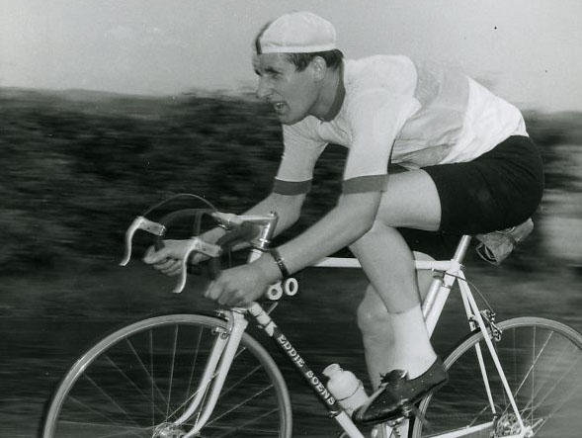

Ron Spencer joined Warrington Road Club in 1958 as a youngster and soon became one of the best Time Trial riders not only in the club, but soon enough the whole UK. Ron was National 12-hour champion in 1963 and second in the BBAR that year. Thirty years later, he was still clocking fast standards against the clock under the hour on the course you ride for this event until his untimely passing in 2011. Warrington Road Club dedicate this Time Trial to the memory of Ron Spencer, to our former President and an active part of the cycling community.

Many thanks for your entry in this event. WRC apologize for not being able to run the 25 as planned, but we think Ron would have approved of us running the 10 instead.

FOUNDED 1923

Presents the Ron Spencer Memorial 10 Mile Time Trial
On Saturday 15th July 2017 1st rider off at 14.01

The event is ‘Promoted for and on behalf of Cycling Time Trials under their Rules & Regulations’.

Event Secretary:
Alan Ottiwell, 73 Highfield Road, Lymm, Cheshire, WA13-0DT (07814-327863) alanottiwell@hotmail.co.uk

Event HQ:
CRANAGE VILLAGE HALL, 7 miles south of Knutsford and 1 mile north of Holmes Chapel on the A50.
Postcode CW4-8EQ. Open from 12:30pm

Time Keepers:
Graham Laurence and Tony Millington

Be Warned!
Dangerous riding causes accidents and most certainly endangers the future of our sport.
Ride with your head up at all times. Observers are being used during this event.

PRIZES

One Prize per Rider (with Exception to Team Prize)

In addition, the Fastest Warrington RC rider to hold the Ron Spencer Memorial Trophy for one year.

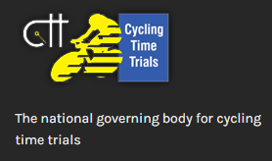

Course J2/3 10 miles:
START in Twemlow Lane at the “J2/3” mark just east of Hermitage Lane in line with the hedge on Hermitage Lane. Proceed eastwards to the A535 at:

TWEMLOW GREEN (1.047 miles). Left along the A535 to:

CHELFORD ISLAND (5.661 miles). Encircle the island and retrace along the A535 to:

FINISH at the “J2/3” mark by the far post of the last field gate on the left of the A535 at Twemlow Green before the Yellow Broom Restaurant.

INTERNET DIRECTIONS BELOW OF THE COURSE:
https://connect.garmin.com/modern/course/15791412
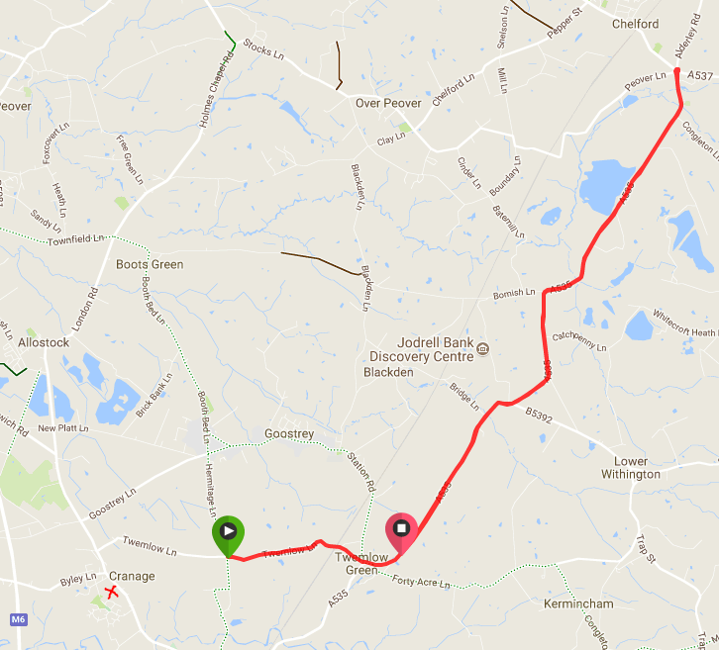
HQ = X Marks the Spot
Directions from HQ to the Start:
Take a left turn on to the A50 and then the first right crossing carefully in to Twemlow Lane. Please respect the rules of the road and take care at the temporary traffic lights. The start is less than 1 mile from the HQ.
https://connect.garmin.com/modern/course/15791582
Directions from the Finish to the HQ:
Please use this route so as to avoid fellow competitors coming the other way on Twemlow Lane. Follow the road round to Twemlow Green crossing carefully in to Twemlow Lane. Cross Twemlow Lane carefully, watching for oncoming traffic and fellow riders in to Goostrey Lane. Stay on Goostrey Lane and do not take any turns until you reach the A50 3 miles down the road. Turn left on to the A50 and travel for half a mile to the HQ across the road on the right.
https://connect.garmin.com/modern/course/15791560

GENERAL NOTES

- Riders must SIGN ON the signing on sheet and collect their numbers at the HQ before starting.

- Rides must SIGN OFF at the HQ once the race has finished. Not doing so will result in disqualification.

- Riders must return their numbers to the HQ after riding.

- Refreshments will be available at the HQ after the event.

SAFETY NOTES

- No parking for riders or their helpers at the start or finish.

- Any rider making a U turn in the vicinity of the start or finish will be disqualified.

- Riders must not stop at the finish but should continue on to the event headquarters where times will be displayed.

- Riders must negotiate Chelford Island in a safe and sensible manner in accordance with CTT Reg. 20 and the rules of the road.

- Riders must be able to brake and stop at the island if traffic conditions require this. Riders MUST NOT approach and encircle the island using tri-bars. Remember - traffic on the island has priority over traffic (including riders) entering it. Any rider seen to be in breach of this regulation will be disqualified from the event and may be reported for further disciplinary action.

- Care at Road Junctions: Riders must exercise care at all junctions. Any competitor who’s riding line causes him/her to cross the white line when approaching or leaving a junction will be liable to disqualification and may be reported to the District Committee for further disciplinary action.

- IN THE INTERESTS OF YOUR OWN SAFETY, Cycling Time Trials and the event promoters strongly advise you to wear a HARD SHELL HELMET that meets an internationally accepted safety standard. In accordance with Regulation 15 ALL JUNIOR & JUVENILE competitors must wear Protective Hard Shell Helmets.

- It is recommended that a working rear light, either flashing or constant, is fitted to the machine in a position visible to following road users and is active whilst the machine is in use.

SEE YOU ON THE DAY, GOOD LUCK & RIDE SAFE

