Rugby Racing Cycling Club  www.rugbyrcc.org.uk | 

10 Mile Open Time Trial
Promoted for and on behalf of Cycling Time Trials under their Rules and Regulations

SATURDAY 29th JULY 2017

Course: K11/10T Start: 2.00 pm
Event Headquarters: Dunchurch Village Hall - Post Code CV22 6PN - Map ref. 486717 (HQ opens 1 pm)
Timekeepers: David Aires & Barry Harden
Event Secretary: Laurie Bird, 11 Mulberry Road, Rugby, CV22 7TD
Tel. 01788 813025 Email: laurie.bird@btinternet.com

Directions to HQ from A45

From the centre of Dunchurch (A45/A426 cross roads) take the A426 towards Rugby. Proceed on A426 for 0.3 mile. Dunchurch Village Hall is on the right. For those with Sat-Navs the post code is CV22 6PN and the map ref. is 486 717. You can see more about the hall on their website www.dunchurchsportsandvhall.co.uk Please do not bring dogs into the Headquarters building.

Parking at Dunchurch Village Hall
There is an off-road car park next to the hall. If the car park is full proceed to the far side of the car park and park on the grass as near to the fence by the main road as possible. Do not park on the main road through the village.
Please do not park on the actual course or at the start and finish.

Numbers
Numbers will be available at the event headquarters. Note that riders are now required to sign off when handing in their number after finishing.
NB. Riders’ PBs are used for field placement in accordance with CTT guidelines.

Directions to the Start
From the HQ turn left onto the A426 and proceed to the cross roads (traffic lights) at the centre of Dunchurch. Turn right onto the A45 (signpost Coventry). At the A45/M45 island follow the sign to Coventry (dual carriageway). The start is in the first lay-by immediately on the left. The total distance from the HQ to the start is 1.9 miles.
Once the Event has started at 14:00, no competitor shall use any part of the course for warming up prior to their start time. Any rider seen doing so risks being disqualified.

Prizes
Fastest | £50, £40, £30, £20, £15 | NB. One prize per rider, excluding team prizes. Where riders are eligible for more than one prize the higher monetary value will apply. If the prize value is the same the order of the prize list will determine priority.  *.Age categories (Based on age on day of event).:  A 40-44, B 45-49, C 50-54, D 55-59, E 60-64, F 65-69, G 70 +.
Ladies | £30, £25, £20, £15, £12
Vet on Std | £30, £25, £20
Junior | £20
Age Categories* | £15 per category
Fastest Team of 3 | £15 per rider

Course Description:
Grid ref | Details | Distance  (miles)
SP 460 718 | Start in lay-by 200 yds west of the A45/M45 Thurlaston island, at the 3rd join in the concrete apron. | 0
SP 415 732 | At island junction with B4455 (Fosse way) take second exit (A45) | 3.146
SP 391 741 | At island junction with A445 encircle the island to retrace (A45) | 4.776
SP 415 732 | Past island at junction with B4455 (Fosse way) | 6.384
SP 465 715 | At A45/M45 turn left (B4429) | 9.649
SP 469 714 | Finish 60 yards past the turn to Thurlaston (Main Street), in line with the eastern and the exposed gate post immediately past the property named “Newhaven.” | 10
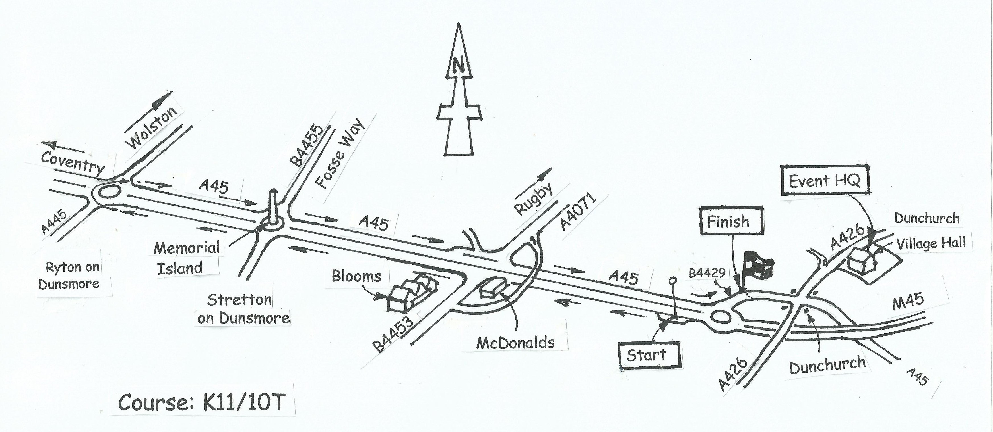
Course Record
The course record is 18-25 set by Matt Bottrill in the Rugby RCC event held 26-7-2014.
Safety
In the interests of safety the organisers strongly recommend the wearing of hard-shell helmets which meet an internationally accepted safety standard. All competitors under the age of 18 must wear a properly affixed helmet.

Thanks
To the marshals and timekeepers, without whom the event could not take place.
To the members and friends for organising the catering.
Previous Winners of Rugby RCC Open 10
1998 | Stuart Dangerfield | Fastrack RT | 20-36 | K41/10
1999 | Stuart Dangerfield | Bio RT – MDT | 20-23 | K41/10
2000 | Stuart Dangerfield | Camel Valley | 20-31 | K41/10
2001 | Stuart Dangerfield | Camel Valley | 19-32 * | K10/10
2002 | Richard Bradley | Stourbridge CC | 20-38 | K10/10
2003 | Darren Willetts | On the Edge RT | 20-14 | K10/10
2004 | Keith Murray | scienceinsport.com | 20-44 | K10/10C
2005 | Stuart Dangerfield | scienceinsport.com | 19-36* | K10/10F
2006 | Jon Simpkins | Banbury Star CC | 21-51 | K10/10C
2007 | Scott Rose | scienceinsport.com | 20-43 | K10/10
2008 | Richard Bradley | Shorter Rochford RT | 20-17 | K10/10
2009 | James Wall | Stratford-on-Avon CC | 21-11 | K10/10
2010 | Matt Bottrill | I-ride.co.uk | 19-30 * | K11/10T
2011 | Matt Clinton | Mike Vaughan Cycles | 19-57 | K11/10T
2012 | Jon Simpkins | Drag 2 Zero.com | 19-42 | K11/10T
2013 | Matt Clinton | Mike Vaughan Cycles | 19-25 * | K11/10T
2014 | Matt Bottrill | Drag 2 Zero.com | 18-25 * | K11/10T
2015 | Matt Bottrill | Drag 2 Zero.com | 19-03 | K11/10T
2016 | Matt Clinton | Mike Vaughan Cycles | 19-06 | K11/10T
* Course record

