Gloucester City CC -rudy project
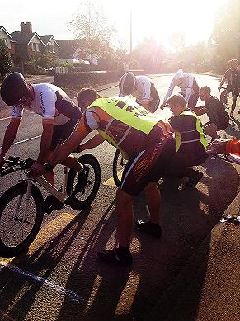 as clearly illustrated heads up!

Gloucester 25 mile and 3up Time Trial.
Sunday 24th September 2017 on course U72
(Promoted for and on behalf of Cycling Time trials under their rules and regulations)

H.Q. Maisemore Village Hall, Church Road (off A417) Maisemore, Gloucester.GL2 8JE

Event Secretary: Gerry McGarr Phone No: 01452 451705
‘Tyndale Cottage’ Email: valmcgarr@valmcgarr.f9.co.uk
130 The Wheatridge East
Upton St Leonards
Gloucester
GL4 5DP
Time Keepers: Chippenham & Dist Whls Michael and Sheila Edwards and Malcolm Grainger Gloucester City CC.

Course description: U72
Start at bus stop lay-by just before the speed de-restriction sign leaving Maisemore (grid reference 811212). Continue to Staunton, turning left at the roundabout. Continue on the A417 across the M50 junction and on to the first roundabout on the edge of Ledbury. Turn here (13.5 miles). Retrace the route, turning right at the roundabout in Staunton (care). Finish beyond the old school buildings beyond Hartpury at the pull-in by a gate into the woods (grid reference 798234).

1. Start out of H.Q. turn right and right onto A417 start on left 200m – give 5 minutes.
2. Shout number as you pass timekeeper at finish
3. Avoid U turns in vicinity of start and finish
4. CTT strongly advise hard shell helmets and rear flashing lights
5. 3 up teams must have same coloured jerseys
6. At Finish please hand in number for free cup of tea/coffee

PRIZES: 3UP Fastest Team 1st £45 Plus hold the Dr Henry Trophy 2nd £30
Solo 25: Men 1st £30 2nd £25 3rd £20 Ladies 1st £10
Seniors Ist £15 2nd £10
V40 1st £10 V50 1st £10 V60 1st £10 V70 1st £10 (one rider one prize)
Winning Team: £10 each
Please stay for presentation of prizes.

