

Present

The Shelsley Walsh Cycling Hill Climb

Sunday 1st October 2017
(Promoted for and on behalf of Cycling Time Trials under their Rules & Regulations)

Sponsored by


Supported by


Time Keepers: Sue Kelly & Charlie Barnett

HEADQUARTERS
Shelsley Walsh Hill Climb,
Shelsley Walsh
Worcestershire, WR6 6RP

Directions
From Worcester. Take the A443 from the centre of Worcester turn Left on the B4204. Continue through Martley and over Ham Bridge. Turn first Right after the bridge and before the hill, Shelsley is about 1 mile on left.
From Great Witley. Take the B4203 towards Bromyard. Cross Stanford Bridge. Turn First Left. Shelsley is about 1 mile on right.
From Bromyard. Take the B4203 to Stanford Bridge. Turn Right before crossing the bridge. Shelsley is about 1 mile on right.
Satnav WR6 6RP
Itinerary for the hill climb, (see separate notice for CycloX)
9.00 Car park open – Please place the attached notice in your car window.
9.30 to 10.30 Hill open for practice – only after signing on
9.00 Stratstone Restaurant open until about 4.00pm
9.00 Signing on open
10.30 Hill closed to riders practice
10.50 Marshalls and time keepers into position
11.10 First rider
11.50 Last rider
12.15 Prize presentation
14.00 Clear up and Close down.

Sunnycam Cup awarded for the fastest time of the day.

Prize List by category

Category | 1st | 2nd
Under 14 | Racing top + £20 | £10
Ladies | Racing top + £20
Juvenile /Junior | Racing top + £20 | £10
Veterans | Racing top + £20 | £10
Senior/Espoir | Racing top + £20 | £10

Prizes will be awarded at 12.15 at the Dias (bottom of the Hill) - (If wet in the Stratstone Restaurant). Please will the first two in each category make themselves available for the presentation.

I would like to thank all the riders for entering our event, the marshals and helpers who have given their time to make this a success and Midland Auto Club for allowing us to use the hill.

Special thanks to our sponsors, Worcester Cycle Centre, Scimitar Sports Clothing and Cycle Experience; please consider using them when you make your next purchases.
Riders Start List
No | Start time | Firstname | Lastname | Club | Category
10 | 11.10 | Denise | Burrows | Wyre Forest Cycle Racing Club | Senior (W)
11 | 11.11 | Max | Hinds | Wyre Forest Cycle Racing Club | Juvenile
12 | 11.12 | James | Parrish | Wyre Forest Cycle Racing Club | Juvenile
13 | 11.13 | Alexander | Brown | Wyre Forest Cycle Racing Club | Juvenile
14 | 11.14 | Dylan | Perkins | Worcester St. Johns CC | Juvenile
15 | 11.15 | Ben | Lawrence | Wyre Forest Cycle Racing Club | Juvenile
16 | 11.16 | Harry | Tait | Worcester St. Johns CC | Juvenile
17 | 11.17 | Tomos | Pattinson | Halesowen C & AC | Juvenile
18 | 11.18 | Jacques | Coates | Performance Cycles CC | Junior
19 | 11.19 | Charlie | Genner | Wyre Forest Cycle Racing Club | Juvenile
20 | 11.20 | Jamie | Crump | Successcycling.co.uk | Junior
21 | 11.21 | William | Truelove | Abergavenny RC | Juvenile
22 | 11.22 | Ollie | Morgan | Worcester St. Johns CC | Junior
23 | 11.23 | Daniel | Gee | Ashfield RC | Veteran
24 | 11.24 | Craig | Hopkins | Wyre Forest Cycle Racing Club | Veteran
25 | 11.25 | Martin | Stanley | Worcester St. Johns CC | Veteran
26 | 11.26 | Philip | Wood | Chapeau CC | Veteran
27 | 11.27 | Tim | Farmer | Saracen Road Club | Veteran
28 | 11.28 | James | Hart | NFTO Race Club | Veteran
29 | 11.29 | Dave | Elliott | Chapeau CC | Veteran
30 | 11.30 | Dan | Grant | Worcester St. Johns CC | Veteran
31 | 11.31 | Andrew | Peat | Solihull CC | Senior
32 | 11.32 | Daniel | Hyde | Chapeau CC | Senior
33 | 11.33 | Robin | Somers | Worcester St. Johns CC | Senior
34 | 11.34 | Richard | Burt | Solihull CC | Veteran
35 | 11.35 | Harry | Leake | Successcycling.co.uk | Espoir
36 | 11.36 | Simon | Bromfield | Charlotteville Cycling Club | Veteran
37 | 11.37 | Jonathan | Morris | Derby Mercury R C | Senior
38 | 11.38 | Edward | Thompson | Wyre Forest Cycle Racing Club | Senior
39 | 11.39 | Adrian | Murray | Worcester St. Johns CC | Veteran
40 | 11.40 | Scott | Palmer | Stourbridge CC | Senior
41 | 11.41 | Neil | Reynolds | Velo Club Montpellier | Veteran
42 | 11.42 | Cameron | Coley-Smith | Stourbridge CC | Senior
43 | 11.43 | Phil | Whiteley | Worcester St. Johns CC | Veteran
44 | 11.44 | Tom | swingler | Halesowen C & AC | Senior
45 | 11.45 | David | McCann | Beacon Roads CC | Senior
46 | 11.46 | Steven | Prince | Stourbridge CC | Veteran
47 | 11.47 | John | Hunt | Beacon Roads CC | Senior
48 | 11.48 | Andrew | Newby | Veloviewer | Senior
49 | 11.49 | Cameron | Biddle | Rivet Racing | Espoir
50 | 11.50 | Oliver | Hayward | Rhino Velo Race Team | Espoir

Course Map
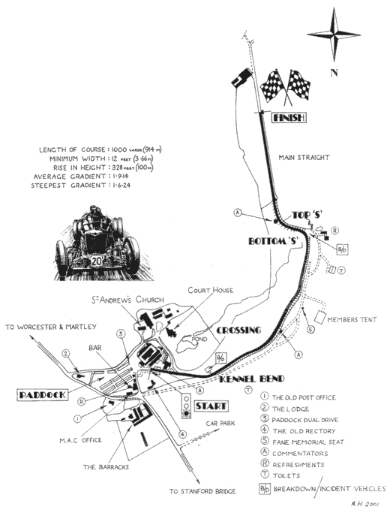

Course Description KH13.
The Cycling Hill Climb will use the same course used by motorcars since 1905 and motor cycles since 1946; it is entirely on private road. Start at (OS map reference SO63172) at the white line on the private road. Ride up the hill in a South to South Westerly direction to finish at the white line marked Finish (OS ref SO623718). The course is 1000 yards (913 meters) with an average gradient of 1:9.

Organiser: Rick Allen, 39 Stainburn Close Worcester WR2 5QJ
Phone 01905 427940.
Note:- There is no mobile phone access at Shelsley.
Email: rickallen48@yahoo.com
(not later than 7.00pm on the 30th September if response is required before the event).

INFORMATION FOR RIDERS:

- Competitors will be directed to park in the Pits, spectators to park in the adjacent field (also CycloX).
- Riders should display the attached sign in the car window as you arrive to help the marshals direct you to the correct park.
- Numbers and signing on sheet will be at the Sign On hut at the entrance to the Pits. Return your race number and sign back in at the Sign On hut.
- The covered areas are for riders to use to warm up and to keep out of the weather.
- Toilets are available in the Pits opposite the Sign On hut and in Stratstone Restaurant.
- Times will not be given at the finish, the result board will be in the Stratstone Restaurant.
- There is very limited (nil) mobile phone reception in the Shelsley area.

INSTRUCTIONS TO RIDERS:

- Riders MUST ride on the LEFT of the cones at all times.
- Riders must ensure they have two operative brakes on their machine.
- Riders must obey instructions given by Marshalls and Officials.
- Riders returning to the bottom of the hill must ride slowly and in control of their machine - RIDERS DEEMED TO BE RIDING DANGEROUSLY WILL BE DISQUALIFIED.
- Riders must not stop in the return lane and should not descend in company with other riders. An area to the left of the bottom "S" can be used to pull off the return lane.
- A Marshall will direct returning riders into the Pit lane - OBEY INSTRUCTIONS.

COMPETITORS CLOTHING:

- Competitors must be clothed from neck to at least mid-thigh. Sleeves shall be at least mid-upper arm length. (NO SLEEVELESS TOPS) e.g T-shirts are OK, vests are not.
- Helmets are mandatory for all riders under 18 years of age and highly recommended for all other riders.
- No competitor may carry advertising or the name of a commercial business on his/her race clothing except where he/she is a member of a club or team that has paid the advertising fee.
- COMPETITORS MUST NOT COMPETE IN CLOTHING OF A TRADE TEAM that is/has been registered with the UCI unless they are members of that team.

Hill Climb Competitor

