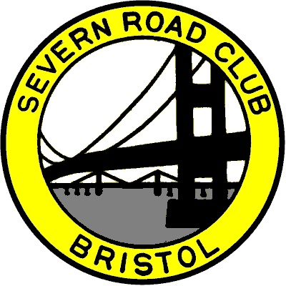
SEVERN ROAD CLUB
Hinton Hill Climb - Course UH90
Saturday 7th Oct 2017 - Start time 3:40pm
Promoted for and on behalf of Cycling Time Trials under their Rules and Regulations

www.severnroadclub.co.uk
Event Secretary:  Tom Bertenshaw  16a Berenda Drive  Longwell Green  Bristol  BS30 9YX. | Timekeepers  Bridget Boon  Ian Boon

Please note that the start sheet is found on the “start sheet” tab on the CTT website.

Headquarters, Start area and Parking

The HQ for this event will be located at the “triangle” in Hinton. Parking will be in a field, through a gate on the right located next to the triangle. The field will be signposted with arrows. There will be toilet facilities at Dyrham village hall, but the key for the building will be kept at the HQ. Please see the HQ if you need the facilities. To reach the HQ, use postcode for “the bull” pub (post code: SN14 8HG) and drive further down the hill until you reach the triangle. See map below.

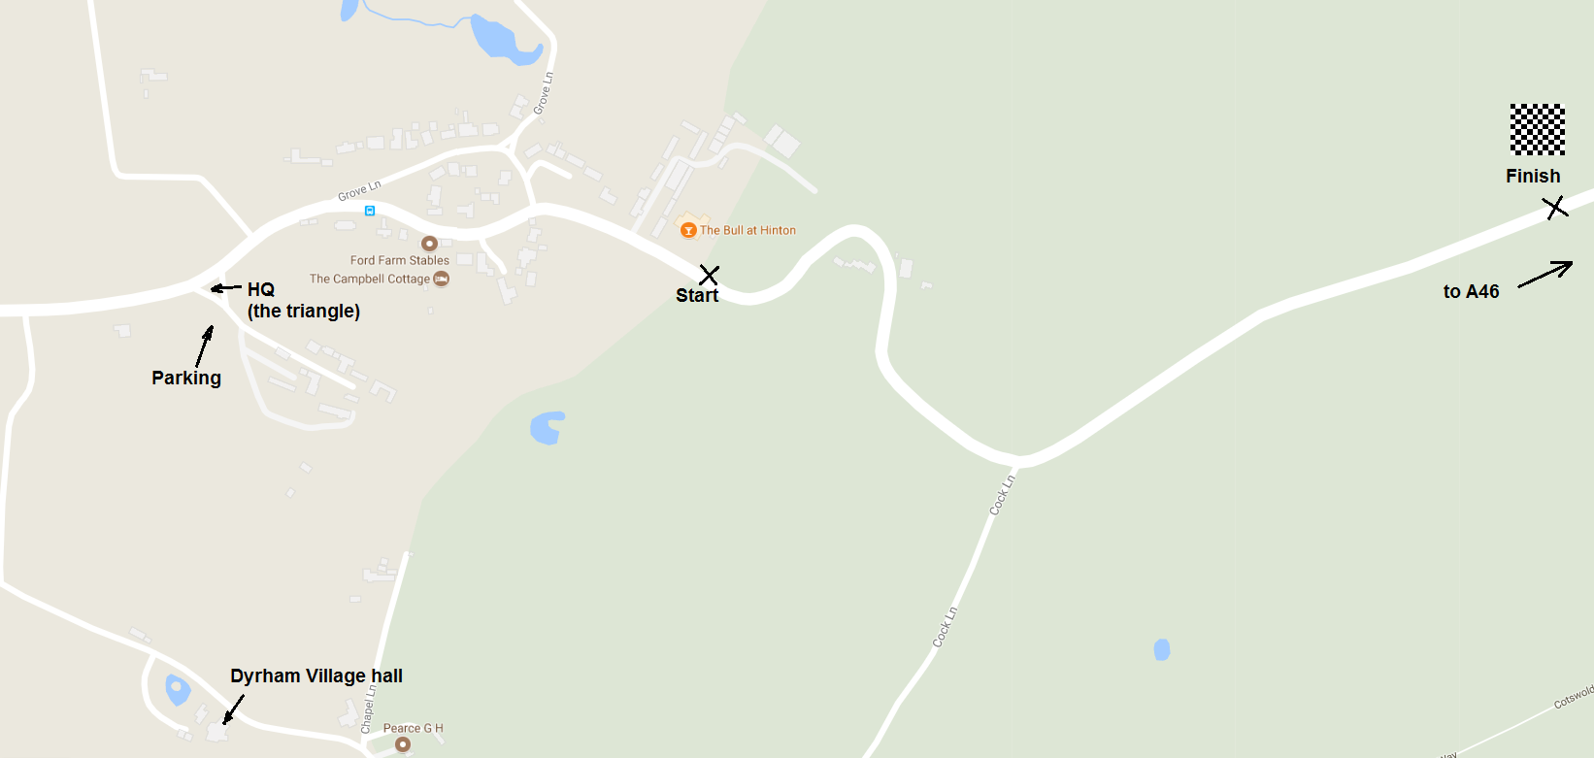

It will not be possible to park at the start area as the landlord is hiring out the entire pub for a private event; the car park is not available to competitors under any circumstances.

Please do not litter the HQ area or the car park (this includes banana skins!) Waste bins will be available at the HQ.

Numbers.
Riders must sign the signing on sheet at the HQ to obtain their race number and check for any last minute information. Please return your number for a free drink.

Course details
START: At the base of Hinton Hill next to "the bull" Pub. Finish is at the crest of the hill just outside of the trees (approx ½ mile). See picture above.

Safety
Riders are asked to take great care and, in particular note the following points:
- Take care when descending the hill after the finish. There are a number of sharp blind bends, so please ensure that you don’t cut these corners whilst descending.
- Refrain from turning around on the race course
- CTT recommends that competitors wear a hard shell helmet that meets an internationally accepted safety standard.
- All juniors/juvenile riders MUST wear protective hard shell helmets.

Prizes

1st Place - £20
2nd Place - £15
3rd Place - £10
4th Place - £5

1st Lady - £10
2nd Lady - £5

1st V40 - £10
1st V50 - £5

