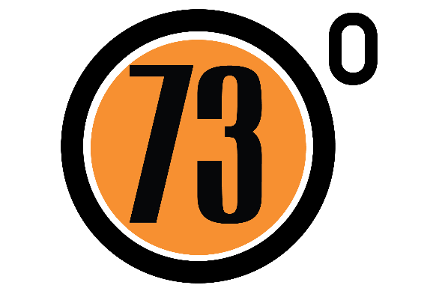

Please note that all competitors are awarded a 10% discount off of all products purchased from 73 Degrees Bicycles until December 31st 2016
73 Degree’s Bicycles is a team based around the Bath area who are a friendly group who take part in all elements of cycling. With help from WestSide Coaching and Clevedon and District Road Club we are organising our first time trial in support of the WTTA who run the Hardriders year after year to great success.
As a group with over 50 years cycling experience between us as a foreword to the startsheet, we thought it would be useful to share some of the handy tips we have learnt over the years.
Race Day
- If it doesn’t hurt then you aren’t going hard enough.
- If you can taste blood then you have gone off too hard.
- Racing is not fun – Finishing is an achievement and feels good but if you smile throughout your ride you should be going harder.
- Anyone caught drafting is not only DQ’d they are also humiliated on social media.
- Your bike should ALWAYS be worth more than the car you arrive in. If it isn’t then you are entitled to purchase a new bike from 73 Degrees Bicycles.
- Never listen to Matt Burden if he states he is unfit, fat and hasn’t trained. He will still do a 19 minute 10.
- Putting on Velotoze overshoes DOES class as a suitable warm up.
- You are forbidden to discuss your result outside of your circle of cycling friends. Other do not understand, do not care or worse they will ask you to explain the motorbike in the Keirin.
- Always prepare an excuse before you start your ride. It could be that you have over trained, had a mechanical or are just using the event for light training. If you require assistance, one of the team and will be happy to help as they have used them all.
- ALWAYS use a powermeter which reads high so you can show people your Garmin after.
- If your heartrate monitor reads zero, please change batteries and check pulse before alerting the organisers who will be very busy.
- Most Important please wipe sweat, snot, spit or gel off of your face before you reach the photographer.
Training
- If spotted at a pub getting drunk by another cyclist you should always refer to it as tapering.
- If overtaken whilst training on the road you are ALWAYS on a recovery ride.
- The turbo trainer is a horrid piece of equipment. It will make you stronger however no amount of music or TV can distract you, meaning you have to be mentally imbalanced to complete any session over 20 minutes. Any such individuals should seek immediate medical attention.
- In addition to the above please feel free to tell everyone that your power is much higher on the turbo.
- You should not discuss family, work or any non-cycling stories with other cyclists. They do not care and are not interested so to avoid embarrassment you should always include watts, heartrate, CDA, FTP, CP20, or gears in a conversation to retain their interest.
- A PowerPoint presentation from Training Peaks or of your training diary should be carried at all times in case anyone requires spontaneous advice on how you have achieved your peak of physical fitness.
- Always add 30% to the time you spend training when discussing with others.
In all seriousness please remember HEAD UP and SAFETY first

WTTA Hardriders 2016

ON SUNDAY AUGUST 28th 2016, STARTING AT 09:00 HOURS

Time Keepers: Peter Rogers and Malcolm Grainger

HEADQUARTERS
The Burrington Inn
Burrington Combe
NR Bristol
BS40 7AT

Please park considerately in the car park. Make room for others if possible. Additional parking is available just down the hill

Please also remember this is a café so please be considerate of the café owners and customers.

Signing On/HQ is Open from 8am

PRIZE LIST

1 Prize per winner (Except Team Prize)

Scratch: 1st £30 2nd £20 3rd £10
Vets 1st £20 2nd £15 3rd £10 Women 1st £20
Team 1st £10 per rider

Best presented bike - Spot Prize Sponsored by Juice Lubes

Anyone who climbs Burrington Combe in their big chainring (53 tooth minimum) will be awarded Superhero status and immediately be asked to join 73 Degrees Cycling Team

Cycling Time Trials Ltd recommends the use of hard shell helmets in time trials
Organiser (entries) :
Glyndwr Griffiths –
Email: dggriffiths@hotmail.co.uk
Mob: 07425133091

This event is run for and on behalf of Cycling Time Trials under their Rules and Regulations

U28 – Course Description

Start is opposite the car park

It is the RIDERS responsibility to know the course. This course is a hilly and therefore as well as including some climbing this also includes some fast technical descents. We advise all riders to pre ride the descent before racing in the event.

Please be careful and remember that your safety is important to us as a team.
Course Description:

Start 20 Metres after first Cattle grid up Burrington Combe
At 3.3 km at the top of Burrington Combe carry straight on
At (5.7 Miles) 9.2 km turn sharp left onto Gibbet Brow/Old Bristol Rd/Harptree hill
* Caution Technical Descent *
At (8.2 Miles) 13.3 km turn sharp left at the bottom of Harptree hill to head onto A368
Continue on this road through Compton Martin
At (11.8 Miles) 19 km in Blagdon turn left to head up hill on Street End to join Rodyate then Two trees
At (13 Miles) 21 km turn left at T junction to head onto the B3134.
At (16.7 Miles) 27 km turn sharp left to turn onto Gibbet Brow/Old Bristol Rd/Harptree hill
* Caution Technical Descent *
At (19.3 Miles) 31 km turn sharp left at the bottom of Harptree hill to head onto A368
Continue on this road through Compton Martin
At (22.9 Miles) 36.8 km in Blagdon turn left to head up hill on Street End to join Rodyate then Two trees
At (23.9 Miles) 38.4 km Finish on brow of hill next to lay by 30 metres before the Junction

Ride with GPS link - https://ridewithgps.com/routes/14651366

CTT link - https://cyclingtimetrials.org.uk/race-details/12492

Directions From the finish to HQ

At the T junction after the finish turn right onto B3134(caution brow of hill). Descend hill for 2 miles back to the HQ.

