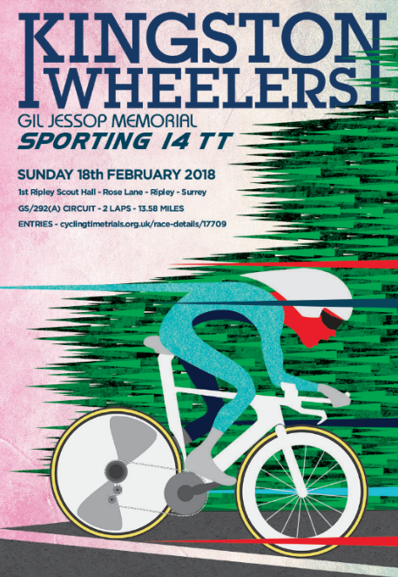



Gil Jessop Memorial 'Sporting 14' Time Trial
25th Edition

Promoted for and on behalf of Cycling Time Trials under their Rules and Regulations

Sunday 18th February 2018 at 08:30

Event Secretary
Alice Lethbridge
kingstonwheelertt@outlook.com

Contact on the Day

Jeremy Maccelari

Tel 07918981041

HQ
- 1st Ripley Scout Group Hall, Rose Lane, Ripley, Surrey GU23 6NE
- 0.5 km SE of junction B2215 (High Street) / B367 (Newark Lane)

Gil Jessop
The Kingston Wheelers Cycling Club was formed in 1924. Six cyclists met in a cafe on the Portsmouth Road near Kingston police station. Gil Jessop, for whom this race is a memorial, joined the club in about 1930. The Second World War curtailed activities for a number of years. The last club run was in 1941 and most members were called up for service. Gil Jessop served in the armed forces and after demob, he helped to reform the club in Chessington in 1953. He later became President of the club until his death in the early 1990s.

Event Records
Men: John Dewey 30:07 (2017) from Rob Sharland 30.31 (2016)
Women: Alice Lethbridge 34:41 (2016) from Alice Lethbridge 36:42 (2015)
Team: Paceline RT 1.35.45 (2015) from Team a3crg 1:38:36 (2008)
Signing On
- Opens at 07:30 (first rider off 8.33)
- Sign-on and start numbers at Event HQ (Ripley Scout Hall)
- Numbers are to be worn in conjunction with Regulation 16. “No time may be recorded if number is not correctly positioned.”
- Allow 5 minutes from HQ to START (0.8 miles)
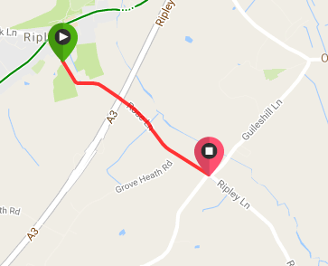
Signing out
Please be aware of the following regulation:
Regulation 17 (b) In Type A events a competitor must return to the event HQ either during the event or within a reasonable time after the last rider has finished the event and must (i) return their race number(s) and (ii) sign the official Signing-out Sheet. Failure to do so will result in a DNF being recorded.

Doping control
This event may be subject to a Doping Control. As soon as you have finished you should return to the event HQ as it is your responsibility to check if you are required for Doping Control. Race numbers required for Doping Control will be displayed at the HQ adjacent to the result board. If your number is displayed you should report immediately to Doping Control which will be nearby. Remember, it is up to you to check and ensure that you comply. If required you must report to Doping Control after finishing without delay.

Safety Instructions
- CTT regulations require compulsory use of helmets for the under 18's. In the interests of your own safety, Cycling Time Trials and the event promoters strongly advise all competitors to wear a hard/soft shell helmet that meets an internationally accepted safety standard.
- Competitors Machines: It is recommended that a working, rear light, either flashing or constant, is fitted to the machine in a position clearly visible to following road users and is active while the machine is in use.
- Competitors are requested not to warm up on the course after the first competitor has started.
- Details of any additional hazards not listed on the start sheet will be displayed at the signing on point. All competitors must read these details when they sign on.
- Competitors must exercise extra care when turning LEFT on to the A246, at West Horsley roundabout and when passing the Start Point at the end of the first circuit. Also competitors crossing the central line of Rose Lane prior to turning left into Hungry Hill Lane may be disqualified.
- The road surface on the course has deteriorated significantly in recent years, and there are now a number of potholes and areas of very rough road on the course. In particular, at the bottom of Hungry Hill Lane, the turn toward the descent of Hungry Hill Lane, with a number of potholes and ruts scattered throughout the course. Competitors are reminded that a safe ride is more important than a fast ride – please exercise extreme care.
- Official Observers will be stationed around the course.
- No times will be given at the finish.

General Notes
- London South District Regulation: No Vehicles, except those of the Timekeepers’ and Event Officials, shall be parked in the vicinity of the start and finish areas

Specific to Event
- Due to the large number of novice riders in this event with no prior times to assist with seeding, riders’ attention is drawn to the regulations that govern Time Trials and prohibits drafting (riding in company).
- Please be aware of parking restrictions in side roads off Rose Lane (near Scout Hut). There is a new car park WITH HEIGHT BARRIER. Those with roof mounted bikes please be aware.

PLEASE KEEP NOISE TO MINIMUM FOR RESIDENTS AND RESPECT PARKING RESTRICTIONS

Prizes
- One prize per rider of the highest value (excluding team prize and course record)
- KW Sporting 14 Artwork by Darren Marshall for fastest man, and fastest woman
- Course record prizes are donated by the club
- The team prize is three riders to count; where a club has enough riders to make up more than one team they many win more than one of the team prizes

Prize List | 1st | 2nd | 3rd | 4th | 5th
Men | £50 | £40 | £30 | £20 | £10
Women | £50 | £40 | £30 | - | -
Veteran Men | £30 | £20 | £10 | - | -
Veteran Women | £30 | - | - | - | -
Junior Men | £15 | - | - | - | -
Junior Women | n/a | - | - | - | -
Men Road Bike | £35 | £25 | £15 | - | -
Women Road Bike | £35 | £25 | £15 | - | -
Team | £45 | £30 | £15 | - | -
Team: New Course Record | £60 | - | - | - | -
Men: New Course Record | £100 | - | - | - | -
Women: New Course Record | £100 | - | - | - | -

Road Bike Competition: Inform the results board on the day if you are competing in this category
To be eligible for this competition you must be riding a bicycle that has:
• Drop handlebars
• No aerobars fitted
• No Discs or Tri/Quad spoke wheels; disc brakes are allowed

For the rider
• Must wear a helmet that is legal in a road race i.e. no pointy TT helmet
• Skinsuits are permitted
• Shoe covers are permitted

Teams
Crawley Wheelers (5 entries)
Dorking Cycling Club (5 entries)
Kingston Phoenix RC (5 entries)
Kingston Wheelers CC (21 entries)
Paceline RT (8 entries)
Twickenham CC (4 entries)
Course
- London South DC – 13.58 mile circuit course - GS/292(A)
- Hungry Hill Lane > East Clandon > West Horsley > Ripley Lane
- 2 laps, 13.58 miles
- The course details are as follows:
OS REF | Details | Distances
062558 | START in Hungry Hill Lane at TP7, 114 yards south of junction with Rose Lane and about 0.8 miles southeast of Ripley. | 0.00 | 0.00
062516 | Proceed along Hungry Hill Lane and Ripley Road to East Clandon, where LEFT into The Street. Follow this road round SHARP RIGHT HAND bend to junction with A246 | 3.12 | 3.12
079523 | LEFT (CARE) and follow A246 to West Horsley roundabout  LEFT 1st exit into The Street and after ¼ mile, fork LEFT into Ripley Lane.  Continue into Rose Lane to junction with Hungry Hill Lane | 1.15  2.61 | 4.27  6.88
062558 | LEFT into Hungry Hill Lane to complete first circuit or FINISH at a point 100 yards before the junction with Rose Lane and Hungry Hill Lane. | 6.70 | 13.58

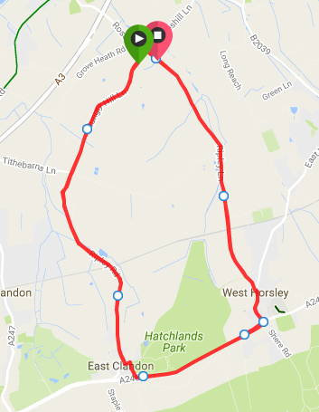

Strava link to the course
https://www.strava.com/segments/8887633

Start Sheet

Number | Start  time | First name | Last name | Club | Gender | Age | Road bike
3 | 08:33:00 | Mark | Griffiths | RT 316 | Male | Senior
4 | 08:34:00 | Benoit | Ramsay | Paceline RT | Male | Senior
5 | 08:35:00 | Ria | Woodfield | Kingston Wheelers CC | Female | Senior
6 | 08:36:00 | Chris | Jolliffe | Crawley Wheelers | Male | Veteran | x
7 | 08:37:00 | Nigel | Robathan | Dorking Cycling Club | Male | Veteran
8 | 08:38:00 | Helen | Sharp | Boot Out Breast Cancer Cycling Club | Female | Senior
9 | 08:39:00 | Laura | Wilkey | Crawley Wheelers | Female | Senior
10 | 08:40:00 | Simon | Pontin | Addiscombe CC | Male | Espoir
11 | 08:41:00 | Gary | Baker | Reading CC | Male | Veteran | x
12 | 08:42:00 | Gill | Thom | Kingston Wheelers CC | Female | Veteran | x
13 | 08:43:00 | Michael | Bradley | CC Bexley | Male | Senior
14 | 08:44:00 | Jack | Hartrey | Kingston Wheelers CC | Male | Juvenile
15 | 08:45:00 | David | Percival | Kingston Phoenix RC | Male | Veteran
16 | 08:46:00 | Derrick | Thirlwell | Kingston Wheelers CC | Male | Veteran
17 | 08:47:00 | Suzanne | Shaw | Kingston Phoenix RC | Female | Veteran
18 | 08:48:00 | Peter | Griffiths | Dorking Cycling Club | Male | Veteran | x
19 | 08:49:00 | Pippa | O'Brien | RT PODA | Female | Veteran
20 | 08:50:00 | Richard | Pearce | Paceline RT | Male | Senior | x
21 | 08:51:00 | Tom | Coombe | Kingston Wheelers CC | Male | Senior
22 | 08:52:00 | Anna | Harborow | Brixton Cycles Club | Female | Senior
23 | 08:53:00 | Ronn | Fraser | Kingston Wheelers CC | Male | Veteran | x
24 | 08:54:00 | Natarsha | Tremayne | Stomp the Pedal | Female | Veteran
25 | 08:55:00 | Dominic | Trevett | Kingston Wheelers CC | Male | Senior | x
26 | 08:56:00 | Lenka | Vackova | Rapha Cycling Club | Female | Senior
27 | 08:57:00 | michael | gates | Chew Valley Cycling Club | Male | Senior
28 | 08:58:00 | Ewan | Tuohy | Dartford Road Club | Male | Senior | x
29 | 08:59:00 | Esme | Cole | Kingston Wheelers CC | Female | Senior | x
30 | 09:00:00 | Daniel | Sharp | Charlotteville Cycling Club | Male | Veteran
31 | 09:01:00 | Helen | Bridgman | Kingston Wheelers CC | Female | Senior | x
32 | 09:02:00 | Duncan | Emery | Twickenham CC | Male | Veteran
33 | 09:03:00 | T-Y | Hsia | Kingston Wheelers CC | Male | Veteran | x
34 | 09:04:00 | Alexander | Kew | Kingston Phoenix RC | Male | Veteran
35 | 09:05:00 | stuart | stow | Twickenham CC | Male | Veteran | x
36 | 09:06:00 | Simon | Trehearn | Kingston Phoenix RC | Male | Veteran
37 | 09:07:00 | Alex | Reid | Kingston Wheelers CC | Male | Senior | x
38 | 09:08:00 | David | Garratt | Onyx RT | Male | Veteran
39 | 09:09:00 | NEIL | HARRIGAN | Gravesend CC | Male | Veteran | x
40 | 09:10:00 | Adam | Stone | North Road CC | Male | Senior
41 | 09:11:00 | tony | venus | Dorking Cycling Club | Male | Veteran
42 | 09:12:00 | Tom | Herbert | Kingston Wheelers CC | Male | Senior | x
43 | 09:13:00 | sean | taylor | Redmon CC | Male | Senior
44 | 09:14:00 | Dan | Cole | Dorking Cycling Club | Male | Veteran
45 | 09:15:00 | Harry | Bunnell | Kingston Wheelers CC | Male | Senior | x
46 | 09:16:00 | Jonathan | Pontin | Addiscombe CC | Male | Senior
47 | 09:17:00 | Liam | Smith | Kingston Wheelers CC | Male | Senior
48 | 09:18:00 | Dan | Pullen | Crawley Wheelers | Male | Veteran
49 | 09:19:00 | Damien | Breen | Brixton Cycles Club | Male | Senior | x
50 | 09:20:00 | Leigh | Schvartz | Team Swindon Cycles | Male | Senior
51 | 09:21:00 | Robin | Johnson | Brighton Mitre CC | Male | Veteran
52 | 09:22:00 | James | Griffin | trainSharp | Male | Senior
53 | 09:23:00 | Rupert | Bole | Kingston Wheelers CC | Male | Veteran
54 | 09:24:00 | Dale | Lush | Kingston Phoenix RC | Male | Senior
55 | 09:25:00 | Helen | Gravatt | London Women's Racing CC | Female | Veteran
56 | 09:26:00 | Martin | Winter | Twickenham CC | Male | Veteran
57 | 09:27:00 | Mark | Aldred | Kingston Wheelers CC | Male | Senior | x
58 | 09:28:00 | Andrew | Bradbury | Paceline RT | Male | Senior
59 | 09:29:00 | Seb | Ashton | Kingston Wheelers CC | Male | Senior | x
60 | 09:30:00 | Alice | Lethbridge | DRAG2ZERO | Female | Senior
61 | 09:31:00 | Craig | Swatton | Crawley Wheelers | Male | Senior
62 | 09:32:00 | Neil | Grunshaw | Kingston Wheelers CC | Male | Senior
63 | 09:33:00 | Simon | Mumme | Paceline RT | Male | Senior | x
64 | 09:34:00 | Henrik | Persson | Kingston Wheelers CC | Male | Senior
65 | 09:35:00 | Daniel | Loveday | Charlotteville Cycling Club | Male | Veteran
66 | 09:36:00 | Matt | Peel | C and N Cycles RT | Male | Senior
67 | 09:37:00 | Craig | Lawrence | Kingston Wheelers CC | Male | Senior
68 | 09:38:00 | Keith | Lea | Paceline RT | Male | Veteran
69 | 09:39:00 | James | Cheeseman | Crawley Wheelers | Male | Senior
70 | 09:40:00 | Ben | Elliott | Paceline RT | Male | Senior
71 | 09:41:00 | David | Eccles | Redmon CC | Male | Veteran | x
72 | 09:42:00 | Jamie | Pine | Nuun-Sigma Sport-London RT | Male | Veteran
73 | 09:43:00 | Nick | Eisinger | Dorking Cycling Club | Male | Veteran
74 | 09:44:00 | Thomas | Whatley | Paceline RT | Male | Senior
75 | 09:45:00 | Rowan | Brackston | London Dynamo | Male | Senior | x
76 | 09:46:00 | Pat | Wright | Paceline RT | Male | Senior
77 | 09:47:00 | Dean | Kirkwood | Kingston Wheelers CC | Male | Veteran
78 | 09:48:00 | Liam | Maybank | Twickenham CC | Male | Veteran
79 | 09:49:00 | James | Black | Imperial College Cycling Club | Male | Senior
80 | 09:50:00 | Edmund | Bradbury | JLT Condor | Male | Senior

Please note regulation 16 “No time may be recorded if number is not correctly positioned.”
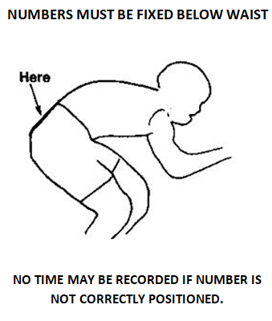

Time Keepers
Richard Blackmore (start) Rob Gardner (finish)

Artwork
Darren Marshall

Event Secretary
Alice Lethbridge

Kingston Wheelers Cycling Club
www.kingstonwheelers.co.uk

