‘Promoted for and on behalf of Cycling Time Trials under their Rules and Regulations’

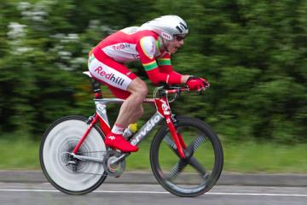

Redhill Cycling Club
18 mile 'Sporting' Time Trial – GS/478

Sunday 25th February 2018 at 09:00

Event Secretary: Steven Bryant
steve@bryantjoinery.co.uk
07930 522458 (for contact on the day)
11 Canfold Cottages,
Bookhurst Road,
Cranleigh, Surrey
GU6 7DR

Headquarters: The Westcott Reading Room,
Institute Road,
Westcott,
Dorking.
RH4 3NP

Timekeepers: Mr. Mick Irons
Mr. Paul Tunnell
Signing On
- Opens at 07:45 (first rider off 09:00)
- Sign-on and start numbers at Event HQ (Westcott Reading Room)
- Numbers are to be worn in conjunction with Regulation 16. “No time may be recorded if number is not correctly positioned.”
- Allow 5 minutes from HQ to START turn left heading west on A25 out of HQ (approximately 0.5 miles)

Signing out
Please be aware of an addition to the regulations for 2017.
Regulation 17 (b) In Type A events a competitor must return to the event HQ either during the event or within a reasonable time after the last rider has finished the event and must (i) return their race number(s) and (ii) sign the official Signing-out Sheet.

Safety Instructions
- CTT regulations require compulsory use of helmets for the under 18's. In the interests of your own safety, Cycling Time Trials and the event promoters strongly advise all competitors to wear a hard/soft shell helmet that meets an internationally accepted safety standard.
- Competitors Machines: It is recommended that a working, rear light, either flashing or constant, is fitted to the machine in a position clearly visible to following road users and is active while the machine is in use.
- Competitors are requested not to warm up on the course after the first competitor has started.
- Details of any additional hazards not listed on the start sheet will be displayed at the signing on point. All competitors must read these details when they sign on.
- The road surface on the course has deteriorated significantly in recent years, and there are now a number of potholes and areas of very rough road on the course. In particular, the decent just after the Punchbowl pub in Oakwoodhill and back up to the A29 there are a number of potholes and ruts scattered on this section please take care. Competitors are reminded that a safe ride is more important than a fast ride – please exercise extreme care. Remember its February – use common sense when choosing what tyres to ride with.
- Official Observers will be stationed around the course.
- No times will be given at the finish.

General Notes
- London South District Regulation: No vehicles shall be parked on the highway within sight of the starting or finishing points.

Specific to Event
- Due to the large number of novice riders in this event with no prior times to assist with seeding, riders attention is drawn to the regulations that govern Time Trials and prohibits drafting (riding in company).

Parking
- The HQ is located very near Nirvana Cycles in the centre of Westcott. First left after the shop if approaching from Dorking direction. There is a limited amount of parking available
- Free public car park between Dorking and Westcott on A25
Location link here – easy ride to/from the HQ.
When parking is full please park considerately and DO NOT block driveways. Use common sense when parking and act with respect toward local residents and other road users.

PLEASE RESPECT THE SURROUNDING HOUSEHOLDERS AND PARK WITH CARE

Prizes

The winner will hold the Crusader Trophy for 1 Year

Fastest Redhill CC rider will hold the Peter Appleyard Memorial Trophy for 1 year

- One cash prize per rider of the highest value (excluding team prize)
- Spot prizes must be collected on the day

Prize List | 1st | 2nd | 3rd | 4th | 5th
Men | £40 | £30 | £20 | £15 | £10
Women | £40 | £20 | - | - | -
Veteran on standard | £30 | £20 | £10 | - | -
Men Road Bike | £25 | £15 | £10 | - | -
Women Road Bike | £25 | - | - | - | -
Spot prize (bottle of wine) | 15th | 25th | 35th | 45th | 55th
Team | £30 | - | - | - | -

Road Bike Competition

To be eligible for this competition you must be riding a bicycle that has:
• Drop handlebars
• No aerobars fitted
• No Discs or Tri/Quad spoke wheels; disc brakes are allowed (Road Race legal deep section wheels allowed)

For the rider
• Must wear a helmet that is legal in a road race i.e. no pointy TT helmet
• Skinsuits are permitted
• Shoe covers are permitted

If you intend to enter the road bike category, please tell the signing-on sheet volunteer.

Please email Steve Bryant on steve@bryantjoinery.co.uk if you have any queries on whether your bike/equipment/clothing is suitable. It is not the role of the timekeeper or any start line staff to provide guidance on eligibility – this must be confirmed in advance. The organisers’ decision on eligibility is final and any bikes deemed ineligible will for the road bike category will still be eligible for the TT category.

Course
- London South DC – 18 mile course - GS/478
- DORKING/ABINGER HAMMER/FOREST GREEN/OAKWOODHILL/BEARE GREEN/NORTH HOLMWOOD -A25/A29/A24/B2126/B2127
- The course details are as follows:
OS REF | Details | Distances
137484 | START at the junction of Logmore Lane with the A25 just west of Wescott | 0.00 | 0.00
096475 | Follow A25 westwards via Coast Hill (1 in 8 ascent) to junction with B2126 at Abinger Hammer (CHECK) | 2.8 | 2.8
124416 | LEFT into Felday Road B2126 and proceed southeast via Holmbury St. Mary to junction with Ockley Road (B2127) at Forest Green | 4.6 | 7.4
118378 | RIGHT onto B2127 and first LEFT into Horsham Road past The Parrot Inn. Proceed south to  Mayes Green. Straight on, now along Walliswood Green Road, past the Scarlett Arms PH to junction with the Walliswood to Oakwoodhil road signposted Oakwoodhill (CHECK) | 2.4 | 9.8
139381 | LEFT into Walliswood to Oakwoodhill Road and proceed eastwards to junction with Honeywood Lane at Oakwoodhill. Bear LEFT past the Punchbowl Inn and down to junction with A29 (CHECK) | 1.6 | 11.0
177428 | LEFT onto A29 and proceed north to Beare Green RBT (roundabout)
166465 | LEFT 1st exit and follow A24 via South Holmwood to FINISH at the centre point of The Red Chilli restaurant on the northbound carriageway | 6.6 | 18.0

Strava link to the course
https://www.strava.com/segments/887716?hl=en-GB

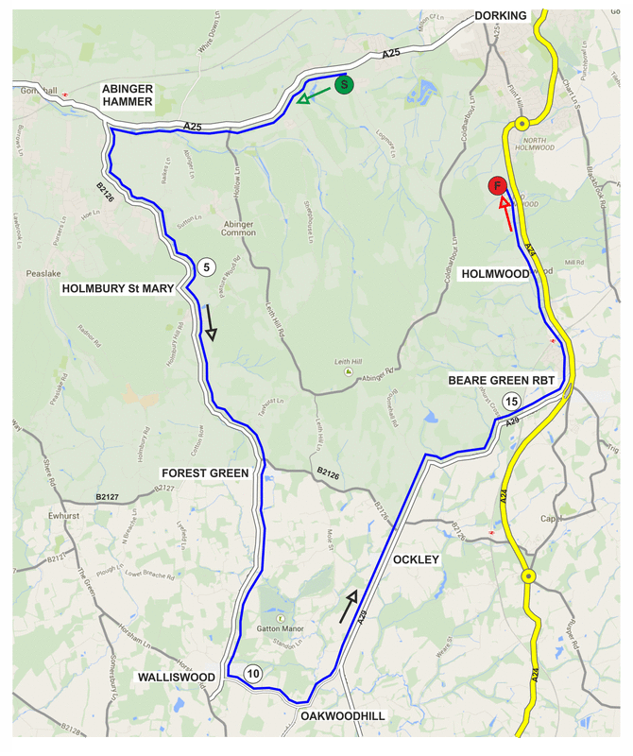
Start Sheet
Bib |  | Start Time | First Name |  | Last Name |  | Club |  | Gender |  | Category
1 | 09:01:00 |  |  | Mark |  | Thompson |  | Redhill CC |  | Male |  | Veteran
2 | 09:02:00 |  |  | Carl |  | Stephens |  | Basildon CC |  | Male |  | Veteran
3 | 09:03:00 |  |  | Andy |  | Bartlett |  | Paceline RT |  | Male |  | Senior
4 | 09:04:00 |  |  | Pippa |  | O'Brien |  | RT PODA |  | Female |  | Veteran
5 | 09:05:00 |  |  | Jamie |  | Pine |  | Nuun-Sigma Sport-London RT |  | Male |  | Veteran
6 | 09:06:00 |  |  | Dan |  | Cole |  | Dorking Cycling Club |  | Male |  | Veteran
7 | 09:07:00 |  |  | Michael |  | Gates |  | Chew Valley Cycling Club |  | Male |  | Senior
8 | 09:08:00 |  |  | Duncan |  | Rimmer |  | Morden CRC |  | Male |  | Veteran
9 | 09:09:00 |  |  | Nigel |  | Robathan |  | Dorking Cycling Club |  | Male |  | Veteran
10 | 09:10:00 |  |  | Gary |  | Brind |  | South Downs Bikes / Casco Europe |  | Male |  | Veteran
11 | 09:11:00 |  |  | Jonathan |  | Pontin |  | Addiscombe CC |  | Male |  | Senior
12 | 09:12:00 |  |  | Paul |  | Moore |  | Paceline RT |  | Male |  | Senior
13 | 09:13:00 |  |  | Rupert |  | Bole |  | Kingston Wheelers CC |  | Male |  | Veteran
14 | 09:14:00 |  |  | Laura |  | Wilkey |  | Crawley Wheelers |  | Female |  | Senior
15 | 09:15:00 |  |  | Christian |  | Yates |  | East Grinstead CC |  | Male |  | Veteran
16 | 09:16:00 |  |  | Paul |  | Barnard |  | South Downs Bikes / Casco Europe |  | Male |  | Senior
17 | 09:17:00 |  |  | Matthew |  | Sim |  | Dorking Cycling Club |  | Male |  | Espoir
18 | 09:18:00 |  |  | Robert |  | Jolliffe |  | New Forest CC |  | Male |  | Veteran
19 | 09:19:00 |  |  | Morag |  | Spence |  | London Dynamo |  | Female |  | Veteran
20 | 09:20:00 |  |  | Matt |  | Peel |  | C and N Cycles RT |  | Male |  | Senior
21 | 09:21:00 |  |  | Phil |  | Ember |  | Paceline RT |  | Male |  |  | Veteran
22 | 09:22:00 |  |  | Chris |  | Jolliffe |  | Crawley Wheelers |  | Male |  |  | Veteran
23 | 09:23:00 |  |  | Luke |  | Worthington |  | Maison du Velo - Storck Bikes UK |  | Male |  |  | Senior
24 | 09:24:00 |  |  | Robin |  | Johnson |  | Brighton Mitre CC |  | Male |  |  | Veteran
25 | 09:25:00 |  |  | Matthew |  | Ferguson |  | Redhill CC |  | Male |  |  | Espoir
26 | 09:26:00 |  |  | Simon |  | Smythe |  | Norwood Paragon CC |  | Male |  |  | Veteran
27 | 09:27:00 |  |  | Shaun |  | Marlor |  | Bec CC |  | Male |  |  | Veteran
28 | 09:28:00 |  |  | Steve |  | Dewis |  | Redhill CC |  | Male |  |  | Veteran
29 | 09:29:00 |  |  | Paul |  | Robinson |  | Dartford Road Club |  | Male |  |  | Veteran
30 | 09:30:00 |  |  | Thomas |  | Whatley |  | Paceline RT |  | Male |  |  | Senior
31 | 09:31:00 |  |  | Richard |  | Birtwhistle |  | Sydenham Whs |  | Male |  |  | Veteran
32 | 09:32:00 |  |  | Jason |  | Hunter |  | Pearson Cycling Club |  | Male |  |  | Veteran
33 | 09:33:00 |  |  | Andrew |  | Walker |  | Redhill CC |  | Male |  |  | Veteran
34 | 09:34:00 |  |  | Joseph |  | Robinson |  | Dartford Road Club |  | Male |  |  | Senior
35 | 09:35:00 |  |  | Andy |  | Lack |  | Paceline RT |  | Male |  |  | Veteran
36 | 09:36:00 |  |  | Neil |  | Harrigan |  | Gravesend CC |  | Male |  |  | Veteran
37 | 09:37:00 |  |  | Dan |  | Bartley |  | Dorking Cycling Club |  | Male |  |  | Veteran
38 | 09:38:00 |  |  | Craig |  | Swatton |  | Crawley Wheelers |  | Male |  |  | Senior
39 | 09:39:00 |  |  | Lenka |  | Vackova |  | Rapha Cycling Club |  | Female |  |  | Senior
40 | 09:40:00 |  |  | Keith |  | Lea |  | Paceline RT |  | Male |  |  | Veteran
41 | 09:41:00 |  |  | David |  | Churchill |  | Bigfoot CC |  | Male |  |  | Veteran
42 | 09:42:00 |  |  | Neal |  | Marrin |  | Finsbury Park CC |  | Male |  |  | Veteran
43 | 09:43:00 |  |  | Peter |  | Owen |  | Norwood Paragon CC |  | Male |  |  | Veteran
44 | 09:44:00 |  |  | Tony |  | Venus |  | Dorking Cycling Club |  | Male |  |  | Veteran
45 | 09:45:00 |  |  | Ewan |  | Tuohy |  | Dartford Road Club |  | Male |  |  | Senior
46 | 09:46:00 |  |  | Mark |  | Aldred |  | Kingston Wheelers CC |  | Male |  |  | Senior
47 | 09:47:00 |  |  | Stephen |  | Wilkinson |  | 34 Nomads CC |  | Male |  |  | Veteran
48 | 09:48:00 |  |  | Ben |  | Elliot |  | Redhill CC |  | Male |  |  | Juvenile
49 | 09:49:00 |  |  | Simon |  | Pontin |  | Addiscombe CC |  | Male |  |  | Espoir
50 | 09:50:00 |  |  | Simon |  | McNamara |  | South Downs Bikes / Casco Europe |  | Male |  |  | Veteran
51 | 09:51:00 |  |  | Martin |  | Winter |  | Twickenham CC |  | Male |  |  | Veteran
52 | 09:52:00 |  |  | Stewart |  | Gregory |  | Nottingham Clarion CC |  | Male |  |  | Veteran
53 | 09:53:00 |  |  | Maurice |  | Joseph |  | Paceline RT |  | Male |  |  | Senior
54 | 09:54:00 |  |  | David |  | Eccles |  | Redmon CC |  | Male |  |  | Veteran
55 | 09:55:00 |  |  | Ben |  | Elliott |  | Paceline RT |  | Male |  |  | Senior
56 | 09:56:00 |  |  | Adrian |  | Blacker |  | Norwood Paragon CC |  | Male |  |  | Veteran
57 | 09:57:00 |  |  | Ryan |  | Harris |  | Redhill CC |  | Male |  |  | Veteran
58 | 09:58:00 |  |  | Sean |  | Taylor |  | Redmon CC |  | Male |  |  | Senior
59 | 09:59:00 |  |  | Emma |  | Naylor |  | University of Bath Cycling Club |  | Female |  |  | Espoir
60 | 10:00:00 |  |  | Liam |  | Maybank |  | Twickenham CC |  | Male |  |  | Veteran
61 | 10:01:00 |  |  | Ben |  | Hopwood |  | Just Pedal RT |  | Male |  |  | Senior
62 | 10:02:00 |  |  | Sam |  | Clarke |  | Team Bottrill / Vanguard |  | Male |  |  | Senior
63 | 10:03:00 |  |  | Zoe |  | Bartlett |  | Folkestone Velo Club |  | Female |  |  | Veteran
64 | 10:04:00 |  |  | Richard |  | Pearce |  | Paceline RT |  | Male |  |  | Senior
65 | 10:05:00 |  |  | Philip |  | Murrell |  | Finsbury Park CC |  | Male |  |  | Veteran

Wishing you a SAFE and FAST ride. Keep your head up.

Please exchange race number for a free drink at HQ and DON’T FORGET YOU MUST SIGN OUT

Redhill Cycling Club
www.redhill.cc

