**Revo Racing**

Presents our Open 25-mile Time Trial (S8/25S)

*(Promoted for and on behalf of Cycling Time Trials under their Rules and Regulations)*

On Sunday, 8th April 2018  
(First rider starts at 09:01)

# Event HQ

**Oakford Village Hall  
Rookery Hill, Oakford  
Devon EX16 9ER**

Open from 08:00 for sign-on and number collection.

Please return your number and remember to sign back in. Failure to do so could mean disqualification.

Please park considerately at the hall and show consideration to village residents by not obstructing the lanes around the village or HQ.

# Event Secretary

Matt Slater, Brendon, Springfield Avenue, Barnstaple EX32 9AU.

Mobile: 07764 538469  
Email: matthewpslater@yahoo.co.uk

Timekeepers: Gill and Ian Daveridge  
Marshals and helpers: Members & friends of Revo Racing.

# Awards

One rider, one prize.

|  |  |  |  |  |
| --- | --- | --- | --- | --- |
| **OVERALL** |  | **LADIES** |  | **VETS** |
| 1st - £30 |  | 1st - £30 |  | 1st (Age 40-49) - £15 |
| 2nd - £20 |  | 2nd - £20 |  | 1st (Age 50-59) - £15 |
| 3rd - £10 |  | 3rd - £10 |  | 1st (Age 60+) - £15 |

**The “Bard Electrical” Road Bike Prize**

Overall, 1st - £25

Ladies, 1st - £25

# Road Bike Category

If you wish to enter the road bike category, please indicate this on the day during sign-on.  
To be eligible for this competition you must be riding a bicycle that has:

* Drop handlebars
* No aerobars
* No Discs, Tri/Quad spoke wheels
* Wheels with rims no deeper than 60mm.

The rider:

* Must wear a helmet that is legal in a road race i.e. no pointy TT helmets or those with cut-off tails such as the Kask Bambino
* Can wear a skinsuit and shoe covers.

# Course Map

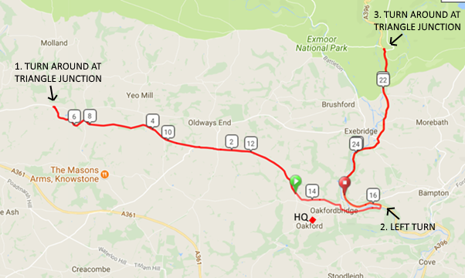

**Course Profile**

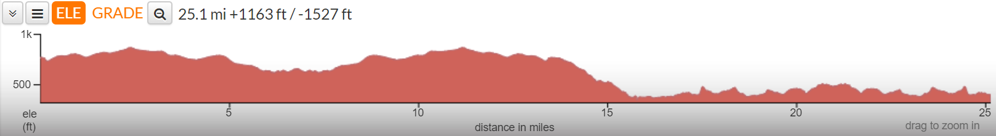

# Course Detail

**START** at a point 3 yards before the junction of the B3227 on the lane signposted to Oakford, immediately opposite property No.1, High Bolham (EX16 9JY) and 2.2 miles to the west of The Black Cat junction. Grid Reference: SS 901 222.

Immediately **TURN LEFT**, joining the B3227 in a westerly direction towards South Molton.  Continue for a distance of 6.8 miles to Wester Bullaford Moor.

**TURN RIGHT**, taking care when crossing traffic andimmediately **TURN RIGHT**again**,**then**TURN LEFT**(traverse triangle junction in a clockwise direction) re-joining the B3227 East.

Continue past the start point and descend the hill towards The Black Cat.Riders are advised to **TAKE CARE**on the descent, particularly where the road bends **SHARP LEFT** before crossing the bridge (15.8 miles).  Beware of oncoming vehicles in the middle of the road.

Just after the bridge, **TURN LEFT** and **LEFT AGAIN**, joining the A396 North towards Minehead.

Continue north along the A396. **TAKE** **CARE** at 18.6 mileswhere the road bends**SHARP LEFT**and continue along the A396 to Machine Cross (21.0 miles).  
  
**TURN RIGHT,**taking carewhen crossing traffic andimmediately **TURN RIGHT**again,then**TURN LEFT**(traverse triangle junction in a clockwise direction) re-joining the A396 South.

Continue back towards The Black Cat and **FINISH** at a point adjacent to the first drain cover after the *Oncoming Vehicle*s warning sign as you enter Oakfordbridge village.  
Distance 25.1 miles. Grid Reference: SS 920 221.

Return to the HQ via The Black Cat junction.

# Riders’ Notes

Allow **15 minutes** to reach the start from the HQ.

**No warming up on the course once the event has started please.**

Those wishing to warm up on the road should consider collecting their numbers then moving their vehicle to a layby on the A396 south of Black Cat junction. Be aware of riders travelling at high speed on the descent.

Please observe the Highway Code. AVOID DISQUALIFICATION AND KEEP YOUR HEAD UP AT ALL TIMES and do not white line. Please fit a working rear light to your cycle (flashing or constant) to be used if conditions are dull. It is also advisable to wear bright clothing.

In the interests of your own safety, Cycling Time Trials and the event promoters strongly advise riders to wear a HARD-SHELL HELMET that meets an approved international safety standard. Local regulation 1: All riders on completion of their competitive ride must continue without stopping or turning in the road to the event HQ.

The risk assessment form and signing-on and signing-off sheets will be on the table at the HQ hall. When signing-on, please look to see if there are any extra safety notes on the risk assessment form added after the pre-race course inspection.

Please remember that Event Officials have no legal right to interfere with or regulate traffic.  
CTT requires that all riders be aware of, and observe the rules applying to company riding and drafting.

Please do not approach the finishing time keepers whilst the event is in progress.  
Call out your number loud and clear on the finish line if possible.

Thank you all for your support and we hope you have a safe and successful ride.

The Revo Racing team.

# Special Thanks

With thanks to our sponsors **Bard Electrical**, **The** **Bark House Hotel** and **Zwift** for their support.

# Start Sheet

|  |  |  |  |  |  |
| --- | --- | --- | --- | --- | --- |
| **Start Time** | **Bib** | **Name** | **Gender** | **Category** | **Club** |
| 09:01 | 1 | Julian Harper | Male | Vet (40-49) | Revo Racing |
| 09:02 | 2 | Nichola Rorke | Female | Vet (40-49) | Exeter Whs CC |
| 09:03 | 3 | Iain Garside | Male | Vet (50-59) | Wellington Wheelers Cycling Club |
| 09:04 | 4 | Helen Wilson | Female | Senior | Taw Velo |
| 09:05 | 5 | Nick Harwood | Male | Vet (50-59) | Revo Racing |
| 09:06 | 6 | David Hall | Male | Vet (50-59) | Royal Navy & Royal Marines CA |
| 09:07 | 7 | Steve Clarke | Male | Vet (50-59) | Bristol South Cycling Club |
| 09:08 | 8 | Chris Fishleigh | Male | Senior | Team DCP |
| 09:09 | 9 | Emily Slater | Female | Vet (40-49) | Taw Velo |
| 09:10 | 10 | Josh Coyne | Male | Senior | Okehampton CC |
| 09:11 | 11 | Mike Rose | Male | Vet (60+) | Exeter Whs CC |
| 09:12 | 12 | Rebecca Cornwell | Female | Senior | Taw Velo |
| 09:13 | 13 | Peter Shelley | Male | Vet (50-59) | Wellington Wheelers Cycling Club |
| 09:14 | 14 | Darren Armstrong | Male | Vet (40-49) | Taw Velo |
| 09:15 | 15 | Stuart Pollard | Male | Senior | Exeter Whs CC |
| 09:16 | 16 | Andrew Kelly | Male | Vet (50-59) | Somerset Road Club |
| 09:17 | 17 | Bob Brabbins | Male | Vet (60+) | Wellington Wheelers Cycling Club |
| 09:18 | 18 | Keith Johnson | Male | Vet (40-49) | Full Gas Racing Team |
| 09:19 | 19 | Maxine Webber | Female | Vet (40-49) | Taw Velo |
| 09:20 | 20 | Richard Babbage | Male | Vet (40-49) | Exeter Whs CC |
| 09:21 | 21 | Ruth Burrows | Female | Senior | Mid Devon CC |
| 09:22 | 22 | Owen Messenger | Male | Vet (40-49) | Team DCP |
| 09:23 | 23 | Nicola Miller | Female | Vet (50-59) | Revo Racing |
| 09:24 | 24 | Nijel Collingham | Male | Vet (50-59) | Taw Velo |
| 09:25 | 25 | Ian Lindsay | Male | Vet (40-49) | Gloucester City Cycling Club |
| 09:26 | 26 | Mat Kelly | Male | Senior | Pure Endurance |
| 09:27 | 27 | Stewart Henderson | Male | Vet (50-59) | Taw Velo |
| 09:28 | 28 | Huw Thomas | Male | Vet (50-59) | Wellington Wheelers Cycling Club |
| 09:29 | 29 | Paul Wynne | Male | Vet (50-59) | Exeter Whs CC |
| 09:30 | 30 | Paul Walshe | Male | Vet (40-49) | Plymouth Corinthian CC |
| 09:31 | 31 | Owen Prior | Male | Senior | Exeter Whs CC |
| 09:32 | 32 | Phil Smith | Male | Vet (50-59) | Mid Devon CC |
| 09:33 | 33 | Gary Webber | Male | Vet (50-59) | Taw Velo |
| 09:34 | 34 | Stephen Blackmore | Male | Senior | Mid Devon CC |
| 09:35 | 35 | Richard Easton | Male | Senior | Pure Endurance |
| 09:36 | 36 | Lloyd Dobson | Male | Senior | Army Cycling Union |
| 09:37 | 37 | Ashley Fletcher | Male | Senior | North Devon Wheelers |
| 09:38 | 38 | Adrian Wilson | Male | Senior | Taw Velo |
| 09:39 | 39 | Simon Edney | Male | Vet (50-59) | Revo Racing |
| 09:40 | 40 | Marcin Bialoblocki | Male | Senior | NOPINZ |