Manchester and District
Ladies’ Cycling Association

Saturday 21st April 2018

2018 "GHS" District Championship,

Ladies Open Handicapped and Men’s Invitation 10-mile Time Trial

Promoted for and on behalf of Cycling Time Trials under their rules and regulations.
Handicapped using standard tables

Event Organiser: H. West, 49 Grendale Avenue, Hazel Grove, Stockport, Cheshire, SK7 6LJ
Tel: - 0161 456 9376 / 07800 854 203

Timekeepers: Mrs J Green and Mrs A Higginson First Rider off at 14:01

Headquarters: Lower Withington Methodist Hall, Lower Withington.
(on the B5392 between Jodrell Bank and Lower Withington)

Numbers will be at the HQ –Please note that each rider must SIGN-ON when collecting their number, and SIGN-OFF when returning it. Failure to do so will result in that rider being classified as DNF.

Follow signs from the H.Q. to the start and from the finish back to the H.Q.

Please allow at least 15 minutes to reach the start from the headquarters.

Course: J2/3 – 10 miles

START
In Twemlow Lane at a “JS 4” mark approx. 5yds east of Hermitage Lane.
Proceed East: - to join the A535 at Twemlow Green,
Left (with Caution) along the A535 to: -

CHELFORD ISLAND 5.994 miles
Encircle the Island and retrace along the A535 to: -

FINISH 10.000 miles
At a ”JF4” mark on the southern verge of the A535 at Twemlow Green
Adjacent to the right-hand field gate post marked with a “JB” in the middle of
the gate at the end of the straight just before the Yellow Broom restaurant.

Note - If unfamiliar with the area follow the signs to the start from leaving the H.Q. and reverse after finishing the event. If in any doubt, please ask.
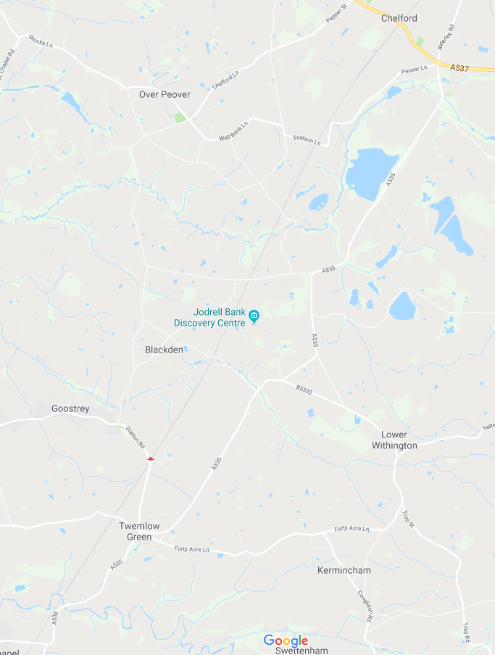
START
FINISH
H.Q.

Care at Road Junctions
Riders must exercise care at all junctions. Any competitor whose riding line causes him/her to cross THE WHITE LINE when approaching or leaving a junction will be liable to disqualification from the event and may be reported to the District Committee for further disciplinary action.

No “U” turns in the vicinity of the start and finishing points, (Observers are watching).

Head up at all times. Observe local regulations pertaining to the course at all times.
Pace must not be given of received. The onus is on the overtaken rider to avoid this.
Marshalls do not have the authority to control road users, so please take care.

CARE AT CHELFORD ISLAND
Riders must negotiate Chelford Island in a safe and sensible manner in accordance with CTT Regulation 20 and the Rules of the Road. Riders must be able to brake and stop at the island if traffic conditions require this. Riders MUST NOT approach the Island using “TRI- BARS”. Remember - traffic on the island has priority over traffic (including riders) entering it. Any rider seen to be in breach of this regulation will be disqualified from the event and may be reported for further disciplinary action.

IN THE INTERESTS OF YOUR OWN SAFETY Cycling Time Trials and the event promoters strongly advise you to wear a HARD SHELL HELMET that meets an internationally accepted safety standard.
In accordance with Regulation 15 ALL Junior competitors must wear Protective Hard Shell Helmets.
It is recommended that a working rear light, either flashing or constant, is fitted to the machine in a position visible to following road users and is active whilst the machine is in use.

Prize Values

Ladies | Fastest Handicap | Men | Combined
1st £20.00 | 1st £12.00 | 1st £20.00 | 1st £12.00
2nd £16.00 | 2nd £11.00 | 2nd £16.00 | 2nd £11.00
3rd £12.00 | 3rd £10.00 | 3rd £12.00 | 3rd £10.00
4th £10.00 |  | 4th £10.00
5th £8.00 |  | 5th £8.00

Fastest team of two Ladies: £10.00 each

Certificates to be awarded to G.H.S. competitors on completion of event.
Certificate to be awarded to fastest M&DLCA Vet on standard at the Annual Dinner.
One rider one prize except Combination and Team awards.

GHS

Num | Name | Club | Start
1 | Melissa Boylin | The Racing Chance Foundation | 14:01:00
2 | Bryn Lawrence | C and N Cycles RT | 14:02:00
3 | Harry Paveley | Innovation Racing | 14:03:00
4 | Joel Ackers | Innovation Racing | 14:04:00
5 | Joe Burns | Sportcity Velo | 14:05:00
6 | Aidan Lawrence | C and N Cycles RT | 14:06:00
7 | Francis Woodcock | Bury Clarion CC | 14:07:00
8 | George Elliot | Innovation Racing | 14:08:00
9 | Samuel Hall | VeloRunner RT | 14:09:00
10 | Tristan Pilling | Team SB Hub | 14:10:00

Ladies

Num | Name | Cat | Club | H/Cap | Std | Start
11 | Natasha Smith | V | Velo Schils Interbike RT | 28:34 |  | 14:11:00
12 | Rachel Crew |  | Cheshire Maverick Cycle Club | N/A |  | 14:12:00
13 | Caroline Booth |  | Salford Cycling Club | N/A |  | 14:13:00
14 | Rachel Trpeski | V | Niteriders | 28:24 | 13:36 | 14:14:00
15 | Christine Roberts | V | The Racing Chance Foundation | 30:14 | 13:22 | 14:15:00
16 | Jayne Dickens | V | Vision Racing /Delamere Dairy/GRM Property Consultants/Swinnerton Cycles | 28:48 | 05:26 | 14:16:00
17 | Lynsey Astles | V | Weaver Valley CC | 28:08 | 11:20 | 14:17:00
18 | Hannah Dines |  | Storey Racing | N/A | 11:04 | 14:18:00
19 | Emma Naylor |  | University of Bath Cycling Club | N/A | 11:01 | 14:19:00
20 | Samantha Hewitt |  | Ashley Touring CC | N/A | 11:00 | 14:20:00
21 | Polly Wilding | V | Congleton CC | 28:24 | 10:51 | 14:21:00
22 | Anna Brunt | V | Seamons CC | 28:24 | 10:31 | 14:22:00
23 | Diana Bite |  | University Of Manchester CC | N/A | 10:08 | 14:23:00
24 | Joanne Harcourt | V | Stretford Wheelers CC | 28:53 | 09:56 | 14:24:00
25 | Carole Sherrin | V | Westmead Team 88 | 29:03 | 08:36 | 14:25:00
26 | Michelle Fairclough | V | Salford Cycling Club | 28:13 | 08:34 | 14:26:00
27 | Sandra Griffiths |  | Vision Racing /Delamere Dairy/GRM Property Consultants/Swinnerton Cycles | N/A | 08:33 | 14:27:00
28 | Emily Martin |  | Weaver Valley CC | N/A | 08:10 | 14:28:00
29 | Karen Bailey | V | East Lancashire RC | 28:08 | 08:00 | 14:29:00
30 | Jill Fielding |  | North Cheshire Clarion | N/A | 07:48 | 14:30:00
31 | Georgina Cape | V | East Lancashire RC | 28:39 | 06:23 | 14:31:00
32 | Sarah Grant |  | Vision Racing /Delamere Dairy/GRM Property Consultants/Swinnerton Cycles | N/A | 06:02 | 14:32:00
33 | Claire Harrison | V | Vision Racing /Delamere Dairy/GRM Property Consultants/Swinnerton Cycles | 28:24 | 05:53 | 14:33:00
34 | Chelsea McCloskey-Lambert |  | Manchester Wheelers | N/A | 05:48 | 14:34:00
35 | Christine Higgs | V | Macclesfield Wheelers | 29:38 | 05:45 | 14:35:00
36 | Alix Archer | V | Maxx R. T. | 28:53 | 05:24 | 14:36:00
37 | Crystal Lane |  | Glossop Kinder Velo Cycling Club | N/A | 05:07 | 14:37:00
38 | Zoe Whiteside | V | Team Bottrill / Vanguard | 28:24 | 05:03 | 14:38:00
39 | Anna Weaver |  | NJC-Biemme-Echelon | N/A | 04:42 | 14:39:00

Men

Num | Name | Club | Invited by | Start
44 | Daniel Goodwin |  |  | 14:44:00
45 | Mark Fenton | Stone Wheelers CC | Jayne Dickens | 14:45:00
46 | Dan Sherrin | Coventry Triathletes | Carol Sherrin | 14:46:00
47 | Chris Rix | Salford Cycling Club |  | 14:47:00
48 | Martin Ince | Salford Cycling Club |  | 14:48:00
49 | James Lawley | Barrow Central Wheelers |  | 14:49:00
50 | Simon Darby | Salford Cycling Club | Emma Naylor | 14:50:00
51 | Mike Noble | Stockport Tri Club (2017) | Crystal Lane | 14:51:00
52 | Julian Ainsworth | Salford Cycling Club | Caroline Booth | 14:52:00
53 | Steve McQuade | Crewe Clarion Wheelers |  | 14:53:00
54 | Ian Bracegirdle | Stretford Wheelers CC | Joanna Harcourt | 14:54:00
55 | Michael Summers | Glossop Kinder Velo Cycling Club | Caroline Booth | 14:55:00
56 | Matthew Sim | Dorking Cycling Club |  | 14:56:00
57 | Andy Robinson | Vision Racing /Delamere Dairy/GRM Property Consultants/Swinnerton Cycles | Claire Harrison | 14:57:00
58 | Martin Alcock | Niteriders | Sandra Griffiths | 14:58:00
59 | Barry Armstrong | Seamons CC | Hannah Dines | 14:59:00
60 | Lee Wood | Congleton CC |  | 15:00:00
61 | Paul Dean | Macclesfield Wheelers |  | 15:01:00
62 | Gavin Lynch | Glossop Kinder Velo Cycling Club |  | 15:02:00
63 | Mike Cotgreave | Westmead Team 88 | Natasha Smith | 15:03:00
64 | William Howarth | East Lancashire RC |  | 15:04:00
65 | Ian Roberts | The Racing Chance Foundation |  | 15:05:00
66 | Kirk Yearsley | Salford Cycling Club |  | 15:06:00
67 | Simon Williams | Ashley Touring CC | Lynsey Astles | 15:07:00
68 | Stephen Sladin | Congleton CC | Christine Higgs | 15:08:00
69 | Mark Fielding | North Cheshire Clarion | Gill Fielding | 15:09:00
70 | Steve Hall | Thatto Cycles Racing Team | Anna Weaver | 15:10:00
71 | John Moor | Manchester Bicycle Club | Emily Martin | 15:11:00
72 | David Ireland | East Lancashire RC |  | 15:12:00
73 | Joseph Cadwallader | Bury Clarion CC | Christine Roberts | 15:13:00
74 | Rufus Brunt | Seamons CC | Anna Brunt | 15:14:00
75 | Roy Nield | East Lancashire RC | Karen Bailey | 15:15:00
76 | Laurence Birdsey | Cheshire Maverick Cycle Club | Georgina Cape | 15:16:00
77 | Danny McCabe | Garstang CC | Polly Wilding | 15:17:00
78 | John Spearman | Seamons CC | Rachel Trperski | 15:18:00
79 | Adam Darby | Salford Cycling Club | Michelle Fairclough | 15:19:00
80 | Austin Foy | Fogartys Insurance Tri Team | Samantha Hewitt | 15:20:00
81 | Stephen Turner | Westmead Team 88 | Alix Archer | 15:21:00
82 | Tony Haley | Vision Racing /Delamere Dairy/GRM Property Consultants/Swinnerton Cycles | Sarah Grant | 15:22:00
83 | Ben Watson | Glossop Kinder Velo Cycling Club | Hannah Dines | 15:23:00
84 | Barry Charlton | Swinnerton Cycles | Rachel Crew | 15:24:00
85 | Joseph Dobson | Manchester Bicycle Club | Diana Bite | 15:25:00
86 | Gavin McCloskey-Lambert | Manchester Wheelers | Chelsea McCloskey-Lambert | 15:26:00
87 | Jonathan Gildea | Para-T | Diana Bite | 15:27:00
88 | Scott Leverington | Springfield Financial Racing Team | Zoe Whiteside | 15:28:00
89 | David James Williams | Velotik Racing Team |  | 15:29:00
90 | Adam Duggleby | Vive Le Velo |  | 15:30:00

Refreshments and Helpers

Refreshments will be available at the headquarters, as will the results board.
Donations of cakes are always welcome.

We also welcome any offers of help, please contact me on 0161 456 9376 if you have any supporters who would be willing to help with the running of the event.

Each year, the M&DLCA awards several prizes and trophies to members of the M&DLCA and affiliated clubs, which are presented at our annual dinner dance in November. Any event on a ‘25’ or ‘50’ mile ‘J’ course counts for these trophies, as long as copies of the results sheet and entry form are sent to the M&DLCA BAR Secretary, K. Jackson, but the only counting ‘10’ mile events are those organised by the M&DLCA. The onus is on the rider to submit, where required, copies of the entry form and results sheet to the M&DLCA BAR Secretary before the 1st October of the current season.

For the latest news, results and photos please visit our website on http://www.mdlca.org.uk

