

Manchester and District
Ladies’ Cycling Association

28th April 2018

Ladies Open Handicapped 10 mile Time Trial

Promoted for and on behalf of Cycling Time Trials under their Rules and Regulations.
Handicapped using standard tables
Run in conjunction with East Lancs Road Club
THIS EVENT IS ROUND 5 OF THE CHESHIRE COURSES POINTS COMPETITION

Event Organiser: K. Jackson, 7 Burford Crescent, Wilmslow, Cheshire 01625 537401
Timekeepers: Ms C White & Mrs C Elliott First rider off at 2:01 pm

Headquarters: Siddington Village Hall, Congleton Road, Siddington, Cheshire, SK11 9JR Please do not rely on the postcode alone to find the venue

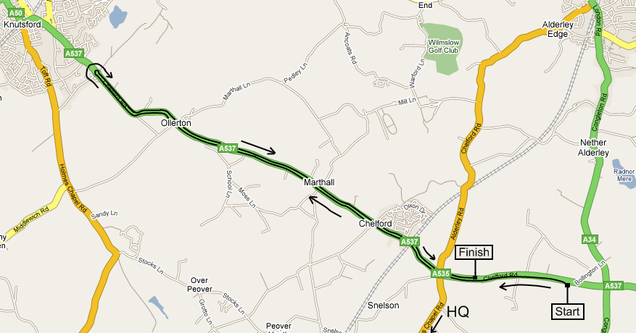
HQ

Course: J2/1
Start on the A537 at a JS1 mark in the centre of the lay-by, approximately 500 yards west of the A34 at Monks Heath. Proceed west on the A537 via Chelford Island (third exit) to Booths Hall Island. 5.268miles
Encircle the island and retrace via Chelford Island (second exit) to Finish at a JF1 mark adjacent to the second stud back from the end of the first lay-by after Chelford Island 10.00 miles

Prizes

1st | £20.00 | 1st handicap | £15.00
2nd | £15.00 | 2nd handicap | £12.00
3rd | £10.00 | 3rd handicap | £10.00
Fastest team of two ladies: £10.00 each

Certificates to be awarded to fastest juvenile and fastest M&DLCA Vet on standard at the Annual Dinner
One rider one prize, except team prize

Refreshments and results will be available in the headquarters, cake donations are very welcome.

Num | Name | Cat | Club | H/Cap | Std | Start
1 | Sandra Griffiths |  | Vision Racing /Delamere Dairy/GRM Property Consultants/Swinnerton Cycles | 8:33 |  | 2:01pm
2 | Jan Scotchford | V | North Lancashire Road Club | 10:03 | 28:58 | 2:02pm
3 | Eleanor Turton |  | Seamons CC | 11:40 |  | 2:03pm
4 | Francesca Lewis |  | Stockport Tri Club(2017) | 12:08 |  | 2:04pm
5 | Holly Carter |  | Rapha Cycling Club | 7:59 |  | 2:05pm
6 | Julia Smith | V | Port Sunlight Wheelers | 9:27 | 28:39 | 2:06pm
7 | Janet Grint | V | Stockport Tri Club(2017) | 10:16 | 28:13 | 2:07pm
8 | Melissa Boylin | Juv | The Racing Chance Foundation |  |  | 2:08pm
9 | Belinda Brennan | V | Stockport Tri Club(2017) |  | 28:02 | 2:09pm
10 | Rachel Batt |  | Buxton CC/Sett Valley Cycles | 7:17 |  | 2:10pm
11 | Karen Bailey | V | East Lancashire RC | 8:00 | 28:08 | 2:11pm
12 | Joanne Harcourt | V | Stretford Wheelers CC | 9:56 | 28:53 | 2:12pm
13 | Hannah Dines |  | Storey Racing | 11:04 |  | 2:13pm
14 | Susan Roberts | V | Rapha Cycling Club |  | 28:24 | 2:14pm
15 | Jill Fielding |  | North Cheshire Clarion | 7:48 |  | 2:15pm
16 | Lynne Skellern | V | Macclesfield Wheelers | 9:11 | 28:58 | 2:16pm
17 | Samantha Hewitt |  | Ashley Touring CC | 11:00 |  | 2.17pm
18 | Gillian Doolan | V | Stockport Tri Club(2017) | 11:25 | 28:53 | 2.18pm
19 | Alexa Dawson | V | Cheshire Maverick Cycle Club |  | 28:13 | 2.19pm
20 | Georgina Cape | V | East Lancashire RC | 6:23 | 28:39 | 2.20pm
21 | Rachel Connerney |  | Cyclesport International RT | 8:21 |  | 2.21pm

Rider Instructions
Event H.Q.
1. There will be no access to the event HQ before 01:00pm. Signing on will commence from 01:10pm. 2. Riders must ensure they do not block any roads around the hall.
3. Extra parking is available in a field adjacent to the village hall and can be accessed via the village hall car park. This will be available from 01:00 pm.
4. As a courtesy to other riders, supporters and children please do not change clothing in a manner that may cause offence.

Numbers will be at the headquarters – Please note that each rider must SIGN-ON when collecting their number, and SIGN-OFF when returning it. Failure to do so will result in that rider being classified as DNF. Pin rear number low down and arm number on left shoulder.
The Risk Assessment document will be available at Signing-On but we highly recommend reading this, in advance, on the CTT District website ( www.manchesterctt.org.uk ) – especially those riders who are not familiar with the course and its junctions (plus its ruts and potholes).

Directions to Start
Directions to Start: Right out of HQ, left at Monks Heath traffic lights onto A537, Chelford Road. Start in first lay-by approx 500yds on left. Please allow ten minutes to the start.

Return to HQ. Continue on A537, Chelford Road, from finish to Monks Heath traffic lights. Extreme care – turn right onto A34 to Village Hall.

Warming Up – Riders must not warm up past the start and finish areas.

Rider Notes:

1. No parking at the start or finish.
2. NO ‘U’ TURNS AT THE START.
3. NO ‘U’ TURNS AT THE FINISH. Riders should either dismount or continue forward into the Sand Quarry entrance where you can turn in the gateway and retrace along the A537 in the normal manner. 4. Riders must not stop at the finish but should continue on to the event headquarters, where times will be displayed.
5. Riders must negotiate Chelford Island in a safe and sensible manner in accordance with CTT Reg. 20 and the rules of the road. Riders must be able to brake and stop at the island if traffic conditions require this. Riders MUST NOT approach and encircle the island using tri-bars. Remember - traffic on the island has priority over traffic (including riders) entering it. Any rider seen to be in breach of this regulation will be disqualified from the event and may be reported for further disciplinary action.
6. Care At Road Junctions. Riders must exercise care at all junctions. Any competitor whose riding line causes him/her to cross the white line when approaching or leaving a junction will be liable to disqualification and may be reported to the District Committee for further disciplinary action.

IN THE INTERESTS OF YOUR OWN SAFETY, Cycling Time Trials and the event promoters strongly advise you to wear a HARD SHELL HELMET that meets an internationally accepted safety standard. In accordance with Regulation 15 ALL JUNIOR competitors must wear Protective Hard Shell Helmets. It is recommended that a working rear light, either flashing or constant, is fitted to the machine in a position visible to following road users and is active whilst the machine is in use.

Other M&DLCA events 2018 – see CTT website for further details, entries on-line, closing dates 10 days before event.
Course | Date & time | Organiser | Information
J2/9  25 miles | Saturday 2nd June  14:00 | Robbie Harcourt | (in conjunction with Salford CC)
J4/16  50 miles | Saturday 16th June  14:00 | Ian Ross | M&DLCA open championship 50 (in conjunction with M&DTTA championship. All riders should enter the M&DTTA Event )
J2/3  10 miles | Saturday 30th June  14:00 | Katherine Jackson | Ladies can invite a man to ride the "Invitation 10 Mile event".
2/9  25 miles | Saturday 7th July  14:00 | Mavis Ross | (in conjunction with Nova CC)

Each year, the M&DLCA awards several prizes and trophies to members of the M&DLCA and affiliated clubs, these are presented at our annual dinner dance on November 16th 2018. Any event on a ‘25’ or ‘50’ mile ‘J’ course counts for these trophies, as long as copies of the results sheet and entry form are sent to the M&DLCA BAR Secretary, K. Jackson, but the only counting ‘10’ mile events are those organised by the M&DLCA. The onus is on the rider to submit, where required, copies of the entry form and results sheet to the M&DLCA BAR Secretary before the 1st October of the current season.
For the latest news, results and photos please visit our website on http://www.mdlca.org.uk
We also have a Facebook page for photos and posts.

