COURSE F11-10
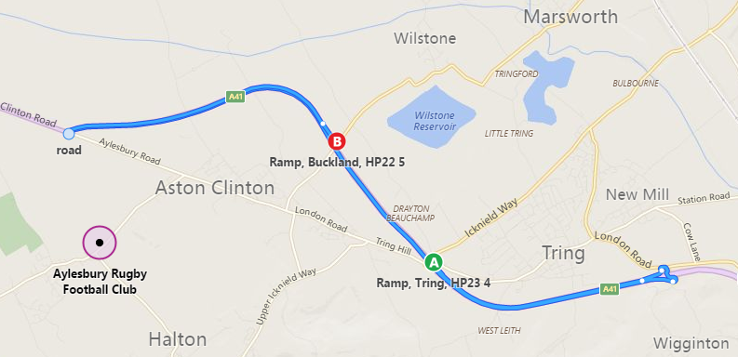

FIRST ROUNDABOUT – RIDERS HAVE GONE WRONG
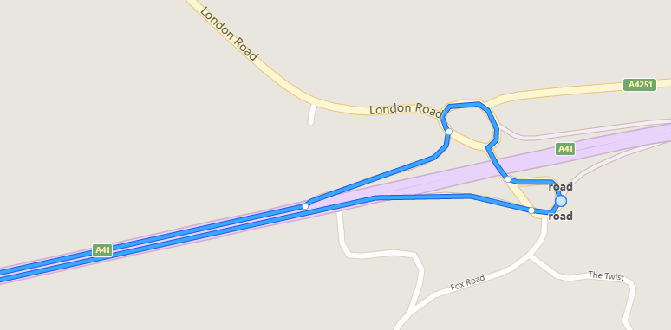

LAST ROUNDABAOUT @2 MILES TO GO
