
Bath Cycling Club Established 1880

Presents the

“Tony Mitchell 25 mile Time Trial”

Including the VTTA West Group 25 mile championship for the Jack Gray Memorial Trophy

Event date: 11th September 2016

(Promoted for and on behalf of Cycling Time Trials under their rules and regulations)

Event secretary: Nigel Vuagniaux Tel. 01225 482363
3 Michaels Mead, Emergency phone on day: 07841 437860
Bath
BA1 4JD Email: nvuagniaux@btinternet.com Note this email will not be available on the day.

Timekeepers: Paul Arayan (Bath CC) & Dennis Davis (Bath CC)

Headquarters: Maiden Bradley Village Hall (BA12 7JG) - open from 7.30am. Numbers at HQ

Course U370 details
Start on the B3092 at entrance to the Frome Showground; proceed to the Blatchbridge roundabout (Rbt) on A361; take 3rd exit on the A361 to Pylon Rbt and take 1st exit (left turn); take 2nd exit at Commerce Park Rbt (straight over); take 3rd exit to turn at the Oldford Rbt (CARE ENTERING RBT - traffic from the right has priority) and retrace to Blatchbridge Rbt. Complete Blatchbridge-Oldford-Blatchbridge circuit TWICE more. After completing the THIRD circuit take 1st exit at Blatchbridge Rbt towards Maiden Bradley to finish opposite start.

Important notes
No warming up on the course after 1st rider has started at 9.07am.
Please sign the official start sheet at the HQ at least 30 minutes before your start. Allow 15 minutes to get from the HQ to the start. Leaving the HQ turn right on B3029 and follow for approx. 2 miles to start in the entrance to the Frome Showground. Race numbers are available at HQ and can be exchanged for a drink after your ride. Please note that we are accepting contributions for cakes.
No U-turns are permitted near the start/finish area.

It is the rider’s responsibility to keep track of number of Blatchbridge-Oldford-Blatchbridge circuits done.
Please shout out your number at the finish and continue directly to the race HQ at Maiden Bradley.
PLEASE RESPECT THE OWNERS REQUEST FOR NO CYCLING SHOES IN HALL!!
All competitors should use the village hall car park. Additional parking is available on the other side of the B3029. Please show consideration to local residents. Toilets at HQ will be open from 7.30am.
A full risk assessment of the course will be on display at HQ on race day.
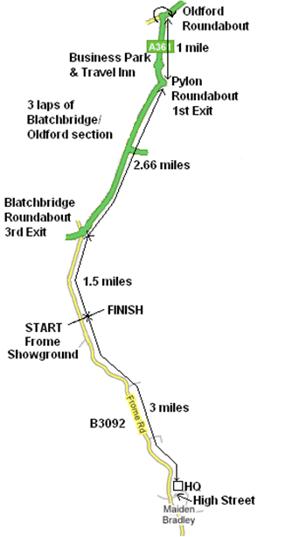
Prizes

Please note – One prize per rider except team prize

1st £17:50 1st Lady £17:50 1st Vet’ 40+ £10:00 1st Vet’ £17:50

2nd £12:50 2nd Vet’ 50+ £10:00 2nd Vet’ £12:50

3rd £7:50 3rd Vet’ 60+ £10:00 3rd Vet’ £7:50

4th Vet’ 70+ £10:00

5th Vet’ 80+ £10:00

Team (3 to score) £5:00 each

Trophys:

“Tony Mitchell” shield for fastest Bath CC Vet’ on standard

“Jack Grey” cup for fastest West Vet’ on actual time

“George Carter” cup for the fastest Bath CC rider

RIDER’S ATTENTION IS DRAWN TO C.T.T. REGULATIONS IN PARTICULAR:

No. 19 – Observance of the law
No. 20 – Paced riding and company riding
No.21 – Use of motor vehicles

Riders must shout out their number when passing the finish line

Please remember to keep your heads UP – watch out for tractors!!

IN THE INTERESTS OF YOUR OWN SAFETY the promoters strongly advise you to wear a HARD SHELL HELMET that meets an internationally accepted standard

BATH CC MEMBERS!! Please bring any club trophies to the race hq, to be engraved in time for presentation at the Club Dinner.

Many thanks to all competitors for taking part and keeping this event alive, have a great ride.

Nigel

