 | Hitchin Nomads CC  F14/25 Open 25 Mile Time Trial  London Millennium Series (7 of 8), Women’s BBAR;  and Tandem Event  Saturday 19 May 2018  Promoted for and on behalf of Cycling Time Trials  under its rules and regulations

Event Secretary
Mr James Cornell
Hitchwood Barn, Hitchwood Lane, Preston, Hertfordshire, SG4 7RW
Tel. 07977 563444

Event Headquarters
Guilden Morden Village Hall, Fox Hill Road, Guilden Morden, SG8 0JF

Signing on and numbers will be available from 1300h. Remember to sign back in when finished, as per CTT Regulation 17(b). We must vacate the Hall by 1800h. Changing rooms with showers are available. There is ample parking on the Recreation Ground adjacent to the Hall. Please leave the parking in front of the Hall for the Event Crew. No parking allowed anywhere on the course. Please don’t wear cycling shoes in the hall as the floor has been recently re-finished. Please drive dead slow within the parking area and use indoor changing facilities where possible. A First Aider will be present within the hall or on the recreation ground at all times.

Timekeepers
Mr Tim Groves, Miss Becki Groves, Mr Frank Turner

Course details F14/25
START: on the Wrestlingworth-Guilden Morden road approx 540 yds south of Wrestlingworth x-rds and 460 yds north of Common Farm. Proceed south to Guilden Morden where turn LEFT (M) 1.95 miles (2nd circuit 13.73 miles) into New Road leading to Shingay cum Wendy and Wendy to T junction 6.34 miles (2nd circuit 18.12 miles) with A1198. At junction bear LEFT (CAUTION) (M) to roundabout, where bear LEFT (M) onto B1042 to Tadlow and cross roads at Wreslingworth where bear LEFT (M)11.48 miles (2nd circuit 23.26 miles) on unclassified road to Guilden Morden and pass start –
Repeat circuit and pass start again and in approx 1.5 miles to:

Please bear to the left of the road to accommodate riders passing on lap 2.

FINISH at south of farm entrance, 50 yds south of Water Hydrant sign and 72 yds north of Bend sign and 149 yds north of large 30 sign. (25 miles)

At various junctions around the course you will be joining a road with traffic priority, therefore please take care and give way. You are reminded to ride on the Left Hand Side of the road except for safe overtaking, in accordance with CTT Regulation 20. Please take special care of this at the Guilden Morden and Wrestlingworth junctions. Riders observed to be not complying with this regulation are subject to disqualification from the event. Marshals will be on the course, which will be signed. However, the onus is on you to negotiate the course correctly and safely.

IMPORTANT SAFETY NOTICE
In the interests of your own safety, Cycling Time Trials and the event promoter strongly advise you to wear a hard-shell Helmet that meets an internationally accepted standard. In accordance with Regulation 15 ALL JUNIOR competitors must wear Protective Hard Shell Helmets. It is recommended that a working rear light either flashing or constant, is fitted to the machine in a position visible to following road users.

Prizes - one rider, one prize rule applies
1st =£40 2nd = £30 3rd = £20
1st Team of three riders = £20 each
1st Woman = £40

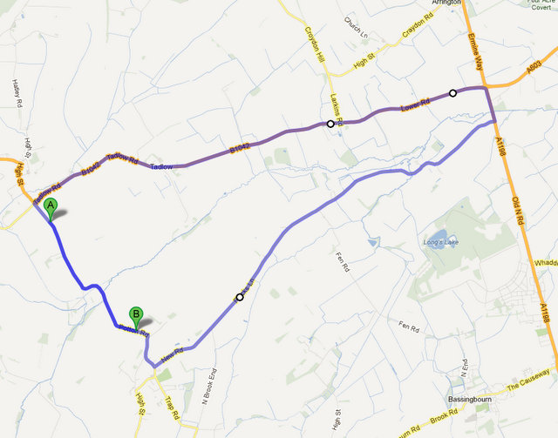
A denotes approximate start location, B denotes approximate finish location after lap 2.

